UNIT 2: HUMANS AND THE ENVIRONMENT
Lesson 4: Speaking

I. OBJECTIVES
By the end of this lesson, students will be able to:
1. Knowledge
- Talk about ways to live green.
2. Core competence
- Be collaborative and supportive in pair work and team work;
- Develop presentation skills;
- Actively join in class activities;
- Be critical thinking.
3. Personal qualities
- Recognise what activities teenagers should do to live green;
- Be aware of the importance of a green lifestyle.
4. Digital Competence:
- 2.2NC1a: Share data, information, and digital content through various tools (presenting green living ideas).
II. MATERIALS
- Grade 10 textbook, Unit 2, speaking
- Computer connected to the Internet
- Projector/ TV/ pictures and cards
- sachmem.vn

Language analysis

Form | Pronunciation | Meaning | Vietnamese equivalent
leave st on (v) | /liːv ˈsʌm.θɪŋ ɒn/ | make or allow something to remain in working condition | không tắt
chemical (n) | /ˈkemɪkl/ | a substance obtained by or used in a chemical process | hóa chất
shade (n) | /ʃeɪd/ | slight darkness caused by something blocking the direct light from the sun | bóng mát, bóng râm

Assumptions
Anticipated difficulties | Solutions
- Ss may lack knowledge about some lexical items.  - Ss may know only the connector “because” to express the reasons. | - Provide them with the meanings and pronunciation of words.  - Provide them with other connectors so that they won’t repeat the word “because” in their presentation.

Board Plan
Date of teaching
Unit 2: HUMANS AND THE ENVIRONMENT
Lesson 4: Speaking
WARM-UP: Board race
Vocabulary
Task 1: Should or shouldn’t.
Task 2: Do the matching.
Task 3: Discussion.
CONSOLIDATION

III. PROCEDURES
Notes:
In each activity, each step will be represented as following:
Deliver the task
Implement the task
Discuss
Give comments or feedback

Stage | Stage aim | Procedure | Interaction | Time
WARM-UP | - To arouse the classroom atmosphere.  - To lead in the lesson. | GAME: Board race (The topic word is green living)  Teacher gives instructions of how to play the game, and gives an example.  Ss discuss in their teams and write down the words.  Ss in each team take turns to write their words on the board.  Teacher confirms the correct words, decides the winner and leads in the lesson.  Rules and an example of the ‘board race game’:  - The class is divided into teams.  - In one or two minutes (depending on the number of the letters in the topic words), Ss have to find the words which are related to the topic and have one letter in the topic word.  - If the word begins with a letter in the topic word, the team gets 1 point.  - If the letter of the topic word appears in the middle position, the team gets 2 points.  - If the letter of the topic word is at the end of the word they have found, the team gets 3 points.  For example, if the topic word is FILMS and with the words found in the table below, a team gets 9 points in total. | T-S  S-T-S  T-S | 6 mins
   |  |  |  |  |  | F | A | M | O | U | S | (1 point)
   |  |  | M | O | V | I | E |  |  |  |  | (2 points)
   |  |  |  |  |  | L | O | V | E |  |  | (1 point)
   |  | C | I | N | E | M | A |  |  |  |  | (2 points)
  A | C | T | R | E | S | S |  |  |  |  |  | (3 points)
  Total |  |  |  |  |  |  |  |  |  |  |  | 9 points
PRE-SPEAKING | To pre-teach some vocabulary so that students can understand the meanings and use them correctly in main speaking tasks. | VOCABULARY  Teacher:  - shows the words one by one, plays the recording and has Ss repeat the sounds of the words.  - has Ss guess the meanings of the words based on pictures, explanations or examples.  1. leave st on (idioms): choose to keep something operational or switched to an "on" position.  Ex: Someone left the lights on the whole time we were gone. Our electricity bill is going to be enormous.  2. chemical (n): a substance obtained by or used in a chemical process    3. shade (n): slight darkness caused by something blocking the direct light from the sun  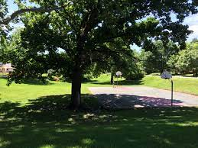  Ss do as instructed.  T confirms the meanings, calls on some individual Ss to make sentences with each word. | T-S  S-S  T-S | 6 mins
PRE-SPEAKING | To introduce more ideas for the main speaking tasks and get students involved in the lesson | TASK 1: WHICH OF THE FOLLOWING ACTIVITIES DO YOU THINK TEENAGERS SHOULD OR SHOULDN’T DO TO LIVE GREEN? PUT A TICK IN THE APPROPRIATE COLUMN. (p.23)  T has Ss work in pairs, read the activities, discuss their meanings and decide which activities they should/ shouldn’t do to go green by putting a tick in the appropriate column.  Ss do as instructed.  Some individual Ss share their answers with the whole class.  T confirms the correct answers.  Key: | T-S  S-S  S-S  T-S | 8 mins
  Activities | Should | Shouldn’t
  1. Leaving your appliances on when not in use |  | ✔
  2. Recycling your used items | ✔
  3. Using plastic bags when shopping |  | ✔
  4. Buying organic food | ✔
  5. Dropping litter in the street |  | ✔
  6. Planting trees | ✔
PRE-SPEAKING | To introduce more ideas for the main speaking task and get students involved in the lesson | TASK 2: THE TABLE BELOW PRESENTS THE REASONS WHY TEENAGERS SHOULD OR SHOULDN’T DO THE ACTIVITIES IN 1. WORK IN PAIRS AND MATCH THEM WITH THE ACTIVITIES. (p.23)  Teacher:  - has Ss read the reasons, and discuss with a peer to do the matching.  - reminds them that besides using because, they can use since/ as/ due to the fact that/ on the ground that to express reasons and encourages them to give more reasons and make small exchanges after doing the matching, e.g.  Student A: Why shouldn’t you leave your appliances on when not in use?  Student B: Because this wastes electricity and creates dangerous situations. Why should you recycle your used items?  Student A: Since this protects natural resources.  Ss do as instructed.  Ss share the answers with the whole class.  Teacher confirms the correct answers and calls on some pairs to make small exchanges like the one above.  Suggested answers:  a - 5; b - 1; c - 3; d - 4; e - 2; f - 6 | T-S  S-S  S-S  T-S | 8 mins
WHILE-SPEAKING | To give students an opportunity to discuss ideas in groups and share with the rest of the class.  - Students are encouraged to apply Digital Competence 2.2NC1a by presenting their ideas using visual aids or slides if available. | TASK 3: WORK IN GROUPS. DISCUSS AND PRESENT YOUR IDEAS ABOUT WHAT YOU SHOULD OR SHOULDN'T DO TO LIVE GREEN. (p.23)  T has Ss work in groups, discussing what they should or shouldn’t do to live green.  - In weaker classes, T reminds them to use the ideas given in 1 and 2 in their discussion. In stronger classes, T encourages them to think of other activities and reasons.  Ss do as instructed.  Ss share their ideas with the rest of the class by playing the game: PASSING THE BALL.  Rules: A song is played while Ss are passing a ball one by one. When the music stops, the student who keeps the ball will make a presentation.  Teacher praises Ss for interesting and imaginative ideas, and for providing well-formulated reasons.  Example: There are many things that we should or shouldn’t do to live green. We should recycle our used items so that we can protect natural resources. We shouldn’t drop litter in the street because this will make the street dirty and pollute the environment. | T-S  S-S  S-S  T-S | 15 mins
CONSOLIDATION | To help students memorise the content of the lesson | WRAP-UP  Teacher asks: What have you learnt today?  - Activities and the reasons why we should or shouldn’t do to live green.  HOMEWORK  - Exercises in the workbook  - Prepare for Listening lesson | T-S | 2 mins

UNIT 2: HUMANS AND THE ENVIRONMENT
Lesson 5: Listening

I. OBJECTIVES
By the end of this lesson, students will be able to:
1. Knowledge
- Listen for specific information in a text about green living;
- Talk about a plan to organise a green event in their area.
2. Core competence
- Be collaborative and supportive in pair work and team work;
- Actively join in class activities;
- Develop presentation skills.
3. Personal qualities
- Be more responsible for the environment and be able to propose plans to solve environmental issues in their residential areas;
- Be ready to make a plan to organize a green event in their area.
4. Digital Competence
- Propose strategies to search for supplementary information for the listening task (1.1NC1d).
II. MATERIALS
- Grade 10 textbook, Unit 2, listening
- Computer connected to the Internet
- Projector/ TV/ pictures and cards
- sachmem.vn

Language analysis

Form | Pronunciation | Meaning | Vietnamese equivalent
schedule (n) | /ˈʃedjuːl/ | a plan that lists all the work that you have to do and when you must do each thing  E.g. They have a very flexible work schedule. | thời gian biểu
specific (adj) | /spəˈsɪfɪk/ | connected with one particular thing only  E.g. The money was collected for a specific purpose. | cụ thể
donation (n) | /dəʊˈneɪʃn/ | money or goods that are given to help a person or organization, or the act of giving them | đồ hiến tặng, sự hiến tặng
delivery (n) | /dɪˈlɪvəri/ | the act of taking goods, letters, parcels, etc. to people's houses or places of work | sự giao hàng

Assumptions
Anticipated difficulties | Solutions
- Ss may lack knowledge about some lexical items.  - Ss may not catch the ideas to decide the statements are true or false. | - Provide them with the meanings and pronunciation of words.  - Remind them to pay attention to the key words in each sentence.

Board Plan
Date of teaching
Unit 2: HUMANS AND THE ENVIRONMENT
Lesson 5: Listening

WARM-UP: Taboo
Vocabulary
Task 1: Look at the picture and answer the questions.
Task 2: True of false.
Task 3: Listen and complete the table.
Task 4: Discussion.
CONSOLIDATION

III. PROCEDURES
Notes:
In each activity, each step will be represented as following:
Deliver the task
Implement the task
Discuss
Give comments or feedback

Stage | Stage aim | Procedure | Interaction | Time
WARM-UP | - To arouse the classroom atmosphere.  - To get students be actively involved in the lesson. | GAME: TABOO  Teacher:  - divides the class into 2 teams, lets each team choose 5 representatives.  - prepares in advance 2 sets of words (maybe written on a sheet of paper), and gives them to the representatives.  - asks the representatives to try to get their teammates to guess words using verbal clues or actions without using the words in their sets and without using their mother tongue in two minutes.  Ss do as instructed.  Ss in each team take turns to describe and guess the words.  Teacher confirms the correct words, decides the winner. The winners are the ones whose team can guess the most words.  Suggested words:  Set 1: adopt, carbon footprint, litter, method, eco-friendly  Set 2: sort, awareness, organic, household appliances, cut down on | T-S  S-S  S-S  T-S | 6 mins
PRE-LISTENING | To pre-teach the pronunciation and the meaning of some vocabulary so that students can understand the content of the listening.  To introduce the topic of the listening and activate Ss’ prior knowledge | VOCABULARY  Teacher:  - shows the words one by one, plays the recording and has Ss repeat the sound of the words.  - has Ss guess the meanings of the words based on pictures, explanations and examples.  1. schedule (n): a plan that lists all the work that you have to do and when you must do each thing. E.g. They have a very flexible work schedule.  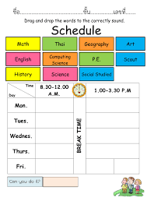  2. specific (adj): connected with one particular thing only.  E.g. The money was collected for a specific purpose.  3. donation (n): money or goods that are given to help a person or organization, or the act of giving them.    4. delivery (n): the act of taking goods, letters, parcels, etc. to people's houses or places of work.    Ss do as instructed.  Teacher confirms the meanings, calls on some individual Ss to make sentences with each word.  TASK 1: WORK IN PAIRS. LOOK AT THE PICTURE AND ANSWER THE QUESTIONS. (p.24)  WHAT ARE THEY DOING? WHY?  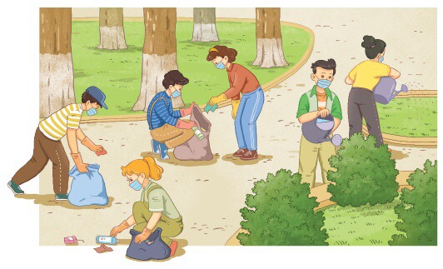  Teacher:  - has Ss work in pairs, look at the picture and tell their partner what they see in the picture.  - - encourages them to use the vocabulary they have learnt to describe the picture, e.g. The students are picking up rubbish, bottles and plastic bags; They are watering plants and trees.  Ss do as instructed.  Some pairs share their answers with the class.  Teacher praises the pairs with interesting ideas and asks the class some more questions to elicit the topic of the listening: Go Green Weekend event such as:  + Are the students wearing school uniforms?  + Are they at school?  + What day of the week do you think it is?  + Do you think this is an organised event?  + What kind of event is it? | T-S  S-S  T-S  T-S  S-S  S-S  T-S | 6 mins  6 mins
WHILE-LISTENING | To help Ss practise listening for specific information. | TASK 2: LISTEN TO AN ANNOUNCEMENT ABOUT A GO GREEN WEEKEND EVENT AND DECIDE WHETHER THE FOLLOWING STATEMENTS ARE TRUE (T) OR FALSE (F). (p. 24)  Teacher:  - tells Ss that they are going to listen to an announcement about a Go Green Weekend event.  - - has them read the statements, underline the key words.  - - checks the key words with the whole class.  - - plays the recording and has Ss do the activity, paying attention to the key words to catch the ideas.  Ss do as instructed.  Ss share their answers with a peer.  Teacher:  - checks the answers as a class, asks SS to explain why they are true or false.  - - plays the recording again if many Ss have incorrect answers, pausing at the places where they can get the correct information.  Key:  1. T ; 2. F (central market -> central park); 3. T; 4. T | T-S  S-S  S-S  T-S | 8 mins
WHILE-LISTENING | To help students practise listening for specific information | TASK 3: LISTEN AGAIN AND COMPLETE EACH GAP IN THE TABLE WITH ONE WORD FROM THE RECORDING. (p.24)  Teacher:  - has Ss read the instruction and focus their attention on the word ‘ONE’  - - has them read the incomplete text and try to have a guess at what part of speech might fit each gap, e.g. 1. noun; 2. adjective  - -plays the recording once for Ss to complete the table.  Ss do as instructed.  Ss share their answers with a peer.  Teacher:  - checks the answers by calling on some Ss to write their answers on the board or read them aloud.  - - plays the recording again if many Ss have incorrect answers, pausing at the places where they can get the correct information.  Key:  1. park  2. plastic  3. Sort  4. Post  5. suggestions | T-S  S-S  S-S  T-S | 8 mins
POST-LISTENING | To give students an opportunity to personalise the language and ideas from the listening in a speaking task.  - T integrates digital competence (1.1NC1d): T asks Ss, "To make your plan for a Green Event successful, what information do you need that wasn't in the recording? How would you find it?" T encourages Ss to propose strategies (e.g., using search engines to find local environmental regulations, searching for 'recycling centers near me', or looking up guides on how to organize a community clean-up) | TASK 4: WORK IN GROUPS. DISCUSS THE FOLLOWING QUESTION. (p.24)  Teacher:  - asks some lead-in questions to see whether Ss have taken part in any environmental activities or events, and how much experience they have, e.g.  + Have you ever taken part in an environmental activity or event?  + How many times have you participated in such activities or events?  + What did you do there?  + How did you feel?  - - put Ss in groups in which there are both not or less experienced Ss and Ss who have taken part in such eco-friendly events.  - - eeminds them that they can use the ideas from the listening and in stronger classes, T encourages them to come up with their own green activities.  Ss do as instructed.  Ss share their ideas with the rest of the class.  T invites some groups to present their ideas to the whole class, and praises the groups for interesting and imaginative ideas. | T-S  S-S  S-S  T-S | 10 mins
CONSOLIDATION | To help students memorise the content of the lesson | WRAP-UP  Teacher asks: What have you learnt today?  - We have listened to a plan to organize a green event and talked about our future plans to hold such events.  HOMEWORK  - Exercises in the workbook.  - Prepare for writing lesson. | T-S | 1 min

UNIT 2: HUMANS AND THE ENVIRONMENT
Lesson 6: Writing

I. OBJECTIVES
By the end of this lesson, students will be able to:
1. Knowledge
- Use lexical items related to the topic “Humans and the environment”;
- Write about ways to improve the environment.
2. Core competence
- Be collaborative and supportive in pair work and team work;
- Actively join in class activities;
- Develop presentation skills.
3. Personal qualities
- Be more responsible for protecting the surrounding;
- Be able and willing to persuade other people to take actions to make a nice and clean environment.
4. Digital Competence
- 3.3NC1a: Apply different copyright regulations (when citing environmental information).
II. MATERIALS
- Grade 10 textbook, Unit 2, writing
- Computer connected to the Internet
- Projector/ TV/ pictures and cards
- sachmem.vn

Assumptions
Anticipated difficulties | Solutions
- Ss may want to use their own suggestions but they may not know how to express their ideas in English.  - Ss in weaker classes may not know how to use connectors correctly to link sentences.  - Ss may not know the structure of a paragraph. | - Be ready to provide them with words/ phrases which they can use to express their ideas in English.  - Provide them with some connectors and some examples.  - GIve them some basic information about the structure of a paragraph.

Board Plan
Date of teaching
Unit 2: HUMANS AND THE ENVIRONMENT
Lesson 6: Writing
Warm-up: Game: Wheel of fortune
Task 1: Match the suggestions for improving the environment with their expected results.
Task 2: Fill in the blanks.
Task 3: Add two more suggestions to improve the environment in your school to the paragraph in 2.
Peer correction
Class correction
Consolidation

III. PROCEDURES
Notes:
In each activity, each step will be represented as following:
Deliver the task
Implement the task
Discuss
Give comments or feedback

Stage | Stage aim | Procedure | Interaction | Time
WARM-UP | - To arouse the classroom atmosphere.  - To get students be actively involved in the lesson. | GAME: THE WHEEL OF FORTUNE  T divides the class into two teams, and explains the game rules:  - Ss in each team read the clues, take turns to spin the wheel, guess the individual letters until they can guess the whole word.  - It is not necessary for the Ss to guess all the individual letters. They can guess the whole word at any time.  Ss do as instructed.  Ss in each team discuss and guess the words.  T confirms the correct words, decides the winner and leads in the lesson.  Suggested words  Round 1:  + Clue: the conditions in which a person, animal or plant lives or operates or in which an activity takes place  + Key: ENVIRONMENT  Round 2:  + Clue: make something or somebody better than before  + Key: IMPROVE  Round 3:  + Clue: an idea or a plan that you mention for somebody else to think about  + Key: SUGGESTION | T-S  S-S  S-S  T-S | 6 mins
PRE-WRITING | To help students recall some suggestions for improving the environment | TASK 1: WORK IN PAIRS. MATCH THE SUGGESTIONS FOR IMPROVING THE ENVIRONMENT WITH THEIR EXPECTED RESULTS. (p.25)  Teacher:  - asks Ss some questions to elicit the topic of the writing as well as some suggestions. e.g.  + Do you have any ideas about how to improve the environment in our school?  + What are they?  - has them work in pairs and asks them to do the matching. In weaker classes, go through the suggestions and expected results to check comprehension.  Ss do as instructed.  Teacher asks individual Ss to call out their answers and confirms the correct ones.  Key:  1.c  2.a  3.b | T-S  S-S  T-S | 6 mins
WHILE-WRITING | To provide students with a model of a well-structured paragraph and practice in using connectors to link sentences. | TASK 2: READ THE INCOMPLETE PARAGRAPH ABOUT WAYS TO IMPROVE THE ENVIRONMENT. FILL IN THE BLANKS WITH THE WORDS AND PHRASES FROM THE BOX. (p.25)  Teacher:  - tells Ss that they are going to write a paragraph about ways to improve the environment in their school. First, they will be provided with an incomplete example as a model for their writing.  - recall the information about the structure of a paragraph:  + A paragraph is a group of sentences that develop ONE main idea.  + A paragraph usually consists of three parts: a topic sentence, supporting sentences and a concluding sentence.  + Two important qualities of a good paragraph are unity (i.e. one main idea is developed) and coherence (i.e. all the sentences and ideas flow smoothly to make clear and logical points about the topic)  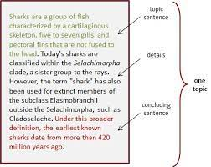  - asks Ss to read the incomplete paragraph and fill in each numbered blank with a word/ phrase in the box.  Ss do as instructed.  Ss discuss and share their answers with a peer.  Teacher checks the answers by calling on some Ss to read their answers to the class.  Key:  1. First  2. For example  3. In conclusion | T-S  S-S  S-S  T-S | 8 mins
WHILE-WRITING | To help students practise developing ideas and writing a paragraph  - (Digital Competence 3.3NC1a) Reminds Ss that if they search for specific environmental data or facts on the Internet to support their suggestions, they must properly cite the sources and follow copyright regulations. | TASK 3: ADD TWO MORE SUGGESTIONS TO IMPROVE THE ENVIRONMENT IN YOUR SCHOOL TO THE PARAGRAPH IN 2. USE THE IDEAS IN 1 TO HELP YOU. (p.25)  Teacher:  - explains the writing task.  - has Ss brainstorm more suggestions in groups.  - walks round the class to offer help and encourages Ss to take notes of their ideas.  - asks some groups to call out their ideas and write them on the board for other Ss’ reference.  - asks Ss to write their suggestions to complete the paragraph individually, sets a limited time for this task and walks round the class to give further support if needed.  - reminds them to use some connectors to link the ideas before they write:  + To list ideas: First, Second, In addition, Additionally, Moreover, Furthermore, Another idea worth noting is that, Finally, …  + To give an example: For example / For instance, To illustrate, …  + To conclude: In conclusion, In brief, In short, To sum up, …  Ss do as instructed.  Ss share their answers with their group members.  T walks round the class to monitor and make a note of some common mistakes. | T-S  S-S  S-S  T-S | 8 mins
POST-WRITING | To give students an opportunity to recognise the common mistakes so that they can avoid in writing | PEER CORRECTION  Teacher:  - explains the marking symbols in the following table.  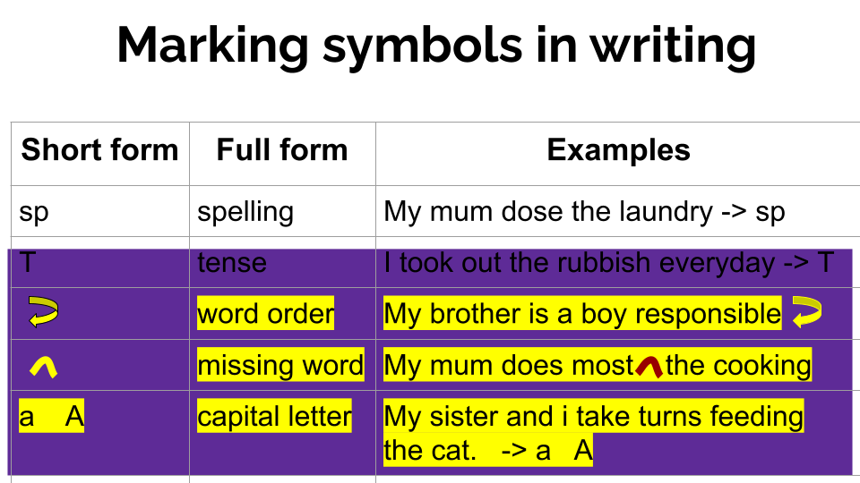  - asks two Ss sitting next to each other to exchange their writing, read their partner’s writing and write the symbols next to mistakes that they can find like the ones in the table above.  - asks Ss to return their partner’s writing and lets them correct themselves.  - reminds them that they can ask for their partner’s help.  Ss do as instructed.  Ss share their ideas with a partner.  Teacher goes around to offer help.  CLASS CORRECTION  Teacher:  - writes Ss’ common mistakes on the board, asks Ss to check whether they make the same mistakes in their writing.  - calls on some Ss to correct those mistakes as a class.  Ss do as instructed.  Teacher:  - further explains the paragraph structure if Ss are not able to develop the three elements in their writing.  - collects Ss’ writing and provides written feedback in the next lesson.  - in weaker classes, provides some suggested answers if necessary.  Sample answer:  Another way would be to plant more trees. For example, we can plant more green trees around the school and in the schoolyard. It reduces CO2 and makes the air we breathe in cleaner. Finally, we can set up more rubbish bins. For instance, we can put more bins in public places such as parks or bus stations. This makes the waste collection easier. | T-S  S-S  S-S  T-S | 9 mins
CONSOLIDATION | To help students memorise the content of the lesson | WRAP-UP  Teacher asks: What have you learnt today?  - We have practised writing a paragraph about suggestions to improve the environment.  HOMEWORK  - Exercises in the workbook  - Prepare for Communication and Culture lesson | T-S | 2mins

