Trường: THPT Đỗ Đăng Tuyển  Tổ: Ngoại Ngữ | Họ và tên giáo viên:  Đặng Bảo Vinh

Period: 1 LESSON 1: INTRODUCTION
Subject: English - Grade: 10
(1 period)

I. Objectives

1. Knowledge:

- Giving self introduction

- The content of English book grade 10 (units and themes)

- Tests (oral test, regular test, mid-term test, final test)

- Some requirements of studying English

2. Competences:

- Introduce themselves

- Know about the content of English book grade 11, tests and some requirements of studying English

3. Qualifications: Develop students’ hard work: self-study, learning enjoyment

II. Teaching aids and learning materials

1. Teaching aids: Chalks, blackboard

2. Learning materials: Textbooks

III. Teaching process

1. Activity 1: Warm-up (15 mins)

a. Aims: Learn how to give self-introduction

b. Procedure:
Teachers and students’ activities | Expected outcomes
*Step 1: Task transformation (T)  - Ask students to introduce themselves  +Name  +Address  +Family members  +Favorite subjects/ reasons  + Hobbies  *Step 2: Task performance (Ss)  - Listen to teacher’s instruction  - Prepare the presentation  *Step 3: Discussion and report (Ss)  - Present to the whole class. (4, 5 students)  *Step 4: Conclusion and judgment (T)  - Give feedbacks  - Give specific explanations  - Suggest answers and lead in the new lesson | - My name’s...........  - I live in..........  - I come from a family of........: my parents, my older sister....and me  - My favorite subject is............because.......  - My hobby is ..............

2. Activity 2: Knowledge building (25 mins)

a. Aims: Know about the content of English book grade 11, tests and some requirements of studying English

b. Procedure:
Teachers and students’ activities | Expected outcomes
*Step 1: Task transformation (T)  - Introduce textbooks (units and themes), tests  - Give some requirements of studying English  *Step 2: Task performance (Ss)  - Listen to teacher’s instruction  - Take notes  *Step 3: Discussion and report (Ss)  - Repeat teacher’s instructions. (2, 3 students)  *Step 4: Conclusion and judgment (T)  - Give feedbacks | 1. The text- book English 12  - The 1st term: * Unit 1 Unit 5: 8 parts for each unit: getting started, language, reading, speaking, listening, writing, culture and project  - Review 1, 2 + Sample test 1, 2  - Tests: 6:  - 4 regilar tests  - 1 mid-term test  - 1 final test  - The 2nd term: * Unit 6 Unit 10: 8 parts for each unit: getting started, language, reading, speaking, listening, writing, culture and project  - Review 3, 4+ Sample test 3, 4  - Tests: 6:  - 4 regilar tests  - 1 mid-term test  - 1 final test  2. Teacher’s demand:  - Prepare the lesson before studying in class.  - Pay attention to the teacher’s explanation  - Take part in the activities that the teacher required such as pairs work, group work or individual  - Each Ss has a notebook and a book

Period 2 UNIT 1: FAMILY LIFE
Lesson 1: Getting started – Household chores
I/ Learning outcomes:
By the end of this lesson, Ss will be able to:
- Knowledge:
- have an overview about the topic Family life;
- gain vocabulary to talk about household chores.
- Competences:
- develop communication skills.
- be collaborative and supportive in pair work and teamwork.
- actively join in class activities.
- Attributes:
- be aware of responsibilities towards family
II/ Teaching and learning resources:
Tape (CD), Tivi, speakers, textbook, teacher's book, copies of pictures, handouts, laptop, posters
III/ PROCEDURE:
Aims | Contents | Outcomes | Steps
ACTIVITY 1: INTRODUCTION & ENGAGE/ WARM UP (5’)
- Introduce the unit topic (Family life);  - Introduce some vocabulary to be learnt in the unit. | 1. Guessing picture(2’)  What is the picture about?  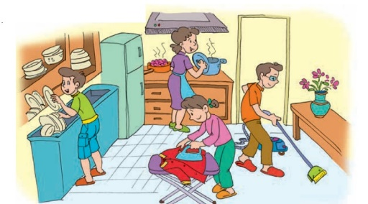 | Students’ oral prediction about the topic  Suggested answer:  Family life/ doing household chores | Elicit  Show the picture to elicit the topic
 | 2.Vocabulary: (3’)  List the household chores that you see in the picture (3’) | Lists of some household chores  Expected answers:  Clean the house  Wash the dishes  Iron clothes  Do the cooking | List  Work in groups of two to list the household chores on the board
ACTIVITY 2: STUDY/ PRESENTATION (15’)
- Understand the related words in the conversation  - Introduce the grammar points to be learnt in the unit. | 1. Vocabulary: (10’)  Look at the photos to guess the meaning of new words  - household (n) /ˈhaʊs.həʊld/  - chore (n) /tʃɔːr/  - breadwinner /ˈbredwɪnə(r)/ (n)  - heavy lifting /ˌhevi ˈlɪftɪŋ/ (np):  - homemaker /ˈhəʊmmeɪkə(r)/ (n):  - laundry /ˈlɔːndri/ (n): | A list of words in notebook | Elicit  Give synonym/ Vietnamese equivalent/ example to elicit vocabulary from Ss
 | * Check vocabulary: | The missing words on the board | Rub out and remember
 | 2. Listen & read (5’)  look at the picture (p.8 - 9) and answer the questions:  - Who are they?  - Where are they?  - What are they doing?  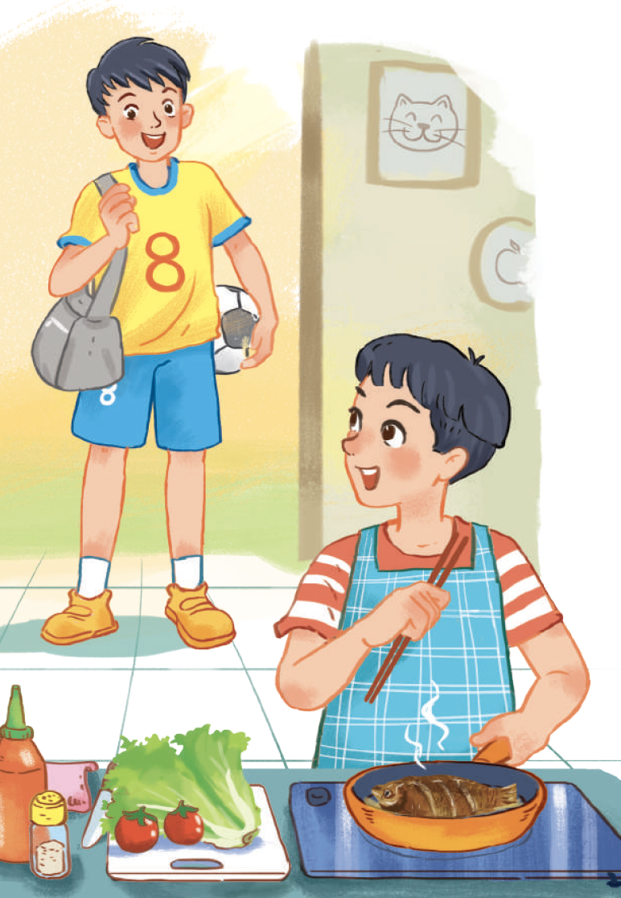 | Ss’prediction about the picture  Suggested answers: They are Nam and Minh. They are at Nam’s home. Nam is cooking. | Set the context for listening and reading the conversation
ACTIVITY 3: ACTIVATE/ PRACTICE (20’)
Practise reading for specific information | 1/ True/False (7’)  Read the conversation again and decide whether the following statements are true (T) or false (F). (p.9)  . | - Ss’ oral prediciton  - Statements identified as true or false  Key:  1.F → Nam is cooking now.  2.T 3.T | Predict then listen and read the conversation  - Work in pairs  - Peer correction  - Teacher’s feedback
- Practise scanning  - Develop students' knowledge of vocabulary for household chores | 2/ Fill in the table (7’)  Write the verbs/verb phrases that are used with the words or phrases in the conversation in 1. (p.9) | Some collocations for household chores  1.put out the rubbish  2.do the laundry  3.shop for groceries  4.do the heavy lifting  do the washing-up | Filling in the table  - Work in pairs  - Peer correction  -Teacher’s feedback
- Identify the present simple and the present continuous, and how they are used in sentences | 3/ Sentence completion (6’)  Complete the sentences from the conversation with the correct forms of the verbs in brackets. (p.9)  - I’d love to, but I’m afraid I can’t. I (prepare) ______ dinner.  - My mum usually (do) ________ the cooking, but she (work) _________ late today. | Completed verbs using th present simple or the present continuous  Answers:  1.‘m preparing  2. does – ‘s working | - Do the task individually  - share the answers with a peer.  - Teacher’s feedback
ACTIVITY 4: CONSOLIDATION/ PRODUCTION (5’)
Help students memorise the target language and skills that they have learned | 1. Wrap up (3’)  Watch the video clip and list all the household chores done in the video | - Ss’ list of household chores on the poster  Suggested answers:  - Clean the toilet  - Wash the clothes  - Vacuum the carpet  - Feed the chicken | Watching and listening  -Work in 4 groups  -Peer correction  - Teacher’s feedback
Inform students what the final product of the project should be and how students can prepare for it. | 2. Homework (2’)  a/ Exercises in the workbook  b/ Project preparation  - Tell Ss the project requirements: Do research on Family Day in Viet Nam or other countries in the world  (related information:time, place, history and reason to celebrate; food, activities)  - Ask Ss to present their plans in the last lesson of the unit. | Ss’ oral presentation of the research results | Groupwork

Period 3 UNIT 1: FAMILY LIFE
Lesson 2: Language
I/ Learning outcomes:
By the end of this lesson, Ss will be able to:
1. Knowledge:
- Pronounce the consonant blends /br/, /kr/, and /tr/ correctly in individual words and in sentences.
- Understand and use some lexical items about family life.
- Distinguish and use present simple and present continuous.
2. Competences:
- Be collaborative and supportive in pair work and team work.
- Access and consolidate information from a variety of sources.
- Actively join in class activities.
3. Attributes:
- Be aware of responsibilities towards family
II/ Teaching and learning resources:
Tape (CD), T.V, speakers, textbook, teacher's book, copies of pictures, handouts, laptop, posters…..
III/ PROCEDURE:
Aims | Content | Outcomes | Steps
ACTIVITY 1: PRONUNCIATION/ WARM UP (10’)
- To help students recognise and practise the consonant blends /br/, /kr/, and /tr/ in words. | 1. GAME: Guess the words  * T gives instructions:  - There are 3 pictures related to the consonant blends /br/, /kr/, and /tr/  - Ss have 5 seconds to think, then guess the word corresponding to the pictures.   | Students’ oral prediction about the pictures.  Suggested answers:  1. tree  2. bread  3. cream | Elicit  Show the pictures to elicit the three consonants.
 | 2. TASK 1: LISTEN AND REPEAT.  Pay attention to the consonant blends /br/, /kr/, and /tr/ (p.9)  * Teacher:  - plays the recording and asks Ss to listen to the words and repeat; tell them to pay attention to the consonant blends.  - makes sure Ss know the meaning of each word. | Repeated words with the consonant blends | Listen to the recording/  teacher & repeat in chorus then individually
 | TASK 2: LISTEN TO THE SENTENCES AND CIRCLE THE WORDS YOU HEAR. (p.9)  * Teacher gives the instruction clearly | Circled words.  Suggested answers:  1. b, 2. c , 3. a | Listen to the recording/  teacher and circle the correct words individually.
ACTIVITY 2: VOCABULARY (10’)
To make sure that students understand the meaning of some lexical items about household chores. | TASK 1: MATCH THE WORDS WITH THEIR MEANINGS. (p.10)  * T gives clear instructions. | Marched words with their meaning  Key:  1. b, 2. d, 3. e, 4. a, 5. c | - Work in pairs.  - Peer correction.  -Teacher’s feedback.
 | TASK 2: COMPLETE THE SENTENCES USING THE WORDS IN TASK 1. (p.10)  * T gives clear instructions. | Completed sentences with the words provided  Key:  1. homemaker  2. groceries  3. heavy lifting  4. housework  5. breadwinner | - Work in pairs.  - Peer correction.  -Teacher’s feedback.
ACTIVITY 3: GRAMMAR (12’)
To give students an opportunity to revise the use of present simple and present continuous | TASK 1: CHOOSE THE CORRECT FORM OF THE VERB IN EACH SENTENCE. (p.10)  * Teacher:  - tells Ss to read the sentences in 4 in Getting Started. T asks them what tense(s) is / are used in each of them. | Completed sentences using the correct form of the verbs  Key:  1. does  2.is putting out  3. cleans  4. is studying  5. does | - Work in pairs.  - Peer correction.  -Teacher’s feedback.
- Practise scanning  - Develop students' knowledge of vocabulary for household chores. | TASK 2: COMPLETE THE PARAGRAPH.  - T asks Ss to look at Remember! box again to master the differences  between Present simple and Present continuous.  - T asks Ss to work in pairs. | Completed paragraph using the simple present or present ontinuous  Key:  1. does  2. is not/isn’t doing  3. is watching  4. are doing  5. is tidying up  6. is trying | - Work in pairs.  - Peer correction.  -Teacher’s feedback.
ACTIVITY 4: EXTRA ACTIVITY (8’)
To help students further practise the present tenses forms. | Extra exercise : 10 questions  Put the verbs into the correct forms: present simple or present continuous.  1. Listen! My sister (sing)______a song.  2. Every night, we (go)___to bed at 11p.m.  3. Now, they (stay)______ in Ha Noi .  4. My grandfather often (read) ________ a newspaper in the morning.  5. Look! Hoa (run)____________.  6. Thuy usually (listen)_____ to the teacher in the class, but she (not listen) ____now.  7.Everyday, Mr. Hoang (not go) ______to work by car.  8. In the autumn, he rarely (go)_______ sailing and (go)________ to school.  9. I (write)____________ a letter to my best friend now.  10. At 11 a.m every day, I (have)_______ lunch and (go)________ to bed. | Completed sentences using the present simple or present continuous  * Key:  1. is singing 2. go  3. are staying 4. reads  5. is running  6. listens/ isn’t listening  7. doesn’t go  8. goes/ goes  9. am writing  10. have / go | - Give the handouts.  - Work in pairs.  - Peer correction.  -Teacher’s feedback.
ACTIVITY 5: CONSOLIDATION: (5’)
To help students memorize the target language and skills that they have learnt | WRAP-UP  - the consonant blends /br/, /kr/, and /tr/  - present simple or present continuous.  HOMEWORK:  - Exercises in the workbook.  - Prepare for lesson 3 Unit 1. | * Students’ list of what they have learnt.  - consonant blends /br/, /kr/, and /tr/.  - some lexical items about household chores.  - present simple vs. present continuous. | * Ss work individually.

Hand – out:
Language analysis
 | Present simple | Present continuous
1. Form | (+) S + V(s/es).  (-) S + do not/ does not (don't / doesn't) + V.  (?) Do/Does + S + V? | (+) S + am/is/are + Ving.  (-) S + am/is/ are + not (‘m not/ isn’t/ aren’t) + Ving.  (?) Am/ Is/ Are + S + Ving?
2. Uses | We use present simple to talk about habits or things we do regularly.  Example: My mother cooks every day. | We use present continuous to talk about things which are happening at the moment of speaking.  Example: My mother isn’t cooking now. She’s working in her office.
3. Time expressions | usually, always, every day, often, never, seldom…  🡪 adverbs of frequency | now, at the moment, at present, presently, …
Put the verbs into the correct forms: present simple or present continuous.
1. Listen! My sister (sing)______a song.
2. Every night, we (go)___to bed at 11p.m.
3. Now, they (stay)______ in Ha Noi .
4. My grandfather often (read) ________ a newspaper in the morning.
5. Look! Hoa (run)____________.
6. Thuy usually (listen)_____ to the teacher in the class, but she (not listen) ____now.
7.Everyday, Mr. Hoang (not go) ______to work by car.
8. In the autumn, he rarely (go)_______ sailing and (go)________ to school.
9. I (write)____________ a letter to my best friend now.
10. At 11 a.m every day, I (have)_______ lunch and (go)________ to bed.

