UNIT 3: MUSIC
Lesson 5: Listening

I. OBJECTIVES
By the end of this lesson, Ss will be able to:
1. Knowledge
- listen for gist and specific information in an interview about a music festival;
- talk about the reasons why they want/ don’t want to go to a music festival.
2. Core competence
- be collaborative and supportive in pair work and team work;
- actively join in class activities;
- develop presentation skills;
- be critical in thinking.
3. Personal qualities
- be more interested in music and music events.

II. MATERIALS
- Grade 10 textbook, Unit 3, Listening
- Computer connected to the Internet
- Projector/ TV/ pictures and cards
- sachmem.vn

Language analysis

Form | Pronunciation | Meaning | Vietnamese equivalent
background (n) | /ˈbæk.ɡraʊnd/ | sounds that can be heard behind other sounds that are louder | hậu cảnh
stage (n) | /steɪdʒ/ | a raised area, usually in a theatre, etc. where actors, dancers, etc. perform | sân khấu
free of charge (n) | /ˌfriː əv ˈtʃɑːdʒ/ | without having to pay | miễn phí
overcrowding (adj) | /ˌəʊvəˈkraʊdɪŋ/ | the situation when there are too many people or things in one place | quá đông
in advance (idiom) | /in ədˈvɑːns/ | before the time that is expected; before something happens  If you're going to come, please let me know in advance. | trước

Assumptions
Anticipated difficulties | Solutions
- Ss may lack knowledge about some lexical items.  - Ss may not catch the ideas to decide the statements are true or false. | - Provide them with the meaning and pronunciation of words.  - Remind them to pay attention to the key words in each sentence.

Board Plan
Date of teaching
Unit 3: MUSIC
Lesson 5: Listening
* Warm-up: Video watching
Vocabulary
Task 1: Look at the picture and answer the questions.
Task 2: Listen to an interview. Tick the information that you hear in the recording.
Task 3: Listen again and decide whether the following statements are true (T) or false (F).
Task 4: Discussion
* Homework

III. PROCEDURES
Notes:
In each activity, each step will be represented as following:
* Deliver the task
** Implement the task
*** Discuss
**** Giving comments or feedback

Stage | Stage aim | Procedure | Interaction | Time
WARM-UP | - To arouse the classroom atmosphere.  - To get Ss be actively involved in the lesson | Video watching: Watch the video and write down the name of the music festivals.  * Teacher gives the instructions and plays the recording.  ** Ss watch the video and write down the name of the music festivals.  *** Ss share their answers with a partner.  **** Teacher:  - checks by having some Ss to call out the answers.  - asks Ss if they know anything about these music festivals.  Suggested answers: Yamaha Revolution Music Festival: an EDM party;  Asia Artist Award: honors outstanding achievements and international contributions of Asian artists in television, film and music; Monsoon Music Festival: a program of which amateurs as well as the audience can jam on stage with professional artists from all over the world, Coachella: an annual music and arts festival held at the Empire Polo Club in Indio, California, in the Coachella Valley in the Colorado Desert; genre: Rock, pop, indie, hip hop, electronic dance music, Epizode: a unique music and art festival held in Viet Nam’s biggest and most blissful island - Phu Quoc, bringing the latest electronic music trends to Asia and showcasing the best regional talents in the same time, Tomorrow Land: a Belgian electronic dance music festival held in Boom, Flanders, Belgium since 2005. | T-S  Ss  S-S  T-S | 6 mins
PRE-LISTENING | - To pre-teach the pronunciation and the meaning of some vocabulary so that Ss can understand the content of the listening.  - To introduce the topic of the listening and get Ss involved in the lesson. | Vocabulary  * Teacher:  - shows the words one by one, plays the recording and has Ss repeat the sound of the words.  - has Ss guess the meaning of the words based on pictures, explanations and examples.  - background (n): sounds that can be heard behind other sounds that are louder    - stage (n): a raised area, usually in a theatre, etc. where actors, dancers, etc. perform    - free of charge (adv): without having to pay    - overcrowding (adj): the situation when there are too many people or things in one place    - in advance (idiom): before the time that is expected; before something happens    ** Ss do as instructed  **** Teacher confirms the meaning, calls on some individual Ss to make sentences with each word.  TASK 1: LOOK AT THE PICTURE AND ANSWER THE FOLLOWING QUESTIONS.  (Ex.1, p.33)  - What kind of event is it?  - Where does the event usually take place?  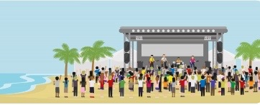  * Teacher asks Ss to work in pairs to look at the picture and discuss the questions.  ** Ss discuss in pairs.  **** Teacher:  - calls on some pairs to share their answers.  - brainstorms more ideas about the picture in a whole-class discussion.  - asks Ss what they know about this type of event or if they have been to a music festival or an outdoor concert.  Suggested answers:  - a music festival / an outdoor concert  - outdoors: on a farm / at a stadium / a park / a beach | T-S  S-S  T-S  T-S  S-S  T-S | 6 mins  6 mins
WHILE-LISTENING | To help Ss practise listening for gist.  - To help Ss practise listening for specific information. | TASK 2: LISTEN TO AN INTERVIEW ABOUT PREPARATIONS FOR AN INTERNATIONAL YOUTH MUSIC FESTIVAL. TICK THE INFORMATION THAT YOU HEAR IN THE RECORDING. (Ex.2, p.33)  * Teacher:  - asks Ss to look through the list of topics and guess what they are going to hear in the recording.  ** Ss do as instructed.  **** Teacher:  - calls on individual Ss to talk about their predictions.  - asks Ss to listen and check if their guesses are correct.  - checks answers as a class and asks Ss to support their answers with clues from the recording, e.g. A: on the beach, country park; D: sold the tickets in advance.  - plays the recording a second time, pausing after the clues in weaker classes.  Key: A, D  TASK 3: LISTEN AGAIN AND DECIDE WHETHER THE FOLLOWING STATEMENTS ARE TRUE (T) OR FALSE (F). (Ex.3, p.33)  * Teacher:  - ask Ss to read the sentences and underline the key words.  - has Ss identify the True / False statements based on what they have remembered from the first listening in 2.  - plays the recording and encourages Ss to note down key words or phrases.  ** Ss do as instructed.  *** Ss work in pairs or groups to compare answers.  **** Teacher:  - checks answers as a class and plays the recording again, pausing at the sentences that contain the clues in weaker classes.  - has Ss correct the false sentences.  Key: 1. F (first -> second); 2. F (They are still setting up the main stage and there’s still a lot to do.); 3. T; 4. F (They have sold the tickets in advance.); 5. T | T-S  S-S  T-S  T-S  Ss  S-S  T-S | 5 mins  9 mins
POST-LISTENING | To give Ss an opportunity to personalise the language and ideas from the listening in a speaking task. | TASK 4: WORK IN GROUPS. DISCUSS THE FOLLOWING QUESTIONS. (Ex.4, p.33)  Do you want to go to a music festival? Why or why not?  * Teacher: - asks some lead-in questions to see whether Ss have taken part in any music festivals, and how much experience they have, e.g. Have you ever taken part in a music festival? How many times have you participated in such events? What did you do there? How did you feel?  - put Ss in groups to discuss the two questions.  - reminds them that they can use the ideas from the warm-up activity and the ideas in their homework in the speaking lesson.  ** Ss do as instructed  *** Ss share their ideas with the rest of the class.  **** Teacher invites some individuals to share their ideas to the whole class, and give comments. | T-S  S-S  S-S  T-S | 10 mins
CONSOLIDATION | To help Ss memorise the content of the lesson | Wrap-up  Teacher asks: What have you learnt today?  - We have listened to an interview about preparations for a music festival.  Homework:  - Exercises in the workbook  - Prepare for Writing lesson | T-S | 2mins

UNIT 3: MUSIC
Lesson 6: Writing

I. OBJECTIVES
By the end of this lesson, Ss will be able to:
1. Knowledge
- use lexical items related to the topic Music;
- write a blog about experiences at a music event.
2. Core competence
- be collaborative and supportive in pair work and team work;
- actively join in class activities;
- be imaginative and creative;
- develop presentation skills.
3. Personal qualities
- be inspired to learn more about music and music events;

II. MATERIALS
- Grade 10 textbook, Unit 2, writing
- Computer connected to the Internet
- Projector/ TV/ pictures and cards
- sachmem.vn

Language analysis

Form | Pronunciation | Meaning | Vietnamese equivalent
hit (n) | /hɪt/ | a song that is very popular | bài hát nổi tiếng
take place (phr.v) | /teɪk pleɪs/ | happen, especially after previously being arranged or planned  The music festival will take place on February 5th. | diễn ra
art exhibition (n) | /ɑːt ˌeksɪˈbɪʃn/ | a collection of works of art, that are shown to the public | bộ sưu tập các tác phẩm nghệ thuật

Assumptions
Anticipated difficulties | Solutions
- Ss may lack ideas to write a blog because they haven’t participated in real music events. | - help Ss brainstorm the ideas based on Ann’s notes and have Ss play a chain game to practise describing an experience.

Board Plan
Date of teaching
Unit 3: MUSIC
Lesson 6: Writing
* Warm-up:
Game: Guess the mystery words.
Vocabulary
Task 1: Read Ann’s blog and complete the notes.
Task 2: Work in groups. Put the words and phrases in the box into the appropriate columns.
Task 3: Write a blog (about 120 words) to share your experience of a music event.
Peer correction
Class correction
* Homework

III. PROCEDURES
Notes:
In each activity, each step will be represented as following:
* Deliver the task
** Implement the task
*** Discuss
**** Giving comments or feedback

Stage | Stage aim | Procedure | Interaction | Time
WARM-UP | - To arouse the classroom atmosphere  - To get Ss be actively involved in the lesson | Game: Guess the mystery words.  * Teacher:  - divides the class into two teams, and explains the game rules.  - Ss look at the pairs of pictures and guess the mystery words  - One point for each earliest correct answer.  - shows one or two examples:  + queen bee    + waterfall    ** Ss do as instructed.  *** Ss in each team think, discuss and guess the words.  **** Teacher confirms the correct words, decides the winner and leads in the lesson.  Suggested words:  come back  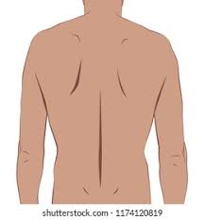  music event    blog writing    experience sharing    music website   | T-S  S-S  S-S  T-S | 5 mins
PRE-WRITING | - To pre-teach the pronunciation and the meaning of some vocabulary so that Ss can understand the content of the reading. | * Teacher:  - shows the words one by one, plays the recording and has Ss repeat the sounds of the words.  - has Ss guess the meaning of the words based on pictures, explanations and examples.  1. hit (n): a song that is very popular 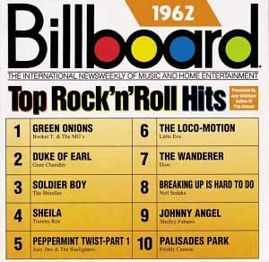  2. take place (phr.v): happen, especially after previously being arranged or planned  The music festival will take place on February 5th.   3. art exhibition (n): a collection of works of art, that are shown to the public    ** Ss do as instructed.  **** Teacher confirms the meaning, calls on some individual Ss to make sentences with each word. | T-S  S-S  T-S | 5 mins
PRE-WRITING | - To provide an example blog on a music website, which Ss can use as a model for their writing. | TASK 1: COMPLETE THE NOTES. (Ex.1, p.33)  Ann has just come back from a music event and shared her experience on a music website. Read her blog and complete the notes below.  * Teacher introduces the context of the blog, elicits the meaning of the word blog and why people write blogs and asks Ss if they read blogs.  ** Ss read the blog individually and complete the notes in 3 minutes.  *** Ss work in groups to compare their answers.  **** Teacher checks the answers as a class. ( In weaker classes, ask questions, e.g. Which event did Ann go to? and have individual Ss answer. In stronger classes, invite Ss to formulate and ask the questions.)  Key: Ann’s notes  - Event: International Youth Music Festival  - When: last Saturday  - Where: in a big country park  - Who with: some friends  - Atmosphere: party  - What we did:  – saw favourite idols perform live on stage and listened to their greatest hits  – tasted yummy food from different countries  – made new friends  - How we felt: excited | T-S  S  S-S  T-S | 6 mins
 | - To provide Ss with some useful words and phrases to describe experiences;  - To help Ss develop ideas for their writing in 3. | TASK 2: PUT THE WORDS & PHRASES INTO THE APPROPRIATE COLUMNS. (Ex.2, p.34)  Work in groups. Put the words and phrases in the box below into the appropriate columns. Some words and phrases can go into more than one column.  * Teacher asks Ss to look at the words and phrases in the box and elicits the meanings of any words or phrases Ss don’t understand.  ** Ss work into groups to put the words and phrases into suitable columns.  **** Teacher:  - calls on some groups to write their answers on the board and has the rest of the class comment on the way they have sorted the words and phrases.  Extention: has Ss play a chain game to practise describing an experience: Put Ss into teams and have each team sit in a circle. One student in each team starts the game by saying what kind of event they went to, e.g. We went to a Pop Music Festival. The next student adds another detail, e.g. The event took place in the country park. This continues until someone in the team gets mixed up, repeats information or can’t think of anything to add. The winner is the team that continues their chain for the longest time.  Key: | T-S  S-S  T-S | 8 mins
  Location | Atmosphere | Activities | Feeling
  beach  stadium | amazing  friendly  relaxed  wonderful  fun | watch fireworks  play games  take photos  see art exhibitions  play musical instruments | amazing  excited  relaxed  wonderful
WHILE-  WRITING | - To help Ss practise developing ideas and an outline for their writing.  - To help Ss practise writing a blog about their personal experience at a music event. | TASK 3: WRITE A BLOG. (Ex.3, p.34)  Imagine you went to a music event. Write a blog (about 120 words) to share your experience. Use the notes in 1 and words and phrases in 2 to help you.  * Teacher:  - has Ss work in groups to make an outline based on Ann’s notes and the words and phrases in 2 .  - explains that if they have been to a music event, they can make use of their experiences; if they haven’t, they can write about an event they know about and imagine they have been to it, or make up an event.  - has Ss write a blog, using their group outline.  - tells Ss that they can refer to Ann’s blog in 1 as a model and asks them to pay attention to punctuation, structures, word choice, linking words, etc.  ** Ss do as instructed.  *** Ss share their answers with their group members.  **** Teacher walks around the class to monitor, make a note of some common mistakes. | T-S  S-S  S-S  T-S | 14 mins
POST-  WRITING | To give Ss an opportunity to recognise the common mistakes so that they can avoid in writing | Peer Correction  * Teacher: - explains the marking symbols in the following table.  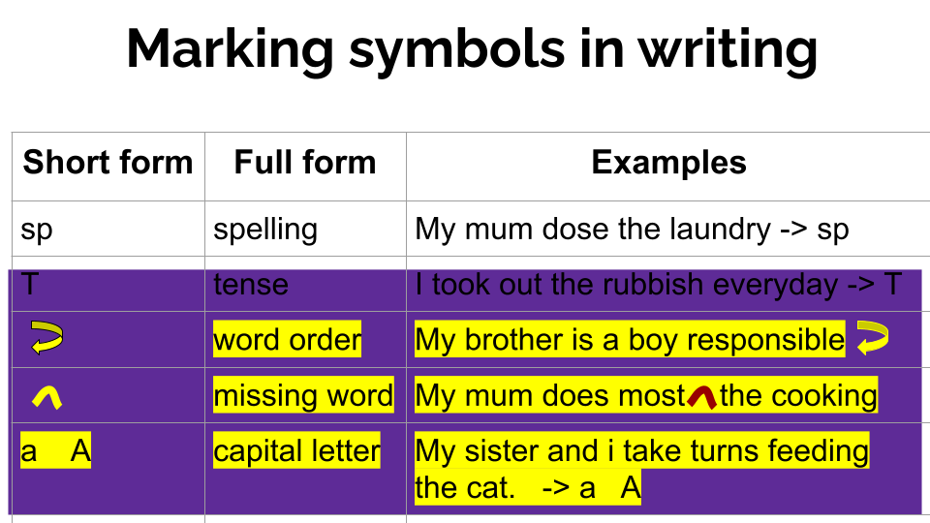  - asks two Ss sitting in different rows to exchange their writing, read their partner’s blog and write the symbols next to their partner’s mistakes like the ones in the table above.  - asks Ss to return their partner’s writing and lets them correct themselves.  - reminds them that they can ask for their partner’s help.  ** Ss do as instructed  *** Ss share their ideas with a partner.  **** Teacher goes round to offer help.  Class Correction  * Teacher:  - writes Ss’ common mistakes on the board, asks Ss to check whether they make the same mistakes in their writing.  - calls on some Ss to correct those mistakes as a class.  ** Ss do as instructed.  **** Teacher: -  collects Ss’ writing and provides written feedback in the next lesson.  - in weaker classes, provides some suggested answers if necessary.  Sample answer:  My sister and I attended the F5 tour at the National Stadium last night. I could sum up the concert in one word, INCREDIBLE. We found our way up to our seats after having a light meal and stood in a queue at the gate of the stadium for 45 minutes. When the curtain was raised to reveal the F5 band, the entire stadium went absolutely crazy. I was thrilled by every of their performances. There was so much emotion in many of their songs, and the way they performed was so terrific. This was such a wonderful experience, a night that I’ll never forget. I’m so grateful to have been able to have that experience. | T-S  S-S  S-S  T-S | 5 mins
CONSOLIDATION | To help Ss memorise the content of the lesson | Wrap-up  Teacher asks: What have you learnt today?  - We have practised writing a blog about experiences at a music event.  Homework:  - Search the Internet for music blogs, choose one that you like most and post it on your class’ Facebook or Zalo group, the blog which gets the most likes will be rewarded.  - prepare for Communication and Culture lesson. | T-S | 2 mins

UNIT 3: MUSIC
Lesson 7: Communication and Culture/ CLIL
I. OBJECTIVES
By the end of this lesson, Ss will be able to:
1. Knowledge
- make and respond to suggestions;
- identify chau van singing and other types of traditional music in Viet Nam.
2. Core competence
- be collaborative and supportive in pair work and team work;
- access and consolidate information from a variety of sources;
- be creative and imaginative in making conversations
- actively join in class activities.
3. Personal qualities
- be willing to learn about national folk music;
- be responsible for maintaining national folk music and national culture.

II. MATERIALS
- Grade 10 textbook, Unit 3, Communication and Culture/ CLIL
- Computer connected to the Internet
- Projector/ TV/ pictures and cards
- sachmem.vn

Language analysis
Form | Pronunciation | Meaning | Vietnamese equivalent
praise (v) | /preɪz/ | say that you approve of and admire somebody/something | ca ngợi
chanting (n) | /ˈtʃɑːntɪŋ/ | the activity of singing a prayer or song to a simple tune, or repeating or singing a word or phrase continuously | vịnh xướng,  lời cầu khấn
psychic (n) | /ˈsaɪkɪk/ | a person who claims to have strange mental powers so that they can do things that are not possible according to natural laws, such as predicting the future and speaking to dead people | bà đồng, ông đồng
saint (n) | /seɪnt/ | a person that the Christian Church recognizes as being very holy, because of the way they have lived or died | vị thánh, vị thần,  thần linh

Assumptions
Anticipated difficulties | Solutions
- Students may lack information about places of culture centres in Viet Nam.  - Students may lack knowledge about some lexical items. | - Have Ss brainstorm some culture centres around Viet Nam.  - Provide them with the meaning and pronunciation of words/ phrases.

Board Plan
Date of teaching
Unit 3: MUSIC
Lesson 7: Communication and Culture/ CLIL
* Warm-up: Video watching
I. Everyday English
Task 1: Listen and complete the conversation. Then practise it in pairs.
Task 2: Work in pairs. Have similar conversations making and responding to suggestions about going to a music show.
II. Culture
Vocabulary
Task 1: Read a passage about chau van singing and complete the mind map.
Task 2: Match each word with its suitable definitions.
Task 3: Work in pairs. Tell your partner what you find most interesting about chau van singing.
* Homework

III. PROCEDURES
Notes:
In each activity, each step will be represented as following:
* Deliver the task
** Implement the task
*** Discuss
**** Giving comments or feedback

Stage | Stage aim | Procedure | Interaction | Time
WARM-UP | - To arouse the classroom atmosphere.  - To help Ss revise some genres of folk music in Viet Nam. | Video watching: Watch the video and say the names of some types of traditional music in Viet Nam.  * Teacher divides the class into two teams and plays the recording.  ** Ss watch the video and say the names of some types of traditional music in Viet Nam.  **** Teacher:  - calls the team members who raise their hand first and confirms the correct answers.  - asks Ss if they know anything about these types of music.  - decides the winner.  Suggested answers: Tuong, Cai luong, Cheo, Ca tru, Xam, Quan ho, Chau van | T-S  S  T-S | 4 mins
EVERYDAY ENGLISH | - To review expressions for making and responding to suggestions.  - To provide Ss with an example conversation in which people make and respond to suggestions about going to a music show. | TASK 1: LISTEN AND COMPLETE THE FOLLOWING CONVERSATION WITH THE EXPRESSIONS FROM THE BOX. THEN PRACTISE IT IN PAIRS. (Ex.1, p.34)  * Teacher:  - has Ss look at the four options A - D and checks if they understand their meanings and use: phrases to make suggestions (How about ..., Shall ...) and respond to suggestions (I’d love to ..., Let’s ...).  - explains the task, asks Ss to read the conversation and find clues for the missing expressions, then has them complete the gaps.  - plays the recording for Ss to listen and complete the conversation between Ann and Mai at the same time.  ** Ss do as instructed.  **** Teacher:  - plays the recording again and confirms the correct answers.  - has Ss read the expressions the speakers use to make and respond to suggestions.  - puts Ss into pairs to practise the conversation.  - invites some pairs to role-play the conversation in front of the class.  Key: 1. C 2. B 3. A 4. D | T-S  Ss  T-S | 6mins
EVERYDAY ENGLISH | To help Ss practise making and responding to suggestions. | TASK 2: WORK IN PAIRS. HAVE SIMILAR CONVERSATION MAKING AND RESPONDING TO SUGGESTIONS ABOUT GOING TO A MUSIC SHOW.  * Teacher:  - has Ss brainstorms some ideas about what kind of music show they want to go to, where and when it happens and who performs;  e.g. + music shows: a traditional music performance, a pop music show, a jazz music show, a rock music show, an IDM music show…  + locations: Hanoi opera house, Thang Long art performance centre, Viet Xo palace, Performing arts theatre Ho Chi Minh city, Ho Chi Minh city opera house, …  - asks Ss to work in pairs to make similar conversations about going to a music show, using the expressions for making and responding to suggestions and the ideas above.  - in stronger classes, encourages Ss to use the expressions for declining a suggestion first, then they can make a new suggestion.  ** Ss do as instructed and practise their conversations.  **** Teacher:  - invites some pairs to role-play their conversations to the class.  - praises for good effort, clear pronunciation, fluent delivery, and interesting | T-S  S-S  T-S | 8 mins
CULTURE | - To pre-teach the meaning and pronunciation of some words/phrases, so that Ss can use them in their presentation later and can understand the reading passage. | Vocabulary  * Teacher:  - shows the words one by one, plays the recording and has Ss repeat the sounds of the words.  - has Ss guess the meaning of the words based on pictures, explanations and examples.  1. praise (v): say that you approve of and admire somebody/something   2. chanting (n): the activity of singing a prayer or song to a simple tune  3. psychic (n): a person who claims to have strange mental powers so that they can do things that are not possible according to natural laws, such as predicting the future and speaking to dead people  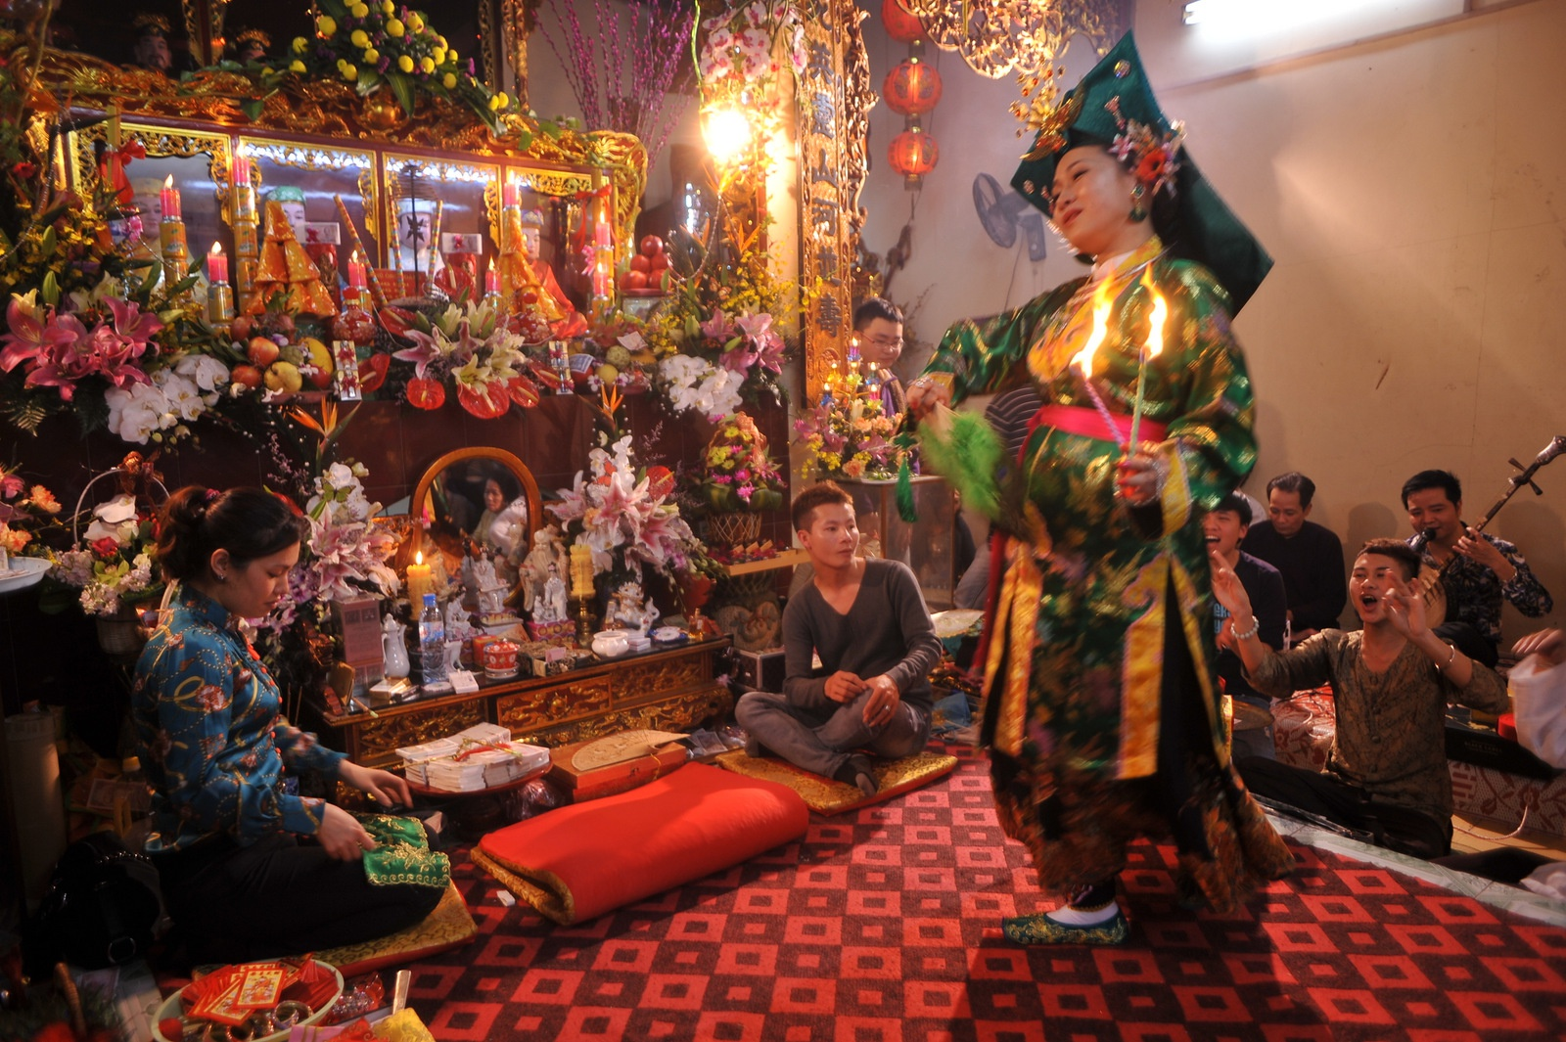  4. saint (n): a person that the Christian Church recognizes as being very holy, because of the way they have lived or died    ** Ss do as instructed.  **** Teacher confirms the meaning, calls on some individual Ss to make sentences with each word. | T-S  S  T-S | 5 mins
CULTURE | - To introduce a type of traditional music in Viet Nam;  - To help Ss practise summarising the main points of a passage using a mind map. | TASK 1: READ A PASSAGE ABOUT CHAU VAN SINGING AND COMPLETE THE MIND MAP BELOW. (Ex.1, p.35)  * Teacher:  - asks Ss if they like traditional music and what types they are familiar with.  - has them look at the picture and describe it, e.g. how many people are performing, what musical instruments the musicians are playing, what they are wearing.  - introduces the type of music they are going to read about in this section.  - asks Ss to read the text and complete the mind map individually.  ** Ss do as instructed.  *** Teacher: - draws the mind map on the board and has individual Ss complete the different branches.  - confirms the correct answers.  Extension: Ask Ss to close their books and remove any answers from the board. Divide Ss into two teams and have them quiz each other on what they have learnt about chau van singing. Set some rules for the quiz, e.g. each team has 30 seconds to formulate a question and 30 seconds to answer one. Keep a tally of the number of correct answers for each team. The winner is the team with more correct answers.  Key:  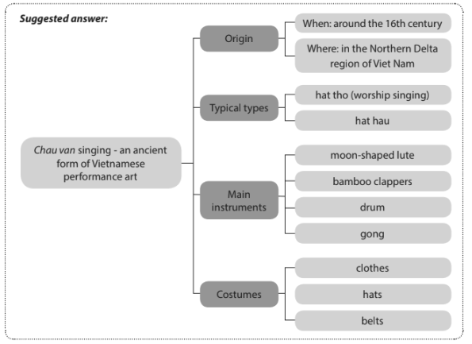 | T-S  S  T-S | 8 mins
CULTURE | - To consolidate students’ understanding of the vocabulary | TASK 2: MATCH EACH OF THE FOLLOWING WORDS IN A WITH ITS SUITABLE DEFINITION IN B.  * Teacher has Ss read the passage again, locate the words in A in the passage, guess their meaning based on the context and do the matching.  ** Ss do as instructed.  *** Ss share their answers with a peer.  **** Teacher invites some individual Ss to give their answers and explanations.  Key: 1. c 2. a 3. b 4. e 5. d | T-S  S  S-S  T-S | 5mins
  A | B
  1. ancient | a. be known by, or be used by more and more people
  2. spread | b. having the usual qualities or features of a particular type of person, thing or group
  3. typical | c. very old; having existed for a very long time
  4. rank | d. a being or spirit who is believed to have power over a particular part of nature or who is believed to represent a particular quality
  5. gods | e. the position that somebody has in a particular organisation, society, etc.
PRODUCTION | To help Ss practise expressing opinions about a traditional type of music. | TASK 3: WORK IN PAIRS. TELL YOUR PARTNER WHAT YOU FIND MOST INTERESTING ABOUT CHAU VAN SINGING.  * Teacher:  - asks Ss to work in pairs and share what they find most interesting about chau van singing.  - suggests that they can talk about chau van’s performance, types, musical instruments, costumes, psychics and its importance.  ** Ss do as instructed.  **** Teacher calls on some pairs to share their ideas with the whole class.  Suggested answer: What I find most fantastic about chau van is that the psychic’s costumes are very colourful and the style of clothes, hats and belts depend on the rank of the gods or saints the performers worship. | T-S  S-S  T-S | 7 mins
CONSOLIDATION | To help Ss memorise the content of the lesson that they have learned | Wrap-up  Teacher asks: What have you learnt today?  - making and responding to suggestions;  - identifying chau van singing.  Homework  - Exercises in the workbook  - Prepare for Looking back and Project lesson | T-S | 2 mins

UNIT 3: MUSIC
Lesson 8: Looking back and project

I. OBJECTIVES
By the end of this lesson, Ss will be able to:
1. Knowledge
- pronounce two-syllable words with correct stress;
- understand and use words and phrases related to music;
- use conjunctions to make compound sentences correctly;
- use to-infinitives and bare infinitives after some verbs correctly;
- do research on traditional music in Viet Nam or another country and give a group presentation about it.
2. Core competence
- develop communication skills and creativity;
- develop presentation skill;
- develop critical thinking skill;
- be collaborative and supportive in pair work and team work;
- actively join in class activities.
3. Personal qualities
- be more creative when doing the project;
- develop self-study skills.

II. MATERIALS
- Grade 10 textbook, Unit 3, Looking back and project
- Computer connected to the Internet
- Projector/ TV/ pictures and cards
- Pictures, A0 paper
- Sachmem.vn

Assumptions
Anticipated difficulties | Solutions
- Students may have underdeveloped presentation skills. | - Give them a suggested checklist for peer assessment and ask them to read carefully and try to practise in advance and apply those techniques in their presentation.

Board Plan
Date of teaching
Unit 3: MUSIC
Lesson 8: Looking back and Project
* Warm-up: Game: The last man standing
I. Looking back
Pronunciation: Listen and mark the stressed syllables in the following words. Then read them out.
Vocabulary: Complete the text using the words and phrases in the box.
Grammar:
1. Match the two parts to make complete sentences.
2. There is a mistake in each sentence below. Find the mistake and correct it.
II. Project
Traditional music
* Homework

Notes:
In each activity, each step will be represented as following:
* Deliver the task
** Implement the task
*** Discuss
**** Giving comments or feedback

Stage | Stage aim | Procedure | Interaction | Time
WARM-UP | - To arouse the classroom atmosphere.  - To help Ss revise words/ phrases related to the topic | Game: The last man standing  Rules: Have ten Ss form a circle and stand at a center with a ball. Ss take turns to speak out a word related to the topic Music and pass the ball to one student. Let them toss it to another student as they name the word related to the theme. If they repeat a word or can’t say any more words, they need to sit down. The last student standing wins the game.  * Teacher: - invites ten Ss to form a circle and stand at a center with a ball.  - explains the game rules to Ss  ** Ss do as instructed  **** Teacher praises the Ss with the most words and the most interesting words/ phrases. | T-S  S-S  T-S | 5 mins
LOOKING BACK | To help Ss revise stress in two-syllable words. | PRONUNCIATION  Listen and mark the stressed syllables in the following words. Then read them out.  * Teacher:  - has Ss do this activity individually, then compare their answers in pairs.  - plays the recording, pausing after each word for Ss to check their answers.  - writes the correct answers on the board if necessary.  - plays the recording again for Ss to repeat the words.  ** Ss do as instructed.  *** Ss compare their answers with a partner.  **** Teacher has Ss practise saying the words in pairs and checks their pronunciation.  Key + Audio script – Track 24:  per'form 'concert 'final 'singer 'famous en'joy | T-S  S  S-S  T-S | 5 mins
LOOKING BACK | To help Ss revise vocabulary items they have learnt in the unit. | VOCABULARY  Complete the text using the words and phrases in the box.  * Teacher:  - asks Ss to read the paragraph quickly and check if they don’t know any words.  - has Ss do this activity individually and write their answers in their notebooks.  ** Ss do as instructed.  **** Teacher calls on individual Ss to write their answers on the board, and checks answers as a class.  Key: 1. music 2. fans 3. artists 4. instrument 5. concerts | T-S  S  T-S | 5 mins
LOOKING BACK | - To help Ss revise compound sentences.  To help Ss revise verbs followed by to-infinitives and bare-infinitives. | GRAMMAR  1. Match the two parts to make complete sentences.  * Teacher asks Ss to read the two parts carefully and find out the clues to do the matching, e.g. He in 2 with his in d; We can in 3 and a…  ** Ss do the matching individually.  *** Ss compare their answers with a partner.  **** Teacher checks the answers as a class.  Key: 1.c 2. d 3. a 4. b  2. There is a mistake in each sentence below. Find the mistake and correct it.  * Teacher:  - asks Ss to read the sentences, then recall verbs that go with to-infinitives or bare infinitives.  - has them underline the mistakes in the sentences and correct them individually.  ** Ss do as instructed.  **** Teacher:  - calls on some Ss to read their answers.  - checks the answers as a class.  Key:  1. attend -> to attend 2. to go -> go  3. buy -> to buy 4. to sing -> sing | T-S  S  S-S  T-S  T-S  S  T-S | 4mins  4 mins
PROJECT | To provide an opportunity for Ss to develop their research and collaboration skills, and to practise giving an oral presentation. | * Teacher:  - gives Ss a checklist for peer and self-assessment and explains that they will have to tick the appropriate items while listening to their classmates’ presentations and write comments if they have any. (The presenters should complete their self-assessment checklist after completing their presentation).  - goes through the criteria for assessing their talk to make sure Ss are familiar with them.  - invites two or three groups to give their presentations and encourages the rest of the class to ask questions at the end.  ** Ss do as instructed.  *** Ss make questions after each presentation.  **** Teacher: gives praise and feedback after each presentation and gives marks for their presentation as part of their continuous assessment.  - asks Ss to complete the self-assessment table, identifies any difficulties and weak areas and suggests further practice for individual Ss. | T-S  S-S  S-S  T-S | 20 mins
CONSOLIDATION | - To consolidate what students have learnt in the lesson.  - To prepare for the next lesson | Wrap-up  Teacher asks: What have you learnt today?  - revise how to pronounce stress in two-syllable words correctly;  - revise the use of words/ phrases related to the topic Music;  - revise how to use conjunctions to make compound sentences correctly;  - revise some verbs followed by to-infinitives and bare-infinitives.  Homework  - Exercises in the workbook  - prepare for Unit 4 lesson1 | T-S | 2mins

APPENDIXES
Suggested checklist for peer assessment:
 | Tick where appropriate | Comments  (in English or Vietnamese)
DELIVERY
- The presenters greeted the audience.

– The presenters spoke clearly and naturally.
- The presenters cooperated when delivering their talk.
- The presenters interacted with the audience.
- The presenters used some photos / pictures to illustrate their ideas.
- The presenters concluded their talk appropriately
CONTENT: The presentation includes the following information about a form of traditional music
- when / where it started
- instrument(s)
- types
- artists / performers
- costumes

Suggested checklist for self-assessment:
 | Tick where appropriate | Comments  (in English or Vietnamese)
DELIVERY
- I greeted the audience.
- I spoke clearly and naturally.
- I cooperated with my group members when delivering the talk.
- I interacted with the audience.
- I used some photos / pictures to illustrate my ideas.
- I concluded my part of the talk appropriately.
CONTENT: Our presentation includes the following information about a form of traditional music
- when / where it started
- instrument(s)
- types
- artists / performers
- costumes

