UNIT 5: INVENTIONS
Lesson 6: Writing
I. OBJECTIVES
By the end of this lesson, Ss will be able to:
1. Knowledge
- Use the lexical items related to the topic Inventions.
- Write about the benefits of an invention.
2. Core competence
- Develop communication skills and creativity.
- Be collaborative and supportive in pair work and team work.
- Actively join in class activities.
3. Personal qualities
- Develop flexibility and creativity in learning.
- Develop self-study skills.
II. MATERIALS
- Grade 10 textbook, Unit 5 – Writing
- Computer connected to the Internet
- Projector/ TV/ pictures and cards
- sachmem.vn

Assumptions
Anticipated difficulties | Solutions
Students may have underdeveloped writing skills. | - Guide students to make an outline of the letter.  - Encourage students to work in pairs and in groups so that they can help each other.  - Provide feedback and help if necessary.

Board Plan
Date of teaching
UNIT 5: INVENTIONS
Lesson 6: Writing

* Warm-up
Game: Hot seat
Task 1: Draw a diagram.
Task 2: Rewrite the sentences.
Task 3: Write a paragraph to describe benefits of the invention.
* Homework

III. PROCEDURES
Notes:
In each activity, each step will be represented as following
* Deliver the task
** Implement the task
*** Discuss
**** Give comments or feedback

Stage | Stage aim | Procedure | Interaction | Time
WARM-UP | To introduce the topic of writing. | GAME: HOT SEAT  * T divides the class into different groups and shows pictures about different types of inventions on the slides.  ** Representative of each group sits on a chair, facing the class.  *** Others from each group look at the picture shown on the slide and describe the picture/ give hints about the picture.  **** Representative of each group says the word out loud.  The group with the largest number of correct answers is the winner.  Key:  1. Electric light  2. Airplane  3. Automobile | T-S  S-S  S-S  S | 5 mins
PRE-WRITING | To provide Ss chances to list some benefits  or uses of their invention. | TASK 1: CHOOSE AN INVENTION IN THIS UNIT. DRAW A DIAGRAM TO SHOW HOW IT IS USED. THEN WORK IN GROUPS TO GUESS ONE ANOTHER'S INVENTIONS. (p.58)  * T asks each student to choose an invention from the unit and keep it secret. T asks them to draw a diagram in their notebooks or on a piece of paper, listing some benefits or uses of their invention.  ** T puts Ss into groups of four or five, and asks them to swap their diagrams with other Ss in the group.  - Ss take turns reading the diagrams and guessing the inventions.  *** Ss work in groups to perform the task given.  **** T checks answers as a class. | T-S  Group work  S  T-S | 7 mins
PRE-WRITING | To help Ss revise useful expressions and structures which they can use in their writing task. | TASK 2: REWRITE THE SECOND SENTENCE SO THAT IT HAS A SIMILAR MEANING TO THE FIRST. USE THE EXPRESSIONS AND THE PROMPTS BELOW TO HELP YOU. (p.58)  * T asks Ss to study the useful expressions in the box.  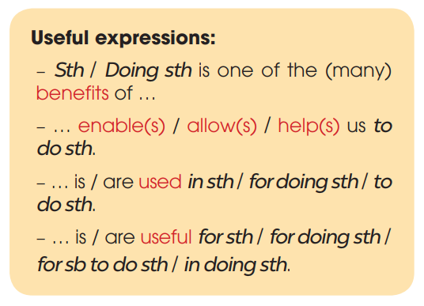  ** T focuses Ss’ attention on the sentences and checks comprehension. T asks Ss to rewrite them, using the suggested words and the structures in the box.  *** Ss work individually to rewrite the sentences.  - T walks round the class to offer help if necessary and uses coloured chalk to underline the structures in the answers.  **** T checks answers as a class.  Key:  1. Helping drivers to find the best routes is one of the benefits of AI in transport.  2. Vacuum cleaners are useful for cleaning / in cleaning the house quickly.  3. Smartphones help us to learn languages.  4. Telephones are used to communicate / for communication / for communicating over long distances. | T-S  T- S  S  T-S | 8 mins
WHILE-WRITING | To help Ss practise developing ideas and writing a paragraph. | TASK 3: WRITE A PARAGRAPH (120 - 150 WORDS) TO DESCRIBE TWO OR THREE BENEFITS OF THE INVENTION YOU CHOSE IN 1. USE THE OUTLINE BELOW TO HELP YOU. (p.58.)  * T tells Ss that they are going to write a paragraph of 120 - 150 words about the benefits of an invention of their choice.  - T asks them to study the suggested outline.  - T reminds them to use the structures they have practised in task 2.  ** Ss work individually to write a draft.  *** Ss check their draft for the first time.  **** T walks round the class to offer help if necessary.  Sample answer:  Electricity is one of the great inventions of the past, because it has brought many benefits for people. First, electricity can be used to light our houses and streets. Without it, the world will be dark and dangerous. Second, electricity is also useful in heating. For example, in cold areas, electric heaters can keep us warm and healthy in long winters. Finally, the most important use of electricity is to run machines. Without electricity, factories, schools and hospitals cannot run normally. Everyone and everything will stop working. Other inventions, such as TVs, computers and robots will become useless without electricity. In conclusion, electricity plays a very important part in our life today and we cannot live without it. | T-S  S  S  T-S | 15 mins
POST-WRITING | To do a cross-check and final check on students’ writing. | PEER CHECK  * T has Ss swap their paragraphs with a partner and comment on each other’s ideas, vocabulary and grammar.  ** Ss work in pairs and swap their 1st drafts for peer review.  *** T then gives feedback on one writing as a model.  **** T collects Ss’ writings to mark and provide written feedback in the next lesson. | T-S  Pair work  T-S  T-S | 7 mins
CONSOLIDATION | To help Ss memorise the target language and skills that they have learned. | WRAP-UP  - Some lexical items related to the topic Inventions  - Write about the benefits of an invention.  HOMEWORK  - Rewrite the paragraph in the notebooks.  - Prepare for the next lesson: Unit 5 – Communication and culture/ CLIL.  - Do exercises in the workbook. | T-S | 3 mins

UNIT 5: INVENTIONS
Lesson 7: Communication and Culture/ CLIL
I. OBJECTIVES
By the end of this lesson, Ss will be able to:
1. Knowledge
- Use the lexical items related to the topic Inventions;
- Practise making and responding to requests.
- Know more information about computer hardware.
2. Core competence
- Be collaborative and supportive in pair work and teamwork.
- Access and consolidate information from a variety of sources.
- Actively join in class activities.
3. Personal qualities
- Develop a sense of problem-solving when deciding suitable computers.
- Understand more about computer hardware.
II. MATERIALS
- Grade 10 textbook, Unit 5, Communication and culture/ CLIL
- Computer connected to the Internet
- Projector/ TV/ pictures and cards
- sachmem.vn

Assumptions
Anticipated difficulties | Solutions
Students may have underdeveloped speaking and co-operating skills. | - Encourage students to work in pairs and in groups so that they can help each other.  - Provide feedback and help if necessary.
Some students will excessively talk in the class. | - Explain expectations for each task in detail.  - Have excessive-talking students practise.  - Continue to explain task expectations in small chunks (before every activity).

Board Plan
Date of teaching
UNIT 5: INVENTIONS
Lesson 7: Communication and Culture/ CLIL
* Warm-up
Card game
I. Everyday English
Task 1: Listen and complete the conversation.
Task 2: Role-play
II. CLIL
Task 1: Match the highlighted words with their meanings.
Task 2: Decide which one is most suitable.
* Homework

III. PROCEDURES
Notes:
In each activity, each step will be represented as following
* Deliver the task
** Implement the task
*** Discuss
**** Give comments or feedback

Stage | Stage aim | Procedure | Interaction | Time
WARM-UP | - To introduce the topic.  - To enhance students’ skills of cooperating with teammates. | CARD GAME  * T divides the Ss into different groups. T gives each group a set of word cards and 1 sheet of A1 paper. Then T asks the groups to select as many words related to computer as possible, stick the word cards on the sheets of A1 paper, and then stick the paper onto the walls/ the board.  ** Ss listen to the instructions and do as required.  *** Ss work in groups and finish their sheets of A1 paper.  **** The group with the largest number of correct answers is the winner.  Suggested answer:  Laptop  Screen  Hardware  Software  Speed  Document  Display  Battery  Light  Weight  Size  Brand  Program  Memory  Data | T-S  S-S  S-S  T-S | 5 mins
EVERYDAY ENGLISH | - To provide Ss with an example conversation in which people make and respond to requests.  - To review expressions for describing feelings. | TASK 1: LISTEN AND COMPLETE A CONVERSATION AT A COMPUTER STORE WITH THE EXPRESSIONS IN THE BOX. THEN PRACTISE IT IN PAIRS. (p. 58)  * T tells Ss that they are going to listen to a conversation between a customer and a shop assistant at a computer store. While listening, they should complete the conversation using the expressions in the box.  - T gives Ss a few minutes to read the expressions in the box and the conversation.  ** Ss listen and complete the conversation with the expressions from the box.  *** T checks answers by asking individual Ss to read the conversation.  **** T puts Ss in pairs and has them practise the conversation.  Key:  1. B 2. C 3. A 4. E 5. D | T-S  S  T-S | 7 mins
 | To help Ss practise making and responding to requests. | TASK 2: ROLE-PLAY  Work in pairs. Role-play similar conversations about other devices you want to buy. Use the example in task 1 and the expressions below to help you. (p. 59)  * T explains the context. Ask Ss to brainstorm more expressions that they may use in the conversations, e.g. Can you help me, please? I’m looking for … Would you mind (bringing) …? I was wondering if you could … Sure, no problem.  - T puts Ss in pairs to role-play similar conversations pretending they are buying another electronic device; makes sure Ss plan their conversations before they start practising it.  ** Ss practise their conversation in pairs.  - T walks around the class and offers help if necessary.  *** Some pairs act out their conversations in front of the class.  **** T praises for good effort, clear pronunciation, fluent delivery, and interesting ideas. | T-S  Pair work | 10 mins
CLIL | To help Ss learn about computer hardware and learn some content vocabulary. | TASK 1: READ THE TEXT BELOW. MATCH THE HIGHLIGHTED WORDS AND PHRASES WITH THEIR MEANINGS. (p. 59-60)  * T writes three words: “processor”, “RAM” and “storage” on the board. T asks Ss if they know what “processor”, “RAM” and “storage” are and why they are important when buying a computer; also elicits that they are different parts of computer hardware (or the electronic parts of a computer).  - T explains they are going to read a text to learn more about these terms, and their importance.  - T has Ss read the text, match the highlighted words and phrases with their meanings. T asks Ss to pay attention to the context of each highlighted word, and look for clues that can help confirm the meaning of each word.  ** Ss work individually, read the text, match the highlighted words and phrases with their meanings.  *** Ss check their answers with their partners.  **** T checks answers as a class, further explains or translates any new words or phrases, e.g. processor speed, gigahertz, gigabytes, battery  Key: 1. c 2. d 3. a 4. e 5. b | T-S  S-S  S-S  T-S | 10 mins
 | To help Ss relate what they have learnt to a problem-solving task and make connections. | TASK 2: LOOK AT THE ADVERTISEMENTS. DECIDE WHICH ONE IS MOST SUITABLE FOR EACH PERSON BELOW. (p.60)  * T tells Ss that two people, Anne and Bob, need their help to decide which computer is best for them.  - T asks Ss to use the information from the text in task 1 and the information in the table to help Anne and Bob decide.  - T goes through the table and elicits the meaning of the abbreviations of data measurements.  - T asks Ss to discuss their answers in pairs.  ** Ss discuss their answers in pairs.  *** Ss say which computers Anne and Bob should buy and why in front of class.  **** T checks answers and gives feedback.  Answers:  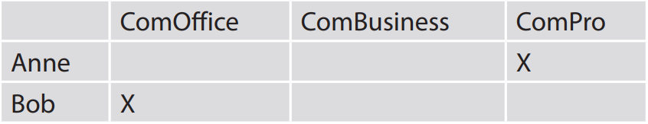 | T-S  S  S  T-S | 10 mins
CONSOLIDATION | To help Ss memorise what they have learned. | WRAP-UP  - Use the lexical items related to the topic Inventions.  - Revise how to make and respond to requests.  - Know more information about computer hardware.  HOMEWORK  - Prepare for the next lesson: Unit 5 – Looking back and project.  - Do exercises in the workbook. | T-S | 3 mins

UNIT 5: INVENTIONS
Lesson 8: Looking back and project
I. OBJECTIVES
By the end of this lesson, Ss will be able to gain:
1. Knowledge
- Review the vocabulary and grammar of Unit 5.
- Apply what they have learnt (vocabulary and grammar) into practice through a project.
2. Core competence
- Develop communication skills and creativity.
- Develop presentation skills.
- Develop critical thinking skills.
- Be collaborative and supportive in pair work and team work.
- Actively join in class activities.
3. Personal qualities
- Be more creative when doing the project.
- Develop self-study skills.
II. MATERIALS
- Grade 10 textbook, Unit 5, Looking back and project.
- Computers connected to the Internet.
- Projector/ TV/ pictures and cards.
- sachmem.vn.

Assumptions
Anticipated difficulties | Solutions
- Students may have underdeveloped speaking and co-operating skills. | - Encourage students to work in pairs and in groups so that they can help each other.  - Provide feedback and help if necessary.
- Some students will excessively talk in the class. | - Explain expectations for each task in detail.  - Have excessive talking students practise.  - Continue to explain task expectations in small chunks (before every activity).

Board Plan
Date of teaching
UNIT 5: INVENTIONS
Lesson 8: Looking back and project
* Warm-up
Brainstorming
I. Looking back
Pronunciation and vocabulary
Solve the crossword.
Grammar
Circle the correct answers.
II. Project
Inventions for the classroom
* Homework

III. PROCEDURES
Notes:
In each activity, each step will be represented as following
* Deliver the task
** Implement the task
*** Discuss
**** Give comments or feedback

Stage | Stage aim | Procedure | Interaction | Time
WARM-UP | - To revise the three-syllable nouns and lead in the next part of the lesson.  - To enhance students’ skills of cooperating with teammates. | BRAINSTORMING  * T divides the board, and divides the class into 2 teams.  ** Ss listen to the instructions.  *** Members of each team take turns and write as many three-syllable nouns about topic Inventions as possible in 2 minutes.  **** The group having more correct answers is the winner.  Suggested answer:  Inventor  Invention  Computer  Telephone  Beverage  Camera  Submarine  Telegraph  Telescope  Typewriter | T-S  Team work  T-S | 5 mins
LOOKING BACK | - To revise words they have learnt in the unit.  - To revise stress placement on common three-syllable nouns. | PRONUNCIATION AND VOCABULARY  Solve the crossword. Use the three syllable nouns in this unit. Read out the correct answers in pairs when you finish. (p. 60)  * T explains that Ss are going to review some of the words they have learnt in this unit in a crossword puzzle. Remind them that all the words must be three-syllable nouns.  - T puts Ss in pairs to solve the crossword.  ** Ss work in pairs to solve the crossword.  *** T checks answers as a class by asking individual Ss to write the words on the board.  **** T has Ss practise saying the words with the correct stress placement. T walks round the class and monitors by correcting any pronunciation mistakes.  Key:  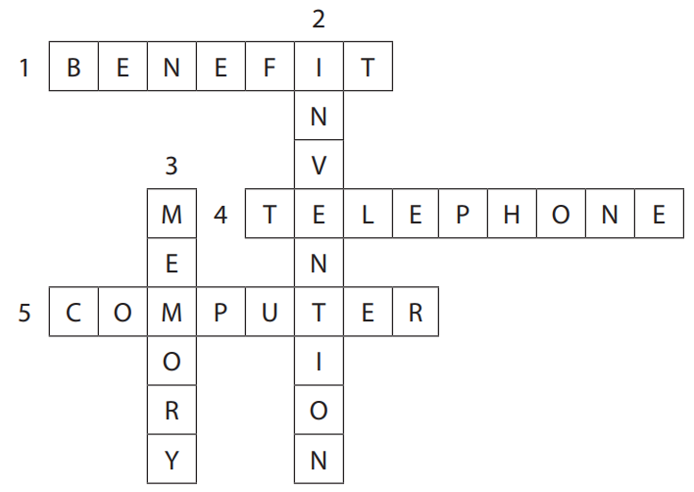 | T-S  Pair work  T-S  T-S | 7 mins
LOOKING BACK | To revise the present perfect, gerunds and to-infinitives. | GRAMMAR  Circle the correct answers. (p. 60)  * T explains to Ss that they are going to review the use of the present perfect tense, gerunds and to-infinitives.  - T asks Ss to read the sentences and circle the correct forms. In weaker classes, T recalls the forms and uses of the present perfect, and the uses of gerunds and to-infinitives.  ** Ss read the sentences and circle the correct forms.  *** Ss check their answers in pairs.  **** T checks answers as a class by asking individual Ss to write the words on the board.  Key:  1. have just installed, using  2. to send, To learn  3. was invented, have changed | T-S  S  S  T-S | 5 mins
PROJECT | - To allow students to apply what they have learnt into practice through a project.  - To provide an opportunity for students to develop their research and collaboration skills, and to practise giving an oral presentation. | INVENTIONS FOR THE CLASSROOM  As Ss have prepared for the project throughout the unit, the focus of this lesson should be on the final product, which is an oral presentation.  * T has Ss work in their groups, gives them a few minutes to get ready for the presentation.  ** T gives Ss a checklist for peer and self-assessment. T explains that they will have to tick appropriate items while listening to their classmates’ presentations and write comments if they have any. The presenters should complete their self-assessment checklist after completing their presentation.  *** Two or three groups give their presentations. T encourages the rest of the class to ask questions at the end.  **** T gives praise and feedback after each presentation. | T-S  Group work  S  T-S | 25 mins
CONSOLIDATION | To help students memorise what they have learned. | WRAP-UP  - Review the vocabulary, pronunciation and grammar of Unit 5.  - Apply what they have learnt into practice through a project.  HOMEWORK  - Prepare for the next lesson: Unit 6 – Getting started.  - Do exercises in the workbook. | T-S | 3 mins

