Period 4 UNIT 1: FAMILY LIFE
Lesson 3: Reading – Benefits of doing housework
I/ Learning outcomes:
By the end of this lesson, Ss will be able to:
- Knowledge:
- have an overview about “Benefits of doing housework”
- gain vocabulary to talk about household chores
- Competences:
- develop reading skills for specific information
- provide Ss with more language and ideas about “Benefits of doing housework”
- Attributes:
- be aware of responsibilities towards household chore sharing in the family
II/ Teaching and learning resources:
Tape (CD), TV, speakers, textbook, teacher's book, copies of pictures, handouts, laptop, posters, Wifi connection
III/ PROCEDURE:

Aims | Content | Outcomes | Steps
ENGAGE/ WARM UP (5’)
- To create a friendly and lively atmosphere in the classroom | Introduction: (5’) | Ss’s chance to get to know each other | Introduce
- To familiarize Ss with the topic of the reading text  - To lead in the reading lesson | Asking questions using picture: (5’)  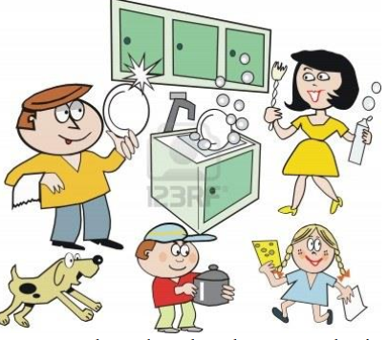  1. Who does the housework in your family?  2. How is the housework shared in your family?  3. What is your duty? | Ss’s oral prediction about the topic  Suggested answers:  1. Mother/ Father/ Children, etc.  2. Equally/ unequally  3. Clean the floor/ Wash the dishes/… | - T raises questions  - Sts answer
STUDY/ PRESENTATION (15’)
- To understand the new words in the reading. | Vocabulary:  + responsible /rɪˈspɒnsəbəl/ (adj): có trách nhiệm.  → (be) responsible for  → responsibility (n)  → take responsibility for  + gratitude /ˈɡrætɪtʃuːd/ (n): lòng biết ơn  → express one’s gratitude to SB  + strengthen /ˈstreŋθən/ (v): củng cố  + bond /bɒnd/ (n) = strong connection  + character /ˈkærəktər/ (n): tính cách | - A list of words in Ss’ notebook | Elicit  Give synonym/ Vietnamese equivalent/ example/pictures to elicit vocabulary from Ss
 | * Listen & repeat | Sts’ pronunciation of the words | Listen to the audio/teacher & repeat in chorus then individually
 | * Check vocabulary: | The missing words on the board | Rub out and remember
- To help Ss practise guessing the meanings of words in context. | Task 2: Read the text and tick (✔) the appropriate meaning of the highlighted words. (ex.2, p.11) (8’) | Some words or phrases ticked  Suggested answers:  1. a 2. b  3. a 4. a  5. b | Asks Ss to read and match the highlighted words and phrases in the text to their meanings.
ACTIVATE/ PRACTICE (20’)
- To practise reading for specific information | TASK 3: Read the text again and answer the answers. (Ex.3, p.12) (10’)  1. Most people think that housework is boring and the responsibility of wives and mothers only.  2. They want to give their children more time to play and study.  3. These are doing the laundry, cleaning the house, and taking care of others.  4. They learn that they have to try to finish their task even though they do not enjoy doing them.  5. Because children learn to appreciate all the hard work their parents do around the house for them. They also start treating doing household chores as special moments shared with their parents. | - Ss’ answers of the questions | - Work in pairs  - Read the text & questions then underline the key words.  - Find the answers.  - Peer correction  - Teacher’s feedback
To help Ss use the ideas and language in the reading or in their own ideas to talk about the benefits they can get from sharing housework | TASK 4: Work in groups. Discuss the question “What benefits do you think you can get from sharing housework?” (‘10’)  → Some hints:  - Learning to take responsibility  - Developing gratitude to their parents  - Strengthen family bonds  - Reduce family stress | Ss’ ideas and oral presentation about benefits of sharing household chores.  Suggested answers  → There are some huge benefits of sharing housework. Firstly,... | - Ss find out the benefits of sharing housework both in the passage and in their own ideas.  - Ss make a mindmap and present what they have discussed.  -Teacher’s feedback
CONSOLIDATION/ PRODUCTION (5’)
- To help students memorise the target language and skills that they have learned | 1.WRAP-UP (3’)  The teacher asks:  - What have you learnt today?  - What are the benefits of doing housework? | Ss’ reflection about the content of the lesson. | - Class work  - Teacher’s feedback
- To guide students to prepare for the next lesson. | 2. HOMEWORK (2’)  a/ Do exercises in the workbook.  b/ Learn the new words by heart.  c/ Ask sts to summarize the passage.  d/ Prepare for Speaking lesson. | Ss’ oral presentation of the research results. | Ss do individually

Period 5 UNIT 1: FAMILY LIFE
Lesson 4: SPEAKING
I/ Learning outcomes:
By the end of this lesson, Ss will be able tKnowledge:
- Explain why children should or shouldn’t do housework.
- Discuss and express their opinions about why children should or shouldn’t do the housework.
- Competences:
- Be collaborative and supportive in pair work and team work;
- Develop presentation skills;
- Actively join in class activities;
- Be critical thinking.
- Attributes:
- Recognise the benefits of doing housework for children;
- Understand why children should or shouldn’t do housework;
- Sharing housework with their families.
II/ Teaching and learning resources:
Tape (CD), Tivi, speakers, textbook, teacher's book, handouts, laptop, posters
III/ PROCEDURE:
Aims | Content | Outcomes | Steps
ACTIVITY 1: WARM UP (5’)
- Create a friendly and lively atmosphere in the classroom  - Lead to the new lesson  - review some words & phrases related to household chores | 1. Game: Miming  - Clean the house  - Wash the dishes  - Water the plants  - Do the cooking  - Put out the rubbish  - Shop for groceries | Students’ oral prediction about the topic | Elicit  Give some phrases related to household chores
ACTIVITY 2: STUDY/ PRESENTATION (15’)
- Recall reasons from the reading text why people think children should or shouldn’t do housework and provide them with more ideas. | TASK 1: Below are reasons why children should or shouldn’t do housework. Put them in the correct column. Add some more if you can.  - Recall lexical items from previous lessons by asking Ss to call out the meaning of some words:  - develop life skills  - take responsibility  - break and damage things  - strengthen family bonds | Students’ oral presentation  KEY:  - phát triển kỹ năng mềm/ cuộc sống  - chịu trách nhiệm  - làm vỡ/ bể và làm hư hỏng đồ đạc  - thắt chặt sự gắn bó gia đình | Elicit  Give some phrases related to family life  Teacher’s feedback
 | - Ask Ss to read the reasons carefully and put them in the correct column  SHOULD SHOULDN’T  -Encourage Ss to raise their ideas | Students’ oral presentation  KEY:  SHOULD  1. Doing housework helps them develop life skills.  2. Doing housework teaches them to take responsibility.  5. Doing housework helps strengthen family bonds.  SHOULDN’T  3. Kids should be given plenty of playtime when they are young.  4. They may break or damage things when doing housework.  6. They need more time to study and do homework.  List some more reasons  Expected answers:  - Chores teach time management.  - Completing chores can make children more confident.  - Most chores are not really for the children and can be dangerous  - Children won’t have time to take part in after-school activities | - Work in pairs  - Peer correction  - Teacher’s feedback  List  Work in pairs to list some more reasons  -Teacher’s feedback
To provide students with an example conversation in which people express their opinions about whether children should or shouldn't do housework. | TASK 2: Complete & Listen the conversation  - Complete the conversation between Anna, Nam and Minh using some ideas from Task 1 (p.12) | - Completed conversation with the ideas provided  Key:  1.Doing housework helps them develop life skills.  2. They should be given plenty of playtime when they are young. | Listen the conversation & check  - Work in pairs  - Peer correction  - Teacher’s feedback
 | Practise the conversation | - Ss’ oral practice | - Work in groups of three  - Teacher’s feedback
ACTIVITY 3: ACTIVATE/ PRACTICE (20’)
To help students practise having conversations in which they can express their opinions about why children should or shouldn’t do housework. | MAKE CONVERSATIONS SIMILAR TO THE ONE IN TASK 2. (p.12)  - Remind Ss to swap roles and role-play their conversations | - Ss’ role-play/ conversation | - Work in groups of three  -Peer correction  - Teacher’s feedback
ACTIVITY 4: CONSOLIDATION/ PRODUCTION (5’)
- To consolidate what students have learnt in the lesson. | 1.WRAP-UP  Teacher asks: “ What are the benefits of doing household chores?” | Students’ oral presentation | -Work in groups of three  -Peer correction  - Teacher’s feedback
- To prepare for the next lesson. | 2. HOMEWORK  - Do exercises in the workbook  - Practice more conversation at home  -Prepare for the Listening lesson | Ss’ oral presentation | Groupwork

Period 6 UNIT 1: FAMILY LIFE
Lesson 1: Listening – Household chores
I/ Learning outcomes:
By the end of this lesson, Ss will be able to:
- Knowledge:
- Listen for details and specific information in a talk show about family life;
- Apply the language they have learnt in the listening in a speaking task about their own experiences.
- Competences:
- develop communication skills;
- be collaborative and supportive in pair work and teamwork;
- actively join in class activities.
- Attributes:
- Recognise how our families have helped us achieve success in our lives;
- Show gratitude towards our families.
II/ Teaching and learning resources:
Tape (CD), Tivi, speakers, textbook, teacher's book, copies of pictures, handouts, laptop, posters
III/ PROCEDURE:
Aims | Content | Outcomes | Steps
ACTIVITY 1: IN TRODUCTION & ENGAGE/ WARM UP (5’)
- To lead in the lesson | What are the roles of men and women in the family? (5)  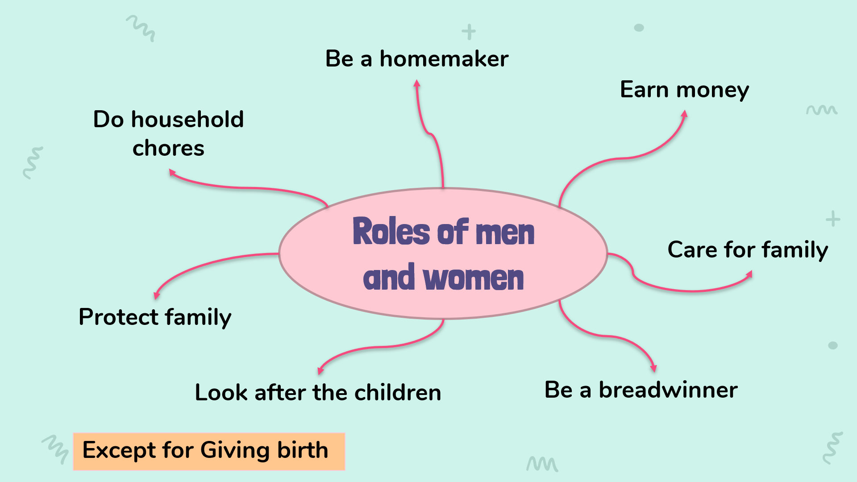 | Lists of the roles of men and women in the family  Suggested answer:  - doing household chores  -Earning money  - Protecting family | Elicit  Show the picture to elicit the topic
ACTIVITY 2: PRE-LISTENING {15’)
To introduce the topic of the listening extract and activate students’ prior knowledge. | 1. look at the photos to guess the meaning of new words (10’)  - Support (n):  - Cheer S.O up (v)  - Routine (n)  - Achievement (n): | A list of words in notebook | Elicit  Give synonym/ Vietnamese equivalent/ example to elicit vocabulary from Ss
 | * Listen & repeat | Sts’ pronunciation of the words | Listen to the audio/teacher & repeat in chorus then individually
 | * Check vocabulary: | The missing words on the board | Rub out and remember
 | 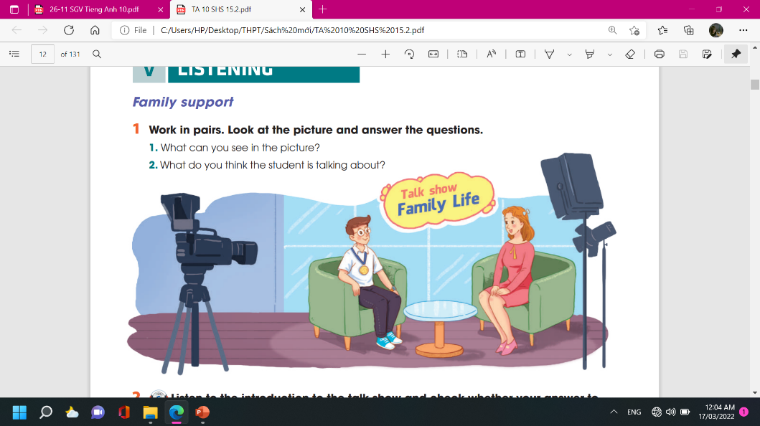  2 TASK 1: LOOK AT THE PICTURE AND ANSWER THE QUESTIONS.  (p. 13)  Suggested questions:  Who are the people?  Where are they?  What is in the background?  What are they doing?  What’s the boy wearing around his neck? | Ss’prediction about the picture  Suggested answers:  A student and the host of a talk show  In a studio  Name of the show: Family Life  Talking; The host is interviewing the student.  A gold medal | Set the context for listening.  - asks Ss to work in pairs, look at the picture and answer the questions.  - tells Ss that there are no right or wrong answers and they should feel free to make any guesses.  ** Ss answer the questions.  *** T confirms, shows the answers on the screen.
ACTIVITY 3: WHILE- LISTENING (20’)
To help students practise listening for specific information in an extract of a talk show and comparing their predictions with what they hear | TASK 2: LISTEN TO THE INTRODUCTION TO THE TALK SHOW AND CHECK WHETHER YOUR ANSWER TO QUESTION 2 ABOVE IS CORRECT OR NOT. (p.13)  * Teachers:  - tells Ss that they are going to listen to part of the talk show and decide whether their guesses are correct.  . | Ss’ prediction  T - S  T – S  S-T | Predict then listen and read the conversation  - Work in pairs  - Peer correction  - Teacher’s feedback  ** T plays the recording.  *** T confirms, shows the answers on the screen and asks Ss to make correction if they made a wrong answer.
To help students practise listening for details. | TASK 3: TRUE OR FALSE. (p.13)  .  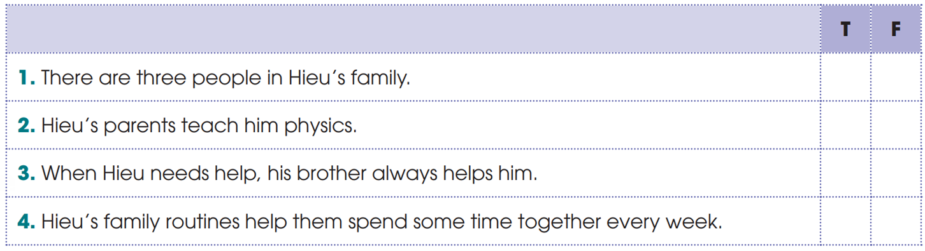 | Statements identified as true or false  Key: 1. F 2. F 3. T 4. T | Ss listen and check their answer.  - asks Ss to read through the statements once and underline the key words in them.  ** T plays the recording twice. Ss do the task and correct the false statements.  *** T checks answers
To help students practise listening for keywords. | 4 TASK 4: LISTEN AND COMPLETE THE SENTENCES. (p.13)  . | Completed sentences with the words provided  Key: 1. difficulties 2. love 3. sad | - Do the task individually  - share the answers with a peer.  - Teacher’s feedback
ACTIVITY 4: POST-LISTENING (10’)
To help students apply the language they have learnt in the listening in a speaking task about their own experiences. | TASK 5: DISCUSSION (p.13)  Work in groups. Discuss the following question.  “How can parents help their children achieve success in their studies?”  . | T - S  S - T - S  T - S | - having Ss work in groups of three and tells them to think about their own family to answer the question.  ** Ss prepare their presentation in groups. Each group chooses a representative to share the group’s ideas with the class.  *** T gives feedback
ACTIVITY 5: CONSOLIDATION/ PRODUCTION (5’)
- To consolidate what students have learnt in the lesson  - To prepare for the next lessons | 1.WRAP-UP (3’)  - How can parents help their children achieve success in their studies | - Ss’ list | -Peer correction  - Teacher’s feedback
- To prepare for the next lessons | 2. HOMEWORK (2’)  - Do the Listening exercises in the Workbook  - Prepare for the Writing lesson | Ss’ oral presentation of the research results | Groupwork

