WEEK 23/ Period 58 UNIT 6
Lesson 4: SPEAKING – Career choices
I/ Learning outcomes:
By the end of this lesson, Ss will be able to:
- Knowledge:
- Understand how to express opinions
- Talk about career choices.
- Competences:
- develop communication skills;
- be collaborative and supportive in pair work and teamwork;
- actively join in class activities.
- Attributes:
- be aware of the importance of gender in choosing careers
II/ Teaching and learning resources:
Tape (CD), Tivi, speakers, textbook, teacher's book, copies of pictures, handouts, laptop, posters
III/ PROCEDURE:
Aims | Contents | Outcomes | Steps
WARM UP (5’)
- To introduce the topic of the job | 1. Guess: Pictures and jobs (5 pictures) | Ss’ guessed jobs  -suggested answers:  nurse, doctor, teacher, sale managers. | - Work in groups of 4
ACTIVITY 1: PRESENTATION (10’)
- To introduce more ideas for the main task & get Ss involved in the lesson  - To introduce to Ss some expressions used in career choices | Decide which jobs are traditionally done by men or women. Use the expressions to help you.  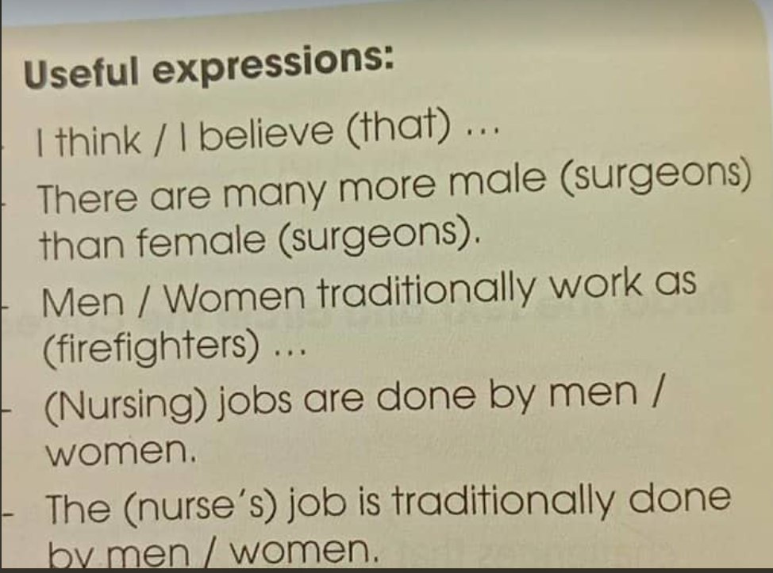 | Ss’ talks  - Expected answers:  Ss1: I think (that) the surgeon’s job is traditionally done by men.  Ss2: I think there are more female shop assistants than male ones.  Ss3: Women traditionally work as drivers  …..  - Suggested answers:  +/ Traditionally male jobs: 1,4,5,7  +/ Traditionally female jobs: 2,3,6,8 | - Elicit  Give useful expressions  -Work in pairs, discuss  -Teacher’s feedback
ACTIVITY 2: CONTROLLED PRACTICE (10’)
- To introduce more ideas for the main task  - To help Ss to express their opinion & develop their speaking skills | Discuss why the jobs mentioned in 1 are traditionally done by men or women. Use the ideas given:  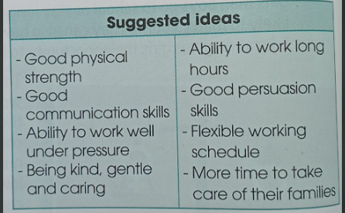 | - Ss’ comprehension of the suggested ideas and practice  Suggested answer:  1. Men traditionally work as firefighters because they have good physical strength and ability to work well under pressure.  2. Nursing jobs/childcare workers are done by women because they are kind, gentle and caring.  3. Airline pilots are traditionally are done by men because they have good physical strength.  ….. | - Elicit the suggested ideas  - Work in pairs  -Present  - Teacher’s feedback
ACTIVITY 3: PRODUCTION(18’)
-To help Ss talk about their career choices and share their ideas with the rest of the class  - To develop Ss’ speaking skill | 1. Talk about their career choices in the future:  2. Wrap up  What have you learnt in the lesson? | - Ss’ oral presentation about their future jobs  Suggested answers:  S1: I think I’ll work as a tourist guide in the future because I am very beautiful and have good communication skills.  S2: Good for you. I’d like to be a policeman because I want to protect people.  S3: Sound great. I’d like to be a doctor because I want to help the sick with hard circumstances.  ….  - Expressions to talk about career choices | -Work in groups of 4  - Teacher’s feedback  Ask & answer  Feedback
HOMEWORK 2’
To review the lesson they have learnt and prepare for the next lesson | - Exercises in the workbook  - Practice speaking about career choices and the reasons why they choose them.  - Prepare the next lesson: Listening | - exercise completion | - Individually

WEEK 23/ Period 59 UNIT 6: GENDER EQUALITY
Lesson 5: Listening
I/ Learning outcomes:
By the end of this lesson, Ss will be able to:
- Knowledge:
- Listen for specific information in a talk about the first woman in space;
- Identify and use lexical items related to gender equality.
- Competences:
- Develop communication skills and problem-solving skills;
- Be collaborative and supportive in pair work and teamwork;
- Actively join in class activities.
- Attributes:
- Develop an awareness of women’s achievements in their jobs;
- Be respectful towards all genders.
II/ Teaching and learning resources:
Tape (CD), Tivi, speakers, textbook, teacher's book, copies of pictures, handouts, laptop, posters
III/ PROCEDURE:
Aims | Contents | Outcomes | Steps
ACTIVITY 1: WARM UP (5’)
- To activate Ss’ knowledge on the topic of the unit.  - To lead into the new unit. | VIDEO WATCHING  Watch a video and take notes of as many names that you can hear as possible.  Link:https://www.youtube.com/watch?v=HIEach7rmDg  Share your notes and discuss the question: Which names have you already known and which names have you never heard of? | - Ss’s notes of as many names that they can hear as possible.  Suggested answer:  Neil Armstrong, Yuri Gagarin, Valentina Tereshkova, Sally Ride. May Jameson, Helen Sharmen, Tim Peak, Kalpona Chawla, Laurel B Clark, Williamina Fleming, Annie Jump Cannon, Henrietta Swan Leavitt, Antonia Maury, Margaret Hamilton, Katherine Johnson, Jerrie Cobb  Suggested answer:  Male names are more well-known than female names. | Elicit  Shows Ss a video about the history of women in space.
ACTIVITY 2: STUDY/ PRESENTATION (17’)
- To provide Ss with relevant vocabulary before they listen  - To introduce the topic of the listening and set the context. | 1. Vocabulary: (10’)  Look at the explanation and the photos to guess the meaning of new words.  1. cosmonaut (n) /ˈkɒzmənɔːt/: phi hành gia (Xô Viết/Nga)  2. space (n) /speɪs/: không gian ngoài vũ trụ  3. parachutist (n) /ˈpærəʃuːtɪst/: người nhảy dù  4. instructor (n) /ɪnˈstrʌktə(r)/: người hướng dẫn/huấn luyện  5. technical (adj) /ˈteknɪkl/: thuộc về kĩ thuật  2. The whole class discuss the job of the woman’s picture in the textbook. | A list of words in Ss’ notebook  Key: She’s a cosmonaut. | Elicit  Give Vietnamese equivalents to elicit vocabulary from Ss  - Work in pairs  - Teacher’s feedback
 | * Check vocabulary: | The missing words on the board | Rub out and remember
To help Ss practise listening for specific information. | 2. Listen  Listen to a talk about Valentina Tereshkova. Choose the best answer to complete each sentence. (p.71) | Completed sentences with words provided  Suggested answers:  1. A  2. B  3. A  4. B  5. B | Set the context for listening  - Work individually  - Peer correction  - Teacher’s feedback
ACTIVITY 3: PRACTICE (15’)
To help Ss practise listening for specific information. | Listen again and give short answers to the following questions (p.71)  1.When was Terashkova born?  2.How old was she when she strted working?  3.When did she join the Soviet space programme?  4.At what age did she travel into space?  5.How many days did she spend in space? | Answered questions  Key:  1. 1937  2. 16  3. 1962  4. 26  5. Three days / 3 days | Listen and answer the questions  - Work in pairs  - Peer correction  - Teacher’s feedback
ACTIVITY 4: PRODUCTION, CONSOLIDATION (8’)
To give Ss an opportunity to give their opinions about the cosmonaut’s job and give reason(s). | Work in groups.  1. Discuss the following questions:  Do you want to be a cosmonaut? Why or why not?  2. Present a summary of their discussions to the class. | - Ss’ oral presentation  Suggested answers:  Yes, I’d like to be a cosmonaut because …  In my group, Nam’d like to be a cosmonaut because he said ....... while Lan said that she doesn’t want to be a cosmonaut. And Hoa ....... | Discuss the question and present a summary of their discussions to the class  - work in groups.
To help Ss memorise the target language and skills that they have learned. | 1. WRAP-UP  - Some lexical items about women in space.  - Listening for specific information.  2. HOMEWORK  - Exercises in the workbook.  - Project preparation. | Ss’ answers  Suggested answers  1. cosmonaut (n): phi hành gia (Xô Viết/Nga)  2. space (n): không gian ngoài vũ trụ  3. parachutist (n): người nhảy dù  4. instructor (n): người hướng dẫn/huấn luyện  5. technical (adj): thuộc về kĩ thuật | Individual work  Whole class

WEEK 23/ Period 60 UNIT 6: GENDER EQUALITY
Lesson 6: Writing

I/ Learning outcomes:
By the end of this lesson, Ss will be able to:
- Knowledge:
- Use lexical items related to the topic Gender Equality;
- Write about jobs for men and women.
- Competences:
- Access and consolidate information from a variety of sources;
- Be collaborative and supportive in pair work and teamwork;
- Actively join in class activities.
- Attributes:
- Develop an awareness of gender equality in the workforce;
- Be respectful towards all genders.
II/ Teaching and learning resources:
Tape (CD), Tivi, speakers, textbook, teacher's book, copies of pictures, handouts, laptop, posters
III/ PROCEDURE:
Aims | Contents | Outcomes | Steps
ACTIVITY 1: WARM UP/ (10’)
- To arouse the classroom atmosphere.  - To get Ss interested in the topic  - To activate Ss’ knowledge of the lesson | 1. WARM-UP: MATCHING AND SORTING.  -Match the pictures with their correct names.  1 2  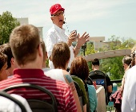  3 4    5 6  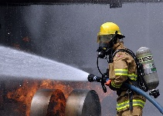  - Worker  - Teacher  - Firefighter  - Surgeon  - Pilot  - Tourist guide  -Put the jobs above into the right column.  Men’s jobs Women’s jobs  - Lead-in: surgeon | Matched pictures with their names  Expected answers:  1.b  2.f  3.e  4.a  5.c  6.d | -T explains the game rules to Ss  - Ss do as instructed.
ACTIVITY 2: PRE-WRITING (15’)
- To help Ss develop ideas for their writing. | TASK 1: CHOOSE SUITABLE INFORMATION FROM THE BOX BELOW TO COMPLETE THE TABLE. (p. 72)  * T tells Ss to look at the table and read the information below the table. T explains any new words if necessary. | Completed table  Suggested answer:  - Main responsibilities: A, D, F  - Main qualities: B, C, E, G, H | T asks students to work in groups to complete the table.
 | TASK 2: WORK IN PAIRS. DO YOU THINK BOTH MEN AND WOMEN CAN DO THE SURGEON’S JOB WELL? GIVE REASONS. USE THE IDEAS BELOW TO HELP YOU. (p.72)  * | Ss’ oral presentation in pairs  Suggested answers:  - Women can do the surgeon’s job well because they can be as physically and mentally strong as men.  - Women can make great surgeons because they can also perform long and tiring operations.  - Women can become good surgeons because men and women have the same abilities to learn and apply medical knowledge. | T asks Ss to study the ideas in the box and think about if they agree or disagree with them  T encourages them to write down their opinions and any new ideas they have come up with, preferably at least one reason/example for each idea.  T invites pairs of Ss to summarise their discussions in front of the class.  T encourages the rest of the class to ask the pairs questions and comment on their ideas.  T walks round the class to provide help if necessary. T gives feedback and summarizes the pairs’ ideas.
ACTIVITY 3: WHILE-WRITING (15’)
To help Ss practise writing a paragraph about the surgeon’s job | TASK 3: WRITE A PARAGRAPH (120 - 150 WORDS) ABOUT THE SURGEON’S JOB. USE THESE GUIDING QUESTIONS TO HELP YOU. (p.72) | Completed paragraph | * T explains the task and asks Ss to study the guiding questions.  - T provides the sample answer below as a model by reading it aloud or displaying it on the board.  - T checks again to make sure Ss understand the structure of the sample and how it answers each of the guiding questions.  - T encourages Ss to provide detailed explanations or examples to support each idea in their paragraph.  - T sets a time limit for Ss to write in class (around 10-15 minutes or more based on Ss’ abilities). T goes around the class and helps if necessary.  ** Using the ideas that they have written in Task 1 and Task 2, Ss work individually (or in pairs for weaker students) to develop their paragraphs about the surgeon’s job.  *** Ss swap their writing with a partner/other pair for peer feedback.  - T asks Ss to focus on both the content and language in their comments.  - Ss make some revisions based on their partners’ suggestions.   T collects Ss’ paragraphs to give face-to-face feedback in private, or gives them back with some oral/written feedback.
ACTIVITY 4: CONSOLIDATION (5’)
To revise what they have learnt and prepare for the next lesson:  Communication and Culture/CLIL | 1. Wrap up (3’)  T asks Ss to talk about what they have learnt in the lesson. | Ss’ oral presentation of the research results | -Groupwork
2. Homework (2’)
- Workbook exercises
- Project preparation

