WEEK 24/ Period 61
UNIT 6: GENDER EQUALITY
Lesson 7: COMMUNICATION AND CULTURE/ CLIL
I/ Learning outcomes:
By the end of this lesson, Ss will be able to:
- Knowledge:
- Have an overview about the topic Gender Equality;
- Express agreement and disagreement.
- Learn about women’s football
- Competences:
- Develop communication skills;
- Be collaborative and supportive in pair work and teamwork;
- Develop presentation skills.
- Attributes:
- Understand more about the gender equality in sports
- Be respectful towards all genders and cultures.
II/ Teaching and learning resources:
Tape (CD), TV set, speakers, textbook, teacher's book, copies of pictures, handouts, laptop, posters
III/PROCEDURE:

Aims | Content | Outcomes | Steps
ACTIVITY 1: WARM-UP (5’)
To activate Ss’ knowledge of the topic | WARM-UP  - Game:  Who’s the faster?  Question 1: The gender gap in primary education in Viet Nam has been eliminated. What do you think about it?  - I think it’s helpful and useful  - No doubt about it  Question 2: Seventy-three percent of Vietnamese women participate in the labor force. What is your opinion?  - I think the Vietnamese government has made considerable progress in gender equality.  - I couldn’t agree with you anymore.  Question 3: Seventy percent of all public school teachers in Viet Nam are women.  - Yes, here you are  - I don’t think so  Question 4: More women than men earn college degrees, although there are slightly more boys than girls at primary and secondary levels.  - You’re welcome  - You ‘re right  Key: 1.A, 2. A, 3.B, 4.B  UNIT 6:GENDER EQUALITY  Lesson 7: COMMUNICATION AND CULTURE/ CLIL | -Ss’ involvement in the class’s activities. | - T divides class into two groups  - T asks four questions and Ss choose the correct response .  - T gives feedback, if necessary, then introduces the lesson.  - Ss discuss what else they could say to express their views more clearly.
ACTIVITY 2:EVERYDAY ENGLISH (20’)
To provide Ss with an example conversation in which people express agreement and disagreement. | Useful expressions  Agreement Disagreement  You’re right. I couldn’t agree with you more. That’s exactly how I feel. That’s not true. I’m afraid I disagree. I’m sorry, but… I totally disagree. I beg to differ…  Task 1:(7 ms)  - Listen and complete a conversation with the expressions from the box. Then practice it in pairs. | A list of expressions of Agreement and  Disagreement in Ss’notebook  - Ss’ oral prediction  -Completed conversation with the expressions provided  Key: 1. D 2. A 3. C 4. B | - T tells Ss that they will learn more expressions of agreement and disagreement.  - T asks Ss to look at the four expressions (A – D) in the box and elicits their meaning and use,  e.g. A and D – to express disagreement; B and C – to express agreement.  -Ss read the conversation and look for context clues for the missing phrases or sentences, then predict the answer before listening.  - T checks answers as a class.  - T goes  . - Ss practise the conversation in pairs.
To help Ss practise expressing agreement and disagreement | Task 2: Work in pairs. Have similar conversations expressing agreement and disagreement about other jobs.  (13 ms)  Role-playing: Asian parents and child | - Ss’ making conversation  - Ss’oral presentation | -T asks Ss to work in pairs and brainstorm different jobs and reasons why parents may object to their children doing these jobs.  - T asks some pairs to share their ideas and write them on the board.  - T asks Ss to look at the list of expressions and encourages Ss to add more to the table, S-S T-S 13 mins  - T walks round the class and provide help when necessary.  -T invites some pairs to role-play their conversations in front of the class. The others listen and give comments on their peers’ performance.  - T gives feedback and adds bonus points for good effort and fluent delivery.
ACTIVITY 3: CLIL (15’)
To help Ss learn about women’s football through CLIL | Task 1: Read the text and fill the timeline about women’s football.  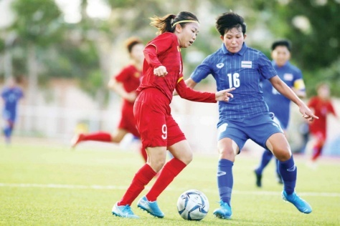  Questions:  “Who are the women in the picture?”  “What sport do they play?” | -Filled timeline about women’s football  Key: 1. 1890s  2. 1921  3. 1971  4. 1971  5. 1991 | - T shows a picture of women playing football and asks Ss some questions.  -T explains or elicits any new or difficult words.  -Ss read the text and complete the timeline with the information mentioned in the text.  - T asks Ss to read the text and complete the timeline.  - T asks Ss to check their answers with the partner  - T give feedbacks
-To help Ss relate what they have learnt about women’s football Viet Nam | Task 2: Fill the timeline about women’s football in Viet Nam. | Key: 1.1990  2. 1997  3. 2001  4. 2006  5. 2019 | -T asks Ss to work in groups of four students.  -T encourages them to discuss each event listed in the timeline and decide the exact year.  -T asks some groups to share their answers with the whole class.  - T gives feedbacks
ACTIVITY 4: PRODUCTION (5’)
- To consolidate what students have learnt in the lesson. | 1.WRAP-UP (3’)  - List of what Ss have learnt | - Ss’ list of what they have learnt today | -Teacher asks: What have you learnt today?  - Ss answer
-To prepare for the next lesson | 2.HOMEWORK (2’)  - Exercises in the workbook  - Preparation for Unit 6- lesson 8 |  | - T instructs  - Ss take notes

WEEK 24/ Period 62
UNIT 6: GENDER EQUALITY
Lesson 8: Looking Back and Project
I/ Learning outcomes:
By the end of this lesson, Ss will be able to:
- Knowledge:
- identify and mark stress in three-syllable adjectives and verbs;
- gain more vocabulary to talk about gender equality;
- use the passive voice with modals.
- Competences:
- develop communication skills;
- be collaborative and supportive in pair work and teamwork;
- actively join in class activities;
- report survey results in an oral presentation.
- Attributes:
- be aware of responsibilities towards gender equality.
II/ Teaching and learning resources:
Tape (CD), TV, speakers, textbook, teacher's book, copies of pictures, handouts, laptop, posters.
III/ PROCEDURE:
Aims | Content | Outcomes | Steps
ACTIVITY 1: WARM-UP (5’)
- To arouse the classroom atmosphere.  - To help Ss revise words/ phrases related to the topic. | WARM-UP  Guessing words from the pictures. | Ss’ involvement in the class’s activities.  Suggested answer:  1. : gender  2.  : equal  3.  : surgeon  4.  : marriage  5.  : cosmonaut | * T explains the game rules to Ss;  * Ss do as instructed.
ACTIVITY 2: LOOKING BACK (20’)
To help Ss revise how to pronounce stress in three-syllable adjectives and verbs. | 1. PRONUNCIATION  Listen and mark the stressed syllables in the words in bold. (p.74) | Stressed syllables in the words provided  1. The surgeon’s job is quite difficult.  2. Soviet cosmonauts learnt how to parachute to safety.  3. I’m proud of my sister. She’s studying at a medical school.  4. We need to continue fighting for equal rights.  Suggested answer:  1. The surgeon’s job is quite ‘difficult.  2. Soviet cosmonauts learnt how to ‘parachute to safety.  3. I’m proud of my sister. She’s studying at a ‘medical school.  4. We need to con’tinue fighting for equal rights. | * T asks Ss to review  the stress patterns of three-syllables adjectives and verbs;  - T asks Ss to read the sentences silently and mark the stressed syllables;  - T plays the recording, pausing after each word in bold;  - T checks answers;  - T plays the recording again and Ss repeat chorally;  - If time allows, T has Ss practice reading the sentences;
To help Ss revise words and phrases related to gender equality. | 2. VOCABULARY  Do the crossword. Use the words you have learnt in this unit. (p.74) | Completed crossword  Suggested answers:  1. kindergarten  2. gender  3. surgeon  4. equal  5. treat | * T asks Ss to predict the words;  - In weaker classes, have Ss work in pairs or groups;  - Check answers as a class;
To help Ss revise the use of the passive voice with modals. | 3. GRAMMAR  Each of the following sentences has a mistake. Underline it and write the correct word(s) in the space given. (p.74) | Corrected sentences  Suggested answers:  1. One paragraph about gender equality ought to write by each student.  ought to be written  2. Action to stop domestic violence must take immediately.  must be taken  3. Should all people be provide with equal access to information?  be provided  4. Young girls mustn’t force into marriage.  mustn’t be forced  5. Can men and women given equal opportunities in the workplace?  be given | * T asks Ss to read each sentence and decide on the mistake and correct it;  - In weaker classes, T has Ss review the grammar rules;  - T can underline to highlight the mistake and Ss correct it.  - If time allows, T asks Ss to work in pairs to compare answers;  - T checks answers, Ss explain why each sentence is wrong;
ACTIVITY 3: PROJECT (15’)
To provide an opportunity for Ss to develop their communication and collaboration skills and to practice reporting survey results in an oral presentation. | STUDENTS’ FUTURE JOBS  Do a survey about students’ future jobs and report the results to the class. (p.75) | * Ss’ oral presentation about the survey results. | * T gives Ss a checklist for peer and self-assessment;  - T goes through the criteria for assessing their talk;  - T invites two or three groups to give their presentations and encourages Ss to ask questions;
ACTIVITY 4: CONSOLIDATION/ PRODUCTION (5’)
To consolidate what Ss have learnt in the lesson. | 1. WRAP-UP (3’)  List of what Ss have learnt. | Ss list of what they have learnt today. | * T asks: What have you learnt today?  * Ss answer.
To prepare for the next lesson | 2. HOMEWORK (2’)  - Exercises in the workbook;  - Preparation for Unit 7- Lesson 1. |  | * T instructs;  * Ss take notes.

WEEK 24/ Period 63
UNIT 7: VIET NAM AND INTERNATIONAL ORGANISATIONS
Lesson 1: Getting started
I/ Learning outcomes:
By the end of this lesson, Ss will be able to:
- Knowledge:
- have an overview about the topic Vietnam and international organisations.
- gain vocabulary to talk about organisations.
- Competences:
- develop communication skills;
- be collaborative and supportive in pair work and teamwork;
- actively join in class activities.
- Attributes:
- Develop an awareness of activities of international organisations;
- Be respectful towards all nations.

II/ Teaching and learning resources:
Tape (CD), Tivi, speakers, textbook, teacher's book, copies of pictures, handouts, laptop, posters
III/ PROCEDURE:
Aims | Contents | Outcomes |  | Steps
ACTIVITY 1: IN TRODUCTION & ENGAGE/ WARM UP (10’)
- Create a friendly and lively atmosphere in the classroom | 1. Introduction: (5’) | Ss’s chance to get to know each other |  | Introduce
- Introduce the unit topic (Vietnam and international organisations);  - Introduce some vocabulary to be learnt in the unit. | 2. Guessing picture(2’)  What is the picture about?  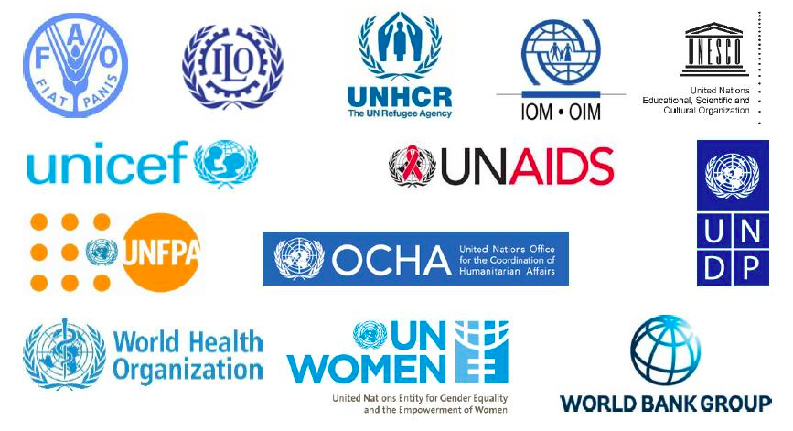 | Students’ oral prediction about the topic  Suggested answer:  Organisations |  | Elicit  Show the picture to elicit the topic
 | 3.Vocabulary:  Name the organisations that you see in the picture (3’) | Organisations listed  Expected answers:  UNICEF,FAO,WHO, UNFPA |  | List  Work in groups of two to name the organisations
ACTIVITY 2: STUDY/ PRESENTATION (15’)
- Understand the related words in the conversation  - Introduce the grammar points to be learnt in the unit. | 1. Vocabulary: (10’)  Look at the photos to guess the meaning of new words  1. peacekeeping (adj): gìn giữ hòa bình  2. harm (n): tổn hại  3. expert (adj): tinh thông  4. investor (n): nhà đầu tư | A list of words in Ss’ notebook |  | Elicit  Give synonym/ Vietnamese equivalent/ example to elicit vocabulary from Ss
 | * Check vocabulary: | The missing words on the board |  | Rub out and remember
- To introduce the unit topic (Viet Nam and international organisations);  - To introduce some vocabulary and the grammar points to be learnt in the unit. | 2. Listen and read(5)  * T plays the recording twice for Ss to listen and read along.  **** T checks comprehension as a class and calls on some Ss to read the paragraphs aloud. | Underlined information related to international organisations |  | Set the context for listening and reading the conversation  *** Ss work in pairs and compare the words and phrases they have underlined and discuss their meanings.
ACTIVITY 3: ACTIVATE/ PRACTICE (15’)
Practise reading for specific information | Task 2: Read the text again and choose the correct answers.  1. Which organisation was formed in 1945?  A. The UN  B. UNICEF  C. The WTO  2. Which organisation aims to help improve children’s health and education?  A. UNDP  B. UNICEF  C. The WTO  3. Which of the following is the largest international economic organisation?  A. The UN  B. UNDP  C. The WTO |  | Correct answers  Key:  - A  - B  - C | * T asks Ss to work in pairs.  *** T asks Ss share their answers with the class.  *** T confirms the correct answers.
To introduce or revise words related to activities of international organisations | Words Meanings  helping people stop fighting (A)  damage or injury (B)  having great knowledge (C)  people or organisations  that invest money (D)  Task 3: Find words in the texts (A, B, C, or D) that mean the following. |  | Completed chart  Key:  1. peacekeeping (adj) /ˈpiːskiːpɪŋ/: gìn giữ hòa bình  2. harm (n/v) /hɑː(r)m/: tổn hại  3. expert (adj/n) /ˈekspɜːrt/: tinh thông  4. investor (n) /ɪnˈvestə(r)/: nhà đầu tư | * T asks Ss to scan the four texts (A, B, C and D) to find the words matching the meanings given.  ** If necessary, T goes through the definitions and elicit the parts of speech Ss need to look for in the texts.
-To help Ss recognise comparative and superlative adjectives | Task 4: Complete the sentences with the words and phrases from Task 1.  1. Since joining the UN, Viet Nam has become __________ and has participated in many UN activities including peacekeeping.  2. UNICEF particularly aims to support ___________ children all over the world.  3. UNDP helps people in developing countries have a __________ life.  4. The WTO is the world's __________ international economic organisation.  5. Viet Nam has also become _________ to foreign investors. |  | Completed sentences  Key:  1. more active  2. the most disadvantaged  3. better  4. largest  5. more attractive | * T has Ss read each sentence and try to recall the comparative or superlative adjective used in the texts.  *** T asks the class to call out the comparative or superlative adjectives only, then call on individual Ss to read the complete sentences.
ACTIVITY 4: CONSOLIDATION/ PRODUCTION (5’)
- To help Ss memorise the target language and skills that they have learned  - To inform Ss of the details for the Project and how Ss can prepare for it | WRAP-UP  - Some lexical items about International organisations  - Reading for specific information  - Comparative and superlative adjectives  HOMEWORK  - Exercises in the workbook  PROJECT PREPARATION  - T tells Ss about the Project requirements: Ss will have to find information about an international organisation. Their presentation should include information as specified by the guiding questions. Ss can choose 136 different ways to present their findings (e.g. PPT presentation, Poster presentation, record a video about the project). | Ss’ answers |  | * T asks Ss to open their books at the last page of Unit 7, the project section, and read the task given.

WEEK 25/ Period 64
UNIT 7: VIET NAM AND INTERNATIONAL ORGANISATIONS
Lesson 2: Language
I/ Learning outcomes:
By the end of this lesson, Ss will be able to:
- Knowledge:
- Pronounce words with more than three syllables with correct stress;
- Understand and use words and phrases related to international organisations;
- Use comparative and superlative adjectives.
- Competences:
- Access and consolidate information from a variety of sources;
- Be collaborative and supportive in pair work and teamwork;
- Actively join in class activities.
- Attributes:
- Develop an awareness of international organisations;
- Be respectful towards all nations.
II/ Teaching and learning resources:
Tivi, speakers, textbook, teacher's book, handouts, laptop, sachmem.vn

III/ PROCEDURE:
Aims |  | Content |  |  |  | Outcomes |  | Implementation
ACTIVITY 1: WARM UP (5’)
- To arouse the classroom atmosphere  - To lead in the lesson |  | 1. GAME: I DARE YOU! (5’)  - T asks Ss to split into two teams.  - Each round a representative from one team (e.g. Team 1) rolls a dice and gets a number (1-6). The opposing team (e.g. Team 2) will find a word with that number of syllables (in the dictionary, on the Internet…) and “dare” Team 1 to guess the correct stress position. Each correct answer equals 1 point. |  |  |  | Ss’ oral answers about more than three syllables words related to the lesson. |  | Lead-in
ACTIVITY 2: STUDY/ PRESENTATION (20’)
To give Ss practice in identifying the stressed syllables in words with more than three syllables. and pronouncing these words.  To help Ss recognise stress in words with more than three syllables and practise saying sentences containing such words.  To revise new vocabulary items related to international organisation  To give Ss practice in using the words in meaningful contexts.  -To give Ss an opportunity to revise comparative and superlative adjectives. | I. PRONUNCIATION  1. LISTEN AND REPEAT. PAY ATTENTION TO THE SYLLABLE WITH THE PRIMARY STRESS. (Ex.1, p.77)  Stress in words with more than three syllables.  2. LISTEN AND MARK THE PRIMARY STRESS IN THE WORDS IN BOLD. THEN PRACTISE SAYING THE SENTENCES. (p.77)  1. Viet Nam is a member of different inter’national organi’sations.  2. Our responsi’bility is to help the most disad’vantaged children.  3. This organi’sation aims to promote environ’mental protection.  4. UNICEF aims to create edu’cational oppor’tunities for all children.  II. VOCABULARY:  1/ TASK 1: MATCH THE WORDS IN BOLD WITH THEIR MEANINGS IN THE BOX. (Ex1, p.78).  TASK 2: COMPLETE THE FOLLOWING SENTENCES WITH THE CORRECT FORM OF THE WORDS IN TASK 1. (Ex2, p.78)  III. GRAMMAR  Comparative and superlative adjectives  - Use comparative adjectives to:  + Compare a person or thing with another person or thing.  Ex: The European markets are usually more competitive than the Asian markets.  The Asian markets are less competitive than the European markets.  + Show changes.  Ex: Since then our country has become more active.  - Use superlative adjectives to compare a person or thing with the whole group of which that person or thing is a member.  Ex1: This trade organisation includes two of the largest economies in the world: The United States and China.  Ex2: UNICEF supports the most disadvantaged children all over the world. |  |  |  | Ss’ pronumciation of the words.  Rules:  ** Ss watch a tutorial video and repeat after the speaker.  Link: https://www.youtube.com/watch?v=65wx9_zmuqQ  + Marked stressed syllables in Ss’ book.  + Ss’ pronunciation of the sentences.  + Matched items in Ss’ books.  Key:  1. C, 2 D, 3. A, 4. E, 5. B  A list of the missing words in the exercise 2 in Ss’ notebook.  Key: 1. Promote, 2. Welcomes, 3. commit  4. aims, 5. enter  Takenotes in Ss’ books. |  | Elicit  Elicit the rule of more than three syllables words.  - Pairwork  - Peer correction  - Teacher’s feedback  Elicit  - Pairwork  - Peer correction  - Teacher’s feedback  - Work in pairs  - Peer correction  - Teacher’s feedback  - T’s elicitation & explanation.  - Answer teacher’s questions  - Teacher’s feedback as a class.
ACTIVITY 3: PRACTICE (10’)
To give Ss an opportunity to revise comparative and superlative adjectives.  To give Ss more practice in using comparative and superlative adjectives. | I. TASK 1: CHOOSE THE BEST ANSWERS. (Ex1, p.78)  II. TASK 2: WRITE ANOTHER SENTENCE USING THE WORD(S) IN BRACKETS. MAKE SURE IT HAS THE SAME MEANING AS THE PREVIOUS ONE. (Ex2, p.78) |  | - Completed sentences.  Key:  1. easier  2. more attractive  3. less competitive  4. the most popular  - write the sentences..  Key:  1. This city is the most popular place for foreign visitors.  2. In many supermarkets, imported goods are cheaper than locally produced goods.  3. The United Nations is the largest international organisation.  4. Our country is more active on the international stage today than it was in the past. |  |  |  |  |  | - T’s instruction  - Work in pairs or individually  - Peer correction  - Teacher’s feedback  - Pairwork  - Peer correction  - Teacher’s feedback
ACTIVITY 4: PRODUCTION (5’)
To give Ss opportunities to produce learned language by themselves. | GAME: 20 QUESTIONS  * T gives each S a piece of paper with the name of a country/international organisation on it. Ss form pairs and stick their piece of paper on their partner’s head.  ** Ss with the sticker on the head ask their partner 20 questions (maximum) as clues to find out which country/international organisation name is written on the paper.  - Ss must use comparative/superlative adjectives, and are encouraged to use learned vocabulary about international organisations. |  |  |  |  | Students’ sentences on the b/b |  | - Groupwork  - Teacher’s feedback.
ACTIVITY 5: CONSOLIDATION (5’)
To help Ss memorise the target language that they have learned. | 1.WRAP-UP  What have you leant today? |  |  | Ss’ oral answers.  Suggested answers:  - stress in in words with more than three syllables.;  - words and phrases related to joining international organisations;  - Use comparative adjectives to compare or show changes. |  |  |  | - Elicit the answers from students  - Teacher’s feedback
Inform students what they have to do at home. | 2. HOMEWORK  - Exercises in the workbook  - Prepare for lesson 4 Unit 7.

WEEK 25/ Period 65
UNIT 7 : VIET NAM AND INTERNATIONAL ORGANISATIONS
Lesson 3: Reading
I/ Learning outcomes: By the end of this lesson, Ss will be able to:
- Knowledge:
- Have an overview about the topic UNICEF’s support for Viet Nam’s education;
- Gain vocabulary to talk about UNICEF’s support for Viet Nam’s education.
- Competences:
- Develop communication skills;
- Be collaborative and supportive in pair work and teamwork;
- Develop presentation skills.
- Attributes:
- Be aware of more about the UNICEF programmes and UNICEF’s support for Viet Nam’s education;
- Develop a respectful and appreciative attitude.
II/ Teaching and learning resources:
Tape (CD), Tivi, speakers, textbook, teacher's book, copies of pictures, handouts, laptop, posters . ..
III/ PROCEDURE:
Aims | Contents | Outcomes | Steps
ACTIVITY 1: IN ENGAGE/ WARM UP (7’)
- Introduce the unit topic (UNICEF’s support for Viet Nam’s education);  - Introduce some vocabulary to be learnt in the unit. | 1. Matching (5’)  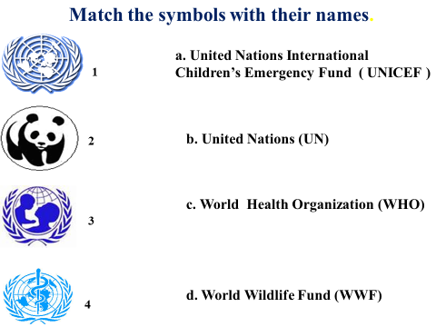 | Matched symbols with their names  Suggested answer:  1-b, 2-d, 3-a, 4- c | Group work  Elicit  - Show the answer to elicit the topic of the unit.
 | 2. Question &Answer (2’)  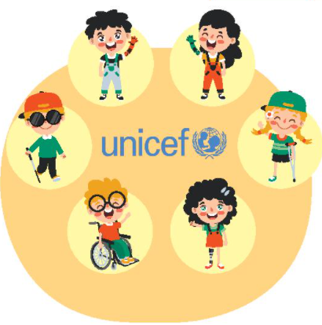  Which of the following do you think unicef does to support Viet nam’s education? (Task 1/ p 79) | Ss’ answers  Expected answers:  a, c, d | WORK IN PAIRS  Q&A  - Show some pictures of UNICEF’s activities, ask questions and choose the ones that UNICEF does to support Viet Nam’s education.  - Check answers.
ACTIVITY 2: STUDY/ PRESENTATION (12’)
- Understand the related words in the conversation  - Introduce the grammar points to be learnt in the unit. | 1. Vocabulary: (7’)  Look at the screen to guess the meaning of new words  1. create (v) /kriˈeɪt/: tạo ra  2. essential (adj) /ɪˈsenʃl/: cần thiết  3. respect (v/n) /rɪˈspekt/: tôn trọng  4. practical (adj) /ˈpræktɪkl/: thực tiễn | A list of words in Ss’ notebook | Elicit  - Give synonym/ Vietnamese equivalent/ example to elicit vocabulary from Ss.
- Help Ss practise guessing the meanings of word in context. | 2. Check vocabulary: 5’  Multiple choice  1. create  a. make something happen  b. increase something  c. refuse something  2. essential  a. usual b. necessary c. successful  3. respect  a. have a good opinion of somebody  b. look down on somebody  c. get on well with somebody  4. practical  a. connected with organisations  b. connected with ideas  c. connected with real situations | Vocabulary chosen  Suggested answer:  1.a, 2.b, 3.a, 4c | -work individually  Multiple choice
ACTIVITY 3: ACTIVATE/ PRACTICE (15’)
- Practise reading for specific information. | 3. Read the text again and answer the following questions.  1. What does UNICEF particularly aim to do for children in Viet Nam?  2. Which programme helps disadvantaged teenagers continue their education?  3. Which programme supports disable teenagers?  4. What is the aim of the Improving Achievements programme? | Answered questions  Key:  1. It particularly aims to create opportunities for all children in Viet Nam to attend school, learn and succeed.  2. It is Education for Disadvantaged Young People programme.  3. It is Providing Education Opportunities for Children with Disabilities programme.  4. Its aims is to better prepare children for the challenges in the future. | - Work in groups  - Peer correction  - Teacher’s feedback
ACTIVITY 4: CONSOLIDATION/ PRODUCTION (11’)
- Help students memorise the target language and skills that they have learned. | 1. Wrap up (8’)  + Fill in the missing information into the diagram.  + talk about the summary of the text according to the diagram | Completed diagram  - Suggested answers:  - 1975  - attend school  - learn  - succeed  - disadvantaged young people  - children with disabilities  - learning achievements | - Remember and fill in  - Work in 4 groups  - Peer correction  - Teacher’s feedback  -choose one representative to talk about it.
- Improve speaking skill by talking about UNICEF ‘s programes for communities. | 2. Homework (3’)  a/ Exercises in the workbook  b/ Speaking preparation |  | Practise speaking  Do at home

APPENDIX: DIAGRAM
UNICEF OFFICE IN VIETNAM
SET UP IN………(1)……….
WITH THE AIMS OF CREATING OPPORTUNITIES FOR VIETNAMESE CHILDREN TO: VIETNAM TO:
…………(2)…….
………(3)……….
………(4)……….
PROVIDING EDUCATION OPPORTUNITIES FOR ………(6)………
PROGRAMMES FOR EDUCATION AIMS FOR VIETNAM
EDUCATION FOR………(5)……
IMPROVING ………(7)………

WEEK 25/ Period 66
UNIT 7
Lesson 4: SPEAKING – Programmes for communities
I/ Learning outcomes:
By the end of this lesson, Ss will be able to:
- Knowledge:
- Discuss and express opinions
- Talk about a project or a programme.
- Competences:
- Develop communication skills;
- Be collaborative and supportive in pair work and teamwork;
- Actively join in class activities.
- Attributes:
- Be aware of a project or a programme that can benefit their local area.
II/ Teaching and learning resources:
Tape (CD), Tivi, speakers, textbook, teacher's book, copies of pictures, handouts, laptop, posters
III/ PROCEDURE:
Aims | Contents | Outcomes | Steps
WARM UP (5’)
- To introduce the topic of programmes for communities | 1. Guess: Pictures and programmes (3 pictures)  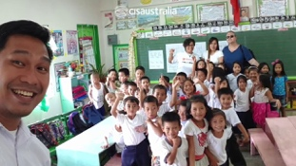  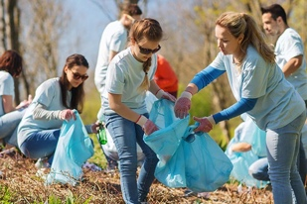 | Ss’ guessed programmes for communities  -suggested answers:  1. planting trees  2. teaching for poor children  3. collecting the garbage | - Work in groups of 4
ACTIVITY 1: PRESENTATION (10’)
- To help Ss recall information from the reading text.  - To introduce to Ss some expressions for the Speaking tasks | Complete the conversation about a UNICEF programme with the sentences in the box. Then practice it in pairs.  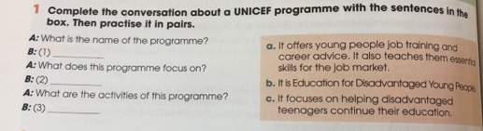 | Ss’ completing the conversation  - Suggested answers:  1.b  2.c  3.a | -Work in pairs, discuss  -Teacher’s feedback
ACTIVITY 2: CONTROLLED PRACTICE (10’)
- To introduce more ideas for the main task  - To help Ss to express their opinion & develop their speaking skills | Work in pairs. Ss A looks at the table below. Ss B looks at the table on page 85. Ask each other the questions in 1 to complete your table:  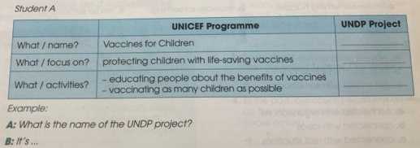  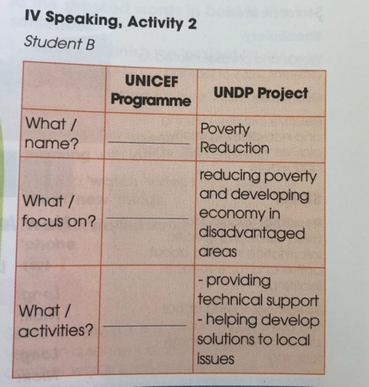 | Completed table  Suggested answer:  Conversation:  Ss A: What is the name of the UNDP Project?  Ss B: It’s called Poverty Reduction  Ss A: What does it focus on?  Ss B: It focus on reducing poverty and developing economy in disadvantaged areas.  Ss A: What are the activities of this project?  Ss B: It provides technical support and helps develop solutions to local issues. | - Elicit the suggested ideas  - Work in pairs  -Present  - Teacher’s feedback
ACTIVITY 3: PRODUCTION(18’)
-To give Ss an opportunity to personalize the topic  - To help Ss express their own opinions about the benefits of a programme or project  - To develop Ss’ speaking skill | 1. Work in groups. Discuss and decide which programme or project in Activity 1 and 2 will bring more benefits to people in your local area. Then share your ideals with whole class:  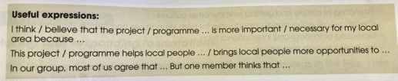  2. Wrap up  What have you learnt in the lesson? | - Ss’ discussion and decision about the benefits of programme or project.  Suggested answers:  A: Now, let’s decide which programme or project will bring more benefits to people in our village. B, what do you think?  B: Well, I think poverty reduction will be a very useful programme for our village. You see, the poor will be provided technical support.  A: You are right, B.  - Expressions to talk about programmes for communities | - Elicit useful expressions  -Work in groups of 4  - Teacher’s feedback  Ask & answer  Feedback
HOMEWORK 2’
To review the lesson they have learnt and prepare for the next lesson. | - Exercises in the workbook  - Practice speaking about programmes for communities.  - Prepare the next lesson: Listening | - Exercise completion | - Individually

WEEK 26/ Period 67
UNIT 7: VIET NAM AND INTERNATIONAL ORGANISATIONS
Lesson 5: LISTENING
I/ Learning outcomes:
By the end of this lesson, Ss will be able to:
- Knowledge:
- listen for specific information in a conversation about Vietnam’s participation in international organisations;
- gain vocabulary related to the international organisations.
- Competences:
- develop communication skills;
- be collaborative and supportive in pair work and teamwork;
- actively join in class activities.
- Attitudes:
- be aware of the importances of international organisations
II/ Teaching and learning resources:
Tape (CD), Tivi, speakers, textbook, teacher's book, posters, laptop.
III/ PROCEDURE:
Aims | Contents | Outcomes | Steps
ACTIVITY 1: WARM UP (7’)
- Create a friendly and lively atmosphere in the classroom | 1. Introduction: (2’) | Ss’ chance to get to know each other | Introduce
- Introduce the topic of the listening and get Ss involved in the lesson | 2. Brainstorming (5’)  Name the international organisations that you know.  International organisations | Students’ oral presentation about the topic  Suggested answer:  The United Nations (UN), the World Health Organisation (WHO), World Trade Organisation (WTO), Asia-Pacific Economic Cooperation (APEC), Association of South East Asian Nations (ASEAN), … | Elicit  Show a network of international organisations
ACTIVITY 2: STUDY/ PRESENTATION (10’)
- Understand the related words in the conversation | 1. Vocabulary: (5’)  - reliable (adj) /rɪˈlaɪəbl/  - non-governmental organisation (N.p)  /ˌnɒn ˌɡʌvnˈmentlˌɔːɡənaɪˈzeɪʃn/  - economic (adj) /ˌiːkəˈnɒmɪk/ | A list of words in Ss’ notebook | Elicit  Give synonym/ Vietnamese equivalent/ example to elicit vocabulary from Ss
 | * Check vocabulary: | The missing words on the board | Rub out and remember
 | 2. Discussion (5’)  Discuss and decide which of these statements are true about Vietnam’s foreign relations. | Ss’ discussion about the statements  Suggested answers: 1,2,4 | Set the context for listening and reading the conversation
ACTIVITY 3: ACTIVATE/ PRACTICE (15’)
Practise listening for specific information | 1. Task 2: Listen to a conversation about Viet Nam’s foreign relations. Decide whether the following statements are true (T) or false (F). (p.81) | - Ss’ oral prediction  - Statements identified as true or false  Key:  1. T  2. F (more than 650)  3. F (more active in international and regional events as well)  4. T | Predict then listen to the conversation  - Work in pairs  - Peer correction  - Teacher’s feedback
- Practise scanning  - Develop students' knowledge of vocabulary for international organisations | 2. Task 3: Listen to the conversation again and complete each sentence with no more than two words from the recording. (p.81) | Completed sentences  Key:  1. international  2. reliable partner  3. participate  4. economic | Fill in the blanks  - Work in pairs  - Peer correction  - T’s feedback
ACTIVITY 4: CONSOLIDATION/ PRODUCTION (13’)
Help Ss apply the language they have learnt in the listening in a speaking task. | 1. Task 4: Work in groups. Discuss the following questions. (p.82)  Which of the following are the benefits for Viet Nam as a member of international organizations? Can you add more? (10’) | Some benefits listed  Suggested answers:  - increase trade with other countries and attract more foreign investors.  - improve Vietnam's position in the world.  - improve the relationships between Vietnam and other countries  - reduce prices or remove taxes on several products between countries  - ensure Vietnam’s peace and tranquility  … | Discuss  -Work in 4 groups  - Present on posters  -Peer correction  - Teacher’s feedback
Inform students what the final product of the project should be and how students can prepare for it. | 2. Homework (3’)  a/ Exercises in the workbook  b/ Project preparation  - do research on an international organisation (name, foundation, aims, activities, …)  - Ask Ss to present their plans in the last lesson of the unit. | Ss’ oral presentation of the research results | Groupwork

WEEK 26/ Period 68
UNIT 7: VIETNAM AND INTERNATIONAL ORGANIZATIONS
Lesson 6: Writing
Writing about Viet Nam's participation in international organizations
I/ Learning outcomes:
By the end of this lesson, Ss will be able to:
1. Knowledge:
- Use lexical items related to the topic International organizations
- Write a paragraph about the benefits for Viet Nam as a member of international organisations
2. Competences:
- Access and consolidate information from a variety of sources
- Be collaborative and supportive in pair work and teamwork
- Actively join in class activities
3. Personal qualities
- Develop an awareness of Viet Nam's participation in international organizations
- Be respectful towards all international organizations
II/ Teaching and learning resources:
Tape (CD), Tivi, speakers, textbook, teacher's book, copies of pictures, handouts, laptop, posters, sachmem.vn
III/ PROCEDURE:
Aims | Contents | Outcomes | Steps
ACTIVITY 1: WARM UP (5’)
- Create a lively atmosphere in the classroom  - Lead into the new lesson. | 1.Warm-up (5’)  Matching logos with their names.  1.    2.    3.    4.    NAMES:  A. World Wildlife Fund  B. World Health Organization  C. The Food and Agriculture Organisation  D. Association of Southeast Asia Nations.  - Is Viet Nam a member of them? | Matched logos with their names.  1B  2D  3A  4C  -Yes,it is. | Elicit  - Show the logo to elicit the topic.  - Introduce the lesson.  - Whole class
ACTIVITY 2: PRE-WRITING (7’)
- Develop ideas for their writing and provide more useful words and phrases. | Task 1: Complete the following sentences. Use the words in the box.(P 82) | Completed sentences  Key:  1. popular  2. cultural  3. open to  4. easier  5. international  6. experiencing | -Read the words in the word box and the sentences  -Elicit the meanings of any words Ss don’t know.  - Work individually.  - Peer correction  - Teacher’s feedback
ACTIVITY 3: PRACTICE (15)
Develop more ideas for their writing and organize them in a diagram. | Task 2: Complete the following diagram. Use the ideas in 1 and your own ideas.  ( P 82) | Completed diagram.  Key:  Key: a/b: 2/6 c/d: 3/5  C: Students’ answers  (Note: The order for each pair may be flexible). | Complete the diagram  - Work in pairs  - Peer correction  - Show the diagram ,invites Ss to complete it.  - Teacher’s feedback
- Know the basic essay structure | Giving the basic essay structure  Part Content  Introduction - Present your topic - Provide background - Gives your thesis statement  Body - Core arguments and analysis - Present evidence - One mailn point per paragraph - Each paragraph starts with a topic sentence - All paragraphs relate to your thesis  Conclusion - Ties together your main points - Shows why your argument matters | the basic essay structure | Introduce the basic essay structure
ACTIVITY 4: PRODUCTION (13’)
Practise writing a paragraph about benefits for Viet Nam as a member of  international organisations. | Task 3: Write a paragraph (120 - 150 words) about the benefits for VietNam as a member of international organizations. Use the information in the diagram in 2.(Page 82) | Sts’ paragraph about the benefits for VN as a member of international organization  Sample answer:  Viet Nam has gained three main benefits since it joined different international organizations. Firstly, it is easier and more convenient for Viet Nam to promote its culture and learn about other cultures. For example, various cultural exchanges help foreigners know more about our country. In addition, Vietnamese people have a better chance of experiencing different cultures. Secondly, this has created greater education opportunities for both Vietnamese and  foreign students. More education opportunities abroad are now open to Vietnamese students. Vietnam's colleges and universities can also accept international students. Finally, joining these organizations has also helped Viet Nam increase both local and international tourism. In fact, VietNam has become one of the most popular destinations for many foreign tourists in the region. It is also easier for Vietnamese people to travel abroad. In short, Viet Nam has benefited greatly from becoming a member of different international organizations. | Write a paragraph  -Write a paragraph (120 - 150 words), based on the information in the completed diagram from the previous activity. (13’)  -Work in 4 groups  -Ss’correction  - Teacher’s feedback
WRAP-UP AND HOMEWORK (5’)
help students memorise the content they have learnt | 1. Wrap up (3’) | - Sts’ list of what they have learnt  Suggested answers:  - the benefits for Viet Nam as a member of international organisations  - the way to write a paragraph about the benefits for VN as a member of international organization | List what they have learnt
Help Sts prepare for the next lesson. | 2. Homework: (2’)  - Workbook exercises  - Prepare for the new lesson | Completed exercises and prepared lesson | - do exercise  - prepare for the new lesson.

WEEK 26/ Period 69
UNIT 7: VIET NAM AND INTERNATIONAL ORGANISATIONS
Lesson 7: COMMUNICATION AND CULTURE/CLIL
I/ Learning outcomes:
By the end of this lesson, Ss will be able to:
- Knowledge:
- Make and respond to invitations
- Learn about FAO and its activities to support Viet Nam
- Competences:
- Develop communication skills and creativity
- Be collaborative and supportive in pair work and team work
- Develop presentation skills
- Attributes:
- Be aware of the relationship between Viet Nam and FAO
- Be respectful towards all international organizations.
II/ Teaching and learning resources:
- Tape (CD), Grade 10 textbook, TV, Laptop
III/ PROCEDURE:
Aims | Contents | Outcomes | Steps
ACTIVITY 1: WARM UP (3’)
- To activate Ss’ knowledge of the topic | MATCHING  INVITATION CARDS EVENTS  1. A. Birthday  2. B. Wedding  3. C. Fashion show  4. D. New year’s Eve  5. E. Housewarming | Matched invitation cards with events  Suggested answer:  1-D  2-E  3-A  4-B  5-C | - Show the picture  - Work in pairs  - Introduce the topic
EVERYDAY ENGLISH - ACTIVITY 2: PRACTICE (12’)
- To help Ss review some expressions for making and responding to invitations. | 1. Task 1: Listen and complete the conversations with the expressions in the box. Then practice them in pairs. (5’) | Ss’ completed conversations with the expression in the box  Suggested answers:  1. C  2. A  3. D  4. B | - Set the context for listening  - Work in pairs  - Practice the conversations  - Peer correction  -Teacher’s feedback
 | 2. Useful expression: (7’)  Useful expressions  Making invitations Responding to invitations  Accepting an invitation Declining an invitation  Informal • • • Formal • • Informal • • Formal • • Informal • • Formal • • | Some expressions to make and respond to invitations  Suggested answers:  Making invitations  Informal  • Do you want to ...?  • Do you feel like ...?  • Let’s go to …  Formal  • Would you like to...?  • Would you care to ...?  Accepting an invitation  Informal  • Sure. I'll be there.  • Yes, I’d love to.  Formal  • I would be delighted.  • Thank you very much for  inviting me.  Declining an invitation  Informal  • I'm sorry, but I can't.  • Sorry, maybe next tim.  Formal  • Oh, I'd love to, but ...  • That's very kind of you, but ... | - Work in groups of 4  - Give some useful expressions to make and respond to invitations  - Teacher’s feedback
EVERYDAY ENGLISH - ACTIVITY 3: PRODUCTION (8’)
- To help Ss practice making and responding to invitations. | Task 2: You want to invite a friend to join you in an activity. Work in pairs. Make similar conversations like the ones in 1.  Model:  T: We’re going to the Italian restaurant to celebrate our victory in the final football match. Do you want to join us?  St: I’d love to, but I’m afraid I have another commitment this evening.  T: Never mind. Maybe another time. | - Students’ conversations  Suggested answers:  Conversation 2:  St A: I’m having a barbecue to celebrate moving in to my new place and I’d love it if you could come.  St B: Sounds great, when is it?  St A: Sunday the 3rd at 1pm.  St B: Awesome, I’ll look forward to it. | - Model  - Work in pairs  - Practice the conversations  - Peer correction  - Teacher’s feedback
CULTURE - ACTIVITY 4: VOCABULARY PRE – TEACHING (5’)
- To help Ss learn more words related to the topic | VOCABULARY  1. form (v) = set up  2. aim (n)  3. poverty (n): the state of being poor  4. technical (adj)  5. nutrition (n)  Eg: A balanced diet provides _______ for your body. | A list of words in Ss’ notebook | - Elicit  - Give synonym/ Vietnamese equivalent/ definition/ example to elicit vocabulary from Ss
CULTURE -ACTIVITY 5: PRACTICE ( 5’)
To help Ss learn about FAO and what it has contributed to the development of VietNam.  FAO and its activities in Viet Nam  participation  anstarted in (3) ______  d its FAO  FAO in  Viet Nam  Viet Nam’s  participation  FAO  FAO in  Viet Nam  Viet Nam’s  participation  formed in (1) ______  started in (3) ______  formed in (1) ______  main aim is to (2) ____  started in (3) ______  has provided (4) ______ and advice to the government  has participated in (5) _____ and nutrition activities | Task 1: Read the text below and complete the diagram. (7’) | Sts’ completed diagram  Key:  1. 1945  2. end hunger and poverty  3. 1978  4. technical support  5. food security | - Do the task individually  - share the answers with a peer.  - Teacher’s feedback
CULTURE – ACTIVITY 6 : PRODUCTION (7’)
To help Ss practice talking about FAO and its activities in Vietnam using the completed diagram | Task 2: Work in pairs. Use the diagram in task 1 to talk about FAO and its activities in Viet Nam | Sts’ oral performance  Suggested answer:  Hello, everybody. Today, I’m glad to be here to talk about FAO and its activities in Vietnam. As far as I know, FAO was formed in 1945 with its main aim of ending hunger and poverty. In Viet Nam, it started working in 1978. Since then, it has provided technical support and advice to Vietnamese government in the field of agriculture. In return for FAO’s support, Vietnam has actively participated in food security and nutrition activities. | - Work in pairs  Some Sts share their talk with the whole class  - Peer correction  - Teacher’s feedback
CONSOLIDATION AND HOMEWORK (5’)
To help students memorise the content they have learnt | 1. Wrap up (3’) | - Sts’ list of what they have learnt  Suggested answers:  - Making and responding to invitations  - FAO and its activities in Vietnam | List what they have learnt
To help sts prepare for the next lesson – Looking back and project | 2. Homework (2’)  a/ Design an invitation card in English.  b/ Preparation for the next lesson: Looking back and project | Sts’ invitation cards in English | - Assign homework  - Do homework

