WEEK 27/ Period 70
UNIT 7: VIET NAM AND INTRERNATIONAL ORGANISATIONS
Lesson 8: Looking back and Project

I/ Learning outcomes:
By the end of this lesson, Ss will be able to:
- Knowledge:
- revise stress in words with more than three syllables ;
- revise words and phrases related to Vietnam and international organisations learnt in the unit;
- revise how to complete comparative and superlative adjectives;
- do research on an international organisation.
2. Competences:
- develop communication skills and creativity;
- develop presentation skills;
- develop critical thinking skills;
- be collaborative and supportive in pair work and team work;
- actively join in class activities.
3. Attributes:
- be more creative when doing the project;
- develop self-study skills.
II/ Teaching and learning resources:
Tape (CD), Tivi, speakers, textbook, teacher's book, copies of pictures, handouts, laptop, posters

III/ PROCEDURE

Aims | Content | Outcomes | Steps
ACTIVITY 1: WARM-UP (5’)
- To arouse the classroom atmosphere.  - To help students revise words/ phrases related to the topic, especially about the names and the functions of the international organisations learnt | WARM-UP  GAME: OUTLAST | Ss’ involvement in the class’s activities. | -T explains the game rules to Ss.  - Ss do as instructed.
ACTIVITY 2: LOOKING BACK (20’)
-To help students revise stress in words with more than three syllables | 1. PRONUNCIATION  Listen and mark the primary stress in the words in bold. Then practise saying the sentences. (p.84) | Some stressed words  Suggested answer:  1. WWF is the world’s largest non-profit en,viron'mental ,organi'sation.  2. Viet Nam has become a more active par'ticipant in the ,inter'national com'munity.  3. Japan is the biggest financial provider to this ,eco'nomic ,organi'sation.  4. UNICEF helps ,disad'vantaged teenagers continue their ,edu'cation.  5. There are more ,edu'cational ,oppor'tunities for Vietnamese students now. | *T asks Ss to read the sentences and check understanding.  - T asks Ss to work in groups of 4 and mark the primary stress of the words in bold. Ss with advanced English level may try marking the secondary stress as well.  - T asks ss to listen to the recording and  checks answers as a class by inviting a representatives of each group to say and write the words, then mark the stress on the board.
- To help Ss revise topic-related words. | 2. VOCABULARY  Complete the text with the correct forms of the verbs in the box. (p.84) | Completed text  Suggested answer:  1. enter  2. commits  3. aims  4. welcomes  5. promote | * Teacher asks Ss to read the words in the box and complete the text with correct forms of the verbs in the box individually .  - T has ss compare their answers in pairs.
To help Ss revise comparative and superlative adjectives. | 3. GRAMMAR  Write another sentence using the word(s) in brackets. Make sure it has the same meaning as the previous one. (p.85) | Rewritten sentences using comparative and superlative adjectives.  Suggested answer:  1. Viet Nam is more attractive to foreign tourists nowadays than it was in the past.  2. No international organization is larger than the United Nations.  3. The international market now is more competitive than it was in the past.  4. Japan is the biggest financial provider to this organization. | *Teacher asks Ss to rewrite the sentence using the word(s) in brackets individually.  - T asks ss to compare their answers in groups of 4 and checks their answers by inviting individual ss to write the correct ones on the board.  *Ss do as instructed.
ACTIVITY 3: PROJECT (15’)
- To provide an opportunity for Ss to develop their communication and collaboration skills, and to practice reporting survey results in an oral presentation. | An International Organizations  Do research on an international organization (p.85) | * Ss’ oral presentation | * T gives Ss a checklist for peer and self-assessment.  - T goes through the criteria for assessing their talk.  - T invites two or three groups to give their presentations and encourages the rest of the class to ask questions at the end.
ACTIVITY 4: CONSOLIDATION/ PRODUCTION (5’)
- To consolidate what students have learnt in the lesson. | 1.WRAP-UP (3’)  List of what Ss have learnt | - Ss’ list of what they have learnt today | *Teacher asks: What have you learnt today?  *Sts answer
-To prepare for the next lesson | 2. HOMEWORK (2’)  - Exercises in the workbook  - Preparation for Unit 8- lesson 1 |  | *T instructs  *Ss take notes

WEEK 27/ Period 71
UNIT 8: NEW WAYS TO LEARN
Lesson 1: Getting started – New learning activities
I/ Learning outcomes:
By the end of this lesson, Ss will be able to:
1. Knowledge
- Be aware of the new learning activities and their importance
- Expand vocabulary of the topic 'New learning activities' and practice them
- Get to know the language aspect: relative pronouns
- Read and listen for specific information in the task 'True or False'
2. Skills
- Develop listening and reading skills
- Be collaborative and supportive in pair work and teamwork
3. Attitude
- Familiarize with new learning activities
- Develop self-study skills
II/ Teaching and learning resources:
Tape (CD), Tivi, speakers, textbook, teacher's book, copies of pictures, handouts, laptop, posters
III/ PROCEDURE:
Aims | Contents | Outcomes | Steps
ACTIVITY 1: IN TRODUCTION & ENGAGE/ WARM UP (5’)
To stir up the atmosphere and activate students’ knowledge on the topic new learning activities | GAME (5’)  Describe the pictures on a piece of paper they receive.       | Described words  Answers:  1. Group work  2. Pairwork  3. Presentation  4. Debate  5. Projects  6. Experiment | Play game  Groupwork
ACTIVITY 2: STUDY/ PRESENTATION (20’)
- To get students revise collocations related to the topic  - To introduce some vocabulary to be learnt in the unit. | Vocabulary game: WHO IS FASTER? (10’)  - Team A & B: 6 verbs  - 6 phrases on the board  - Each team: go to the board, stick your cards to form a correct phrase.  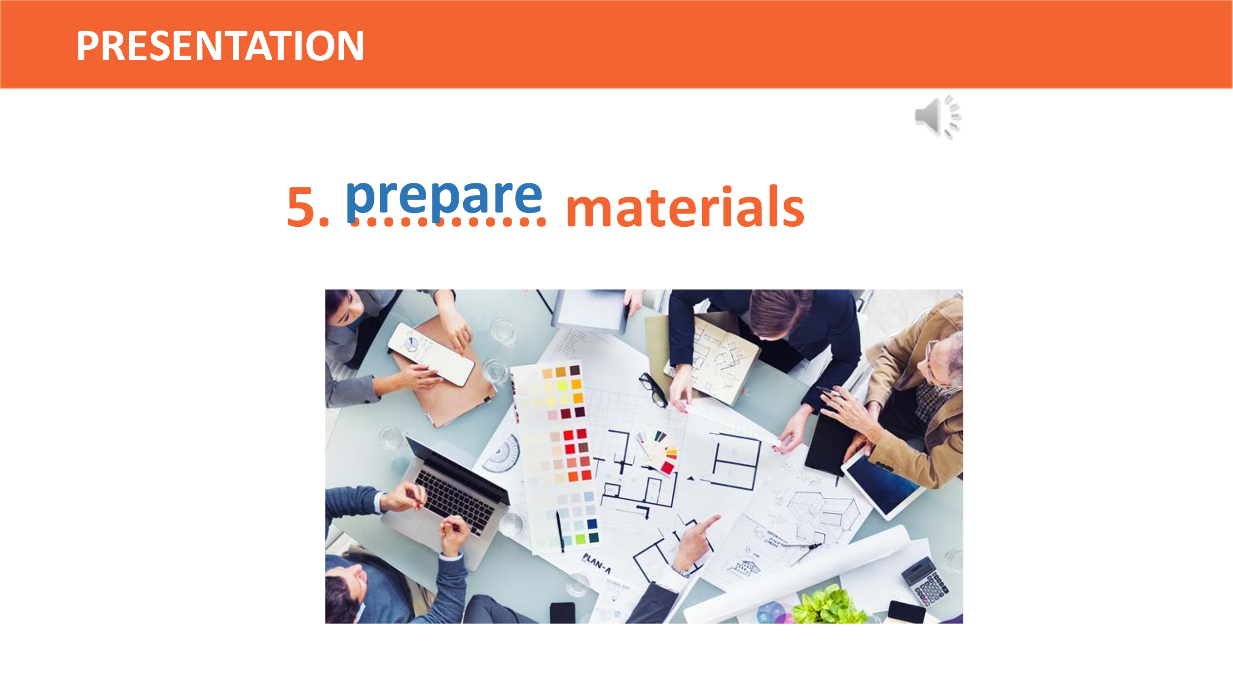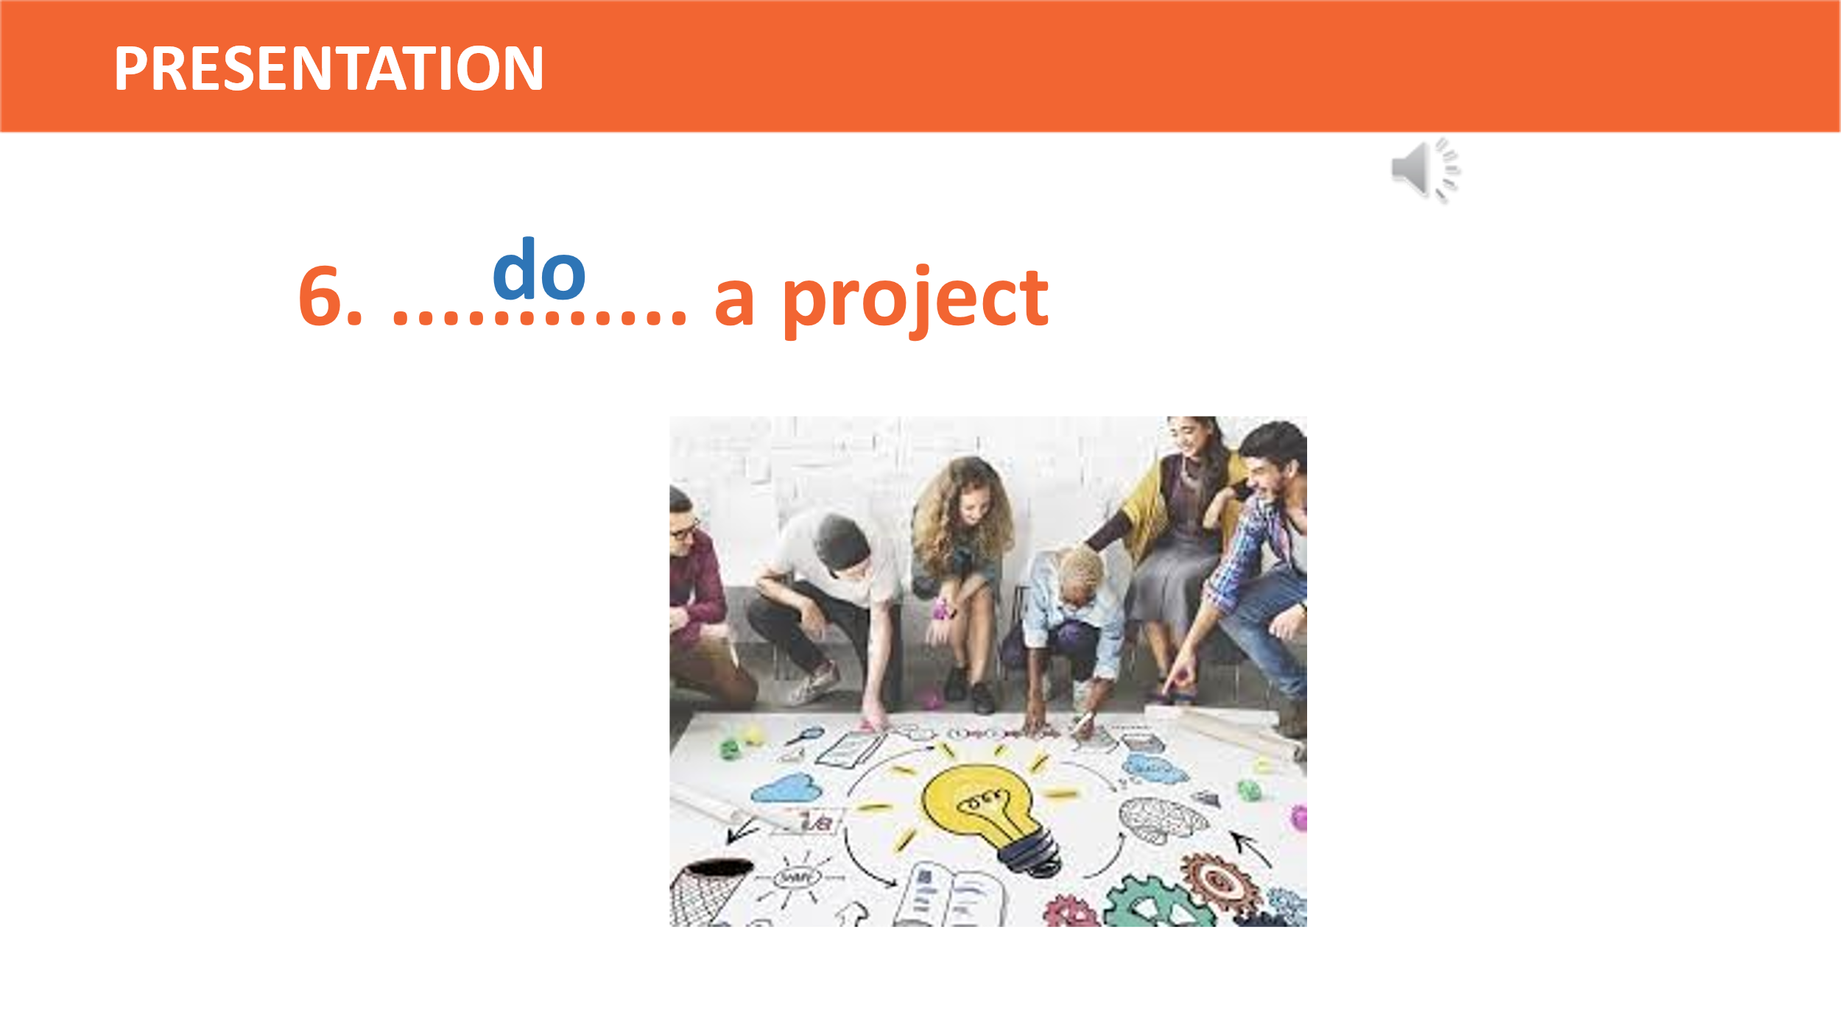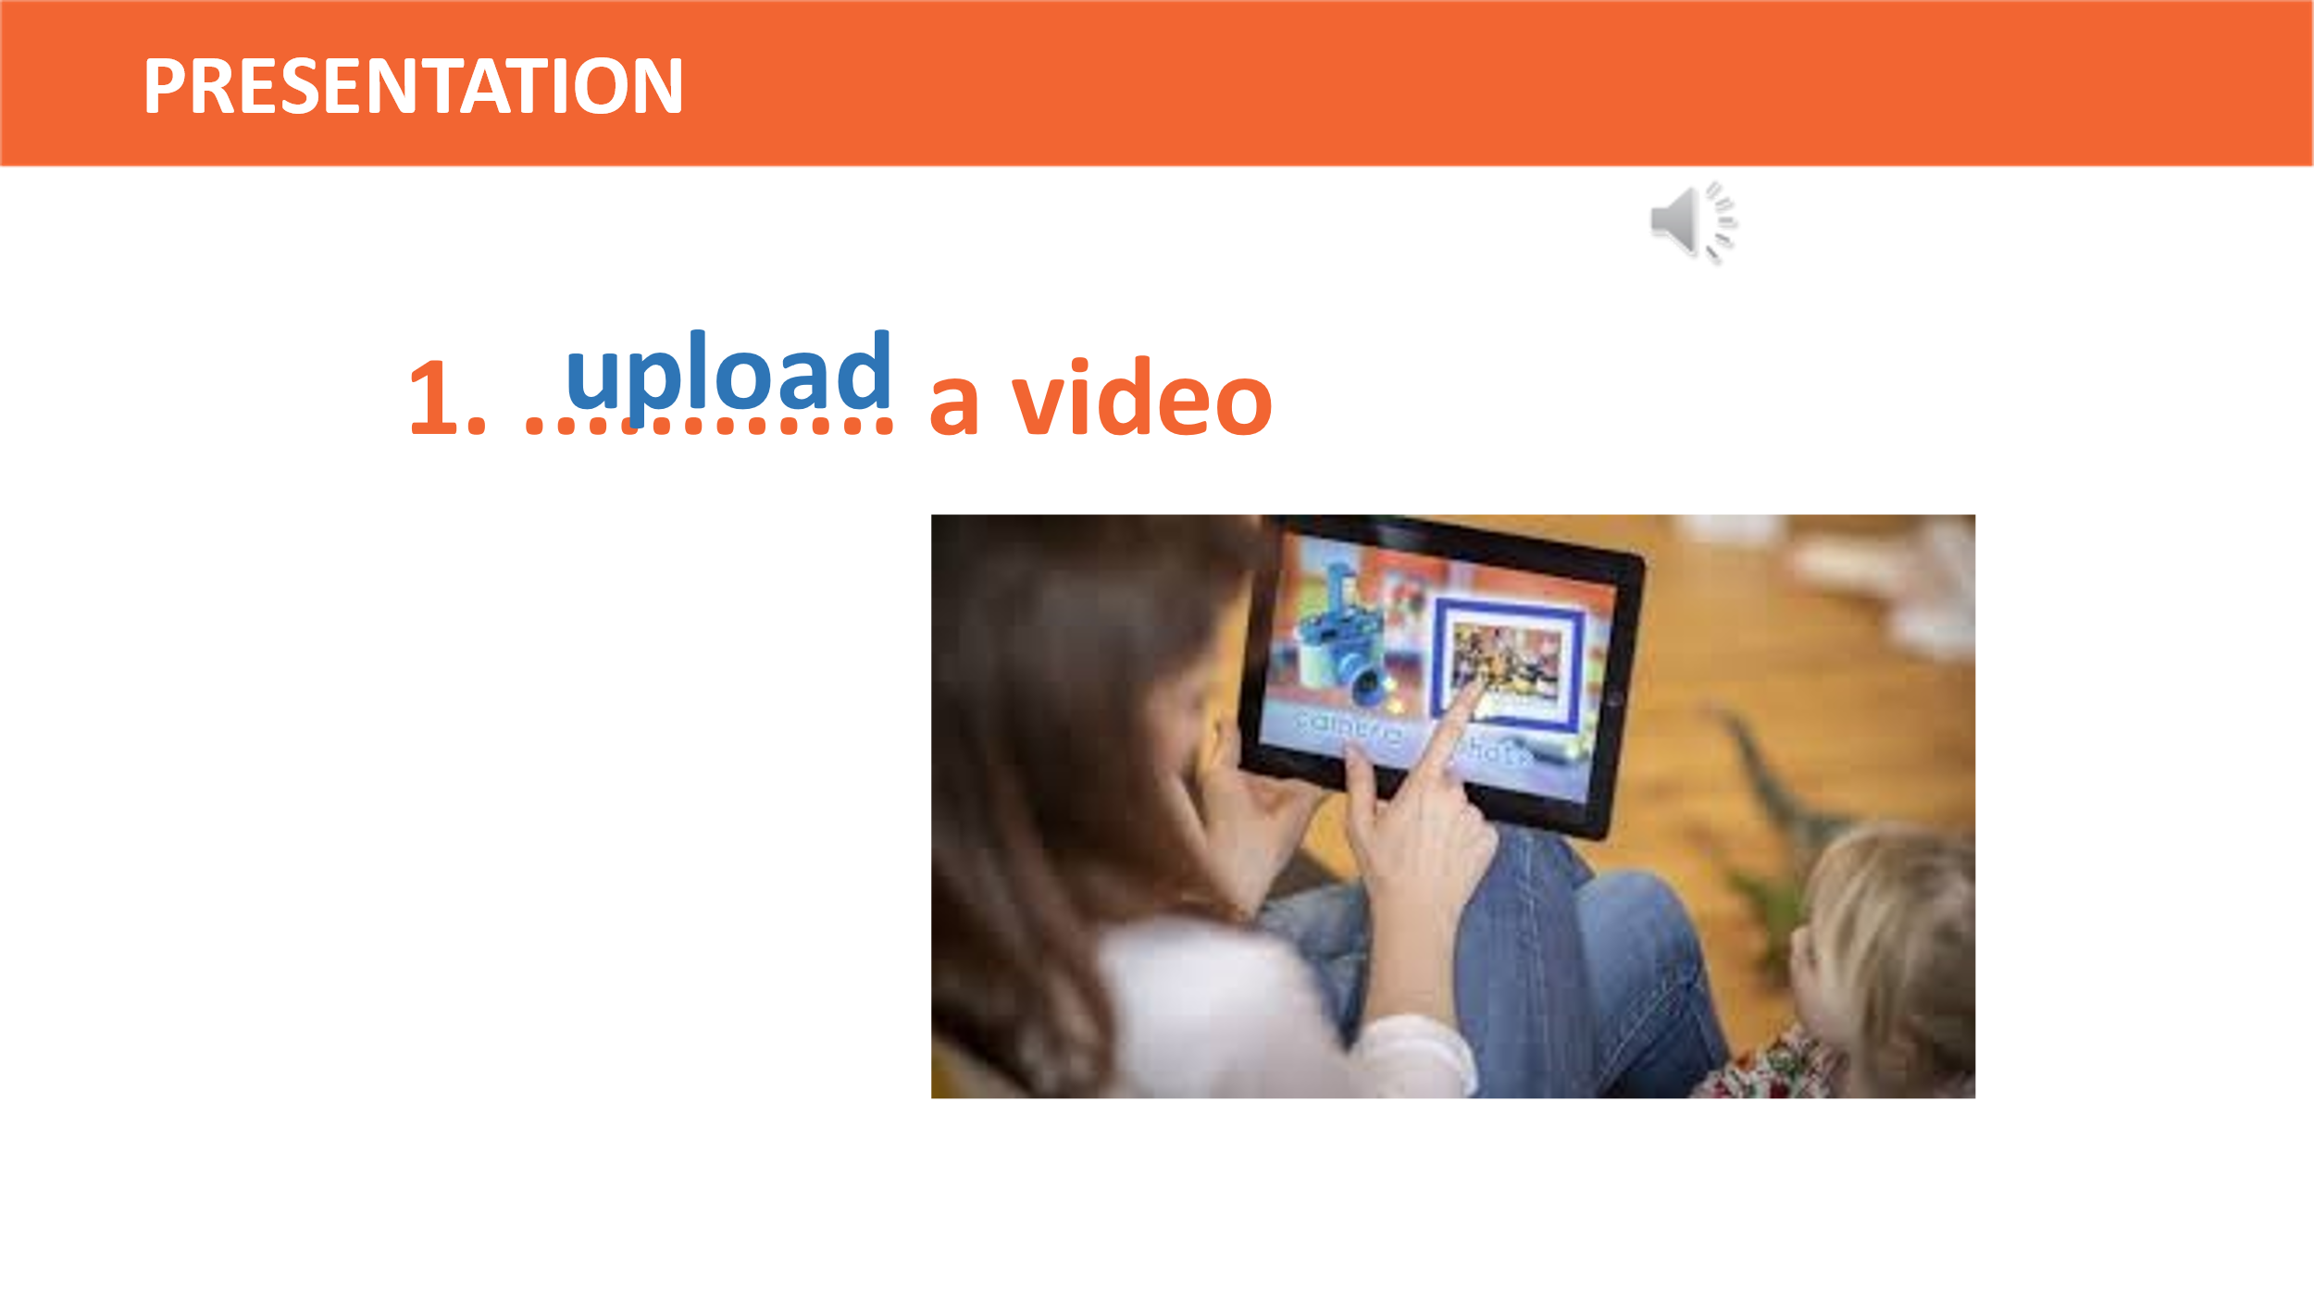  WORD(S) ON THE BOARD  a video ; information; a topic; notes;  materials; a project  VERBS ON CARDS  Watch; prepare; do; take; discuss; search | A list of words in Ss’ notebook  1. upload a video:  2. find/search for information  3. discuss a topic  4. take notes:  5. prepare materials:  6. do a project | Groupwork  Playing with cards  Making correct phrases  Teacher’s feedback  Giving synonym/ Vietnamese equivalent/ example to elicit vocabulary from Ss.
 | * Check vocabulary: (5’) | The missing words on the board | Rub out and remember
To help students practice some skills (reading and listening) for specific information | 2. Listen & read (5’)  Look at the picture (p.8 - 9) and answer the questions:  What are Long and Nick talking about?   | Ss’prediction about the picture  Suggested answers: - They are talking about their learning activities.  - They are talking about their homework. | - Setting the context  - Predicting  - Peer correction  - Teacher’s feedback
ACTIVITY 3: ACTIVATE/ PRACTICE (13’)
To have students get specific information of the text. | TASK 2: TRUE OR FALSE (p.87) (7’)  *T asks Ss to read the conversation again and decide if the statement is T (True) or F (False).  *T shows 3 statements on the slide and introduces the task. | Ss’oral prediction  Statements identified as True or False.  Answers:  1. T; 2. F; 3. T | - Predicting  - Listening and reading  - Pairwork  - Peer correction  - Teacher’s feedback
To identify the types of relative clauses and how they are used in sentences | TASK 3: COMPLETE THE SENTENCES WITH WHO, WHICH, THAT OR WHOSE. (p.94) (8’) | - Completed sentences with relative pronuns  Answers:  1. that  2. who  3. that  4. which | - Doing the task individually  - sharing the answers with a peer.  - Teacher’s feedback
ACTIVITY 4: CONSOLIDATION/ PRODUCTION (7’)
To consolidate what students have learnt in the lesson | 1. Wrap up (5’)  - Learn language items:  + Words/phrases related to topic 'New learning activities'  + Grammar: relative pronouns  - Get to know different learning activities and how they are done in and out of class. | - Ss’ list of new learning activities on the poster and collocation  - Ss’ ability to use relative pronouns | Watching and listening  - Groupwork  - Peer correction  - Teacher’s feedback
To review the lesson and prepare for the next lesson | 2. Homework (2’)  a/ Exercises in the workbook  b/ Project preparation  - Write a short paragraph about your favorite learning activity and give explanations in your notebook.  - Present their plans in the last lesson of the unit. | Ss’ oral presentation of the research results | Groupwork

WEEK 27/ Period 72
UNIT 8: NEW WAYS TO LEARN
Lesson 2: Language
I/ Learning outcomes:
By the end of this lesson, Ss will be able to:
- Knowledge:
- put the stress in the correct words in the sentence.
- use the lexical items related to the topic New ways to learn.
- review the use of relative pronouns and relative clauses
- distinguish and know how to use defining and non-defining relative clauses
- Competences:
- be collaborative and supportive in pair work and teamwork
- access and consolidate information from a variety of sources
- actively join in class activities
- Attributes:
- be willing to learn new language points
- be aware of the importance of electronic devices in learning.
II/ Teaching and learning resources:
Tivi, speakers, textbook, teacher's book, handouts, laptop, sachmem.vn

III/ PROCEDURE:
Aims | Content |  |  |  | Outcomes |  | Steps
ACTIVITY 1: WARM UP (5’)
-To arouse the classroom atmosphere  -To lead to the new lesson | 1. Game: Name ten items related to online learning. (5’) |  |  |  | -Ten items related to online learning.  Suggested answers: laptop, smartphone, tablet, headphones, touch pen, earphones, microphone, webcam, internet, wifi. |  | Work in groups  List ten items.
ACTIVITY 2: STUDY/ PRESENTATION (15’)
-To help students identify and practice the stressed words in the sentences  To help students practise identifying the stressed words in the sentences |  | I. Pronunciation  1. Listen and repeat. Pay attention to the stress words in bold in the sentences.  (page 87)  -Elicit the rule: Stressed words in the sentence are content words such as main verbs, nouns, adjectives and adverbs.  2. Read and underline the stressed words in the sentences.  (page 87) |  |  |  | Stressed words in the sentences.  Stressed words in the sentences.  Suggested answer:  1. Our teacher often gives us videos to watch at home.  2. I never read books on my tablet at night.  3. It is a new way of learning and students really like it.  4. You can find a lot of useful tips on this website.  5. They should make an outline for their presentation | - Pair work  - Peer correction  - Teacher’s feedback  - Work in pairs.  - Peer correction  - Teacher’s feedback  - Work in pairs  - Peer correction  - Teacher’s feedback
To enrich students’ vocabulary  To help students to use the words in context |  | II. Vocabulary  1/ Match the words with their meanings. (Ex.1, p.88).  2. Complete the sentences using the words in 1. (Ex.2, p.88) |  |  |  | Matched words with their meaning  Answers:  1. c 4.e  2.d 5.b  3.a  Completed sentences with words provided  Answers:  - face-to-face  - online learning  - prepare for  - strategy  blended learning | Work in pairs.  Match the words and phrases with their meanings.  Teacher gives feedback  Fill in the blanks with the above words.  Teacher gives feedback
To help students review the use of relative pronouns and relative clauses  To help students distinguish and know how to use defining and non-defining relative clauses |  | III/ Grammar  1.Relative pronouns  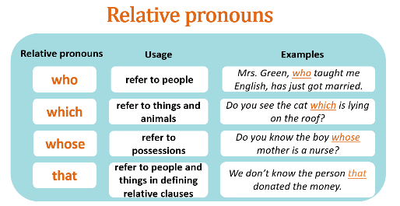  2. Defining and non-defining relative clauses.  Ex: The man who visited us yesterday is a famous doctor.  Ex: My uncle, who visited us yesterday, is a famous doctor.  + Defining relative clause is used to give essential information about someone or something – information that we need in order to understand what or who is being referred to.  + Non-defining relative clause is used to give extra information about the person or thing. It is not necessary information. We don’t need it to understand who or what is being referred to. |  |  |  | Relative pronouns.  Defining and non-defining relative clauses. | Show the poster containing usage and examples of relative pronouns.  Elicit from students defining and non-defining relative clauses
ACTIVITY 3: PRACTICE (12’)
To help Ss practice using relative clauses. |  | - Make the two parts to make complete sentences.  - Join the following sentences. Use “who”, “that”, “which” or “whose”. Add commas where necessary | Complete sentences  Answers:  1. d 2. e 3. b 4. c 5. a  Answers:  1.My brother, who is good at computers, teaches me how to use a laptop.  2.Peter, whose sister is taking an online Maths course, is a friend of mine.  3.Lan has read the book which/that I lent her.  4.The boy who had designed this invention is only 10 years old.  5.That app, which can help improve your pronunciation, is easy to use. |  |  |  |  | Students work in pairs to make complete sentences.
ACTIVITY 4: PRODUCTION (8’)
To give Ss chances to use relative clauses. |  | - Complete the following sentences beginning with the given words. Use relative clauses.  a/ I have just received the letter………………..  b/ Tom is the person……  c/ Yesterday. I bought the dress…………………  d/ I don’t like the stories……………….. |  |  | Completed sentences |  | -Students work in groups.  -Teacher gives feedback.
ACTIVITY 5: CONSOLIDATION (5’)
To help Ss memorise the target language that they have learned |  | 1.WRAP-UP  What have you leant today? |  | Suggested answers:  - Stressed words in sentences.  - Words and phrases related to the topic New ways to learn.  - Relative pronouns  - Defining and non-defining relative clauses. |  |  | - Elicit the answers from students  - Teacher gives feedback.
Inform students what they have to do at home. |  | 2. HOMEWORK  - Exercises in the workbook  - Prepare for lesson 3 Unit 8.

WEEK 28/ Period 73
UNIT 8: NEW WAYS TO LEARN
Lesson 3: Reading
I/ Learning outcomes:
By the end of this lesson, Ss will be able to:
- Knowledge:
- gain vocabulary to talk about online and face-to-face learning
- understand 2 texts about advantages and disadvantages of online and face-to-face learning
- Competences:
- develop communication skills
- be collaborative and supportive in pair work and teamwork
- develop presentation skills
- actively join in class activities
- Attributes:
- be aware of choosing suitable ways of learning and make use of their strong points
II/ Teaching and learning resources:
TV, laptop, textbook, teacher's book, copies of pictures
III/ Procedure:
Aims | Contents | Outcomes | Steps
ACTIVITY 1: WARM -UP (3’)
Introduce the topic of reading texts (Ways of learning). | * Guessing game: Look at 2 sets of pictures and guess what each set is about.  Set 1:    Set 2:    Lead-in: We can see that there are many different ways to learn such as online learning or face-to-face learning and it’s also what we are going to learn in the Reading lesson today. | Ss’s chance to get to know the topic of the reading texts.  Key:  -Set 1: Online learning  -Set 2: Face-to-face learning | Elicit  -Show the sets of pictures to elicit the topic  - Work individually.
ACTIVITY 2: PRE- READING (12’)
Get Ss get involved in the lesson. | 1. Brainstorming: (5’)  List some advantages & disadvantages of online learning and face -to-face learning. | Some advantages & disadvantages of online learning and face -to-face learning that Ss have known. | Brainstorm  -Work in groups of four.
Understand some words and phrases related to the topic of the texts. | 2. Vocabulary: (7’)  - online learning (n) (picture)  - face-to-face learning (n) (picture)  - blended learning (n) (translation)  - distraction (n) (situation)  Ex: I find it hard to work at home because there are too many distractions.  -> distract (v)  * distract sb/ sth (from sth)  - immediately (adv): without delay  (explanation)  - exchange (v): (explanation)  to give sth to sb and receive sth from that person  - focus (v) : (situation)  Ex: She was distracted and finding it hard to focus.  * focus on/ upon sb/ sth  Check vocabulary: | A list of words in Ss’ notebook  The missing words on the board | Elicit  - Show pictures, give Vietnamese equivalents/ examples to elicit vocabulary from Ss  Rub out and remember
ACTIVITY 3: WHILE-READING (18’)
Practise reading for the main idea | 1/ Choose the correct answer. (5’)  Read the texts. What are the students talking about? (p.89) | Main idea  Key: B | Read the texts and then choose the correct answer.  - Work in pairs  - Peer correction  - Teacher’s feedback
Practise reading for specific information | 2/ Tick in the correct box. (5’)  Read the texts again and decide who mentions the following.(p.90) | Ss’ comprehension of the reading texts.  Key:  Kim: 1,3,5  Laura: 2,4,6 | Read the texts and tick in the correct box.  - Work in pairs  - Peer correction  - Teacher’s feedback
Summarize the reading texts | 3/ Complete the diagram. (8’)  Read the texts again and complete the diagram below. | A completed diagram  Key:  1. face-to-face learning  2. not have to go to school but not miss any lessons  3. need to have a fast internet connection  4. can communicate with teachers and classmates immediately and directly when having questions  5. have fewer distractions than learning online | Read the texts and complete the diagram.  - Work in pairs.  - Peer correction  - Teacher’s feedback
ACTIVITY 4: POST-READING (10’)
- Enhance presentation skills  - Practise team working  - Give Ss authentic practice in using target language | Discussion:  Discuss the following questions:  - Which way of learning do you think is better? Why? | Ss’ oral presentations of better way of learning | Discuss and then present.  -Work in groups of four, discussing the questions.  - Present.  - Give feedback
HOMEWORK (2’)
- Help Ss know what to do at home after the lesson. | - Review the vocabulary items provided  - Do exercises in the workbook (p.60-61)  - Prepare for the next lesson: U8-Speaking | -Vocabulary related to the topic of the reading texts  - Answers to the questions in exercises 1, 2 (p.60-61) | Listen & note down.
* Diagram: (While-reading)
Ways of learning

(1) …………
online learning

advantages
advantages
disadvantages

can work in groups and discuss with friends
(4) …...
(3) ……..
can’t talk to teachers and classmates (face to face)
(2) ……
can email teachers and classmates at any time
can exchange comments and ideas about projects with classmates by using an online discussion board

can ask for answers or help immediately when having a problem
(5) ………..

WEEK 28/ Period 74
UNIT 8: NEW WAYS TO LEARN

Lesson 4: Speaking – Online learning

I/ Learning outcomes:
By the end of this lesson, students will be able to:
1. Knowledge
- Gain an overview about the topic Online learning
- Memorize vocabulary to talk about online learning.
2. Core competence
- Gain some language expressions to talk about advantages and disadvantages
- Talk about the advantages and disadvantages of online learning and give reason for their ideas
3. Attributes
- Familiarize with online learning and ready to adapt this new way of learning.
- Develop self-study skills
II/ Teaching and learning resources:
- Tivi, speakers, textbook, teacher's book, copies of pictures, laptop.

III/ PROCEDURE:
Aims | Contents | Outcomes | Steps
ACTIVITY 1: WARM UP (5’)
-To activate students’ knowledge on the topic of the unit. | Game: Jigsaw puzzle  -Guess the name of each device in each puzzle and guess the key picture behind after each puzzle is opened.  Picture 1: Picture 2:  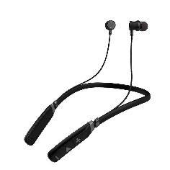  Picture 3: Picture 4:    Picture 5:   | -Names of divices and key picture  Key picture:    Suggested answer:  Picture 1: earphones  Picture 2: headset  Picture 3: laptop  Picture 4: wifi router  Picture 5: Zoom  Key picture: Online learning | Elicit  -Show the picture to elicit the answers  -T leads into the topic of today lesson: Online learning
ACTIVITY 2: BRAINSTORMING (5’)
- -To set the context for the speaking part. | -Think and fill in the table the advantages and disadvantages of online learning when compared to face-to-face learning  - …… - …… | Filled table  Suggested answers.  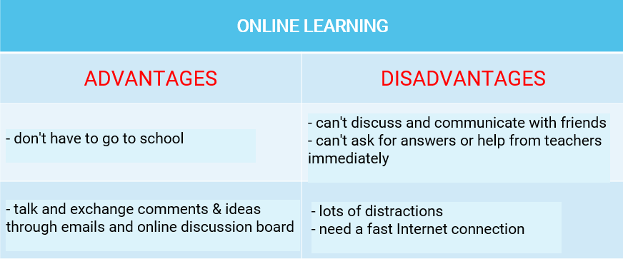 | - Ss work in pairs.  - Ss answer orally.  - T gives feedback
ACTIVITY 3: CONTROLLED PRACTICE (5’)
- To get Ss involved in speaking activities. | TASK 1: FILL IN THE TABLE  -Put the advantages and disadvantages of online learning from the box into suitable categories. You may add more to each categories. | Filled table  Suggested answers:  Advantages: a, d, e  Disadvantages: b, c, f. | -Ss work in pairs  -T gives correction on the slide.  -T explains some new words and phrases.
ACTIVITY 3: LESS CONTROLLED PRACTICE (12’)
-To help Ss brainstorm ideas for the speaking activity | TASK 3: FILL IN THE TABLE (p.90)  Work in groups. Each group chooses to be either For or Against online learning. Discuss and provide explanations to support your side. Use the table below to note your ideas. | Filled table  - Suggested answers:  FOR  +We can learn anytime and anywhere with an Internet connection. (We don’t have to go to  school and we can save a lot of time travelling. We can do assignments when we have free  time as they are uploaded online.)  + We can organise our own study schedule. (We choose to attend the courses that are suitable  for our schedule. The timetable may not be fixed.)  AGAINST  + This can harm our health. (If we sit in front of a computer for a long time, it can cause shortsightedness or backache.)  + We may have technical problems. (We can't follow the teacher's lesson or submit homework.) | -Ss work in groups and fill in the chart.  -T asks one group to give their answers and asks if other groups want to add anything else.  -T gives correction on the slide.
ACTIVITY 4: FREE PRACTICE (15’)
-To provide Ss with useful expressions for the following speaking task.  - to give Ss an opportunity to discuss and express opinions about online learning. | TASK 4: ROLE-PLAY (p.90)  Discuss your opinions about online learning. Use your notes in Task 1,2,3  USEFUL LANGUAGES:  - Advantages:  - A positive aspect of …….  - A benefit of ……. is …..  - A good point about… is …  - An argument in favor of .. is …  - Disadvantages:  - A negative aspect of…. is ……  An argument against …. is …..  A drawback of .… is …. | - Ss’ role-play/ conversation. | - T provides some more expressions and useful structures so that Ss can apply in their speaking task.  -Ss work in groups of three.  - T gives feedback.
ACTIVITY 4: CONSOLIDATION (3’)

-To consolidate what students have learnt in the lesson | WRAP-UP | -List of what they have learnt in the lesson | -T asks students to talk about what they have learnt in the lesson.
-To review the lesson and prepare for the next lesson | HOMEWORK  a/ Exercises in the workbook  b/ prepare the next lesson: Unit 8- Listening

WEEK 28/ Period 75
UNIT 8: NEW WAYS TO LEARN

Lesson 5: Listening
I/ Learning outcomes:
By the end of this lesson, Ss will be able to:
- Knowledge:
- Gain an overview about the topic Blended-learning class
- Memorize vocabulary to talk about blended learning.
- Competences:
- develop communication skills;
- be collaborative and supportive in pair work and teamwork;
- Actively join in class activities.
- Attributes:
- Identify the differences between traditional and blended-learning class.
II/ Teaching and learning resources:
Tape (CD), Tivi, speakers, textbook, teacher's book, copies of pictures, handouts, laptop, posters
III/ PROCEDURE:
Aims | Contents | Outcomes | Steps
ACTIVITY 1: IN TRODUCTION & ENGAGE/ WARM UP (7’)
- To activate students’ knowledge on the topic of the unit  - To set the context for the listening part | 1. Video watching (4’)  Watch the video then name 3 components of blended learning.  Link: https://www.youtube.com/watch?v=-bwhR1ZKGRE | - Ss’ answers  Suggested answer:  3 components are  - face-to face learning activities  - digital learning objects  - independent study time | Watch and listen  -Work in 4 groups  -Peer correction  - Teacher’s feedback  Elicit  Show the video to elicit the topic
- To provide students with vocabulary for the following listening task | 2. GUESS THE WORD(S) (7’)  Guess the word(s) as instructed from the slides  Slide 1: Fill in the blank  You can _____ your own videos on YouTube.  Slide 2: Another word for ‘online class’?  Slide 3: What is it?    Slide 4: What is he doing?    Slide 5: Fill in the blanks  There has been a _____ ____ from 5.3 billion to 11.2 billion.    Slide 6: Fill in the blank  To ____ ____ to your email, you need to type in your account and password. | Lists of words  Expected answers:  1. upload  2. e-class  3. folder  4. take notes/ taking notes  5. population growth  6. log in | List  - Work in pairs to list the new words on the board  - Teacher’s feedback
 | TASK 1: Tick what you often do to prepare for a lesson (2’)  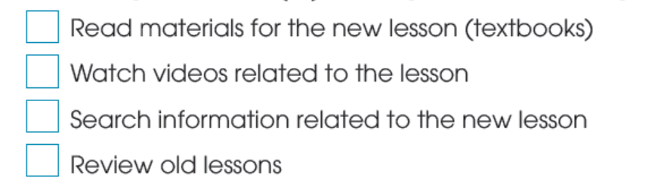 | - Ss’ answers | Tick  - Work individually
ACTIVITY 2: WHILE - LISTENING (18’)
To help Ss practice listening for specific information and key words | TASK 2: ANSWER THE QUESTIONS (p.91)  Listen to the first part of the conversation between a teacher and her students, then answer the following questions.  TASK 3: COMPLETE THE FLOW-CHART (p.91)  Provide kind of information for each gaps in the sentences  Listen to the second part of the conversation and complete the flowchart with no more than TWO words. | Answers:  - She is talking about the homework given to the class.  - She has uploaded videos on the E-Class.  Ss’ oral prediciton  Cue:  - an adj, noun  - a verb (infinitive)  - a noun/noun phrase  - a verb (infinitive)  - a verb (infinitive)  Answers:  - homework  - take notes  - information  - discuss | Listen then answer  - Work in pairs  - Peer correction  - Teacher’s feedback  Predict and work individually  Listen then fill in the gaps  - Work in pairs  - Peer correction  -Teacher’s feedback
ACTIVITY 3: POST LISTENING (13’)
To give Ss an opportunity to use the ideas and language in the listening to talk about their opinions and give reasons | TASK 4: WORK IN GROUPS. DISCUSS THE QUESTIONS (p.91)  Compare ‘Blended Learning’ and ‘Traditional Learning’ based on 4 criteria.  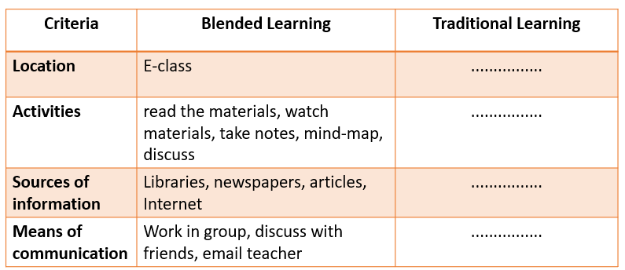 | Answers:  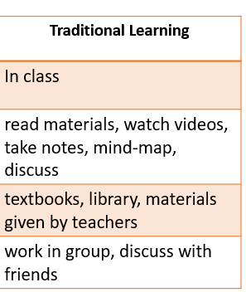 | Discuss  - Work in groups of 4  - Peer correction  -Teacher’s feedback
To review the lesson and prepare for the next lesson | Homework (2’)  Prepare the “Writing” lesson.

WEEK 29/ Period 76
UNIT 1: NEW WAYS TO LEARN
Lesson 6: Writing – Writing a paragraph about the benefits of blended learning.
I/ Learning outcomes:
By the end of this lesson, Ss will be able to:
- Knowledge:
- Know how to use the lexical items and useful expresssions related to the topic New ways to learn.
- write about the benefits of blended learning.
- Competences:
- develop writing skills;
- be collaborative and supportive in pair work and teamwork;
- actively join in class activities.
- Attributes:
- Recognize the benefits of blended learning so that students can make use of their time in class to study better;
- Be more active in blended learning classrooms.
II/ Teaching and learning resources:
Tape (CD), Tivi, speakers, textbook, teacher's book, copies of pictures, handouts, laptop, posters
III/ PROCEDURE:
Aims | Contents | Outcomes | Steps
ACTIVITY 1: WARM UP (4’)
- To introduce the topic of writing  - To set the context for the writing part | GUESSING GAME:  - Can you list two ways of learning in the picture?  - What is the mixture of these two ways of learning ?   | Ways of learning listed  Suggested answer:  - Online learning  - Traditional classroom learning  - Blended learning | Introduce
ACTIVITY 2: PRE-WRITING (15’)
- To provide students with some ideas about the benefits of blended learning.  - To help students get some more ideas to prepare for the writing task | 1/Task 1  Discuss and tick the benefits of blended learning (p.92)  2/ BRAINSTORMING  Find some other benefits of blended learning. | Ideas about benefits of blended learning.  Expected answers:  1. It helps Ss have more control of their own learning.  2. It is easier to get access to lesson materials.  4. Ss can develop better communication and teamwork skills.  More ideas about the benefits of blended learning. | Discuss then tick  - Work in pairs  Elicit  - Work in pairs  - Teacher’s feedback
- To help students get some more ideas to prepare for the writing task | 3/ Task 2: Use the benefits in task 1 and your own ideas to complete the following outline. (p.92)  . | - Completed table  Suggested answers:  - Second, Ss can develop better communication and teamwork skills.  - Explanation 1: We can use different ways to communicate in class.  - Concluding sentence: I think we should have more blended learning classes at school because they keep us engaged and help us learn useful skills. | Use the benefits in 1 then complete the table  - Work in groups  - Teacher’s feedback
- To provide students with some useful expressions | 4/ USEFUL EXPRESSIONS:  Put the following phrases in the appropriate columns:  - First/Second,  - The first/second benefit of … is + N/V-ing  - This enables + us + to-V  - Firstly/Secondly/Finally,  - This allows students to +V  - To conclude,  - In conclusion,  - It helps us + V  - We will be able + to-V  - In brief,  - First and foremost,  - Last but not least,  Linking words/ structures Expressions about the benefits of something | Useful expressions  Key:  Linking words/ structures Expressions about the benefits of something  -Firstly/ Secondly/Finally, -First/ Second, - The first/ second benefit of … is +N/V-ing - To conclude, - In conclusion - In brief, - First and foremost, - Last but not least, - We will be able + to-V - This enables + us + to-V - It helps us + V - This allows students to +V | Discuss  - Work in groups  - Teacher’s feedback
ACTIVITY 3: WHILE-WRITING (15’)
- To practise writing a paragraph about the benefits of blended learning. | Task 3: Use the outline in task 2 and write a paragraph about the benefits of blended learning. (p.92) | A paragraph about the benefits of blended learning. | Write  -Work in groups
ACTIVITY 4: POST- WRITING / WRITING CRITERIA (10’)
- To do a cross-check and final check on students’ writing. | CROSS-CHECKING  * T has the groups swap and give feedback on each other’s writing. T shows a writing rubric to help Ss do the peer review.  - Topic sentence: …/10  - Supporting detail sentences: …/10  - Elaborating detail sentences: …/10  - Legibility: …/10  - Spelling and grammar: …/10  TOTAL: …/50 | A completed paragraph  about the benefits of blended learning. | Check  -Work in groups  - Teacher’s feedback
ACTIVITY 5: HOMEWORK (1’)
- To allow students to finalize their versions after being checked by friends and teacher | Homework:  Do exercises in the workbook  Prepare for the next lesson: Communication and Culture

WEEK 29/ Period 77
UNIT 8: NEW WAYS TO LEARN

Lesson 7: Communication and Culture/ CLIL
I. Objectives:
By the end of this lesson, Ss will be able to:
- Knowledge:
- Expand vocabulary with the topic: modern schools;
- Share opinions about the learning activities at school.
- Competences:
- Give instructions to download a learning app into their smartphones;
- Develop reading skill for specific information;
- Be collaborative and supportive in class discussion;
- Actively join class activities.
- Attributes:
- Be ready to give instructions and share opinions;
- Understand the main features of modern schools.
II/ Teaching and learning resources:
TV, speakers, textbook, pictures, handouts, laptop, posters
III/ Procedure:
Aims | Contents | Outcomes | Steps
ACTIVITY 1: WARM UP (5’)
- To arouse the classroom atmosphere. | GAME:  Guessing the learning apps  T shows some learning apps on the slide, asks students to guess what the pictures refer to and what they are used for    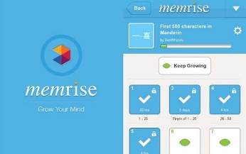  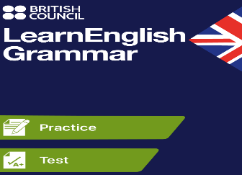 | Ss’ involvement  Named learning apps:  1.duolingo used for learning English at elementary level  2. memrise used for learning English vocabulary  3. LearnEnglish Grammar used for learning English grammar | Teacher’s instructions  Individual work  -Guess the pictures
EVERYDAY ENGLISH -ACTIVITY 2: GIVING INSTRUCTIONS (8’)
To review how to give instructions | 1. Listen and complete the following conversation with the words in the box. Then practise it in pairs.  (p.93) | Completed conversation  Key:  1. A - go  2. D -type  3. C - click  4. B - wait | Individual work  -listen to the conversation and complete it.  Teacher’s feedback  Pairwork  - role-play the conversation
EVERYDAY ENGLISH - ACTIVITY 3: PRODUCTION (10’)
- To help students practise giving instructions | 2. Work in pairs. Make similar conversations about how to install another study app on a smartphone. | The similar conversation  Suggested answers:  A: Can you show me how to install the Zalo app on my smartphone? I want to make video calls with my friends.  B: Of course. First, go to the Apple store or Google play. Second, type “Zalo” in the search box at the top of the screen, then click the “Search” button.  A: Let me try. OK, I can see the app Zalo. What do I do next?  B: Now, click “Get” next to the “Zalo” icon and wait until the download is complete. | Pairwork  - make similar conversations  - role-play their conversation in front of the class.
CULTURE - ACTIVITY 4: READING (10’)
- To pre-teach some new words/phrases of the reading text  - To help Ss get to know main features of modern schools  - To help Ss to practise reading for specific information about modern schools | 1. Vocabulary  - Encourage (v)  Eg. Her parents have always encouraged her in her career.  - Challenge (n)  Eg. He has overcome a lot of challenges in his life to be successful.  - Audio-visual    - Field trip    2. Read a text about modern schools and answer the questions  (p. 93)  1. What is the role of teachers in modern schools?  2. What are two common features of modern schools?  3. How do students use computers in the learning process?  4. How do students learn about the real world? | * A list of words/ phrases  and examples for illustration  * Correct/ Acceptable answers for the questions  Suggested answers:  1. Teachers play the role of a guide for students.  2. Two common features of modern schools are class discussion and group learning.  3. They use them to access digital learning resources.  4. They participate in field trips and school camps. | -Elicit some vocabulary of the reading text from Ss  Individual work  - read the text  - share the answers with their partners  Pairwork  -ask and answer the questions.  Teacher’s feedback
CULTURE - ACTIVITY 5: PRODUCTION (7’)
- To help Ss relate what they have learnt to their own school | Work in groups. Discuss whether your school has similar features and learning activities. Choose the learning activity you like/ dislike best. Explain the reasons.  7 options to choose from:  - Class discussions  - Group learning  - Expressing personal opinions  - Asking questions  - Working in small groups  - Accessing digital learning resources  - Using audio-visual materials | Ss’ discussion  Ss’ oral presentation on learning activity | Group work  Some representatives of some groups to share their ideas with the whole class.
CONSOLIDATION (3’)
-To help Ss memorise the content of the lesson that they have learned | Wrap-up  - Consolidate what Ss have learnt in the lesson. | A list of what students have learnt. | - summarize what they have learnt.
HOMEWORK (2’)
- To practise what they have learnt  - To guide Ss to prepare for the next lesson | Homework  - Do exercises in the workbook.  - Prepare for the new lesson: Looking back and Project lesson. |  | Teacher’s homework

WEEK 29/ Period 78
UNIT 8: NEW WAYS TO LEARN
Lesson 8: Looking Back and Project
I/ Objectives:
By the end of this lesson, Ss will be able to:
- Knowledge:
- identify and mark stressed words in sentences;
- revise vocabulary items in Unit 8;
- revise the relative clauses with who, which, that and whose.
- Competences:
- develop communication skills;
- be collaborative and supportive in pairwork and teamwork;
- actively join class activities;
- report survey results in an oral presentation.
- Attributes:
- be more aware of different effective ways to learn.
II/ Teaching and learning resources:
TV, speakers, textbook, teacher's book, laptop
III/ PROCEDURE:
Aims | Contents | Outcomes | Steps
ACTIVITY 1: WARM-UP (5’)
- To arouse the classroom atmosphere.  - To help Ss revise words/ phrases related to the topic. | WARM-UP  Matching  1. Face to face learning  2. Online learning  3. Blended learning  4. E-learning  a. a way of learning that combines online materials with traditional classroom methods  b. a learning system based on formalized teaching but with the help of electronic resources  c. an instructional method where course content and learning material are taught in person to a group of students.  d. a way of learning that happens on the Internet | Matched words with definitions  Ss’answers:  1- c; 2-d; 3-a; 4-b | Individual work  - Match the words with their definitions  Teacher’s feedback
ACTIVITY 2: LOOKING BACK (20’)
To help Ss revise how to identify and mark stressed words in sentences | 1.PRONUNCIATION  Listen and underline the stressed words in the sentences. Then practise reading them. | Ss’ oral practice in front of the class  Stressed words in the sentences:  Suggested answers:  1.Many students bring smartphones to school nowadays.  2. You can download the app to study English.  3. Thanks to the technology, students can learn anywhere.  4. My sister is looking for information for her presentation tomorrow. | Individual work  - practise reading the sentences with the stressed words  Teacher’s feedback
To help Ss revise words and phrases related to the topic in U.8. | 2. VOCABULARY  Complete the sentences using the words in the box. | The completed sentences using the correct words  Suggested answers:  1. online  2. Traditional  3. connection  4. blended  5. teamwork | Individual work  - do it individually  - share the answers with their partners  - peer correction  Teacher’s feedback
To help Ss revise the use of the relative pronouns who, which, that, whose | 3. GRAMMAR  Complete the sentences with who, which, that, whose. You may use more than one relative pronoun in some sentences. | Completed sentences with relative pronouns provided  Suggested answers:  1. who/ that  2. which/ that  3. which  4. whose  5. which/ that  6. who | Pairwork  - do the exercise in pairs  - share the answers with other pairs  Teacher’s feedback
ACTIVITY 3: PROJECT (15’)
To provide an opportunity for Ss to develop their communication and collaboration skills and to practise reporting survey results in an oral presentation | TECHNOLOGY FOR LEARNING  Work in groups. Do a survey to find out how students in your school use electronic devices to learn. Try to find at least 15 students to interview. | The completed survey including names of students using the electronic devices in learning, the types of electronic devices, how often they use them and the purposes for using them  Ss’ oral presentation in front of the class | Groupwork (groups of 8 or 10)  - have a checklist from the teacher for peer and self-assessment;  - Two or three groups give their presentations on their groups’ findings  Teacher’s feedback  (after each presentation)
ACTIVITY 4: CONSOLIDATION (3’)
To consolidate what Ss have learnt in the lesson. | WRAP-UP (3’)  List what Ss have learnt in the lesson. | A list of what students have learnt | - summarize what they have learnt
HOMEWORK (2’)
- To do the exercises in the workbooks  - To guide Ss to prepare for Review 3. | HOMEWORK  - do exercises in the workbook;  - prepare for Review 3 |  | Teacher’s homework

