Period 7 UNIT 1: FAMILY LIFE
Lesson 6: Writing – Writing about family routines
I/ Learning outcomes:
By the end of this lesson, Ss will be able to:
- Knowledge:
- Use lexical items related to the topic “Family life”;
- Write an email to a friend about family routines.
- Competences:
- Develop communication skills;
- Be collaborative and supportive in pair work and teamwork;
- Actively join in class activities.
- Attributes:
- Be able and willing to share housework in the family.
II/ Teaching and learning resources:
- Grade 10 textbook, Unit 1, writing
- Computer connected to the Internet
- Projector/ TV/ pictures and cards
III/ PROCEDURE:
Aims | Content | Outcomes | Steps
ACTIVITY 1: WARM UP (7’)
- To introduce the concept of family routines and activities that can become part of them. | Which pictures can be family routines? (7’)  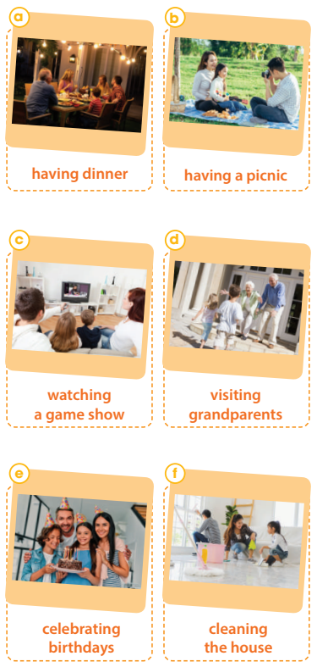 | - Ss’ ideas about family routines. | - To show the pictures and tell them to say what they depict.
ACTIVITY 2: STUDY/ PRESENTATION (15’)
-To provide an example email about family routines, which Ss can use as a model for their writing. | - Read Joey’s email about his family routines and complete the table with the information from it. (10’)  Routines When/ How often Things to do to strengthen family bonds  1. have dinner together  2. every Friday evening  3. - make a list of chores - choose tasks | - Useful expressions of an email.  Suggested answers:  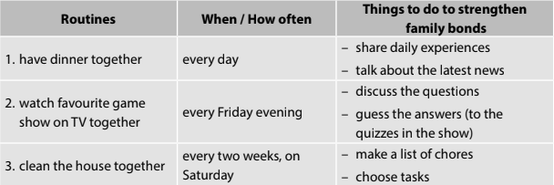 | - To explain the task  - To have Ss read the table headings.  - To read the email and underline the relevant information, then complete the table.
ACTIVITY 3: ACTIVATE/ PRACTICE (17’)
- To help students practise writing part of an email about family routines using given ideas. | 1. Instruct how to write the middle paragraph of the email.  + A paragraph is a group of sentences that develop ONE main idea.  + A paragraph usually consists of three parts: a topic sentence, supporting sentences and a concluding sentence.  + Two important qualities of a good paragraph are unity and coherence | - Some basic information about the structure of a paragraph  . | - To tell Ss that they are going to write a paragraph about family routines. They don’t have to write a whole email, and the opening and ending have been provided.  - To give Ss some basic information about the structure of a paragraph.
- To practise writing part of an email about family routines by using given ideas.  - To help students practise developing ideas and writing a paragraph. | 2. Complete the email about Dong’s family routines using the information in the box.  . | - Completion of the middle of an email.  Sample:  First, my family always have breakfast together. We often eat bread or noodles and share our plan for the day while eating. Second, we watch our favourite film on TV together every Saturday evening. We watch a film and share snacks. Then, we exchange opinions after the film. Third, on the second Sunday of the month, we visit our grandparents. When coming to our grandparents’ house, we usually do some housework for them and have lunch with them. They look really happy when talking and eating with us. | - To explain the task.  - To have Ss read the information in the table and check comprehension.  - To ask Ss to write the middle paragraph of the email.  - To offer support when necessary.
- To give students an opportunity to recognise the common mistakes so that they can avoid in writing | 3. Peer correction | - Ss’ sharing the writing and giving comments. | - To ask two Ss sitting next to each other to exchange their writing, read their partner’s writing and write the symbols next to their partner’s mistakes like the ones in the table above.  - To ask Ss to return their partner’s writing and lets them correct themselves.  - To remind them that they can ask for their partner’s help.
ACTIVITY 4: CONSOLIDATION/ PRODUCTION (6’)
- To help students memorise the target language and skills that they have learned. | 1. WRAP-UP  - We have practised writing a paragraph about family routines. | Ss’ oral presentation of writing an email about daily routines. | pairwork
- To help students memorise the content of the lesson and how students can prepare for new lesson. | 2. HOMEWORK  a/ Exercises in the workbook  b/ Prepare for Communication and Culture lesson |  | Groupwork

Period 8 UNIT 1: FAMILY LIFE
Lesson 7: Communication and culture/ CLIL
I/ Learning outcomes:
By the end of this lesson, Ss will be able to:
- Knowledge:
- express their opinions in a conversation about whether family members should spend time together;
- understand British family values.
- Competences:
- be collaborative and supportive in pair work and team work;
- access and consolidate information from a variety of sources;
- actively join in class activities.
- Attributes:
- be more respectful of Vietnamese and British family values;
- be able and willing to embrace those family values.
II/ Teaching and learning resources:
- Grade 10 textbook, Unit 1, Communication and Culture/ CLIL
- Computer connected to the Internet
- Projector/ TV/ pictures and cards
III/ PROCEDURE:
Aims | Content | Outcomes | Steps
ACTIVITY 1: WARM UP (7’)
- To arouse the classroom atmosphere.  - To help students revise words/ phrases related to the topic. | List the advantages or disadvantages of sharing housework. | List of advantages or disadvantages of sharing housework | List  - Work in groups to list the advantages or disadvantages of sharing housework.
EVERYDAY ENGLISH - ACTIVITY 2: PRESENTATION (12’)
- To provide students with an example conversation in which people exchange opinions about  teenagers doing housework. | 1. Listen and complete the conversation with the expressions in the box. | Completed conversation with the expressions provided  Key:  1.A  2. C  3. B | - Listen to the audio/teacher & complete the conversation.
 | 2. Practise the conversation. | - Sts’ role play | - Work in groups of three to practise the conversation.
EVERYDAY ENGLISH - ACTIVITY 3: PRACTICE (6’)
- To help Ss practise expressing their opinions in a conversation about whether family members should spend time together. | - Have similar conversations exchanging opinions about whether family members should spend time together. | - Ss’ oral presentation of expressing opinions.  (e.g. Advantages: It strengthens family bonds; It makes children happy, develops their self-confidence; Children can learn life skills and how to behave from their parents.  Disadvantages: Children may become too dependent on their parents, do not have enough time for friends or other relationships, etc.) | Making a conversation  - Work in groups  - Peer correction  -Teacher’s feedback
CULTURE - ACTIVITY 4: STUDY/ PRESENTATION (12’)
- To pre-teach the meaning and pronunciation of some words/ phrases, so that students can use them in their presentation later and can understand the reading passage. | 1. Vocabulary  1. pass on sth (phr.v): give something to someone who lives after you die, usually a person in your family    2. truthful (a): honest and not containing or telling any lies    3. respectively (adv): with each relating to something previously mentioned, in the same order as first mentioned  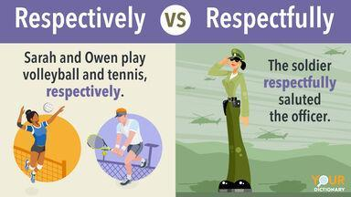 | List of words/ phrases in Ss’ notebook | Elicit  - Give synonym/ Vietnamese equivalent/ example to elicit vocabulary from Ss
- To help students learn about British family values and practise reading for specific information. | 2. Read the text and complete the table.  Read the text and list the five family values of British people in the 21st century in the table below. | - Table completion  Keys:  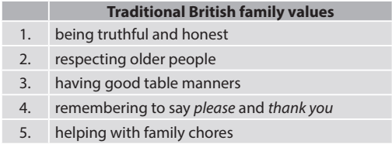 | Filling in the table  - Work in pairs  - Peer correction  -Teacher’s feedback
CULTURE - ACTIVITY 5: PRODUCTION (5’)
- To compare traditional British family values with traditional Vietnamese family values. | Discussion  Work in groups. Discuss whether Vietnamese people have similar family values.  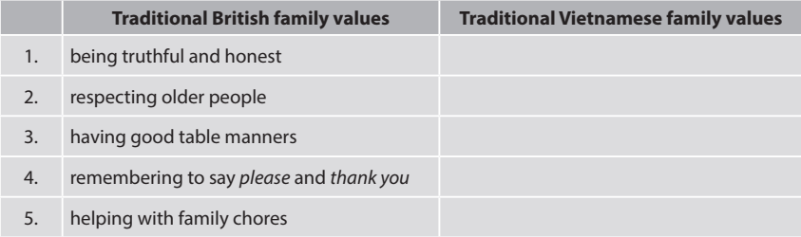 | - Ss’ oral presentation | Making a comparison  - Work in 4 groups  - Peer correction  - Teacher’s feedback
ACTIVITY 6: CONSOLIDATION (3’)
- To help students memorise the target language and skills that they have learned. | 1. WRAP-UP  - The ways to express opinions  - British and Vietnamese family values | - Ss’ oral presentation of expressing their opinions in a conversation about whether family members should spend time together and British and Vietnamese family values
 | 2. HOMEWORK  - Do exercises in the part Looking back  - Exercises in the workbook  - Prepare for Looking back and Project lesson |  | Groupwork

Period 9 UNIT 1: FAMILY LIFE
Lesson 8: Looking back & Project
I. OBJECTIVES
By the end of this lesson, Ss will be able to :
1. Knowledge
- review pronouncing consonant blends /br/, /kr/, /tr/
- review the vocabulary and grammar of Unit 1
- do research on Family Day in Viet Nam or other countries in the world and give a group presentation about it.
2. Core competence
- develop communication skills and creativity;
- develop presentation skills;
- develop critical thinking skills;
- be collaborative and supportive in pair work and team work;
- actively join in class activities.
3. Personal qualities
- be more creative when doing the project;
- develop self-study skills.

II/ TEACHING AND LEARNING RESOURCES:
- Textbook
- Laptop connected to the Internet
- TV/ pictures and cards
- Pictures, A0 paper
III/ PROCEDURE:
Aims | Content | Outcomes | Steps
ACTIVITY 1: WARM-UP (5mins)
- To arouse the classroom atmosphere.  - To help students revise words/ phrases related to the topic |       Brainstorming  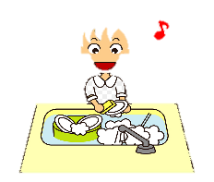  Household chores       | List of words about the topic “Household chores” | List  Write down as many words as they can think of about the topic “Household chores”.
ACTIVITY 2: LOOKING BACK (17 mins)
To help students revise the consonant blends /br/, /kr/, and /tr/.  To help students revise words and phrases related to the topic of household chores, which they have learnt in the unit.  To help students revise the Present simple and Present continuous. | 1. PRONUNCIATION: LISTEN AND WRITE /BR/, /KR/ OR /TR/. (p.16)  6 mins  Listen and write /br/, /kr/, or /tr/ above the word that has the corresponding consonant blends. Then practise reading the sentences.  2. VOCABULARY: COMPLETE THE TEXT. (p.16) 5 mins  Complete the text. Use the correct form of the word and phrases in the box.  3. GRAMMAR: THERE IS A MISTAKE IN EACH SENTENCE BELOW. FIND THE MISTAKE AND CORRECT IT. (p.16) 6 mins | Ss’ practice reading the corresponding consonant blends  /kr/ /br/  1. I like ice cream, but my brother likes bread pudding.  /br/  /tr/ /kr/ /tr/  2. Tracy crashed her car into a tree and broke her leg.  /br/  /kr/ /br/  3. They often have crab soup for breakfast.  Completed text with words and phrases provided  1. does the cooking  2. does the heavy lifting  3. laundry  4. cleaning the house  5. does the washing-up  Corrected sentences  Key:  1. I’m wanting to see you. → want  2. I look after his dog. → ’m / am looking  3. Nam’s often looking untidy. → (often) looks  4. She cooks dinner. → ’s / is cooking  5. Excuse me, do you read the newspaper? Could I borrow it? → are you reading  6. What are your family doing in the evenings? → do / does ... do | - Do the task individually  - share the answers with a peer.  - Teacher’s feedback  - Do the task in groups of four.  - Write the missing words/ phrases on the board.  - Teacher’s feedback  - Do the task in pairs.  - Share the answers with another pair.  - Teacher’s feedback
ACTIVITY 3: PROJECT (21 mins)
To provide an opportunity for students to develop their research and collaboration skills and to practise giving an oral presentation. | Do research on Family Day in Viet Nam or other countries in the world    Present your findings to the class. Your presentation should include:  - Where it is celebrated  - When it is celebrated  - When it was first celebrated  - Why it is celebrated  - What people often do to celebrate the day | Ss’ oral presentation | * Teacher:  - Gives Ss a checklist for peer and self-assessment and explains that they will have to tick the appropriate items while listening to their classmates’ presentations and write comments if they have any. (The presenters should complete their self-assessment checklist after completing their presentation).  - Goes through the criteria for assessing their talk to make sure Ss are familiar with them.  - Invites two or three groups to give their presentations and encourages the rest of the class to ask questions at the end.  ** Ss do as instructed.  *** Ss make questions after each presentation.   Teacher:  - Gives praise and feedback after each presentation and gives marks for their presentation as part of their continuous assessment.  - Asks Ss to complete the self-assessment table, identifies any difficulties and weak areas and suggests further practice for individual Ss.
ACTIVITY 4: CONSOLIDATION (2 mins)
- To consolidate what students have learnt in the lesson.  - To prepare for the next lesson. | 1. WRAP-UP  - Revise the consonant blends /br/, /kr/, and /tr/.  - Revise words/ phrases related to the topic Household chores.  - Revise Present simple and Present continuous.  2. HOMEWORK  - Exercises in the workbook  - Prepare for Unit 2 lesson 1 |  | *T instructs  *Ss take notes

