UNIT 9: PROTECTING THE ENVIRONMENT
Lesson VI: WRITING
I/ Learning outcomes:
By the end of this lesson, Ss will be able to:
- Knowledge:
- Use the lexical items related to the topic Protecting the environment
- Write about a wildlife organization
- Competences:
- Develop writing skills and creativity
- Be collaborative and supportive in pair work and team work
- Actively join in class activities
- Attributes:
- be aware of protecting endangered animals and the planet’s natural environment.
II/ Teaching and learning resources:
Tivi, textbook, teacher's book, copies of pictures, handouts, laptop, posters
III/ PROCEDURE:
Aims | Contents | Outcomes | Steps
ACTIVITY 1: WARM UP (6’)
- Introduce the World Wildlife Fund  Lead in | - Guessing Game:  Which organization is it?  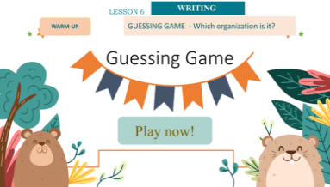 | Guessed picture  Answer key:  (1) THE WORLD WIDE FUND FOR NATURE (WWF)  (2) SAVE THE ELEPHANTS | Elicit  - Show the picture to guess
ACTIVITY 2: PRESENTATION (10’)
- Understand the related words in the text  - Introduce some vocabulary to be learnt in the text. | - Guilding questions: (4’)  - Do you recognize the animal?  - Where does it come from?  - What do the letters WWF stand for?  2. Vocabulary: (6’)  1. originally (adv) – explanation  2. non-governmental (a) – trans  3. organization (n) – explanation and visual  4. non-profit (a) - trans  5. die out (v) = become extinct - synonym | Answered questions  Key  - A panda.  - It comes from China.  - WWF stands for WORLD WIDE FUND FOR NATURE (formally The World Wildlife Fund).  - A list of words in Ss’ notebook | - Ss work individually  - Give synonym/ Vietnamese equivalent/ example to elicit vocabulary from Ss
ACTIVITY 3: PRACTICE (20’)
- To provide further information about a wildlife organization and a model for the writing task. | 1/ Read the text about WWF and complete the table (5’)  World Wide Fund For Nature(WWF)  Kind of organization (1) …………  Set up in (2 …………  Aims (3) ……… -to build a future in which humans respect nature.  Focus of their work (4) ………  Number of projects supported (5) ………………… | Completed table  Answer key:  1. Non-governmental organisation  2. 1961  3. to stop the process of destroying the planet’s natural environment  4. the survival of endangered animals and the protection of their natural habitats  5. 1,300 | Filling in the table  - work in groups  - Teacher’s feedback
- To help Ss practise developing ideas and writing about a wildlife organisation. | 2/ Write a paragraph (120-150) about Save the Elephants, using the information in the table below (15’) | Ss’ writing | - Work in groups
ACTIVITY 4: PRODUCTION (7’)
- To do a cross-check and final check on students’ writing. | 1. Peer-correction  - Class correction: | Completed paragraph  Sample paragraph  Save the Elephants (STE) is a non-profit organisation. It was set up in 1993 by Iain Douglas-Hamilton, and today it is one of the world’s largest organisations to save elephants worldwide. It aims to make sure elephants do not die out and protect the habitats in which elephants are found.  Much of the work of STE focuses on stopping the illegal hunting of elephants especially in Africa and Asia, working together with scientists and experts to conduct research on behaviours of elephants, and raising people’s awareness through films, televisions and new media sources. So far, it has conducted 335 projects in 40 countries and helped to protect thousands of elephants worldwide. | - exchange Ss’writing  - Ss correct the mistakes  - Teacher’s feedback
 | Homework (2’)  a/ Exercises in the workbook  b/ Communication and culture/clil | Teacher’ oral presentation | Individual  - Ask Ss to present their plans in the last lesson of the unit.

UNIT 9: PROTECTING THE ENVIRONMENT
Lesson 7: COMMUNICATION & CULTURE/ CLIL
I/ Learning outcomes:
By the end of this lesson, Ss will be able to:
- Knowledge:
- To review expressions for making and responding to apologies .
- To help students learn about Earth Hour through CLIL( Environmental studies) and learn some content vocabulary.
- To give Ss an opportunity to personalize the CLIL topic.
- Competences:
- be collaborative and supportive in pair work and team work;
- access and consolidate information from a variety of sources;
- be creative and imaginative in making conversations
- actively join in class activities.
- Attributes:
- be willing to learn about making and responding to apologies;
- be aware of the importance of preserving the environment
II/ Teaching and learning resources:

Tape (CD), Tivi, textbook, teacher's book, Laptop,

III/ PROCEDURE:

Aims |  | Contents |  |  |  | Outcomes |  | Steps
ACTIVITY 1:WARM UP (5’)
- To arouse the classroom atmosphere.  - To help Ss review expressions for making and responding to apologies. |  | Video watching: Watch the video and say sorry.  * In this video, Paul says sorry for making Noelia fall over. Watch the video and:  -Complete the conversation with the correct information. |  |  |  | Completed conversation.  Suggested answers:  1, sorry  2, really  3, all right  4, pay attention  5, not to run  6, fault  7, too  8, it’s fine  9, worry | Elicit  - show the video to elicit Ss’answers.
EVERY DAY ENGLISH - ACTIVITY 2: (7’) ACTIVATE/PRACTISE
To review expressions for making and responding to apologies. |  | Listen and complete the following conversation with the expressions from the box. then practise it in pairs. (ex.1, p.107) |  |  |  | Completed conversation with expressions provided  Key:  1. B  2. C  3. D  4. A | Read the conversation, listen and complete it  Work in pairs  - Complete the conversation  - Practise the conversation
EVERY DAY ENGLISH - ACTIVITY 3: (10’) PRODUCTION
-To help Ss practise making and responding to apologies. |  | Make similar conversation making and responding to apologies .  - Going to school late.  - Submitting the asignment late  - Keep S.O waiting so long  …….. |  |  |  | Ss’ conversation using useful expressions  Expected answers:  + (1)- I hope you’ll excuse me for going to school late because my bike was broken  -Don’t mention it, …….  ** conversations performed by Ss |  | Brainstorm :  - tell some different situations ,where and when it happens and what to say .  Practise  - asks Ss to work in pairs to make similar conversations ,using the expressions for making and responding to apologies (Ex2, page 107)
CULTURE : ACTIVITY 4:VOCABULARY PRETEACHING (5’)
- To pre-teach the meaning of some words/phrases, so that Ss can use them in their presentation later and can understand the reading text.  - To help Ss learn some content vocabulary . |  | Look at the pictures and answer the question:  What do you know about Earth Hour?      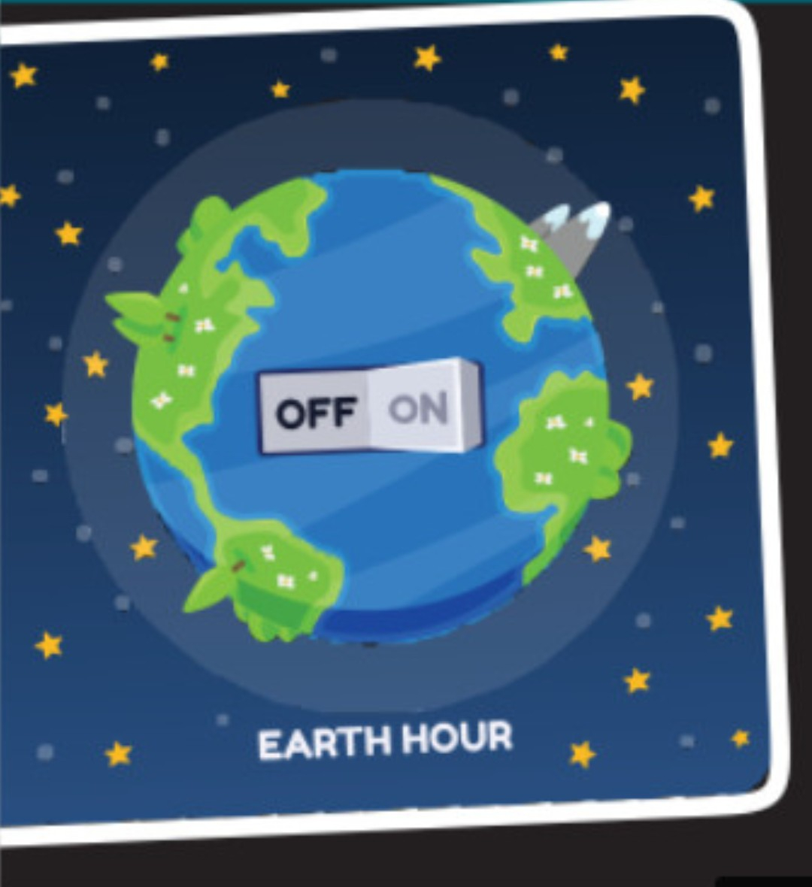 |  |  |  | Ss’answers about Earth Hour  *suggested answers  - Organized by World Wide Fund for Nature.  -Held from8.30 p.m. – 9.30p.m on the last Saturday of March  - To show the public support for protecting the environment and saving the planet  …..  *A list of some words  - encourage (v)  - impact(n)  - promote (v) |  | Elicit  - give pictures to elicit ideas and vocabulary from Ss
CULTURE – ACTIVITY 5 ( ACTIVATE) ( 10’)
- To help Ss learn about Earth Hour through CLIL.  - To help Ss learn some content vocabulary . | Read the text and complete each blank of the fact file about Earth Hour with One word. (ex.1, p.108) |  | Completed blanks  Key:  - Saturday  - Support  - Climate  - Activities  - 2009 |  |  |  |  | ask Ss to read the text about Earth Hour and complete the table  - work in pairs  - peer correction  - teacher’s feedback
CULTURE – ACTIVITY 6 ( PRODUCTION) (5’)
To give Ss an opportunity to personalise the CLIL topic. |  | *Questions  1. Who organised Earth hour ?  2.What’s Earth Hour ?  3. How often is held ?  4. What does it ask people to do ? |  | Answered questions  Suggested answers:  1.WWF  2. Earth hour is a global event organised by WWF  3. Every year  4.It shows the public support for protecting the environment and saving the planet |  |  |  | - asks Ss to work in pairs and find out what they already about Earth Hour.  -Teacher calls on some pairs to share their ideas with the whole class.
CONSOLIDATION & HOMEWORK (3’)
-To help Ss memorise the content of the lesson that they have learned |  | Wrap-up  Homework  - Exercises in the workbook  - Prepare for Looking back and Project lesson |  |  | Suggested answer:  -making and responding to apologies;  - Learning about Earth Hour through CLIL.

UNIT 9: PROTECTING THE ENVIRONMENT
Lesson 8: Looking back and project
I/ Learning outcomes:
By the end of this lesson, students will be able to:
1. Knowledge
- Review the vocabulary and grammar of Unit 9
- Apply what they have learnt (vocabulary and grammar) into practice through a project
2. Core competence
- Develop communication skills and creativity
- Develop presentation skill
- Develop critical thinking skill
- Be collaborative and supportive in pair work and team work
- Actively join in class activities
3. Personal qualities
- Be more creative when doing the project
- Develop self-study skills
II/ Teaching and learning resources:
- Grade 10 textbook, Unit 1, Looking back & Project
- Computer connected to the internet
- Pictures, A0 paper
- Projector/ TV
- sachmem.vn
III/ PROCEDURE
Aims | Content | Outcomes | Steps
ACTIVITY 1: WARM-UP (5’)
To revise the activities related to the environment and lead in the next part of the lesson. | Describe activities in the picture  *Groups of 4 ss looking the pictures  *Ss give names of activities in the picture based on the group’s notes, 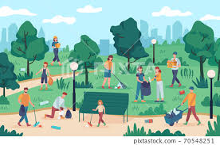 | Described activities  + Collecting the garbage.  + Cleaning the park.  + Taking the rubbish out. | - Looking at the picture and taking notes individually  - Sharing the notes  - Teacher’s feedback.
ACTIVITY 2: LOOKING BACK (15’)
- To revise sentence stress and practise speaking with a natural rhythm. | 1. PRONUNCIATION  Listen and mark the stressed syllables in the words in bold. Then practise saying the sentences with a natural rhythm. | *Ss’ saying the sentences with a natural rhythm.  Answer key:  1. 'Don’t 'buy 'products that are 'made from 'wild 'animal 'parts.  2. 'What can we 'do to 'help the 'animals in the 'wild?  3. 'Larger 'tigers tend to 'live in 'colder 'areas while 'smaller 'tigers 'live in 'warmer 'countries.  4. 'Elephants are en'dangered because of il'legal 'hunting and 'body 'part 'trade.  5. Do you 'know why so many en'dangered 'animals are disap'pearing? | - Listening to the recording  - Marking the stressed syllables  - Practising with a natural rhythm.  - Pairwork  - Teacher’s feedback.
-To revise the vocabulary items Ss have learnt in the unit. | 2. VOCABULARY  Choose the correct word to complete each sentence. | *Completed sentences with words chosen.  Answer key:  - habitats  - impact  - endangered  - warming | - Working individually.  - Ss’ comparison with partners.  - Ss’ writing.  - Ss’ explanations.  - T’s feedback.
To revise the use of reported speech. | 3. GRAMMAR  Change the following sentences into reported speech. | * Written sentences of reported speech.  Answer key:  1. The teacher explained that the rising sea level was / is a result of global warming.  2. My friend told me that she would take part in the competition the following month.  3. The speaker said the clearing and burning of forests led / lead to air pollution.  4. Tuan asked Minh whether he was interested in joining the event that weekend.  5. Nam asked Mai when she was going to deliver the presentation on the environment | - Individual work.  - Writing and explaining  -Peer correction  - Teacher’s feedback.
ACTIVITY 3: PROJECT (20’)
To provide an opportunity for Ss to develop their research and collaboration skills | Group presentations:  A local or an international environmental organisation  The presenters should complete their self-assessment checklist after completing their presentation. | * Ss’ confidence and fluency during their presentation. | - Ss’ presentations,  - Ss’questions and further discusions at the end.  - T’s feedback/ comments.  - T’s praise/ awards.
ACTIVITY 4: CONSOLIDATION/ PRODUCTION (5’)
- To consolidate what students have learnt in the lesson | 1.WRAP-UP (3’)  Teacher asks students to talk about what they have learnt in the lesson. | - Ss’ list of what they have learnt today | - Groupwork.  - T’s summary
-To prepare for the next lesson | 2. HOMEWORK (2’)  - Exercises in the workbook  - Prepare for the next lesson: Unit 2 – Lesson 1. Getting started. |  | - Teacher’s instruction  - Taking notes
CHECKLIST (HANDOUTS)

 | Tick where  appropriate | Comments (in English or  Vietnamese)
DELIVERY
– The presenters greeted the audience
– The presenters spoke clearly and naturally
- The presenters cooperated when delivering their talk
- The presenters interacted with the audience.
– The presenters used some photos / pictures to illustrate organisation’s aims and activities.
- The presenters concluded their talk appropriately.
CONTENT: The presentation includes the following information about a local or an international environmental organisation:
– name
– when it was set up
– the organisation’s aims
– current activities

 | Tick where  appropriate | Comments (in English or  Vietnamese)
DELIVERY
– I greeted the audience
– I spoke clearly and naturally
- I cooperated with my group members when delivering the talk
- I interacted with the audience.
– I used some photos / pictures to illustrate organisation’s aims and activities.
- I concluded my part of the talk appropriately.
CONTENT: The presentation includes the following information about a local or an international environmental organisation:
– name
– when it was set up
– the organisation’s aims
– current activities
UNIT 10: Ecotourism
Lesson 1: Getting started – An eco-friendly fieldtrip to Phong Nha Cave
I/ Learning outcomes:
By the end of this lesson, Ss will be able to:
- Knowledge:
- have an overview about the topic Ecotourism.
- gain vocabulary to talk about Ecotourism.
- Competences:
- develop communication skills.
- be collaborative and supportive in pair work and teamwork.
- actively join in class activities.
- Attributes:
- be aware of responsibilities towards Ecotourism.
II/ Teaching and learning resources:
Tape (CD), Tivi, speakers, textbook, teacher's book, copies of pictures, handouts, laptop, posters
III/ PROCEDURE:
Aims | Contents | Outcomes | Steps
ACTIVITY 1: WARM UP (5’)
- To introduce the unit topic (Ecotourism); | 1. Answer the question: (5’)  - What do you know about Eco-friendly fieldtrip?  Eco- friendly  fieldtrip | Students’ oral prediction about the topic  Suggested answer:  - not damage the environment  - not leave litter  - bring food with less packaging | Elicit  T Asks and Ss answer questions
ACTIVITY 2: STUDY/ PRESENTATION (15’)
-To help Ss understand the related words in the conversation  - To introduce the grammar points to be learnt in the unit. | 1. Vocabulary: (10’)  - ecotourism:  - eco-friendly  - fieldtrip (n)  - stalactite (n)  - damage (v):  - packaging (n): | A list of words in Ss’ notebook | Elicit  T gives synonym/ Vietnamese equivalent/ example to elicit vocabulary from Ss
 | * Check vocabulary: | The missing words on the board | T rubs out the words and Ss remember and rewrite them
To introduce the unit topic | 2. Listen & read (5’)  look at the picture (p.110) and answer the questions:  - What is it?  - Where is it?  - Have you ever visited it? | Ss’prediction about the picture  Suggested answers: -It is Phong Nha Cave in Quang Binh  Province. | -T plays the CD  -Ss listen and repeat the conversation
ACTIVITY 3: ACTIVATE/ PRACTICE (15’)
To check Ss’ comprehension of the conversation. | 1. Find and correct mistakes (5’)  1. On an eco-friendly fieldtrip, tourists enjoy, explore and damage the environment.  2. Nam will take pieces of stalactites because they take a long time to form.  3. Mai will bring snacks with a lot of packaging on the trip. | Mistakes corrected  Key:  1.and → but not.  Or damage→ protect/learn about  2. will →will not  3. will →will not  Or a lot of→ less | -Working in pairs, Ss Read the conversation again. Then find and correct a mistake in each sentence below.  -Ss do peer correction  - Teacher gives feedback
- To help Ss revise phrases related to ecotourism. | 2. Put each phrase into the correct column (5’)  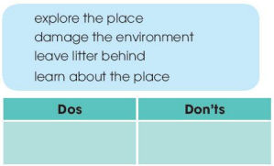 | Dos Don’ts  -Explore the place -learn about the place -damage the environment -leave litter behind | -Ss work in pairs  - Ss do peer correction  -Teacher gives feedback
-To identify the present simple and the present continuous, and how they are used in sentences | 3. Sentence completion (5’)  Complete the sentences.  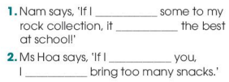 | Completed sentences  Answers:  1. add - will be  2. were - wouldn't | - Ss do the task individually  and then share the answers with a peer.  - Teacher gives feedback
ACTIVITY 4: CONSOLIDATION/ PRODUCTION (10’)
To help students memorize the target language and skills that they have learned | 1. Wrap up (7’)  Talk about the advantages and disadvantages of Ecotourism | - Ss’ talk about the advantages and disadvantages of Ecotourism | -SS work in 4 groups  - Teacher gives feedback
To inform students what the final product of the project should be and how students can prepare for it. | 2. Homework (3’)  a/ Exercises in the workbook  b/ Project preparation  - Tell Ss the project requirements: Do research on one tourist attraction in our country.  - Ask Ss to present their plans in the last lesson of the unit. | Ss’ oral presentation of the research results | Ss work in Groups

UNIT 10: ECOTOURISM - Lesson 2: LANGUAGE
I/ Learning outcomes:
By the end of this lesson, students will be able to gain:
- Knowledge:
- Use the lexical items related to the topic ecotourism;
- Identify intonation patterns and use appropriate intonation (i.e. rising or falling tone);
- Use conditional sentences Type 1 and Type 2 correctly.
- Competences:
- Be collaborative and supportive in pair work and teamwork
- Access and consolidate information from a variety of sources
- Actively join in class activities
- Attributes:
- Develop a sense of an ecotourist
- Be aware of tourism and their impact on the environment
II/ Teaching and learning resources:
- Grade 10 textbook, Unit 10, Language
- Computer connected to the Internet
- Projector/ TV/ pictures and cards
- sachmem.vn
III/ PROCEDURE:
Aims | Contents | Outcomes | Steps
ACTIVITY 1: WARM UP (4’)
- To lead into the new lesson | *Warm-up  JUMBLED-WORD:  I/A/T/O/I/N/T/N/O/N  New lesson:  UNIT 10  Lesson 2: LANGUAGE | Rearranged- word:  INTONATION | T gives the jumbled- word  Ss rearrange the letters into a meaningful word.  T leads in the new lesson
ACTIVITY 2: STUDY/ PRESENTATION (5’)
To help students recognise the intonation patterns in different types of sentences. | I. PRONUNCIATION  Task 1: Listen to these sentences. Pay attention to the intonation and repeat. (p. 111)  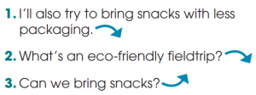  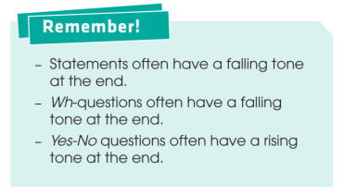 | The intoated statements, Wh -questions and Yes-No questions. | * T Asks students to listen to some sentences and indicate the falling and rising tones at the end of each sentence.  *T checks understanding by asking individual students to briefly explain the intonation patterns in the three types of sentences: statements, Wh-questions and Yes-No questions.  *T asks students to read the notes in the Remember! Box and
ACTIVITY 3: ACTIVATE/ PRACTICE (7’)
To help students practise different intonation patterns in a conversation. | Task 2: Work in pairs and role-play this conversation. Pay attention to the intonation. Then listen and check. (p. 111)  Audio script:  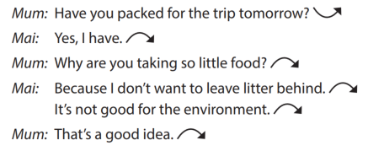 | Role-play conversation with correct intonation | * T has students work in pairs to role-play the conversation paying attention to the three intonation patterns they have just learnt.  *T asks students to peer check and gives comments
ACTIVITY 4: STUDY/ PRESENTATION (10’)
To help students understand the meanings of words / phrases related to ecotourism. | II. VOCABULARY  Task 1. Below is what ecotourists do. Match each sentence on the left with its explanation on the right. (p. 112) | Sentence- Explanation matches  Answers:  1. b 2. a  3. e 4. d  5. c | * In pairs, students read the statements, focusing their attention on the key word highlighted in each sentence and then do the task.  *T checks answers and gives feedback.
To help students practise these words in meaningful contexts. | Task 2: Complete these sentences with the highlighted words in Task 1. (p. 112) | Filled-words  Answers:  1. profit; crafts  2. aware; impact  3. responsible | * T asks students to work in pairs and complete each of the sentences.  *T asks students to peer check and give comments to their partners.
ACTIVITY 5: STUDY/ PRESENTATION (12’)
To help students recognise the differences between Types 1 and Type 2 conditional sentences. | III. GRAMMAR:  Task 1: Decide whether these can be real (R) or not (N). (p. 112)  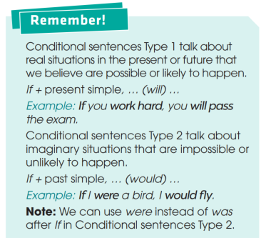 | Real (R) and Not (N) statements  Answers:  1. N 2. R  3. N 4. R | * T Asks students to study the sentences individually.  *T Asks students to peer check and gives comments  * Ss take notes.
To help students practise conditional sentences Types 1 and Type 2. | Task 2: Put the verbs in brackets in the correct forms. (p. 112) | Verbs in correct form  Answers:  1. will stay  2. would grow  3. were / was. would be  4. give. will reduce | * Students complete the task individually.  *T asks students to peer check and gives comments to their work.
ACTIVITY 5: PRODUCTION/ WRAP UP (5’)
To give students a chance to apply what they have learnt. | * Game: Surprising matching! | Conditional sentences | *Divide the class into 4 groups.  - Group A will write If clause type 1. Group B will write Main clause type 1.  - Group C will write If clause type 2 . Group D will write Main clause type 2.  *Match members of group A with ones of group B, and do the same with group C and D.  * Discuss with the Ss and give comments to the surprising results.
ACTIVITY 7: HOMEWORK (2’)
Remind Ss to revise what they have learnt and prepare for the next lesson. | - Lesson revision  - Exercises in the workbook  - Unit 10: Lesson 3-Reading  - Use the lexical items related to the topic ecotourism;  - Identify intonation patterns and use appropriate intonation (i.e. rising or falling tone) |  | *Ask Ss to do at home.

UNIT 10: ECOTOURISM
Lesson 3: READING – Ecotour brochures
I. AIMS/OBJECTIVES OF THE LESSON
I/ Learning outcomes:
By the end of this lesson, Ss will be able to:
- Knowledge:
- Read for main ideas and specific information in a brochure about ecotours.
- Guess the meaning of words/phrases in context.
- Competences:
- Develop communication skills and creativity.
- Be collaborative and supportive in pair work and team work
- Develop presentation skills.
- Actively join in class activities.
- Attributes:
- Be aware of tourism and their impact on the environment.
- Develop a sense of an ecotourist.
II/ Teaching and learning resources: Tape (CD), Tivi, speakers, textbook, teacher's book, copies of pictures, handouts, laptop, posters
III/ PROCEDURE:
Aims | Contents | Outcomes | Steps
ACTIVITY 1: IN TRODUCTION & ENGAGE/ WARM UP (5’)
- To introduce the topic of the reading and get Ss involved in the lesson.  - Introduce some new words to be learnt in the lesson. | `. Guessing picture: (5’)  Name the tours  -  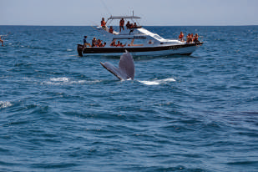  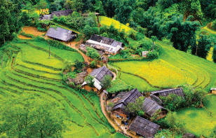 | Students’ oral prediction about the topic  Suggested answer:  - Reef Tour  - Trekking Tour  - National Park Tour  - Whale-watching Tour | Elicit  Teacher shows the pictures and asks students to name the tours in these pictures.  - Students give the answers.  - Teacher and students discuss the answers.  - Teacher confirms the appropriate names of the tours and provides suggested answers.
 | 3.Vocabulary: (3’)  - protect (v)  - souvenir (n)  - explore (v)  - coral reef (n.p)  * Check vocabulary: | Lists of some new words.  - The missing words on the board | - Look at the explanation and the photos to guess the meaning of new words.  - Rub out and remember
ACTIVITY 2: STUDY/ PRESENTATION (7’)
- Understand the related words in the conversation  - Introduce the grammar points to be learnt in the unit. | Work in pairs. Answer these questions. | Ss’ answers for the questions | Elicit  - Teacher puts Ss in pairs to ask and answer the questions.  - Teacher explains that each photo is part of a brochure advertising a tour in four different places: Australia, Viet Nam, Zimbabwe, Hawaii and asks them to discuss what tourists can do on the tours without reading the texts.  - Teacher has some students share their answers with the whole class.  - Teacher gives comments and checks students’ pronunciation if necessary.
ACTIVITY 3: ACTIVATE/ PRACTICE (15’)
- To help students practise guessing the meaning of words from context. | Read the brochures below. Then work in pairs to solve the crossword using words from the brochures.  as a class. | - Completed crossword  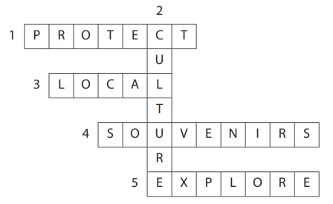 | - Teacher points out that the part of speech (v, n, adj) as well as the brochure where they can find the words are provided in brackets.  - Teacher asks students to work in pairs to solve the crossword using words from the brochures.  - Teacher walks round the class and provide help if necessary.  - Teacher checks the answers
ACTIVITY 4: ACTIVATE/ PRACTICE (9’)
- To help students practise reading for specific information. | Which tour does each statement below talk about? Write a, b, c or d. | Ss’ oral presentation  Suggested answers:  1. d (Clue: Buy local souvenirs to help the local Whale Protection Program)  2. c (Clue: Learn how you can help save wild animals in the local research centre)  3. b (Clue: Children not allowed)  4. a (Clue: Watch 3D documentaries to learn about sea animals and the coral reef, and what you can do to protect it) | - T Asks students to do the activities 3 in pairs in 5'.  - T tells students to compare their answers with other group. Let them discuss and correct for one another.  -T goes around offering to help.  - T checks with whole class.
ACTIVITY 5: CONSOLIDATION/ PRODUCTION (8’)
- To help students use the language and ideas from the unit to make suggestions for more  eco-friendly tours. | Work in groups. Think of new ideas for making one of the tours better for the environment. | Ss’ oral presentation:  New ideas for making tours better for the environment.  Suggested answers:  A. If they ban swimming with fish, the Great Barrier Reef will be better protected. Tourists should not be allowed to dive very close to the coral reefs.  B. Tourists should always follow the walking paths and trails on the Sapa Trekking Tour. The local people with whom the tourists stay should only use local ingredients. If they only use local ingredients, their carbon footprint will be lower.  D. The boats on the Whale-watching Tour should not get too close to the whales or make too much noise. If the boats are environmentally friendly, they will not harm the whales or their habitats. This is because environmentally-friendly boats use less fuel and oil, make small waves and are quiet. | -Ss discuss in groups  -Teacher asks students some groups to present a summary of their ideas or just the most useful ones in front of the class.  - Teacher encourages the rest of the class to give comments and praises for good effort and interesting ideas.
-To Inform students what they have to prepare for the next lesson. | 2. Homework (1’)  a/ Exercises in the workbook  b/ New lesson preparation

