Period 10 UNIT 2: HUMANS AND THE ENVIRONMENT
Lesson 1: Getting started – Go Green Club
I/ Learning outcomes:
By the end of this lesson, Ss will be able to:
- Knowledge:
- Have an overview about the topic Human and the Environment.
- Gain vocabulary to talk about activities to adopt a greener lifestyle.
- Competences:
- Develop communication skills and environmental awareness.
- Be collaborative and supportive in pair work and teamwork.
- Actively join in class activities.
- Attributes:
- Develop a greener lifestyle and awareness of environmental issues;
- Be responsible to the environment.
II/ Teaching and learning resources:
- Tivi, speakers, textbook, teacher's book, copies of pictures, handouts, laptop, and posters

III/ PROCEDURE:
Aims | Content | Outcomes | Steps
ACTIVITY 1: IN TRODUCTION & ENGAGE/ WARM UP (5’)
- Introduce the unit topic ( Humans and the environment);  - Introduce some vocabulary to be learnt in the unit. | 1a. What are they doing?  1b. What for? (2’)  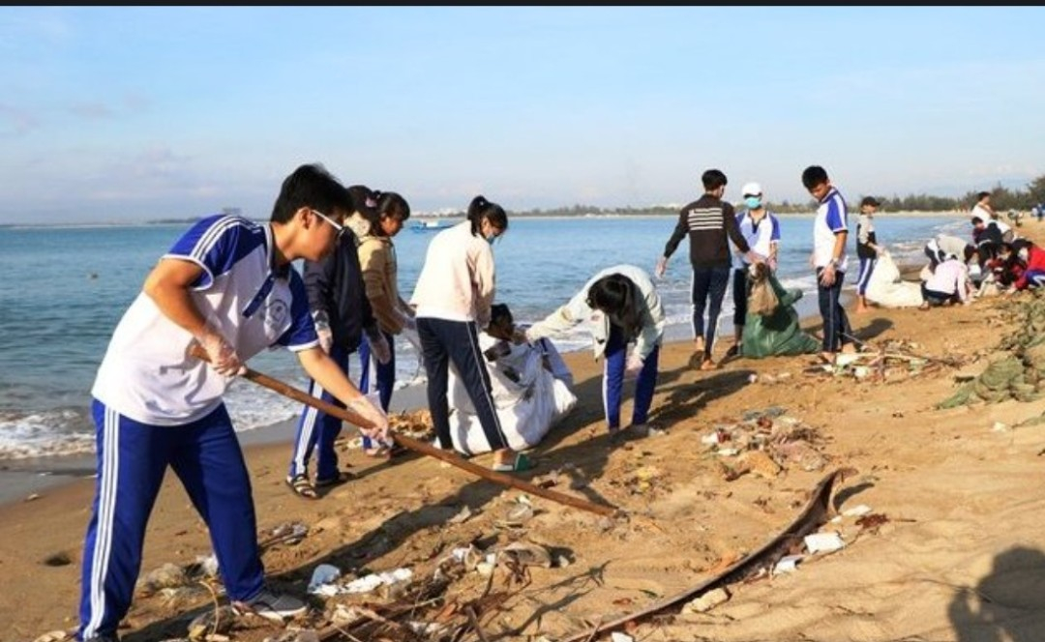 | Students’ oral prediction about the topic  Suggested answer:  2a. collecting garbage on the beach./ cleaning up the beach.  2b. to protect the environment. | Elicit  Show the picture to elicit the topic
 | 2. List the work that you do to protect the environment (3’)  T gives some cues to help students if they can’t do the task. | List of the work to protect the environment  Expected answers:  - planting trees.  - collecting garbage.  - sweeping school yard/ classrooms.  - Saving water, energy.  - watering flowers, plants  - taking out garbage.  - …………………. | Work in pairs to list some of the work that you do to protect the environment on the board
ACTIVITY 2: STUDY/ PRESENTATION (15’)
- Understand the related words in the environment.  - Introduce the grammar points to be learnt in the unit. | 1. Vocabulary  1. adopt (v) /əˈdɒpt/: start to use a particular method  2. awareness (of) (n) /əˈweənəs/: interest in and concern about a particular situation or area of interest  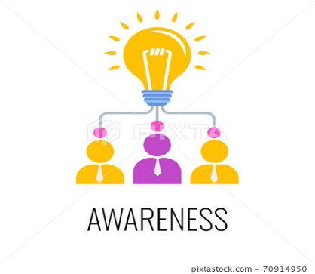  3. carbon footprint (n) /ˌkɑːbən ˈfʊtprɪnt/: a measure of the amount of carbon dioxide that is produced by the activities of a person or company  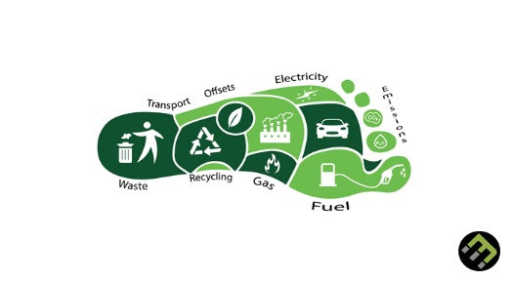  4. set up (v) /set ʌp/: = establish (synonym)  5. reduce (v) /rɪˈdʒuːs/ >< increase ( antonym) | A list of words in notebook | Elicit  Give synonym/ Vietnamese equivalent/ example to elicit vocabulary from Ss
 | * Listen & repeat | Sts’ pronunciation of the words | Listen to the audio/teacher & repeat in chorus then individually
 | * Check vocabulary:  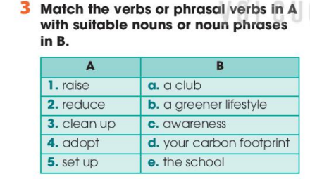 | - The missing words on the board.  - Do the task 3.  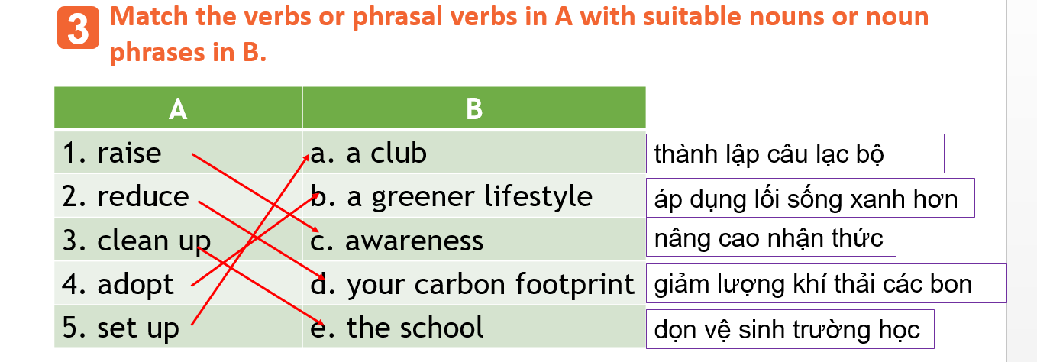 | Rub out and remember
 | 2. Listen & read (5’)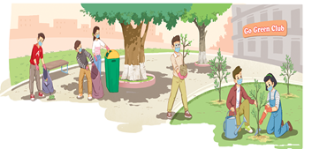  look at the picture (p.18 - 19) and answer the questions:  - Who are they?  - Where are they?  - What are they doing?  - Is cleaning up the school/ the street/ public places a way to adopt a green lifestyle?  * T leads to the new lesson.  * T plays the recording twice, has Ss listen to the conversation, read along and underline the activities in the conversation which are good for the environment.  ** Ss do the task individually.  *** Ss share their answers with a partner.   T checks their answers with the whole class.  * T has the Ss read the conversation in pairs.  ** Ss read the conversation.  *** One or two pairs read aloud. | Ss’prediction about the picture  Suggested answers:  - They are students.  - They are at school.  - They are cleaning up the school and planting trees.  - Yes, it is.  Suggested answers:  - adopting a greener lifestyle.  - raising local people’s awareness of environmental issues.  - reducing my carbon footprint | Set the context for listening and reading the conversation
ACTIVITY 3: ACTIVATE/ PRACTICE (15’)
Practise reading for specific information | TASK 2: READ AND ANSWER THE QUESTIONS. (p.19)  Read the conversation again and answer the following questions.  * T asks Ss to work individually to read the questions and underline the key words, then share their ideas with a partner who sits next to them.  ** Ss do Task 2 individually first.  *** Ss share and discuss with their partners about the key words.   T corrects their answers as a class.  - Who set up the Go Green Club?  - What does the club want to achieve?  - What does Nam think the club will do in the future?  - What is the first activity of the club?  - What is Mike keen to do?  - What do they decide at the end of the conversation?  * T asks Ss to scan the conversation, locate the key words to find the answer for each the question with the partner who sits behind them.  ** Ss do the task in pairs.   T divides the class into two big teams, and has Ss in each team take turns to choose a number in the game Lucky number to check the answers.  Nam will tell Mike the time and the place of the club meeting.  . | - Ss’ oral prediciton  - Ss’ answers  Key:  - The Youth Union in Nam’s school set it up.  - The club wants to improve the environment and encourage people to adopt a greener lifestyle.  - He thinks the club will organize more activities to raise people’s awareness of environmental issues.  - It is cleaning up the school right after the ceremony  - He is keen to reduce his carbon footprint. | Predict then listen and read the conversation  - Work in pairs  - Peer correction  - Teacher’s feedback
- Identify the present simple and the present continuous, and how they are used in sentences | TASK 4: COMPLETE THE FOLLOWING SENTENCES BASED ON THE CONVERSATION IN TASK 1. (p.19)  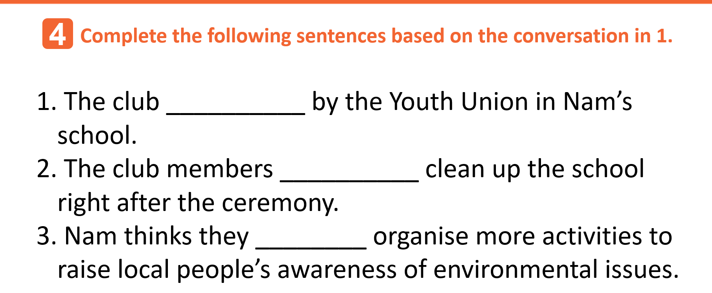  * T has Ss read each sentences, try to think of a verb or an auxiliary verb that will complete the gap.  ** Ss do the task individually.  *** Ss share the answers with a peer.   T asks the whole class to call out the verb forms first, then calls on individual Ss to read the complete sentences. | Completed sentences  using the present simple and the present continuous  Key:  1. was set up  2. are / ‘re going to  3. will / ‘ll | - Do the task individually  - share the answers with a peer.  - Teacher’s feedback
ACTIVITY 4: CONSOLIDATION/ PRODUCTION (5’)
Help students memorise the target language and skills that they have learned | 1.WRAP-UP (3’)  Watch the video clip and list all the work done to protect the environment in the video | - Ss’ list of household chores on the poster  Suggested answers:  - planting trees.  - collecting garbage.  - sweeping school yard/ classrooms.  - Saving water, energy.  - watering flowers, plants  - taking out garbage. | Watching and listening  -Work in 4 groups  -Peer correction  - Teacher’s feedback
Inform students what the final product of the project should be and how students can prepare for it. | 2. HOMEWORK (2’)  1. Exercises in the workbook  2. Project preparation  * Teacher:  - Has Ss look at the last page of Unit 2, the Project lesson and asks them what topic of the project is.  - Tells them the project requirements: Ss will have to make a plan for a Go Green Weekend in which they will:  + suggest activities for the event, provide the reasons and expected results of the activities;  + include information as stated in the table on page 27 in the Student’s Book.  + present their plans in the last lesson of the unit.  - Reminds Ss that beside brainstorming Go Green Weekend activities, they:  + can search for ideas on the Internet, in the newspapers, etc. for reference.  + should use photos/pictures to illustrate their ideas.  - Puts Ss into groups and has them choose their group leader; Asks them to assign tasks for each member, making sure that all group members contribute to the project work.  - Helps Ss set deadlines for each task. | Ss’ oral presentation of the research results | Groupwork

Period 11 UNIT 2: HUMANS AND THE ENVIRONMENT
Lesson 2: Language

I/ Learning outcomes:
By the end of this lesson, Ss will be able to :
1. Knowledge
- Pronounce the consonant blends /kl/, /pl/, /gr/, and /pr/ correctly in isolation and in sentences;
- Understand and use some lexical items about humans and the environment;
- Distinguish and use will and be going to to talk about the future;
- Use the passive voice correctly.
2. Competence
- Be collaborative and supportive in pair work and team work;
- Access and consolidate information from a variety of sources;
- Actively join in class activities.
3. Attributes:
- Adopt greener lifestyle and awareness of environmental issues;
- Be responsible for environment protection.

II/ Teaching and learning resources:
- Grade 10 textbook, Unit 2, Language
- Computer connected to the Internet
- Projector/ TV/ pictures and cards

III. PROCEDURES

Stage | Stage aim | Procedure | Interaction | Time
WARM-UP | - To arouse the classroom atmosphere.  - To lead in the lesson. | GUESSING GAME: WHAT AM I GOING TO DRAW?  -T shows the picture of dark clouds and asks ss “What’s going to happen ?”  -Ss answer.........................................................  - It is going to rain  - T gives comments ,asks some more questions to lead in the lesson.  + Is using these vehicles good for the environment?  + Why is using them not good for the environment? | T-S  S-S  T-S | 4 mins
PRONUNCIATION | To help students recognize and practise the consonant blends /kl/, /pl/, /gr/, and /pr/ in individual words. | TASK 1: LISTEN AND REPEAT.  Pay attention to the consonant blends /kl/, /pl/, /gr/, and /pr/. (p.19)  * T shows the following pictures, and asks Ss to describe each picture with a word.  v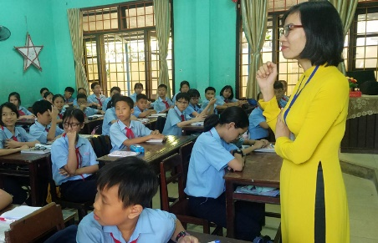  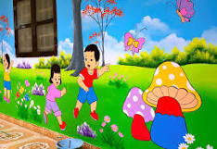  class ground play    gift green clean    place protect  - T has Ss work in pairs to categorize those pictures.  ** Ss do as instructed.  *** Ss share their ideas with a partner.   T confirms the correct answers and leads in the task.  * Teacher:  - plays the recording and asks Ss to listen to the words and repeat; tells them to pay attention to the consonant blends. (Teacher can play the recording as many times as necessary)  - makes sure Ss know the meaning of each word.  ** Ss do as instructed.   T checks whether Ss have improved their pronunciation by randomly calling on individual Ss to read the words aloud. | T-S  S-S  S-S  T-S  T-S  S-S  T-S | 6mins
 | To help students recognise the consonant blends /kl/, /pl/, /gr/, and /pr/ in sentences and pronounce them correctly. | TASK 2: LISTEN AND PRACTISE SAYING THE FOLLOWING SENTENCES. (p.19)  * Teacher:  - checks Ss’ comprehension of the sentences.  - plays the recording, has Ss focus on the words containing the consonant blends and asks them to circle these words.  - plays the recording again, pausing after each sentence, for Ss to repeat.  ** Ss do as instructed.  *** Ss practise reading the sentences in pairs.   T goes round to offer help and collects common mistakes to correct as a class. | T-S  S-S  S-S  T-S | 5 mins
VOCABULARY | To make sure that students understand the meaning of some lexical items about humans and the environment. | TASK 1: MATCH THE WORDS AND PHRASES TO THEIR MEANINGS. (p.20)  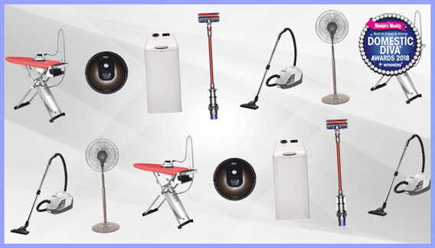  1. household appliances 2. energy 3. carbon footprint    4. litter 5. eco-friendly  * T gives clear instructions.  ** Ss work in pairs to discuss and do the matching.  *** Ss share the answers with the whole class.   T confirms the correct answer.  Key: 1. d - 2. e - 3. a - 4. b - 5. c | T-S  S-S  S-S  T-S | 4 mins
 | To give students practice in using the words/phrases in meaningful contexts. | TASK 2: COMPLETE THE SENTENCES USING THE WORDS OR PHRASES IN 1. (p.20)  * Teacher:  - has Ss read the sentences carefully to decide which word/phrase in 1 can be used to complete each of the sentences.  - explains that they should use the context clues to decide on the word/ phrase, e.g. in the first sentence, the gapped word is an adjective (eco-friendly)  ** Ss work in pairs to discuss and find the answers.  *** Ss share the answers with the whole class.   T confirms the correct answers and asks Ss to give the reasons why they have chosen the word/phrase for each sentence.  Key:  1. Eco-friendly  2. household appliances  3. carbon footprint  4. energy  5. litter | T-S  S-S  S-S  T-S | 4 mins
 | To help students memorize the words/phrases they have learnt. | TASK 3: MAKE SENTENCES, USING THE WORDS/PHRASES IN TASK 1.  * T divides the class into teams, asks Ss to write as many sentences as they can in 2 minutes, using the words/phrases in 1. T reminds them to make at least one sentence with each word/ phrase.  ** Ss works in small teams and do as instructed.  *** The teams with the most sentences take turns to read aloud their sentences.   T gives comments, collects common mistakes to correct. | T-S  S-S  S-S  T-S | 4 mins
GRAMMAR | - To give students an opportunity to revise the use of will and be going to to talk about future actions.  - To give students an opportunity to revise the passive voice. | THE FUTURE WITH WILL AND BE GOING TO  Complete the following sentences with will or the correct forms of be going to. (p.20)  * Teacher:  - tells Ss to read the explanations in the Remember! box on page 20 and asks Ss questions to elicit the differences between will and be going to, for example:  + Do both structures talk about the future?  + Which auxiliary do we use to talk about plans made at the moment of speaking / before the moment of speaking?  + Can we use both structures for predictions?  - in weaker classes, T gives more examples to make sure Ss understand the use of will and be going to; in stronger classes, has Ss come up with their own example sentences.  - asks Ss to work in pairs or individually to choose will or the correct form of be going to to complete each sentence.  - reminds them to use some clues in the sentence to decide on the correct tense form. e.g. 1: I don’t think; 2: have already made the decision; 3: I’m sure; 4: Look at; 5: I forgot to phone Dad.  ** Ss do as instructed.  *** Ss share their answers with a partner.   T check Ss’ answers and asks them to explain their choices (using the clues above).  Key:  1. will  2. are going to  3. will  4. is going to  5. will  PASSIVE VOICE  Rewrite the following sentences using the passive voice. Begin each sentence as shown.  * Teacher:  - asks Ss to read the explanation in the Remember! box on page 21 and asks Ss questions to check their understanding of the grammar point, for example:  + When do we use the passive voice?  + What do we focus on?  + How do we form the passive voice? (the verb be and the past participle of the main verb).  - in weaker classes, gives more examples to make sure Ss understand the use and forms of the passive voice in different tenses; in stronger classes, has Ss come up with their own example sentences in both passive and active structures.  - asks Ss to work independently and rewrite the sentences using the passive voice.  - reminds Ss of the correct verb forms in different tenses; of the use of the preposition by to mention the doer of the action.  - elicits that if the subject in the active voice is they or we, Ss don’t need to indicate the doer in the passive voice.  ** Ss do as instructed.  *** Ss work in pairs to compare their answers.   T checks the answers as a class by having individual Ss read out the sentences or write them on the board.  Key:  1. A green lifestyle is adopted by more and more people.  2. The rubbish was not put in the bins after the party yesterday by the students.  3. More trees will be planted in the neighbourhood.  4. A lot of clean-up activities are going to be organised by our club this weekend .  5. Important environmental issues were discussed at the meeting. | T-S  S-S  S-S  T-S  T-S  S-S  S-S  T-S | 6 mins  6 mins
CONSOLIDATION | To help students memorise the target language and skills that they have learned | WRAP-UP  * Teacher asks: What have you learnt today?  - Consonant blends /kl/, /pl/, /gr/, and /pr/  - Some lexical items about humans and the environment;  - Will and be going to to talk about the future;  - Passive voice.  HOMEWORK  - Exercises in the workbook.  - Prepare for Lesson 3, Unit 2. | T-S | 2 mins

