Period 13 UNIT 2: HUMANS AND THE ENVIRONMENT
Lesson 4: Speaking
I/ Learning outcomes:
By the end of this lesson, Ss will be able to:
- Knowledge:
- gain vocabulary to talk about ways to live green
- Competences:
- develop communication skills;
- be collaborative and supportive in pair work and team work;
- actively join in class activities.
- Attributes:
- be aware of the importance of a green lifestyle.
II/ Teaching and learning resources:
Tape (CD), Tivi, speakers, textbook, teacher's book, copies of pictures, handouts, laptop, posters
III/ PROCEDURE:
Aims | Content | Outcomes | Steps
ACTIVITY 1: WARM UP (3’)
- Introduce the unit topic (Humans and the environment);  - Introduce some vocabulary to be learnt in the unit. | What are the pictures about?  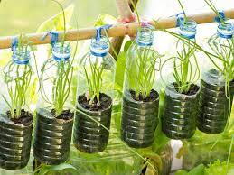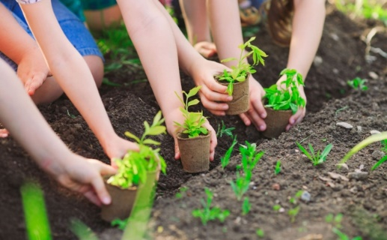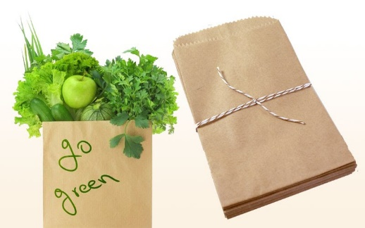 | Students’ oral prediction about the topic  Suggested answer:  Living green/ green lifestyle | Elicit  Show the pictures to elicit the topic
ACTIVITY 2: PRE-SPEAKING (20’)
To pre-teach some vocabulary so that students can understand the meanings and use them correctly in main speaking tasks. | VOCABULARY (6’)  * Teacher:  - shows the words one by one, models and has Ss repeat the words.  - has Ss guess the meanings of the words based on pictures, explanations or examples.  1. leave st on (idioms): choose to keep something operational or switched to an "on" position.  Ex: Someone left the lights on the whole time we were gone. Our electricity bill is going to be enormous.  2. chemical (n) /ˈkemɪkəl/: a substance obtained by or used in a chemical process    3. shade (n) /ʃeɪd/: slight darkness caused by something blocking the direct light from the sun  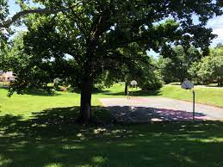  4. break down (phv) /breɪk daʊn/: to divide something into smaller parts  T confirms the meanings, calls on some individual Ss to make sentences with each word. | A list of words in notebook | Elicit  Give idiom, pictures definition, example to elicit vocabulary from Ss
To introduce more ideas for the main speaking tasks and get students involved in the lesson | TASK 1: WHICH OF THE FOLLOWING ACTIVITIES DO YOU THINK TEENAGERS SHOULD OR SHOULDN’T DO TO LIVE GREEN? PUT A TICK IN THE APPROPRIATE COLUMN. (p.23) (6’)  * T has Ss work in pairs, read the activities, discuss their meanings and decide which activities they should/ shouldn’t do to go green by putting a tick in the appropriate column.  ** Ss do as instructed.  *** Some individual Ss share their answers with the whole class.   T confirms the correct answers.  Activities Should Shouldn’t  1. Leaving your appliances on when not in use ✔  2. Recycling your used items ✔  3. Using plastic bags when shopping ✔  4. Buying organic food ✔  5. Dropping litter in the street ✔  6. Planting trees ✔ | Ss’prediction about the activitives  Suggested answers:  1. shouldn’t  2. should  3. shouldn’t  4. should  5. shouldn’t  6. should | Set the context for speaking
To introduce more ideas for the main speaking task and get students involved in the lesson | TASK 2: THE TABLE BELOW PRESENTS THE REASONS WHY TEENAGERS SHOULD OR SHOULDN’T DO THE ACTIVITIES IN 1. WORK IN PAIRS AND MATCH THEM WITH THE ACTIVITIES. (p.23) (8’)  * Teacher:  - has Ss read the reasons, and discuss with a peer to do the matching.  - reminds them that besides using because, they can use since/ as/ due to the fact that/ on the ground that to express reasons and encourages them to give more reasons and makes small exchanges after doing the matching, e.g.  Student A: Why shouldn’t you leave your appliances on when not in use?  Student B: Because this wastes electricity and creates dangerous situations. Why should you recycle your used items?  Student A: Since this protects natural resources.  ** Ss do as instructed.  *** Ss share the answers with the whole class.   Teacher confirms the correct answers and calls on some pairs to make small exchanges like the one above. | Matched reason with the activities  Suggested answers:  a - 5; b - 1; c - 3; d - 4; e - 2; f - 6 | Set the context for speaking
ACTIVITY 3: WHILE-SPEAKING (15’)
To give students an opportunity to discuss ideas in groups and share with the rest of the class. | TASK 3: WORK IN GROUPS. DISCUSS AND PRESENT YOUR IDEAS ABOUT WHAT YOU SHOULD OR SHOULDN'T DO TO LIVE GREEN. (p.23)  * T has Ss work in groups of 5, discuss what they should or shouldn’t do to live green.  - In weaker classes, T reminds them to use the ideas given in 1 and 2 in their discussion. In stronger classes, T encourages them to think of other activities and reasons.  ** Ss do as instructed.  *** T invites 3 groups to share their ideas with the rest of the class, other groups can put questions.   Teacher praises Ss for interesting and imaginative ideas, and for providing well-formulated reasons. | Ss’ oral presentation  Example: There are many things that we should or shouldn’t do to live green. We should recycle our used items so that we can protect natural resources. We shouldn’t drop litter in the street because this will make the street dirty and pollute the environment. | - Groupwork  - Teacher’s feedback
ACTIVITY 4: POST-SPEAKING (7’)
Help students memorise the target language and skills that they have learnt | 1.WRAP-UP (5’)  T asks Ss to close the books and answer the questions:  What should you do to live green?  What shouldn’t you do to live green? | Ss’ answers  Suggested answers:  - Use renewable energy  - Stop throwing out food  - Use compost  - Save water  - Use public transportation | - Pair work  -Peer correction  -Teacher’s feedback
2. HOMEWORK (2’)
- Learn the vocabulary by heart
- Prepare for the next lesson: Unit 2- Lesson 5: Listening

Period 14 UNIT 2: HUMANS AND THE ENVIRONMENT
Lesson 5: Listening
I/ Learning outcomes:
By the end of this lesson, Ss will be able to:
- Knowledge:
- Listen for specific information in a text about green living;
- Talk about a plan to organise a green event in their area.
- Competences:
- Be collaborative and supportive in pair work and team work;
- Actively join in class activities;
- Develop presentation skills.
- Attributes:
- Be more responsible for the environment and be able to propose plans to solve environmental issues in their residential areas;
- Be ready to make a plan to organize a green event in their area.
II/ Teaching and learning resources:
Tape (CD), Tivi, speakers, textbook, teacher's book, handouts, cell phones, pictures, laptop.
III/ PROCEDURE:
Aims | Content | Outcomes | Steps
ACTIVITY 1: WARM UP (5’)
- To arouse the classroom atmosphere.  - To get students be actively involved in the lesson. | Game: GUESSING WORDS | List of words related to the topic  Set 1: adopt, litter, eco-friendly  Set 2: sort, awareness, household appliances | - T divides class into 2 teams.  - T introduces the rule of game:  - T leads into the new lesson.
ACTIVITY 2: PRE-LISTENING (10’)
To pre-teach the pronunciation and the meaning of some vocabulary so that students can understand the content of the listening. | * Teaching Vocabulary  1. schedule (n): a plan that lists all the work that you have to do and when you must do each thing.  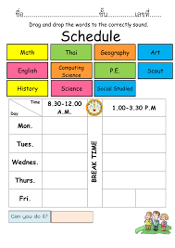  2. specific (adj): connected with one particular thing only.  E.g. The money was collected for a specific purpose.  3. donation (n): money or goods that are given to help a person or organization, or the act of giving them.  4. delivery (n): the act of taking goods, letters, parcels, etc. to people's houses or places of work.    * Checking Vocabulary: Slap the board | List of words in Ss’notebook | T uses some techniques in teaching Vocab: picture, example, explanation,
To introduce the topic of the listening and activate Ss’ prior knowledge | Task 1: Look at the picture and answer the question: What are they doing? Why?  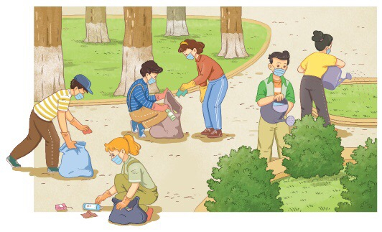 | Ss’ answers about the picture.  Suggested answer:  The students are picking up rubbish, bottles and plastic bags; They are watering plants and trees. | - T has Ss work in pairs and and tell their partner about what they see in the picture.  - Ss discuss with their friends.  - T invites some pairs to share their ideas.  - T gives feedback.
ACTIVITY 3: WHILE-LISTENING (15’)
- To help Ss practise listening for specific information. | Listen to an announcement about a Go Green Weekend event and do the following tasks.  Task 2: Multiple choice: Choose the best answer  1/ A Go Green Weekend event is being organized …………….  A. the upcoming Friday  B. the upcoming Saturday  C. the upcoming Sunday  D. the upcoming Thursday  2/ How many teams will be at a Go Green Weekend event?  A. 2 B. 3 C. 4 D. 5  3/ The Clean-up team will take the responsibility for cleaning …………….  A. the central park  B. the central museum  C. the central market  D. the central pub  4/ Items from local residents will be collected by …………….  A. the Donation Team  B. the Media Team  C. the Clean-up Team  D. None of the above Teams  5/ The Media Team will be responsible for …………….  A. picking up rubbish, bottles and plastic bags  B. sorting used items and putting them into the correct bags  C. watering small trees and flowers  D. posting pictures of the event on the club’s website  Task 3: Matching: Match the activities below with the corresponding team.  A B  1. The Media Team A. Watering small trees and flowers  - The Clean-up Team - Putting used items into the correct bags  - The Donation Team - Making suggestions for the club’s future activities | Completed sentences .  Suggested answer:  Task 2:  - C  - B  3 - A  4 - A  5 - D  Task 3:  1 - C  2 - A  3 – B  Matched activities with the corresponding team | - T gives handouts to Ss, asks them to work in groups of four, look at the handouts and have an overview of the two tasks.  - T asks Ss to listen to the recording 3 times and do two tasks.  - T lets Ss play the game on KAHOOT and has Ss check the answer by listening again.  - Teams having the highest marks will be the winner.  - T gives feedback.
ACTIVITY 4: POST-LISTENING (10’)
To give students an opportunity to personalise the language and ideas from the listening in a speaking task. | DISCUSSION:  “If you have to organize a green event in your area, what will you do?”  Cues:  + Have you ever taken part in an environmental activity or event?  + How many times have you participated in such activities or events?  + What did you do there?  + How did you feel? | Ss’ oral presentation. | - T asks Ss to work in groups of four and discuss the question.  - T gives Ss some cues/ questions to answer.  - T invites some Ss to present and lets other Ss give feedback.  - T comments.
ACTIVITY 5: CONSOLIDATION (3’)
To help students memorise the content of the lesson | WRAP UP: PICKING UP  What have just been mentioned in the lesson? Pick them up.  - 4 new words: schedule, specific, donation, delivery  - Green products  - Go Green Club  - Green living  - Holding a green event in the area. | 4 new words.  Suggested answer:  : schedule, specific, donation, delivery  - Green living  - Holding a green event in the area. | - T shows the screen about the content of the lesson and asks Ss to pick up the right content of the lesson.  - T invites some Ss to answer and lets the others give feedback.  - T comments.
HOMEWORK (2’)
Inform students what the final product of the speaking topic. | Work in individual to talk about the ways to hold a green event in your area. Then, post your video clip on the link: https://flip.com/e234a15f | Ss’ video clip on the link of Flipgrid | T gives Ss homework to do.

Period 15 UNIT 2: HUMAN AND THE ENVIRONMENT
Lesson 6: Writing
I/ Learning outcomes:
By the end of this lesson, Ss will be able to:
- Knowledge:
- Use lexical items related to the topic “Humans and the environment”;
- Write about ways to improve the environment.
- Competences:
- Be collaborative and supportive in pair work and team work;
- Actively join in class activities;
- Develop presentation skills.
- Attributes:
- Be more responsible for protecting the surrounding;
- Be able and willing to persuade other people to take actions to make a nice and clean environment.
II/ Teaching and learning resources:
- Grade 10 textbook, Unit 2, writing
- Computer connected to the Internet
- Projector/ TV/ sub-board
III/ PROCEDURE:
Aims | Content | Outcomes | Steps
ACTIVITY 1: WARM UP (6’)
- To arouse the classroom atmosphere.  - To get students be actively involved in the lesson. | GAME: RUNNING MAN (6’) | List of some ways to protect the environment  Expected answers:  Buying organic foods  Not using plastic bags  Planting trees | List  Work in groups to list the ways to protect the environment on the board
ACTIVITY 2: PRE - WRITING (6’)
- To help students recall some suggestions for improving the environment | MATCH (6’)  Match the suggestions for improving the environment with their expected results. (p.25) | Ss’ oral presentation  Key:  1.c  2.a  3.b | Match  Work in pairs to match the suggestions for improving the environment with expected results
ACTIVITY 3: WHILE-WRITING (18’)
To provide students with a model of a well-structured paragraph and practice in using connectors to link sentences. | 1/ FILL IN THE BLANKS (8’)  Read the incomplete paragraph about ways to improve the environment. Fill in the blanks with the words and phrases from the box. (p.25). | Completed paragraph with the words and phrases provided  Key:  1. First  2. For example  3. In conclusion | - be provided with an incomplete example as a model for their writing.  - recall the information about the structure of a paragraph  - Work in pairs  - Teacher’s feedback
To help students practise developing ideas and writing a paragraph | 2 COMPLETE THE PARAGRAPH (10’)  Add two more suggestions to improve the environment in your school to the paragraph in 2. Use the ideas in 1 to help you. (p.25) | A completed paragraph using more suggestions | - Work in groups of four
ACTIVITY 4: POST-WRITING (14’)
To give students an opportunity to recognize the common mistakes so that they can avoid in writing | 1. CORRECTION (12’)  a. PEER CORRECTION  - T explains the marking symbols in the following table.  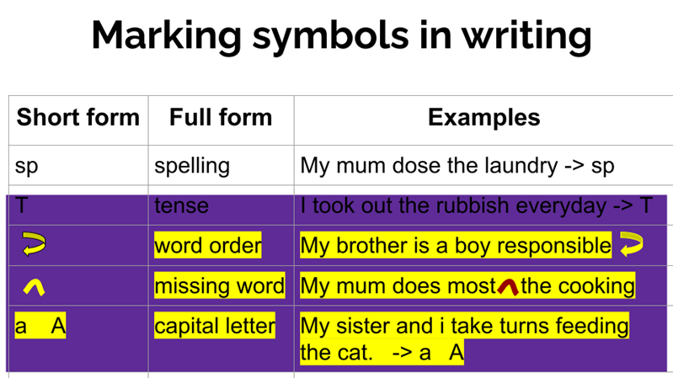  b. CLASS CORRECTION  - - T writes Ss’ common mistakes on the board, asks Ss to check whether they make the same mistakes in their writing. | Ss’ recognition of mistakes  Sample answer:  Another way would be to plant more trees. For example, we can plant more green trees around the school and in the schoolyard. It reduces CO2 and makes the air we breathe in cleaner. Finally, we can set up more rubbish bins. For instance, we can put more bins in public places such as parks or bus stations. This makes the waste collection easier. | - exchange their writing, read their partner’s writing and write the symbols next to mistakes that they can find like the ones (following the table provided).  - Correct those mistakes as a class.  - Teacher’s feedback
To help students memorise the content of the lesson | 2. WRAP-UP (1’)  We have practised writing a paragraph about suggestions to improve the environment.  3. HOMEWORK (1’)  - Exercises in the workbook  - Prepare for Communication and Culture lesson | Ss’ oral presentation | Individual

