UNIT 3: MUSIC
Lesson 2: Language
I/ Learning outcomes:
By the end of this lesson, Ss will be able to:
- Knowledge:
- pronounce two-syllable words with correct stress;
- understand and use words and phrases related to music;
- use conjunctions to make compound sentences;
- use to-infinitives and bare infinitives after some verbs.
- Competences:
- be collaborative and supportive in pair work and team work
- access and consolidate information from a variety of sources
- actively join in class activities
- Attributes:
- be willing to learn new language points
- be aware of the important role of music in life.
II/ Teaching and learning resources:
Tivi, speakers, textbook, teacher's book, handouts, laptop, sachmem.vn
III/ PROCEDURE:
Aims | Content | Outcomes | Steps
ACTIVITY 1: WARM UP (5’)
- To arouse the classroom atmosphere  - To lead in the lesson | 1. Board game: (5’)  S I N G E R  F A M O U S  A T T R A C T  A R T I S T  P E R F O R M | Ss’s chance to get to know some two-syllable words related to the topic Music | Lead-in
PRONUNCIATION
ACTIVITY 2: STUDY/ PRESENTATION (5’)
To give Ss practice in identifying the stressed syllables in two-syllable words and pronouncing these words. | 2. LISTEN AND REPEAT. PAY ATTENTION TO THE STRESSED SYLLABLE IN EACH WORD. (Ex.1, p.29)  Stress on the first syllable Stress on the second syllable  singer programme common careful relax perform attract decide | Some pronounced two-syllable words  Rules:  - Most two-syllable nouns and adjectives have the stress on the first syllable.  - Most two-syllable verbs have the stress on the second syllable. | Elicit  Elicit the rule of the two-syllable words.
ACTIVITY 3: PRACTICE (5’)
To help Ss identify stressed syllables in two-syllable words in sentences and pronounce these words correctly. | 1. LISTEN AND MARK THE STRESSED SYLLABLES IN THE WORDS IN BOLD. (Ex.2, p.29) | Stressed syllables in two-syllable words | Practice  - Do the task individually and work in pairs to compare the answers.  - Ask some students to read the sentences aloud and give feedback.
VOCABULARY
ACTIVITY 4: PRESENTATION (5’)
To make sure that sts understand the meaning of some lexical items about MUSIC. | 1/ MATCH THE WORDS WITH THEIR MEANINGS. (Ex.1, p.30). | Matched words with their meaning  Key:  1.c, 2d, 3e, 4a, 5b | Elicit  - Work in pairs  - Peer correction  - Teacher’s feedback
ACTIVITY 5: PRACTICE (5’)
To give Ss practice in using the words in meaningful contexts. | - COMPLETE THE SENTENCES USING THE WORDS IN 1. (Ex.2, p.30) | Completed the sentences with words provided  Keys: 1. Talented, 2. audience, 3. single, 4. judge, 5. perform | - Work in pairs  - Peer correction  -Teacher’s feedback
GRAMMAR
ACTIVITY 6: PRESENTATION 1 (COMPOUND SENTENCES)(5’)
- To give Ss the opportunity to revise how to form compound sentences. | - Revise the compound sentences  + A simple sentence consists of one independent clause.  Ex: The cat chased the mouse.  + A compound sentence consists of two or more independent clauses joined by a coordinating conjunction (e.g. for, and, nor, but, or, and yet, so). (Hint: The conjunctions spell FANBOYS.)  Ex: The cat chased the mouse, and the mouse ran into the hole. | Some notes on compound sentences | Elicit  - Answer teacher’s questions  - Give feedback
ACTIVITY 7: PRACTICE (5’)
_to give Ss chance to use conjunctions to make a compound sentence. | - Make compound sentences using the correct conjunctions in brackets. | Completed compound sentences  Key:  - I am a jazz fan, and my favourite style is from the late 1960s.  - Jackson wants to go to the music festival on Saturday, but he has a maths exam on that day.  - You can book the tickets online, or you can buy them at the stadium ticket office.  - The concert didn’t happen, so we stayed at home. | Practice  - work in pairs  - peer corrections  - Teacher’s feedback
ACTIVITY 8: PRESENTATION 2 (TO-INFINITIVES AND BARE INFINITIVES)(5’)
To give Ss the opportunity to revise  to-infinitives and bare infinitives | - Revise to-infinitives and bare infinitive  Some verbs are followed by to-infinitives: decide, expect, plan, want, promise, agree, hope, hesitate,…  - Some verbs are followed by bare infinitives: make, help, let,hear, notice ,…. | Some verbs followed To infinitive or bare infinitive usage | Elicit  Elicit some verbs followed by to-infinitive and some verbs followed by bare infinitive from students
ACTIVITY 9: PRACTICE (5’)
To give Ss chance to use  to-infinitives and bare infinitives in contexts. | - Complete the following sentences, using the to-infinitive or bare infinitive of the verbs in brackets. | Completed sentences  Key: 1. to send 2. fall 3. to delay 4. watch | Practice  - work in pairs  - peer corrections  -Teacher’s feedback
ACTIVITY 10: PRODUCTION (5’)
To use compound sentences, to-infinitive or bare infinitive to make a sentence. | - Make a sentence using compound sentences or to-infinitive or bare infinitive | Students’ sentences using compound sentences or to-infinitive or bare infinitive | Uncontrolled practice  - Work in groups  - Teacher’s feedback.
ACTIVITY 11: CONSOLIDATION (5’)
To help Ss memorise the target language that they have learned | 1.WRAP-UP | Suggested answers:  - stress in two-syllable words;  - words and phrases related to music;  - conjunctions to make compound sentences;  - to-infinitives and bare infinitives after some verbs. | Elicit  - Elicit the answers from students  - Teacher’s feedback
Inform students what they have to do at home | 2. HOMEWORK  - Exercises in the workbook  - Prepare for lesson 3 Unit 3.

UNIT 3: MUSIC
Lesson 3: Reading – American Idol
I/ Learning outcomes:
By the end of this lesson, Ss will be able to:
- Knowledge:
- read for specific information in a text about a famous TV music show;
- guess the meaning of words/phrases in context;
- talk about reasons why they want or don’t want to participate in a music competition.
- Competences:
- be collaborative and supportive in pair work and team work;
- access and consolidate information from a variety of sources;
- develop presentation skill;
- actively join in class activities.
- Attributes:
- recognise different musical shows;
- be eager to get more information about music shows.
II/ Teaching and learning resources:
Tape (CD), Tivi, speakers, textbook, teacher's book, copies of pictures, handouts, laptop, posters.
III/ PROCEDURE:
Aims | Content | Outcomes | Steps
ENGAGE/ WARM UP (5’)
- To create a friendly and lively atmosphere in the classroom;  - To introduce the unit topic (Music show);  - To lead in the lesson | 1. What is the picture about? (2’)   | Students’ oral prediction about the topic  Suggested answer:  Music show | Elicit  Show the picture to elicit the topic
 | 2. List more music shows you know (3’) | List of some music shows  Expected answers:  The voice kids  American idol  Rap Viet | List  Work in groups of two to list some music shows
STUDY/ PRESENTATION (15’)
- To understand the related words in the reading | 1. Vocabulary (7’)  - compete (v) = contest  competitive (a)  competitor(n)= contestant  competition (n)= contest    2. participate(v) in = take part in  participant (n)  3.audience (n) the group of people who have gathered to watch or listen to something (a play, concert, somebody speaking, etc.)  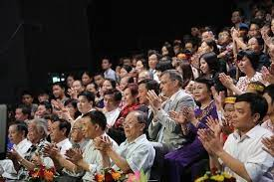  4. play a role in (idiom): be involved in or have an effect on  Ex: Water plays an important role in our life.  5. judge (n): someone who decides on the result of a competition | A list of words in Ss’ notebook | Elicit  Give synonym/ Vietnamese equivalent/ example/pictures to elicit vocabulary from Ss
 | * Listen & repeat | Sts’ pronunciation of the words | Listen to the audio/teacher & repeat in chorus then individually
 | * Check vocabulary: | The missing words on the board | Rub out and remember
- To help Ss practise guessing the meanings of words in context. | Task 2: Read a text about a famous music show. Match the highlighted words and phrases in the text to the meanings below. (ex.2, p.31) (8’) | Matched words and phrases with the meaning  Suggested answers:  1. b 2. a  3. d 4. c | Asks Ss to read and match the highlighted words and phrases in the text to the meanings.
ACTIVATE/ PRACTICE (20’)
- To practise reading for specific information | TASK 3: Read the text again and choose the best answers. (Ex.3, p.32) (10’) | Completed sentences  Key: 1. B 2. A  3. A 4. C  5. C | - Work in pairs  - Read the questions and underline the key words  - Choose the correct options  - Peer correction  - Teacher’s feedback
To help Ss use the ideas and language in the reading to talk about whether they want to take part in Vietnam Idol and give reasons. | TASK 4: Work in pairs. Discuss whether you want to participate in Vietnam idol. Give your reasons. (10’)    Reasons like dislike  1.lifting your mood  2.leading to stress and anxiety  3.reducing stress  4.be prepared for disappointment  5.enhancing social and emotional learning  6.creating sense of camaraderie and community  Model:  I like/dislike participating in Vietnam idol because I think………… | Ss’ ideas and oral presentation about the reasons Ss like or dislike Vietnam idol.  Suggested answers  Like: 1,3,5,6  Dislike:2,4, | - Ss work in pairs to make notes of things they like and dislike about the show to support their opinions  - T has Ss present a summary of their discussion  -Teacher’s feedback
CONSOLIDATION/ PRODUCTION (5’)
- To help students memorise the target language and skills that they have learned | 1.WRAP-UP (3’)  List the content Ss have learnt | Ss’ reflection about the content of the lesson. | - Class work  - Teacher’s feedback
- To inform students what the final product of the project should be and how students can prepare for it. | 2. HOMEWORK (2’)  a/ Exercises in the workbook  b/ - Search for more music shows on the Internet, take note the regulations and the prizes and post them on the Facebook/Zalo group of your class  - Prepare for Speaking lesson | Ss’ oral presentation of the research results | Groupwork

UNIT 3: MUSIC
Lesson 4: Speaking – Talking about a TV music show
I/ Learning outcomes:
By the end of this lesson, Ss will be able to:
- Knowledge:
- talk about a music show.
- Competences:
- be collaborative and supportive in pair work and team work;
- develop presentation skill;
- actively join in class activities;
- be creative;
- be critical in thinking.
- Attributes:
- be eager to create a new musical show;
- be ready to share their ideas with the whole class;
- be able to self-study.
II/ Teaching and learning resources:
Television, laptop, textbook, teacher's book, handouts.
III/ PROCEDURE:
Aims | Content | Outcomes | Steps
WARM UP (5’)
- To arouse the classroom atmosphere.  - To lead in the lesson. | Warm-up: (5’) Picture guessing     | Ss know the names of music shows.  Suggested answer:  - The voice kids  - RapViet  - Vietnam Idol Kids | Warm-up  - Ss look at the pictures and write down the names of the music shows.  - Ss share their answers with a partner.  - T checks by having some Ss to call out the answers.  - T leads in the new lesson.
PRESENTATION (10’)
- To pre-teach some vocabulary so that Ss can understand the meaning and use them correctly in main speaking tasks. | Activity 1. Vocabulary (5’)  - dress up (ph.v): /dres ʌp/ wear clothes that are more formal than those you usually wear    - runner-up (n): /ˌrʌnər ˈʌp/  a person or team that finishes second in a race or competition    - cash (n): /kæʃ/ money in the form of coins or notes    - come up with (ph.v): suggest or think of an idea or plan   | A list of words in ss’ notebook | Elicit  - T shows pictures/ gives explanations to elicit vocabulary from Ss.
 | * Listen & repeat | Sts’ pronunciation of the words | Listen to the audio/teacher & repeat in chorus then individually.
 | * Check vocabulary: | The missing words on the board | Rub out and remember
- To introduce more ideas for the main speaking tasks and get Ss involved in the lesson | 2. Task 1: Read about a TV music show and complete the notes below. (5’)  1. Name: I know your face  2. People who give their scores: …  3. Number of participants: …  4. What participants have to do: …  5. How participants win the show:  …  6. Prize(s): … | Ss’ complete notes about the TV music show.  Suggested answers:  2. two main judges and a guest artist  3. six  4. dress up and perform as famous international or local artists in a live show every week  5.  – 3 participants with the highest scores after 5 weeks go to the final night.  – TV audiences vote and decide on the winner and two runners-up.  6. cash | Individually  - Ss look at notes first and try to guess the information.  - T tells Ss to read the TV show description and complete the note.  - Ss compare their answers in pairs.  - T checks answers as a class.
PRACTICE (25’)
To help Ss brainstorm ideas for the speaking activity. | 1/ Match the information in column A with details in column B (3’)  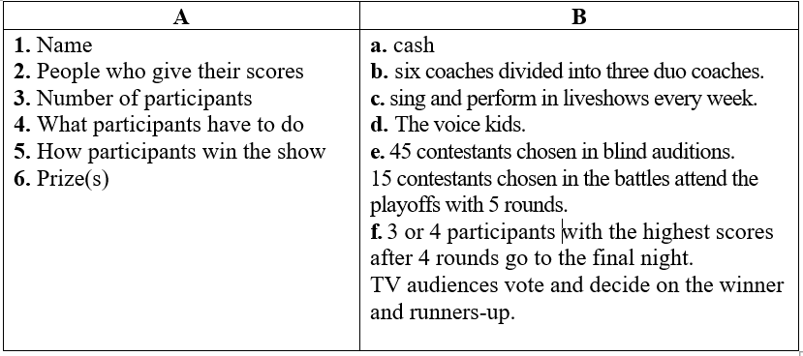 | - Ss’ complete notes about the TV music show.  Key:  1.d  2. b  3. e  4. c  5. f  6. a | - Ss work in groups of four to match the information in the handouts.  - Peer correction  - Teacher’s feedback
 | 2/ Task 2: Make up a new music show. Use the points in Task 1 and the activity Matching to organise your ideas. (7’) | Ss’ ideas about a TV music show.  Suggested answer:  - Your face sounds familiar  - Hidden voices  - X-factor  … | Brainstorming  - T asks Ss to refer back to their notes in Task 1 & Matching;  - T has Ss work in groups to brainstorm ideas for their new show and take notes.
To give Ss the opportunity to present their music shows to the class. | 3/ Present your show to the whole class. Use your ideas in Task 2 and the given expressions. Vote for the best show. (15’)  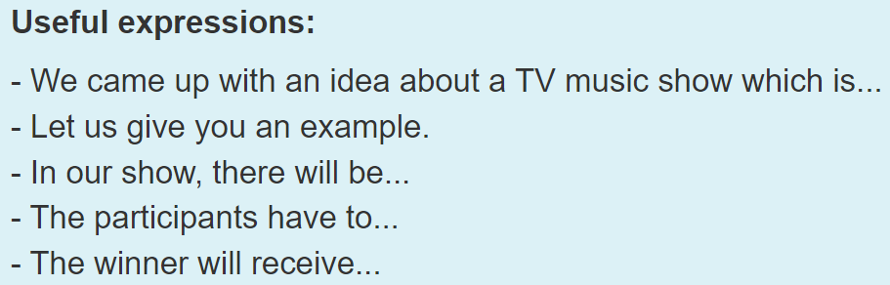 | Ss’ presentation about a TV music show. | - Ss work in groups to prepare for the presentation, using the given expressions.  - Some groups talk about their show.  - Class feedback  - T asks Ss to vote for the most interesting show.  - T gives feedback.
CONSOLIDATION/ PRODUCTION (5’)
To help Ss memorise the content of the lesson | 1.WRAP-UP (3’)  Teacher asks:  - What information should be included in a presentation about a TV music show?  - Can you talk something about your favourite TV music show? | - Ss’ reflection about the content of the lesson. | - T asks and Ss answer.
To help Ss prepare for the project | 2. HOMEWORK (2’)  a/ Exercises in the workbook  b/ Project preparation  - Search the Internet for some information about a form of traditional music in Vietnam or another country. | Ss’ report of information about a form of traditional music in Vietnam or another country. | Groupwork

