UNIT 3: MUSIC
Lesson 5: Listening

I/ Learning outcomes:
By the end of this lesson, Ss will be able to:
1. Knowledge.
- Listen for gist and specific information in an interview about a music festival;
- Talk about the reasons why they want/ don’t want to go to a music festival.
2. Competences.
- Be collaborative and supportive in pair work and team work;
- Actively join in class activities;
- Develop presentation skills;
- Be critical in thinking.
3. Attributes.
- Be more interested in music and music events.

II/ Teaching and learning resources:
- Grade 10 textbook, Unit 3, Listening
- Computer connected to the Internet
- Projector/ TV/ pictures and cards
- sachmem.vn

III/ PROCEDURE:

Aims | Content |  | Outcomes |  | Steps
WARM UP (6’)
- Arouse the classroom atmosphere.  - Get Ss be actively involved in the lesson | 1. Videos: (2’) | - Students’ oral prediction about the music festival |  | Watch videos
 | 2. Match the videos with their titles of the events (2’) | Suggested answer: music festival  1.Advertisment (Yamaha)  2. Football  3. Mid Autumn |  | Elicit  Stop the videos to elicit the titles
 | 3. Where do the events usually take place? (2’) | Expected answers:  On a farm/ at a stadium/ a park/ a beach |  | List  Work individually
ACTIVITY 1: PRESENTATION (6’)
- Understand and use the words related to the music events | New words  look at the photos to guess the meaning of new words  1. background (n): sounds that can be heard behind other sounds that are louder    2. stage (n): a raised area, usually in a theatre, etc. where actors, dancers, etc. perform    3. free of charge (adv): without having to pay    4. overcrowding (adj): the situation when there are too many people or things in one place    5. in advance (idiom): before the time that is expected; before something happens   | A list of words in Ss’notebook |  | Elicit  Give synonym/ Vietnamese equivalent/ example to elicit vocabulary from Ss
 | * Listen & repeat | Sts’ pronunciation of the words |  | Listen to the audio/teacher & repeat in chorus then individually
 | * Check vocabulary: | The missing words on the board |  | Rub out and remember
ACTIVITY 2: ACTIVATE/ PRACTICE (12’)
Practise listening for specific information | Today, we’ll listen to the music festival. Listen and do the tasks  TASK 2 (4’): Listen to an interview about preparations for an international youth music festival. Tick the information that you hear in the recording. (Ex.2, p.33)  TASK 3 (8’): Listen again and decide whether the following statements are true (T) or false (F). (Ex.3, p.33) | - Ss’ oral prediciton  - Ss’ answers  Key:A, D  Statements identified as true or false  Key: 1. F (first -> second); 2. F (They are still setting up the main stage and there’s still a lot to do.); 3. T; 4. F (They have sold the tickets in advance.); 5. T |  | Predict then listen and give answer  - Work individually  - Peer correction  - Teacher’s feedback  - Ss work in pairs or groups and compare answers
ACTIVITY 3: Production(10’)
Give Ss an opportunity to personalise the language and ideas from the listening in a speaking task. | Task 4 (10’)  Tell your friends about your experience on a music festival using the cues given:  - What is the name of the festival? - When did you attend?  - Where did the festival take place?  - Who did you go with?  - How do you feel about this festival? | - Ss’ oral presentation about the music festival |  | -SS talk about their music festival.  - T gives feedback
ACTIVITY 4: Consolidation (5’)
Help Ss memorise the content of the lesson | 1.Wrap-up  - We have listened to an interview about preparations for a music festival  2. Homework  - Exercises in the workbook  - Prepare for Writing lesson | - The vocabulary related to music festival and the content of the listening |  | - work individually

UNIT 3: MUSIC
Lesson 6: Writing
I. OBJECTIVES
By the end of this lesson, Ss will be able to:
- Knowledge:
- use lexical items related to the topic Music;
- write a blog about experiences at a music event.
- Core competence:
- be collaborative and supportive in pair work and team work;
- actively join in class activities;- be imaginative and creative ;- develop presentation skills.
- Personal qualities:
- be inspired to learn more about music and music events;
II/ Teaching and learning resources:
Tape (CD), Tivi, speakers, textbook, teacher's book, copies of pictures, handouts, laptop, posters
III/ PROCEDURE:
Aims | Content | Outcomes | Steps
ACTIVITY 1: WARM UP (8’)
-To arouse the classroom atmosphere  - To get Ss be actively involved in the lesson | 1.Introduction: (5’)  Game: Guess the mystery words.  : | Ss’s chance to know how to play the games | Introduce  The game
- Introduce some vocabulary to be learnt in the unit. | 2. What is the picture about? (2’) | Suggested answer:  Music | Elicit
Music event
 blog writing
 music website
ACTIVITY 2: STUDY/ PRESENTATION (15’)
- To pre-teach the pronunciation and the meaning of some vocabulary so that Ss can understand the content of the reading. | VOCABULARY:  1. hit (n): a song that is very popular  2. take place (phr.v): happen, especially after previously being arranged or planned  The music festival will take place on February 5th.  3.art exhibition (n): a collection of works of art, that are shown to the public | A list of words in notebook | Elicit  Give explanation/ Vietnamese equivalent/ example to elicit vocabulary from Ss
 | * Listen & repeat | Sts’ pronunciation of the words | Listen to the audio/teacher & repeat in chorus then individually
 | * Check vocabulary: | The missing words on the board | Rub out and remember
- To provide an example blog on a music website, which Ss can use as a model for their writing. | TASK 1: COMPLETE THE NOTES. (Ex.1, p.33)  Ann has just come back from a music event and shared her experience on a music website. Read her blog and complete the notes below.  e.g. Which event did Ann go to? | Notes completed  Key: Ann’s notes  Event: International Youth Music Festival  When: last Saturday  Where: in a big country park  Who with: some friends  Atmosphere: party  What we did:  saw favourite idols perform live on stage and listened to their greatest hits  – tasted yummy food from different countries  – made new friends  How we felt: excited | Work in pairs and note down  Copy in their notebooks
- To provide Ss with some useful words and phrases to describe experiences;  - To help Ss develop ideas for their writing in 3. | TASK 2: PUT THE WORDS & PHRASES INTO THE APPROPRIATE COLUMNS. (Ex.2, p.34)  Key:  _{Location} _{Atmosphere} _{Activities} _{Feeling} Feeling  _{beach} _{stadium} _{amazing} _{friendly} _{relaxed} _{wonderful} _{fun} _{watch fireworks} _{play games} _{take photos} _{see art exhibitions} _{play musical} _{instruments} _{amazing} _{excited} _{relaxed} _{wonderful} amazing excited relaxed wonderful | Competed column with the words and phrases provided | Work in groups of 4
ACTIVITY 3:
ACTIVATE\PRACTICE (17’)
- To help Ss practise developing ideas and an outline for their writing.  - To help Ss practise writing a blog about their personal experience at a music event. | TASK3: WRITE A BLOG. (Ex.3, p.34)  Imagine you went to a music event. Write a blog (about 120 words) to share  your experience. Use the notes in 1 and words and phrases in 2 to help you.  1. Instruct how to write the middle paragraph of the email.  2.Write a blog  3 Peer Correction  -Sample answer:  My sister and I attended the F5 tour at the National Stadium last night. I could sum up the concert in one word, INCREDIBLE. We found our way up to our seats after having a light meal and stood in a queue at the gate of the stadium for 45 minutes. When the curtain was raised to reveal the F5 band, the entire stadium went absolutely crazy. I was thrilled by every of their performances. There was so much emotion in many of their songs, and the way they performed was so terrific. This was such a wonderful experience, a night that I’ll never forget. I’m so grateful to have been able to have that experience. | Blog written | Work in teams
ACTIVITY 4: CONSOLIDATION/PRODUCTION (6’)
To help Ss memorise the content of the lesson | 1.WRAP-UP (3’)  - We have practised writing a blog about experiences at a music event.  2 Homework: - Search the Internet for music blogs, choose one that you like most and post it on your class’ Facebook or Zalo group, the blog which gets the most likes will be rewarded.  - prepare for Communication and Culture lesson. |  | Teacher’s feedback

UNIT 3: MUSIC
Lesson 7: COMMUNICATION & CULTURE
I/ Learning outcomes:
By the end of this lesson, Ss will be able to:
- Knowledge:
- make and respond to suggestions
- identify chau van singing and other types of traditional music in Viet Nam.
- Competences:
- be collaborative and supportive in pair work and team work;
- access and consolidate information from a variety of sources;
- be creative and imaginative in making conversations
- actively join in class activities.
- Attributes:
- be willing to learn about national folk music;
- be responsible for maintaining national folk music and national culture.
II/ Teaching and learning resources:

Tape (CD), Tivi, textbook, teacher's book, Laptop,

III/ PROCEDURE:

Aims |  | Content |  | Outcomes |  |  | Steps
ACTIVITY 1:WARM UP (5’)
- To arouse the classroom atmosphere.  - To help Ss revise some types of traditional music in Viet Nam. |  | Video watching: Watch the video and say the names of some types of traditional music in Viet Nam. |  | * Ss’ individual presentation  Suggested answers: Tuong, Cai luong, Cheo, Ca tru, Xam, Quan ho, Chau van |  | * Teacher divides the class into two teams and plays the recording.  - asks Ss to give their answers.
EVERY DAY ENGLISH - ACTIVITY 2: (7’) ACTIVATE/PRACTISE
- To review expressions for making and responding to suggestions.  - To provide Ss with an example conversation in which people make and respond to suggestions about going to a music show. |  | Listen and complete the following conversation with the expressions from the box. then practise it in pairs. (ex.1, p.34) |  | Completed conversation  Key:  1. C  2. B  3. A  4. D |  | * Teacher:  - has Ss look at the four options A - D and checks if they understand their meanings and use: phrases to make suggestions  - asks Ss to read the conversation and find clues for the missing expressions, then has them complete the gaps.  - plays the recording for Ss to listen and complete the conversation  - puts Ss into pairs to practise the conversation.
EVERY DAY ENGLISH - ACTIVITY 3: (10’) PRODUCTION
-To help Ss practise making and responding to suggestions. |  | Have similar conversation making and responding to suggestions about going to a music show. |  | ** Ss’ making conversation  Expected answers:  + music shows:  a traditional music performance, a pop music show, …….  + locations:  Hanoi opera house, Thang Long art performance centre, ** conversations performed by Ss |  |  | * Teacher:  - has Ss brainstorm some ideas about what kind of music show they want to go to, where and when it happens and who performs;  - asks Ss to work in pairs to make similar conversations ,using the expressions for making and responding to suggestions
CULTURE : ACTIVITY 4:VOCABULARY PRETEACHING (5’)
- To pre-teach the meaning of some words/phrases, so that Ss can use them in their presentation later and can understand the reading passage. |  | Vocabulary  1. praise (v)   2. chanting (n):   3. psychic (n): 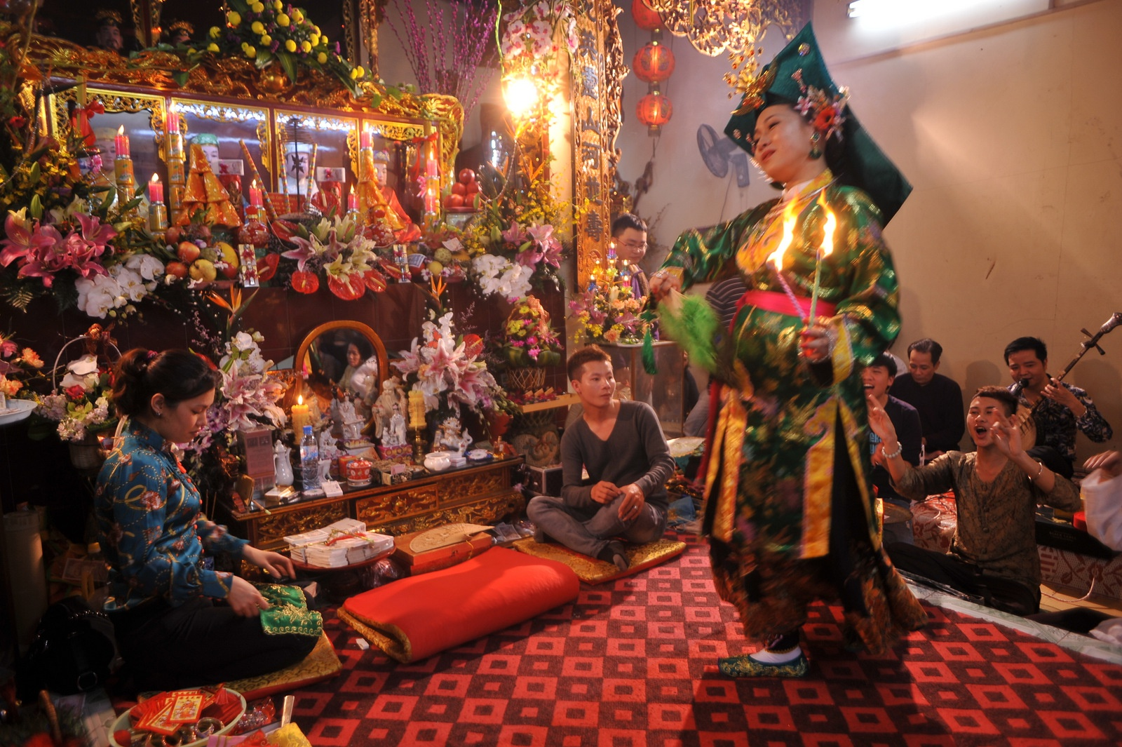  4. saint (n):  |  | A list of words in notebook |  |  | * Teacher:  - has Ss guess the meaning of the words based on pictures,
CULTURE – ACTIVITY 5 ( ACTIVATE) ( 10’)
- To introduce a type of traditional music in Viet Nam;  - To help Ss practise summarising the main points of a passage using a mind map. | Read a passage about chau van singing and complete the mind map below. (ex.1, p.35) |  | Completed mind map  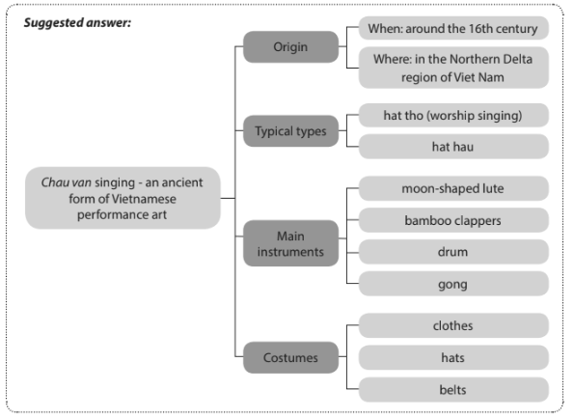 |  |  |  | * Teacher:  - asks Ss if they like traditional music and what types they are familiar with.  - has them look at the picture and describe it,  - introduces the type of music they are going to read about in this section.  - asks Ss to read the text and complete the mind map individually.
CULTURE – ACTIVITY 6 ( PRODUCTION) (5’)
To help Ss practise expressing opinions about a traditional type of music. |  | Tell your partner what you find most interesting about chau van singing. |  |  | ** Ss’ oral performance  Suggested answer: What I find most fantastic about chau van is that the psychic’s costumes are very colourful and the style of clothes, hats and belts depend on the rank of the gods or saints the performers worship. |  | * Teacher:  - asks Ss to work in pairs and share what they find most interesting about chau van singing.  *Teacher calls on some pairs to share their ideas with the whole class.
CONSOLIDATION & HOMEWORK (3’)
-To help Ss memorise the content of the lesson that they have learned |  | Wrap-up  Homework  - Exercises in the workbook  - Prepare for Looking back and Project lesson |  |  | Suggested answer:  -making and responding to suggestions;  -identifying chau van singing.

