UNIT 10: ECOTOURISM
Lesson 1: Getting started – An eco-friendly fieldtrip to Phong Nha Cave

I. OBJECTIVES
By the end of this lesson, students will be able to gain:
1. Knowledge
- An overview about the topic “Ecotourism”;
- Words and phrases related to ecotourism;
2. Core competence
- Develop communication skills and awareness of tourism and their impact on the environment;
- Be collaborative and supportive in pair work and teamwork;
- Actively join in class activities.
3. Personal qualities
- Develop a sense of being an ecotourist;
- Be aware of tourism and their impact on the environment.
II. MATERIALS
- Grade 10 textbook, Unit 10, Getting started
- Computer connected to the Internet
- Projector/ TV/ pictures and cards
- sachmem.vn

Language analysis
Form | Pronunciation | Meaning | Vietnamese equivalent
- stalactite (n) | /ˈstæləktaɪt/ | piece of rock hanging down from the roof of a cave | nhũ đá, thạch nhũ, vú đá
- fieldtrip (n) | /ˈfiːldˌtrɪp/ | a visit made by students to study something away from their school or college | chuyến tham quan
- packaging (n) | /ˈpæk.ɪ.dʒɪŋ/ | the materials in which objects are wrapped before being sold | bao bì, giấy gói hàng

Assumptions

Anticipated difficulties | Solutions
- Students may not know some words in the conversation.  - Students may not know how to work in teams. | - Provide students with some lexical items before listening and reading the conversation.  - Give short, clear instructions and help if necessary.

Board Plan
Date of teaching
UNIT 10: ECOTOURISM
Lesson 1: Getting started – An eco-friendly fieldtrip to Phong Nha Cave

* Warm-up: Brainstorming
Vocabluary
Task 1. Listen and read.
Task 2: Correct the mistakes.
Task 3: Put each phrase into the correct column.
Task 4: Complete these sentences from Task 1.
* Homework
Choose a local tourist attraction and find information about it.

III. PROCEDURES
Notes:
In each activity, each step will be represented as following
* Deliver the task
** Implement the task
*** Discuss
 Give comments or feedback

Stage | Stage aim | Procedure | Interaction | Time
WARM-UP | - To activate students’ knowledge on the topic of the unit.  - To create a lively atmosphere in the classroom.  - To lead into the new unit | BRAINSTORMING  * T asks Ss to brainstorm answers for the question: What would you like to do this summer vacation?  ** Ss work in groups to do brainstorming.  *** T and Ss discuss the answers.   T provides suggested answers and focuses on the phrase “take part in an eco-tour” to lead in the topic of the unit.  Suggested answer:  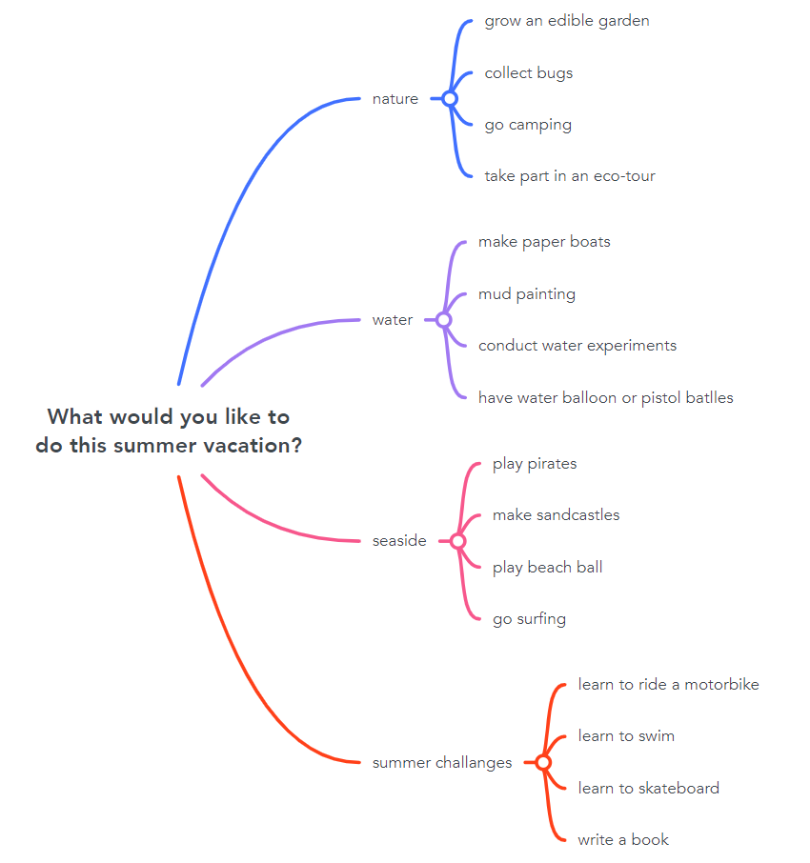 | T-S  S-S  T-S | 10 mins
PRESENTATION | To introduce some vocabulary related to the unit | VOCABULARY  * T asks Ss to look at the explanation and the photos to guess the meaning of new words.  ** Ss say the Vietnamese meanings of the words.  1. stalactite (n): piece of rock hanging down from the roof of a cave  2. fieldtrip (n): a visit made by students to study something away from their school or college  3. packaging (n): the materials in which objects are wrapped before being sold  *** Other Ss correct if the previous answers are incorrect.   T shows the meanings, says the words aloud and asks Ss to repeat them. | T-S  S  S-S  T-S | 5 mins
PRACTICE | To introduce the unit topic. | TASK 1. LISTEN AND READ. (p. 110)  * T asks Ss to look at the picture (p. 110), the heading of the conversation and answer the questions:  What can you see?  (A cave / Phong Nha Cave) Who are the speakers?  (Nam, Mai, and their teacher) What do you think they are discussing?  (A trip to the cave).  * T then plays the recording twice, has Ss listen to the conversation, read along and underline words / phrases related to the environment in the conversation.  ** Ss do the task individually.  *** T puts Ss in pairs and asks them to compare the words and phrases they have underlined and discuss their meaning.   T checks comprehension as a class. | T-S  T-S  S  Pair work  T-S | 10 mins
 | To check students’ comprehension of the conversation. | TASK 2. READ THE CONVERSATION AGAIN. THEN FIND AND CORRECT A MISTAKE IN EACH SENTENCE BELOW. (p. 111)  * T asks Ss to find a mistake in each sentence and correct it:  - T asks them to identify and underline the key words in the sentences first. Then T has them read the conversation again and locate the part that contains the information for each sentence.  - T has them compare the information in the conversation with each sentence to know which part of the sentence is incorrect, and how to correct it.  ** Ss do the task individually.  *** T has Ss work in pairs to discuss and compare their answers.   T checks the answers as a class.  - T has them call out the part of the sentence which is incorrect first. Then T asks them to give the corrections.  - Finally, T has some students read the complete correct sentences.  Suggested answers:  1. On an eco-friendly fieldtrip, tourists enjoy, explore and damage the environment.   but not  (OR: On an eco-friendly fieldtrip, tourists enjoy, explore and damage the environment. 🡪 protect/ learn about)  2. Nam will take pieces of stalactites because they take a long time to form.   will not / won’t  3. Mai will bring snacks with a lot of packaging on the trip.    will not / won’t  (OR: Mai will bring snacks with a lot of packaging on the trip.   less) | T-S  S  Pair work  T-S | 5 mins
 | To help students revise phrases related to ecotourism | TASK 3: PUT EACH PHRASE INTO THE CORRECT COLUMN. (p. 111)  * T has Ss read the phrases in the box and explains that these are things that tourists should do or shouldn’t on an eco-friendly fieldtrip.  ** T asks Ss to sort the phrases into the columns of Dos and Don’ts.  *** T puts Ss in pairs and asks them to compare their answers.  ****T checks answers as a class and elicits the meaning of any words students don’t know or find hard to understand.  Answers:  Dos: explore the place, learn about the place  Don’ts: damage the environment, leave litter behind | T-S  S  Pair work  T-S | 7 mins
 | To help students identify conditional sentences Type 1 and Type 2. | TASK 4: COMPLETE THESE SENTENCES FROM TASK 1. (p. 111)  * T asks Ss to read the two incomplete sentences and focus attention on the word ‘if’, eliciting what kind of words are missing (verbs).  ** T asks Ss to complete the sentences, using words from Task 1.  *** T puts Ss in pairs and asks them to compare their answers.   T checks the answers as a class.  Answers:  1. add, will be  2. were, wouldn’t | T-S  S  Pair work  T-S | 5 mins
WRAP-UP  HOMEWORK | - To help students memorise the target language and skills that they have learned  - To inform students what the final product of the Project should be like and how Ss can prepare for it. | WRAP-UP  - Some lexical items about ecotourism  - Reading for specific information  - Scanning  HOMEWORK  - Choose a local tourist attraction and find information about it.  - Exercises in the workbook  PROJECT PREPARATION  - Ask Ss to open their books at the last page of Unit 10, the Project section, look at the picture and say what the topic of the project is (An ecotour).  - Students will have to design an ecotour and then give an oral presentation of their ideas in the last lesson of the unit.  - Alternatively, ask students to prepare a poster presenting their ideas. In a poster presentation, students will display their inventions on posters and hang them around the classroom. One representative from each group will stand next to the poster. The rest will walk around, study the posters and talk to any representative of a group if they want to learn more about an invention.  - Then the class will sit down and vote for the best invention.  - Suggested steps students should follow:  - Collect information (search the Internet, read newspapers, etc.);  - Illustrate their ecotours on computers or on posters, etc.  - Rehearse for the oral or poster presentation.  - Put students into groups and have them choose their group leader. Then ask them to assign tasks for each group member, making sure that all group members contribute to the group work. | T-S | 3 mins

UNIT 10: ECOTOURISM
Lesson 2: Language
I. OBJECTIVES
By the end of this lesson, students will be able to gain:
1. Knowledge
- Use the lexical items related to the topic “Ecotourism”;
- Identify intonation patterns and use appropriate intonation (i.e. rising or falling tone);
- Use conditional sentences Type 1 and Type 2 correctly.
2. Core competence
- Be collaborative and supportive in pair work and teamwork;
- Access and consolidate information from a variety of sources;
- Actively join in class activities.
3. Personal qualities
- Develop a sense of an ecotourist;
- Be aware of tourism and their impact on the environment.
II. MATERIALS
- Grade 10 textbook, Unit 10, Language
- Computer connected to the Internet
- Projector/ TV/ pictures and cards
- sachmem.vn

Language analysis
Conditional sentences | Form | Use & Examples
Type 1 | If + present simple, … (will) … | Conditional sentences type 1 talk about real situations in the present or future that we believe are possible or likely to happen.  If you work hard, you will pass the exam.
Type 2 | If + past simple, … (would) … | Conditional sentences type 2 talk about imaginary situations that are impossible or unlikely to happen.  If I were a bird, I would fly.

Assumptions
Anticipated difficulties | Solutions
- Students may be confused when using conditional sentences type 1 and type 2.  - Students may have underdeveloped speaking and co-operating skills. | - Give short and clear explanations with legible examples for each case.  - Give clear instructions, give examples before letting students work in groups.  - Provide feedback and help if necessary.

Board Plan
Date of teaching
UNIT 10: ECOTOURISM
Lesson 2: Language
* Warm-up
Matching: Caves in Phong Nha – Ke Bang National Park
I. Pronunciation
Task 1: Listen and repeat.
Task 2: Role-play the conversation.
II. Vocabulary
Task 1. Match the sentences with the explanations.
Task 2: Complete the sentences.
III. Grammar
Task 1: Decide whether these statements can be real (R) or not (N).
Task 2: Put the verbs in brackets in the correct form.
Game: Surprising matching!
* Homework

III. PROCEDURES
Notes:
In each activity, each step will be represented as following
* Deliver the task
** Implement the task
*** Discuss
 Give comments or feedback

Stage | Stage aim | Procedure | Interaction | Time
WARM-UP | To activate students’ prior knowledge and introduce caves in Phong Nha – Ke Bang National Park. | MATCHING: CAVES IN PHONG NHA – KE BANG NATIONAL PARK  * T reveals that beside Phong Nha Cave, there are 9 other caves in Phong Nha – Ke Bang National Park and asks Ss to match the pictures with the correct names of the caves.  ** Ss work in groups of four to do the matching task.  *** T and Ss discuss the answers.   T confirms the answers as a class.  Key:  Phong Nha Cave Son Doong Cave  Hang En Cave Hang Toi Cave (Dark Cave)  Hang Voi Cave (Elephant Cave) Thien Duong Cave (Paradise Cave)  Tra Ang Cave Tu Lan Cave  Hang Va Cave Hang Vom & Hang Gieng Vooc Cave | T-S  Group work  T-S | 5 mins
PRONUNCIATION | To help students recognise the intonation patterns in different types of sentences. | TASK 1: LISTEN TO THESE SENTENCES. PAY ATTENTION TO THE INTONATION AND REPEAT. (p. 111)  * T asks Ss to listen to some sentences and has them pay attention to the arrows at the end.  ** T asks Ss to listen to the sentences again, but this time have them use their hands to indicate the falling and rising tones at the end of each sentence. T then asks Ss to read the notes in the Remember box and checks understanding by asking individual SS to briefly explain the intonation patterns in the three types of sentences: statements, Wh-questions and Yes-No questions and provide an example for each kind.  ***T plays the recording again, pausing after each sentence for Ss to repeat. T encourages them to use their hands to indicate the intonation pattern.   T confirms the correct intonation. | T-S  T-S  T-S  T-S | 5 mins
 | To help students practise different intonation patterns in a conversation. | TASK 2: WORK IN PAIRS AND ROLE-PLAY THIS CONVERSATION. PAY ATTENTION TO THE INTONATION. THEN LISTEN AND CHECK. (p. 111)  * T asks Ss to read quickly through the conversation and checks understanding.  ** T has Ss work in pairs to role-play the conversation.  *** T asks Ss to peer check and give comments to their partners.   T asks Ss to pay attention to the three intonation patterns they have just learnt.  Key:  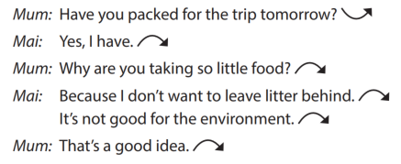 | T-S  Pair work  T-S | 5 mins
VOCABULARY | To help students understand the meanings of words / phrases related to ecotourism. | TASK 1. BELOW IS WHAT ECOTOURISTS DO. MATCH EACH SENTENCE ON THE LEFT WITH ITS EXPLANATION ON THE RIGHT. (P. 112)  * T explains the context of the activity and tells Ss that the statements represent things that ecotourists do.  ** Ss read the statements, focusing their attention on the key word highlighted in each sentence.  *** T puts Ss in pairs and asks them to compare their answers.   T checks answers as a class:  - Explain or elicit any new or difficult words  - Draw attention to the prepositions after some of the highlighted words  - Tell students they should try to memorise both the words and the prepositions that go with them.  Key:  1. b  2. a  3. e  4. d  5. c | T-S  S  Pair work  T-S | 4 mins
 | To help students practise these words in meaningful contexts. | TASK 2: COMPLETE THESE SENTENCES WITH THE HIGHLIGHTED WORDS IN TASK 1. (p. 112)  * T asks Ss to work in pairs and tells them to read the sentences carefully and decides which highlighted word in Task 1 can be used to complete each of the sentences.  ** Ss work in pairs to complete the task.  *** T asks Ss to peer check and give comments to their partners.   T checks answers as a class:  - Have Ss call out the word they have used in each sentence first.  - Confirm the correct answers.  - Ask Ss to explain the meaning of each word using the definitions in Task 1.  - Ask some students to read the complete sentences.  Key:  1. profit; crafts  2. aware; impact  3. responsible | T-S  Pair work  T-S | 10 mins
GRAMMAR | To help students recognise the differences between Types 1 and Type 2 conditional sentences. | TASK 1: DECIDE WHETHER THESE STATEMENTS CAN BE REAL (R) OR NOT (N). (p. 112)  * T asks Ss to study the sentences individually.  ** Ss decide which statement is possible or likely to happen, and which one is imaginary or unlikely to happen.  *** T asks Ss to peer check and give comments to their partners.   T checks answers as a class:  - Tell students that all sentences that are ‘possible or likely to happen’ are conditional sentences Type 1, while sentences that are ‘imaginary or unlikely to happen’ are conditional sentences Type 2.  - Ask students to read the notes in the Remember box. Check understanding by asking questions about each type.  Key:  1. N  2. R  3. N  4. R | T-S  S  Pair work  T-S | 6 mins
 | To help students practise conditional sentences Types 1 and Type 2. | TASK 2: PUT THE VERBS IN BRACKETS IN THE CORRECT FORMS. (p. 112)  * T asks Ss to put the verbs in brackets in the correct forms and tells them to pay attention to the meaning of each sentence, and whether the situation is possible (Conditional sentence Type 1) or not (Conditional sentence Type 2).  ** Ss complete the task individually.  *** T asks Ss to peer check and give comments to their partners.   T checks answers as a class:  - Have individual students write the sentences on the board.  - Go through each sentence and ask Ss to explain why they have used that particular form.  Key:  1. will stay  2. would grow  3. were / was; would be  4. give; will reduce | T-S  S  Pair work  T-S | 5 mins
EXTRA ACTIVITY | To give students a chance to apply what they have learnt. | GAME: SURPRISING MATCHING!  *T divides the class into 4 groups.  - Group A will write If clause type 1. Group B will write Main clause type 1.  - Group C will write If clause type 2 Group D will write Main clause type 2.  - T then will match members of group A with ones of group B, and do the same with group C and D.  ** Ss do as instructed.  *** T and Ss discuss and give comments to the surprising results.   T confirms the possible answers and restates the use of Conditional sentences type 1 and type 2. | T-S  S  S-S  T-S | 4 mins
WRAP UP  HOMEWORK | To help Ss memorise what they have learned | WRAP-UP  - Use the lexical items related to the topic ecotourism;  - Identify intonation patterns and use appropriate intonation (i.e. rising or falling tone)  - Use conditional sentences Type 1 and Type 2 correctly.  HOMEWORK  - Prepare for the next lesson: Unit 10 - Reading  - Exercises in the workbook | T-S | 1 min

UNIT 10: ECOTOURISM
LESSON 3: Reading – Ecotour brochures

I. OBJECTIVES
By the end of this lesson, Ss will be able to gain:
1. Knowledge
- Develop reading skills for specific information in a brochure about ecotours.
2. Core competence
- Develop communication skills and creativity;
- Be collaborative and supportive in pair work and team work;
- Develop presentation skills;
- Actively join in class activities.
3. Personal qualities
- Develop a sense of an ecotourist;
- Be aware of tourism and their impact on the environment.
II. MATERIALS
- Grade 10 textbook, Unit 10, Reading
- Computer connected to the Internet
- Projector/ TV/ pictures and cards
- sachmem.vn

Language analysis
Form | Pronunciation | Meaning | Vietnamese equivalent
- protect (v) | /prəˈtekt/ | to keep someone or something safe from injury, damage, or loss | bảo vệ
- souvenir (n) | /ˌsuː.vənˈɪər/ | something you buy or keep to help you remember a holiday or special event | quà lưu niệm
- explore (v) | /ɪkˈsplɔːr/ | to search and discover (about something) | khám phá

Assumptions

Anticipated difficulties | Solutions
- Students may lack knowledge about some lexical items.  - Students may have underdeveloped reading, speaking and co-operating skills. | - Provide students with the meaning and pronunciation of words.  - Let students read the text again (if necessary).  - Create a comfortable and encouraging environment for students to speak.  - Encourage students to work in pairs, in groups so that they can help each other.  - Provide feedback and help if necessary.

Board Plan
Date of teaching
UNIT 10: ECOTOURISM
Lesson 3: Reading – Ecotour brochures
* Warm-up
Name the tours
Task 1: Answer these questions.
Task 2: Solve the crossword.
Task 3: Which tour does each statement below talk about?
Task 4: Think of new ideas for making one of the tours better for the environment.
* Homework

III. PROCEDURES
Notes:
In each activity, each step will be represented as following
* Deliver the task
** Implement the task
*** Discuss
 Give comments or feedback

Stage | Stage aim | Procedure | Interaction | Time
WARM-UP | To introduce the topic of reading. | NAME THE TOURS  * T shows the pictures and asks Ss to name the tours based in these pictures.  ** Ss raise hands to provide the answers.  *** T and Ss discuss the answers.   T confirms the appropriate names of the tours and provides suggested answers.  Suggested answers:  Reef Tour Trekking Tour  National Park Tour Whale-watching Tour | T-S  S  T-S  T-S | 5 mins
PRE-READING | To introduce the topic of the reading and get students involved in the lesson. | TASK 1: WORK IN PAIRS. ANSWER THESE QUESTIONS. (p. 113)  * T puts Ss in pairs to ask and answer the questions.  **T explains that each photo is part of a brochure advertising a tour in four different places: Australia, Viet Nam, Zimbabwe, Hawaii and asks them to discuss what tourists can do on the tours without reading the texts.  *** T has some Ss share their answers with the whole class.   T gives comments and checks students’ pronunciation if necessary. | T-S  T-S  S  T-S | 7 mins
WHILE-READING | To help students practise guessing the meaning of words from context. | TASK 2: READ THE BROCHURES BELOW. THEN WORK IN PAIRS TO SOLVE THE CROSSWORD USING WORDS FROM THE BROCHURES. (p. 113)  * T points out that the part of speech (v, n, adj) as well as the brochure where they can find the words are provided in brackets.  ** T asks Ss to work in pairs to solve the crossword using words from the brochures.  *** T walks round the class and provides help if necessary.   T checks the answers as a class.  - Have individual Ss write the words on the board.  - In weaker classes, check understanding of the words by asking students to make sentences with them.  Key:  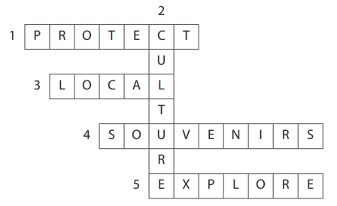 | T-S  Pair work  T-S  T-S | 10 mins
 | To help students practise reading for specific information. | TASK 3: WHICH TOUR DOES EACH STATEMENT BELOW TALK ABOUT? WRITE A, B, C OR D. (p. 113)  * T reminds Ss of the scanning skill:  - Ask Ss to read the four statements and underline the key words in each of them.  - Check the key words students have underlined.  - Remind Ss that the statements may include paraphrased information. Tell them to read through the brochures again looking for the key words they underlined in the statements or words with the same or similar meaning.  ** T asks Ss to match each statement with the correct brochure.  *** T asks Ss to peer check and give comments to their partners.   T checks answers as a class.  Key:  1. d (Clue: Buy local souvenirs to help the local Whale Protection Program)  2. c (Clue: Learn how you can help save wild animals in the local research centre)  3. b (Clue: Children not allowed)  4. a (Clue: Watch 3D documentaries to learn about sea animals and the coral reef, and what you can do to protect it) | T-S  T-S  Pair work  T-S | 10 mins
POST-READING | To help students use the language and ideas from the unit to make suggestions for more eco-friendly tours. | TASK 4: WORK IN GROUPS. THINK OF NEW IDEAS FOR MAKING ONE OF THE TOURS BETTER FOR THE ENVIRONMENT. (p. 114)  * T asks Ss if they think the four tours in Task 2 are friendly to the environment and has Ss read the brochures again and underline things that make them eco-friendly.  ** T puts Ss into groups. Each group should choose a tour and brainstorm ideas for making it more eco-friendly. Ss read the example, then elicit which brochure it refers to (c) and how it will help the environment  *** T asks Ss some groups to present a summary of their ideas or just the most useful ones in front of the class.   T encourages the rest of the class to give comments and praises for good effort and interesting ideas.  Suggested answers:  A. If they ban swimming with fish, the Great Barrier Reef will be better protected. Tourists should not be allowed to dive very close to the coral reefs.  B. Tourists should always follow the walking paths and trails on the Sa Pa Trekking Tour. The local people with whom the tourists stay should only use local ingredients. If they only use local ingredients, their carbon footprint will be lower.  D. The boats on the Whale-watching Tour should not get too close to the whales or make too much noise. If the boats are environmentally friendly, they will not harm the whales or their habitats. This is because environmentally-friendly boats use less fuel and oil, make small waves and are quiet. | T-S  Group work  S  T-S | 10 mins
WRAP-UP  HOMEWORK | To help Ss memorise the target language and skills that they have learned | WRAP-UP  - Some lexical items about ecotourism.  - Reading for general and specific information in a brochure about ecotours.  HOMEWORK  - Prepare for the next lesson: Unit 10 – Speaking  - Exercises in the workbook | T-S | 3 mins

UNIT 10: ECOTOURISM
Lesson 4: Speaking – How to become an ecotourist

I. OBJECTIVES
By the end of this lesson, Ss will be able to gain:
1. Knowledge
- Talk about how to become an ecotourist.
2. Core competence
- Develop communication skills and creativity;
- Be collaborative and supportive in pair work and team work;
- Develop presentation skills;
- Actively join in class activities.
3. Personal qualities
- Develop a sense of being an ecotourist;
- Be aware of tourism and their impact on the environment.
II. MATERIALS
- Grade 10 textbook, Unit 10, Speaking
- Computer connected to the Internet
- Projector/ TV/ pictures and cards
- sachmem.vn

Language analysis
Functions | Useful expressions | Examples
Giving suggestions | … should (not) / ought (not) to / do sth. | We should not litter on the beach or the street.
 | One of the things … can / should (not) do / is (to) do sth. | One of the things we should not do is to litter on the beach or the street.
 | I suggest that … (should / should not) do sth. | I suggest that we should not litter on the beach or the street.
 | It will (be better / good …) if …/ do / avoid doing sth. | It will be better for the environment if we avoid littering on the beach or the street.

Assumptions
Anticipated difficulties | Solutions
Students may lack knowledge about some useful structures. | Provide students with the form and use of some useful structures in their talk.
Students may have underdeveloped speaking and co-operating skills. | - Create a comfortable and encouraging environment for students to speak.  - Encourage students to work in pairs, in groups so that they can help each other.  - Provide feedback and help if necessary.
Some students will excessively talk in the class. | - Explain expectations for each task in detail.  - Have excessive talking students practise.  - Continue to clarify task expectations in small chunks (before every activity).

Board Plan
Date of teaching
UNIT 10: ECOTOURISM
Lesson 4: Speaking
* Warm-up
Matching game
Task 1: Match each verb on the left with a phrase on the right.
* Speaking: Benefits of volunteering activities
Task 2: Discuss which of the things in Task 1 we should or should not do to become ecotourists.
Task 3: Talk about what tourists should or should not do if they are on an ecotour to a tourist attraction in your local area.
Task 4: Share your ideas with the whole class. Vote for the best ideas.
* Homework

III. PROCEDURES
Notes:
In each activity, each step will be represented as following
* Deliver the task
** Implement the task
*** Discuss
 Give comments or feedback

Stage | Stage aim | Procedure | Interaction | Time
WARM-UP | - To introduce the topic of reading.  - To enhance students’ skills of cooperating with teammates. | MATCHING GAME  Task 1: Match each verb on the left with a phrase on the right. Use the pictures to help you. (p. 114)  * T puts Ss work in groups of four. Each group will have to match a verb with the appropriate phrase. The fastest groups with the correct answers will be the winner.  ** Ss work in groups.  *** Ss give comments to other groups.   T confirms the answers.  Key:  1. c 2. d 3. a  4. b 5. f 6. e) | T-S  S-S  T-S | 5 mins
CONTROLED PRACTICE | To help students brainstorm more ideas for the main speaking task. | TASK 2: WORK IN PAIRS. DISCUSS WHICH OF THE THINGS IN TASK 1 WE SHOULD OR SHOULD NOT DO TO BECOME ECOTOURISTS. USE THE EXPRESSIONS BELOW TO HELP YOU. (p. 115)  * T asks Ss to read the useful expressions and the examples in the box. T asks S to work in pairs and discuss which of the activities in Task 1 they should do, and which they should not do to become ecotourists.  ** Ss do as instructed.  *** T walks round the class and provides help and encourages pairs to try to use the structures in the box.   T asks some pairs to present their ideas in front of the whole class and praises them for interesting suggestions and fluent delivery. | T-S  S  T-S  S-S | 10 mins
LESS-CONTROLED PRACTICE | To give students an opportunity to discuss in groups and give suggestions to ecotourists. | TASK 3: WORK IN GROUPS. TALK ABOUT WHAT TOURISTS SHOULD OR SHOULD NOT DO IF THEY ARE ON AN ECOTOUR TO A TOURIST ATTRACTION IN YOUR LOCAL AREA. USE THE DISCUSSION QUESTIONS BELOW TO HELP YOU. (p. 115)  * T asks S to study the discussion questions first and checks understanding by eliciting some responses from the whole class. T puts Ss into groups and asks each group to choose a tourist attraction in their local area.  - Tell them to talk about what tourists should or should not do if they are on an ecotour to that tourist attraction.  - Remind them that they are going to share their ideas with the whole class later.  - Give sheets of paper form them to take notes of their ideas.  ** Ss do as instructed.  *** T walks round the class and provide help when necessary. | T-S  S  T-S | 10 mins
FREE PRACTICE | To help students present their ideas in front of the class. | TASK 4: SHARE YOUR IDEAS WITH THE WHOLE CLASS. VOTE FOR THE BEST IDEAS. (p. 115)  * T has each group prepare a brief presentation of their ideas. T allows a time limit of 3 - 4 minutes for Ss to practise their presentations in their group. T invites some groups to present in front of the class while the rest of the class give feedback and say what they like about it. When Ss finish their presentations, T lets them reflect on their performance.  ** Ss do as instructed.  *** T walks round the class and provides help when necessary.   T asks other students to give further comments. T then praises for good effort, highlights the presenters’ strong points and makes suggestions for better organisation and presentation of their ideas. | T-S  S  T-S | 17 mins
WRAP-UP  HOMEWORK | To help students memorise the target language and skills that they have learned | WRAP-UP  Talk about how to become an ecotourist  HOMEWORK  - Prepare for the next lesson: Unit 10 – Listening  - Exercises in the workbook | T-S | 3 mins

UNIT 10: ECOTOURISM
Lesson 5: Listening – An ecotour in the Mekong Delta
I. Objectives
By the end of this lesson, Ss will be able to gain:
1. Knowledge
- Use the lexical items related to the topic “Ecotourism”;
- Listen for specific information in a tour guide speech welcoming ecotourists in the Mekong Delta.
2. Core competence
- Develop communication skills and creativity;
- Be collaborative and supportive in pair work and team work;
- Actively join in class activities.
3. Personal qualities
- Develop a sense of an ecotourist;
- Be aware of tourism and their impact on the environment.
II. Materials
- Grade 10 textbook, Unit 10, Listening
- Computer connected to the Internet
- Projector/ TV/ pictures and cards
- sachmem.vn

Assumptions
Anticipated difficulties | Solutions
Students may have underdeveloped listening skills. | - Play the recording many times if necessary.  - Encourage students to work in pairs, in groups so that they can help each other.  - Provide feedback and help if necessary.
Some students will excessively talk in the class. | - Explain expectations for each task in detail. Have excessive talking students practice.  - Continue to explain task expectations in small chunks (before every activity).

Board Plan
Date of teaching
UNIT 10: ECOTOURISM
Lesson 5: An ecotour in the Mekong Delta
* Warm-up
Answer the questions.
* Listening
Task 1: What do you think ecotourists can do there?
Task 2: Listen to a tour guide introducing the tour. Number the pictures in Task 1 in the order you hear them.
Task 3: Fill in each gap in the brochure.
Task 4: Discuss the question.
* Homework

III. PROCEDURES
Notes:
In each activity, each step will be represented as following
* Deliver the task
** Implement the task
*** Discuss
 Give comments or feedback

Stage | Stage aim | Procedure | Interaction | Time
WARM-UP | - To introduce the topic of reading.  - To set the context of the listening text and activate students’ prior knowledge. | ANSWER THE QUESTIONS  *T asks Ss some questions about river deltas.  1. How many river deltas are there in Viet Nam?  2. Do you know the names of the 2 river deltas in Viet Nam?  3. Do you know another name for Cuu Long River Delta?  **Ss spend some time thinking about the answers for the questions.  ***Some Ss share the answers with the whole class.  ****T confirms the answers and leads in the new lesson.  Suggested answers:  1. There are 2.  2. Red River Delta and Cuu Long River Delta.  3. Mekong Delta. | T-S  S  S-S  T-S | 5 mins
PRE-LISTENING | To introduce more topic-related vocabulary and activate students’ prior knowledge. | TASK 1: WORK IN PAIRS. LOOK AT THE PHOTOS FROM AN ECOTOUR IN THE MEKONG DELTA. WHAT DO YOU THINK ECOTOURISTS CAN DO THERE? (p. 115)  * T sets the context.  - Ask Ss to imagine they are ‘travelling’ to Mekong Delta today.  - Describe or show it on the map. (It is in the far south of Viet Nam, covering 13 cities and provinces such as Can Tho, Long An, Tien Giang, Ben Tre, Vinh Long, Tra Vinh, Hau Giang, Soc Trang, Dong Thap, An Giang, Kien Giang, Bac Lieu and Ca Mau.)  - Introduce or pre-teach some words or phrases to help students describe the pictures, e.g. floating market, host family, weaving (village).  ** T puts Ss in pairs and asks them to study the pictures and describe what they see in each one. T encourages Ss to think what ecotourists can do there based on the pictures.  *** T asks some Ss to share their ideas with the whole class.   T and Ss discuss the ideas.  Suggested answers:  - Picture a: Have a traditional meal/food (with a host family or at a local restaurant)  - Picture b: Visit a weaving village, buying traditional arts and crafts  - Picture c: Visit a floating market, buying fruits there | T-S  S-S  S-S  T-S | 7 mins
WHILE-LISTENING | To help students practise listening for specific information to order pictures. | TASK 2: LISTEN TO A TOUR GUIDE INTRODUCING THE TOUR. NUMBER THE PICTURES IN TASK 1 IN THE ORDER YOU HEAR THEM. (p. 115)  * T tells Ss to listen to a tour guide introducing an eco-friendly tour in the Mekong Delta. T asks Ss to order the pictures while they are listening to the recording.  ** Ss do as instructed.  *** T has Ss swap their textbooks for peer checking.   T checks the answers as a class.  Key:  1. c  2. b  3. a | T-S  S  S-S  T-S | 10 mins
 | To help students practise listening for specific information. | TASK 3: LISTEN AGAIN. FILL IN EACH GAP IN THE BROCHURE BELOW WITH ONE WORD. (p. 115)  * T tells Ss that they are going to listen to the recording again.  ** Ss have some time to study the brochure first then fill in the gaps in a brochure.  *** T asks Ss to discuss their answers in pairs when they finish.   T checks the answers as a class, plays the recording again, pausing after each answer.  Key:  1. eco-friendly  2. local  3. souvenirs  4. traditional | T-S  S  S-S  T-S | 10 mins
POST-LISTENING | To give students the opportunity to use the ideas and language in the listening to talk about their opinions and give reasons. | TASK 4: WORK IN GROUPS AND DISCUSS THE QUESTION. (p. 115)  * T has Ss look at the brochure in 3 again and underline the activity they find most interesting.  ** T puts Ss in pairs to discuss their choices.  *** T invites some groups to share their ideas in front of the class.   Other groups discuss the questions, take notes of the ideas and give feedback to their friends. | T-S  S-S  S | 10 mins
WRAP-UP  HOMEWORK | To help Ss memorise the target language and skills that they have learned. | WRAP-UP  - Some lexical items related to the topic Ecotourism  - Listen for specific information in a tour guide speech welcoming ecotourists in the Mekong Delta  HOMEWORK  - Prepare for the next lesson: Unit 10 – Writing  - Exercises in the workbook | T-S | 3 mins

UNIT 10: ECOTOURISM
Lesson 6: Writing – Writing a website advertisement for an ecotour

I. OBJECTIVES
By the end of this lesson, Ss will be able to gain:
1. Knowledge
- Use the lexical items related to the topic Ecotourism;
- Write a website advertisement for an ecotour.
2. Core competence
- Develop communication skills and creativity;
- Be collaborative and supportive in pair work and team work;
- Actively join in class activities.
3. Personal qualities
- Develop a sense of an ecotourist;
- Be aware of tourism and their impact on the environment.

II. MATERIALS
- Grade 10 textbook, Unit 10, Writing
- Computer connected to the Internet
- Projector/ TV/ pictures and cards
- sachmem.vn

Assumptions

Anticipated difficulties | Solutions
Students may have underdeveloped writing skills. | - Encourage students to work in pairs and in groups so that they can help each other.  - Provide feedback and help if necessary.

Board Plan
Date of teaching
UNIT 10: ECOTOURISM
Lesson 6: Writing – Writing a website advertisement for an ecotour
* Warm-up
Video watching
* Writing
Task 1: Look at the photos and complete the notes.
Task 2: Rewrite the sentences.
Task 3: Write a website advertisement for an ecotour to Hoi An villages.
* Homework

III. PROCEDURES
Notes:
In each activity, each step will be represented as following
* Deliver the task
** Implement the task
*** Discuss
 Give comments or feedback

Stage | Stage aim | Procedure | Interaction | Time
WARM-UP | - To introduce the topic of writing.  - To set the context for the writing part. | VIDEO WATCHING  * T plays a video and asks Ss to guess the place in the video.  ** Ss raise hands to provide the name of the place.  *** Ss discuss their friends’ answers.   T confirms the answer as a class.  Video link: https://www.youtube.com/watch?v=ZSyoQflfkyU  Answers: Hoi An Ancient Town | T-S  S  S-S  T-S | 5 mins
PRE-WRITING | To brainstorm ideas for their writing task | TASK 1: LOOK AT THE PHOTOS OF AN ECOTOUR TO HOI AN VILLAGES (DA NANG, VIET NAM), AND COMPLETE THE NOTES BELOW. THEN DISCUSS YOUR IDEAS IN PAIRS. (p. 116)  * T tells Ss that they are going to write about an ecotour in Hoi An.  ** T puts Ss in pairs to work on the notes together:  - Asks Ss to focus attention on the pictures on page 54 and study them.  - Asks each question and has students read the examples.  *** Ss discuss their answers.   T checks the answers as a class.  Suggested answers:  What do you think is special about Hoi An villages?  - coconut palms near Thu Bon River  - traditional crafts such as colourful paper lanterns  What do you think tourists can do there?  - do the gardening at a local farm  - ride bicycles through the villages  - travel on basket boats  - visit craft villages  What can tourists do to make their trip more eco-friendly?  - use eco-friendly transport such as bicycles  - buy traditional crafts to help local people | T-S  Pair work  S-S  T-S | 7 mins
 | To help students revise expressions and structures to use in their writing task. | TASK 2: REWRITE THESE SENTENCES ABOUT HOI AN VILLAGES. USE THE EXPRESSIONS BELOW TO HELP YOU. (p. 116)  * T asks Ss to study the useful expressions in the box, then focuses attention on the sentences and checks comprehension.  ** T asks Ss to rewrite them, using the suggested words and the structures in the box.  *** T asks Ss to swap their textbook for peer checking.   T checks answers as a class.  Suggested answers:  1. Hoi An villages are well-known for their beautiful vegetable and herb gardens.  2. Tourists can spend the morning working on a local farm.  3. Tourists are recommended to buy handmade products to help local businesses | T-S  S  Pair work  T-S | 8 mins
WHILE-WRITING | To help students practise writing a website advertisement for an ecotour to Hoi An villages. | TASK 3: WRITE A WEBSITE ADVERTISEMENT (120 – 150 WORDS) FOR AN ECOTOUR TO HOI AN VILLAGES. USE WHAT YOU HAVE LEARNT IN TASK 1 AND TASK 2 AND THE SUGGESTED OUTLINE BELOW TO HELP YOU. (p. 116)  * T asks Ss to study the suggested outline in their Student’s Book.  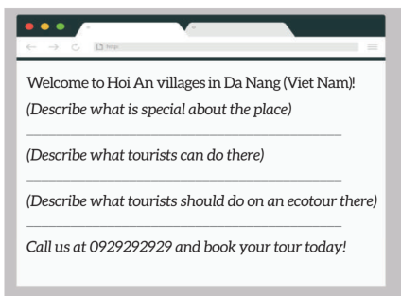  ** T gives Ss a time limit to do the writing task.  *** T walks round the class to provide help when necessary. | T-S  S  T-S | 15 mins
POST-WRITING | To do a cross-check and final check on students’ writing. | PEER CHECK  * T has the groups swap and gives feedback on each other’s writing.  ** Ss work in pairs and swap their draft letters for peer review.  *** T then gives feedback on one writing as a model.  ****T collects Ss’ writings to mark and provides written feedback in the next lesson.  Sample answer:  Welcome to Hoi An villages in Da Nang, Viet Nam!  Hoi An villages are famous for their beautiful vegetable and herb gardens. They are also well-known for the coconut palms near the Thu Bon River and traditional crafts such as colourful paper lanterns.  Here in Hoi An villages, you can spend the morning gardening on the local farms. Other leisure activities include riding bicycles through the villages, travelling on basket boats and visiting craft villages.  We offer an ecotour to Hoi An villages, and tourists are encouraged to use eco-friendly transport such as bicycles to avoid polluting the environment. You can also buy local products and beautiful crafts to help local businesses!  Call us at 0929292929 and book your tour today! | T-S  Pair work  T-S  T-S | 7 mins
WRAP-UP  HOMEWORK | To help Ss memorise the target language and skills that they have learned. | WRAP-UP  - Some lexical items related to the topic Ecotourism.  - Write a website advertisement for an ecotour.  HOMEWORK  - Rewrite the paragraph in the notebooks.  - Prepare for the next lesson: Unit 10 – Communication and culture/ CLIL.  - Exercises in the workbook. | T-S | 3 mins

UNIT 10: ECOTOURISM
Lesson 7: Communication and Culture/ CLIL
I. OBJECTIVES
By the end of this lesson, Ss will be able to gain:
1. Knowledge
- Use the lexical items related to the topic “Ecotourism”;
- Ask for and give advice;
- Know more information about tourism's impact on the environment.
2. Core competence
- Be collaborative and supportive in pair work and teamwork;
- Access and consolidate information from a variety of sources;
- Actively join in class activities.
3. Personal qualities
- Develop a sense of an ecotourist;
- Be aware of tourism and their impact on the environment.
II. MATERIALS
- Grade 10 textbook, Unit 10, Communication and culture/ CLIL
- Computer connected to the Internet
- Projector/ TV/ pictures and cards
- sachmem.vn

Language analysis
Useful expressions
Asking for advice | Giving advice
- Can you help me with (sth)?  - I have a problem and I need your help / advice.  - Should I (do sth)?  - What do you think I should (do / bring…)? | - You should / ought to / had better (do sth).  - It’s / It'll be a good idea (to do sth).  - If I were you, I would (do sth).  - What about / How about (doing sth)?  - Why don’t you (do sth)?  - I’d recommend (doing sth).

Assumptions
Anticipated difficulties | Solutions
Students may have underdeveloped speaking and co-operating skills. | - Encourage students to work in pairs and in groups so that they can help each other.  - Provide feedback and help if necessary.
Some students will excessively talk in the class. | - Explain expectations for each task in detail.  - Have excessive talking students practise.  - Continue to explain task expectations in small chunks (before every activity).

Board Plan
Date of teaching
UNIT 10: ECOTOURISM
Lesson 7: Communication and Culture/ CLIL
* Warm-up
Brainstorming
I. Everyday English
Task 1: Listen and complete the conversation.
Task 2: Make similar conversations.
II. CLIL
Task 1: Complete the table.
Task 2: Tick the appropriate column.
* Homework

III. PROCEDURES
Notes:
In each activity, each step will be represented as following
* Deliver the task
** Implement the task
*** Discuss
 Give comments or feedback

Stage | Stage aim | Procedure | Interaction | Time
WARM-UP | To introduce the topic. | BRAINSTORMING  * T asks Ss to answer the question: “What kind of advice do you need before a tour/trip?”  ** Ss raise hands to do brainstorming.  *** T and Ss discuss the answers.   T provides the suggested answers and introduces the topic of the listening task.  Suggested answers:  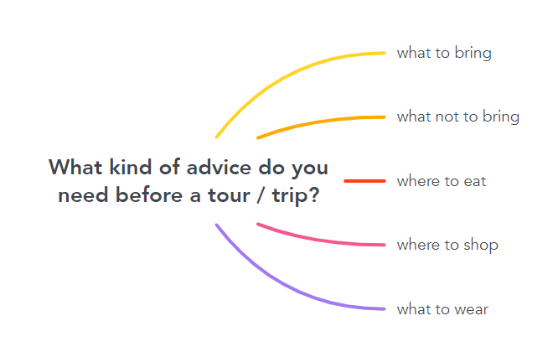 | T-S  S  T-S  T-S | 5 mins
EVERYDAY ENGLISH | To introduce and help students remember different structures to ask for and give advice. | TASK 1: LISTEN TO A CONVERSATION BETWEEN A WOMAN AND A TOUR GUIDE. FILL IN EACH GAP WITH ONE WORD YOU HEAR. THEN PRACTISE IT WITH YOUR PARTNER. (p. 117)  * T tells Ss that they are going to listen to a conversation between a woman and a tour guide:  - While listening, Ss should complete the conversation with the words they hear.  - Gives them some time to skim through the conversation. Checks understanding of the words such as surfing, surfboard and wetsuit.  - Encourages them to guess the answers before listening.  ** Ss listen to the conversation and complete the listening task.  *** T asks Ss to swap their textbooks for peer checking.   T checks the answers as a class:  - Plays the recording again, pausing after each word to confirm the correct answers.  - Puts Ss into pairs and has them practise the conversation.  Answers:  1. should  2. were  3. Should  4. recommend | T-S  S  Pair work  T-S | 7 mins
 | To help students practise asking for and giving advice about a trip. | TASK 2: WORK IN PAIRS. MAKE SIMILAR CONVERSATIONS ASKING FOR AND GIVING ADVICE ABOUT TRIPS. USE THE EXPRESSIONS BELOW TO HELP YOU. (p. 117)  * T gives the instruction of the task:  - Tells Ss that the words they used to fill in the gaps in 1 are part of expressions for asking for and giving advice.  - Asks Ss to read the list of expressions and checks understanding.  ** Ss work in pair to complete the task:  - Ss role-play conversations similar to the one in Task 1.  - Ss should pretend that one of them is a tourist and the other is the tour guide.  - Ss have a few minutes to plan their conversations before they role-play them.  - Ss should decide on the type of tour, the place, the activities and what advice to ask for and give.  - Ss then swap roles.  *** T walks round the class and provides help when necessary.   T asks some pairs to role-play their conversations in front of the whole class, praises for good effort, clear pronunciation and fluent delivery. | T-S  Pair work  T-S  S-S | 10 mins
CLIL | To help students learn about types of tourism through CLIL (Environmental studies) and learn some content vocabulary. | TASK 1: READ THE TEXT BELOW AND FILL IN EACH GAP IN THE TABLE BELOW WITH ONE OF THE HIGHLIGHTED WORDS FROM THE TEXT. (p. 117)  * T sets the context:  - Asks Ss some questions to find out what they already know about the topic:  - What kinds of impact does tourism have on the environment?  - Name different kinds of tourism which are good / bad for the environment that you know?  - Asks Ss what they want to know about the topic. Writes their questions on the board:  - How much damage will tourism do to the environment in the future? (CO2-emissions from tourism will increase by 25% in the next 15 years);  - What are the main ways for tourism to damage the environment?  (direct and indirect: When tourists are littering on the street, they are damaging the environment directly. When tourists are travelling by plane and vehicles which emit CO2, they are damaging the environment indirectly).  - Asks Ss to look at the two pictures and think of to opposite adjectives to describe each, e.g. crowded vs. private, noisy vs. quiet, polluted vs. eco-friendly.  ** T tells Ss that they are going to read about four popular types of tourism and puts them into categories in the table according to their negative or positive impact on the environment.  *** T and Ss elicit any new or difficult words, e.g. Why is tourism called ‘the smokeless industry’? (Because it is an industry without chimneys and is considered environmentally friendly).   T confirms the answers as a class.  Key:  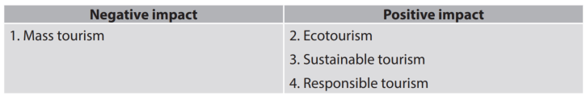 | T-S  S  S-S  T-S | 10 mins
 | To help students understand differences between four main types of tourism. | TASK 2: WHICH KIND OF TOURISM DOES EACH DESCRIPTION BELOW FIT BEST? TICK THE APPROPRIATE COLUMN. (p. 118)  * T tells Ss to read the text again to decide which statement fits which type of tourism.  ** Ss do the task in groups.  *** T lets Ss discuss their answers.   T checks answers as a class:  - Has Ss call out their answers first.  - Then provides, or asks some Ss to provide the clue for the answers in the text  Key:  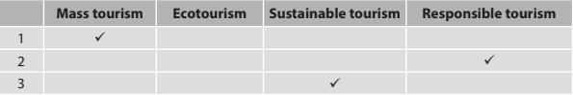 | T-S  Group work  S-S  T-S | 10 mins
WRAP-UP  HOMEWORK | To help Ss memorise what they have learned | WRAP-UP  - Use the lexical items related to the topic Ecotourism.  - Ask for and give advice.  - Know more information about tourism's impact on the environment.  HOMEWORK  - Prepare for the next lesson: Unit 10 – Looking back and project.  - Exercises in the workbook . | T-S | 3 min

UNIT 10: ECOTOURISM
Lesson 8: Looking back and project
I. OBJECTIVES
By the end of this lesson, Ss will be able to gain:
1. Knowledge
- Review the vocabulary and grammar of Unit 10;
- Apply what they have learnt (vocabulary and grammar) into practice through a project.
2. Core competence
- Develop communication skills and creativity;
- Develop presentation skills;
- Develop critical thinking skill;
- Be collaborative and supportive in pair work and team work;
- Actively join in class activities.
3. Personal qualities
- Be more creative when doing the project;
- Develop self-study skills.
II. MATERIALS
- Grade 10 textbook, Unit 10, Looking back and project
- Computer connected to the Internet
- Projector/ TV/ pictures and cards
- sachmem.vn

Assumptions
Anticipated difficulties | Solutions
Students may have underdeveloped speaking and co-operating skills. | - Encourage students to work in pairs and in groups so that they can help each other.  - Provide feedback and help if necessary.
Some students will excessively talk in the class. | - Explain expectations for each task in detail.  - Have excessively talkative students practise.  - Continue to explain task expectations in small chunks (before every activity).

Board Plan
Date of teaching
UNIT 10: ECOTOURISM
Lesson 8: Looking back and project
* Warm-up
Video watching
I. Looking back
Vocabulary: Complete the conversation.
Pronunciation: Role-play the conversation.
Grammar: Put the verbs in brackets in the correct forms.
II. Project
Design an ecotour
* Homework

III. PROCEDURES
Notes:
In each activity, each step will be represented as following
* Deliver the task
** Implement the task
*** Discuss
 Give comments or feedback

Stage | Stage aim | Procedure | Interaction | Time
WARM-UP | To introduce an ecotourism complex and lead in the next part of the lesson. | VIDEO WATCHING  * T plays the video and asks Ss to guess the name of the place.  ** Ss watch the video and try to find out the name of the place based on the sights in the video as soon as possible.  *** T and Ss discuss the answers.   T confirms the answers as a class.  Link video: https://www.youtube.com/watch?v=iCspAti-0T8&t=18s  Key:  🡪 Trang An Ecotourism Complex  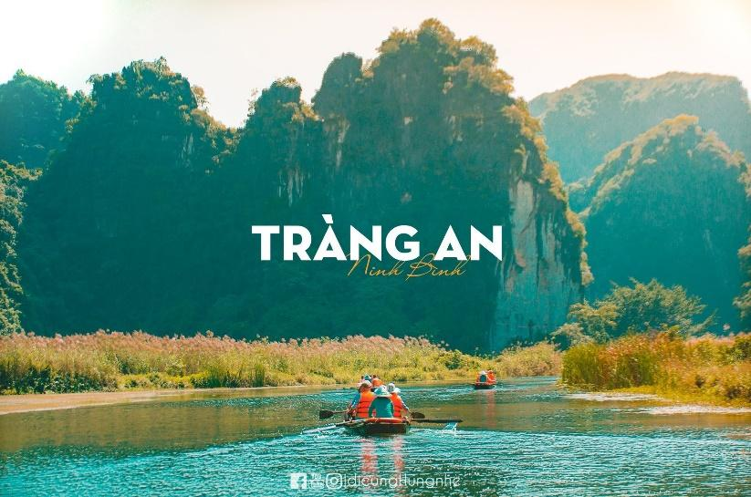 | T-S  S  T-S  T-S | 5 mins
LOOKING BACK | To revise words students have learnt in this unit | VOCABULARY  Choose the correct words to complete the conversation. (p. 118)  * T asks Ss to read each sentence and check comprehension and asks Ss to study the context carefully and decide on the correct words to complete the conversation.  ** Ss complete the task individually.  *** T asks Ss to exchange their textbooks for peer checking.   T checks answers as a class by asking individual students to read the sentences.  Key:  1. sustainable  2. protect  3. profits  4. litter  5. aware  6. ecotourism  7. impact | T-S  S  Pair work  T-S | 5 mins
 | To practise different intonation patterns | PRONUNCIATION  Work in pairs. Role-play the conversation above. Try to use appropriate intonation. (p. 118)  * T asks Ss to work in pairs to role-play the conversation in Vocabulary.  ** Ss role-play the conversation, using the appropriate intonation.  *** T asks some pairs to role-play or read out loud the conversation in front of the class.   T praises for good effort and natural delivery. | T-S  Pair work  T-S | 5 mins
 | To revise conditional sentences Type 1 and Type 2. | GRAMMAR  Put the verbs in brackets in the correct forms. (p. 118)  * T explains to Ss that they are going to review the use of conditional sentences Type 1 and Type 2, gives Ss some time to review the grammar rules in the Language lesson before doing the activity.  ** Ss complete the task individually.  *** T asks Ss to swap their textbooks for peer checking.   T corrects the answers as a class by asking individual students to read the sentences and explain why they used conditional sentences Type 1 or Type 2.  Key:  1. were / was; would live  2. work; will be  3. allow; will have  4. had; would go | T-S  S  Pair work  T-S | 7 mins
PROJECT | To provide an opportunity for students to develop their research and collaboration skills, and to practise giving an oral presentation. | DESIGN AN ECOTOUR  * As Ss have prepared for the project throughout the unit, the focus of this lesson should be on the final product, which is an oral presentation.  ** T has Ss work in their groups.  - Give them a few minutes to get ready for the presentation.  - Give Ss a checklist for peer and self-assessment. Explains that they will have to tick appropriate items while listening to their classmates’ presentations and write comments if they have any.  - The presenters should complete their self-assessment checklist after completing their presentation.  - If necessary, T goes through the assessment criteria to make sure Ss are familiar with them.  *** T invites two or three groups to give their presentations, encouraging the rest of the class to ask questions at the end.   T gives praise and feedback after each presentation. | T-S  Group work  S-S  T-S | 20 mins
WRAP-UP  HOMEWORK | To help students memorise what they have learned | WRAP-UP  - Review the vocabulary and grammar of Unit 10.  - Apply what they have learnt (vocabulary and grammar) into practice through a project.  HOMEWORK  - Exercises in the workbook. | T-S | 3 mins

