UNIT 7: THE WORLD OF MASS MEDIA
Lesson 8: Looking back and project

I. OBJECTIVES
By the end of this lesson, Ss will be able to:
1. Knowledge
- Review the vocabulary and grammar of Unit 7;
- Apply what they have learnt (vocabulary and grammar) into practice through a project.
2. Core competence
- Develop communication skills and creativity;
- Develop presentation skills;
- Develop critical thinking skills;
- Be collaborative and supportive in pair work and team work;
3. Personal qualities
- Be responsible for the community

II. MATERIALS
- Grade 12 textbook, Unit 7, Looking back and project
- Computer connected to the Internet
- Projector / TV/ pictures and cards
- hoclieu.vn

Assumption
Anticipated difficulties | Solutions
Students may have underdeveloped speaking, writing and co-operating skills when doing the project. | - Encourage students to work in pairs and in groups so that they can help each other.  - Provide feedback and help if necessary.
Some students will excessively talk in the class. | - Explain expectations for each task in detail.  - Continue to explain task expectations in small chunks (before every activity).

III. PROCEDURES
1. WARM-UP (5 mins)
a. Objectives:
- To stir up the atmosphere and activate students’ knowledge on the topic;
- To enhance students’ skills of cooperating with teammates.
b. Content:
- Game: Lucky number
c. Expected outcomes:
- Students can recall the vocabulary they have learnt in Unit 7.
d. Organisation:

TEACHER’S ACTIVITIES | STUDENTS’ ACTIVITIES | CONTENTS
Game: Lucky number  - Ss work in 2 teams.  - There are 7 numbers, 2 of which are lucky ones.  - Each team takes turn to send a representative to turn his/her back to the board and choose a number.  - If he/she chooses a lucky number 🡪 one point without answering the question.  - If he/she chooses the other numbers 🡪 receive a word and describe it without saying the word directly.  - Other Ss try to guess the words. One point for a correct answer.  - The team with the most points is the winner. | - Students join the game, choose a number and describe the word. | Suggested words:  1. mass media  2. leaflet  3. billboard  4. loudspeaker  5. pie chart
e. Assessment:
- Teacher observes the groups and gives feedback.

2. ACTIVITY 1: LOOKING BACK (12 mins)
a. Objectives:
- To help Ss review the pronunciation of linking /r/.
- To help Ss revise words and phrases they have learnt in this unit.
- To help Ss review the use of adverbial clauses of manner and result.
b. Content:
- Pronunciation: Work in pairs and mark the places where the linking /r/ can appear. Listen and check. Then practise saying the sentences. (p.98)
- Vocabulary: Solve the crossword with the words you’ve learnt in this unit. What is the hidden word? (p.98)
- Grammar: Circle the mistake in each sentence. Then correct it. (p.99)
c. Expected outcomes:
- Students can use the knowledge they have learnt in this unit to complete the tasks successfully.
d. Organisation:
TEACHER’S ACTIVITIES | STUDENTS’ ACTIVITIES | CONTENTS
Pronunciation: Work in pairs and mark the places where the linking /r/ can appear. Listen and check. Then practise saying the sentences. (4 mins)
- Ask Ss to read through the sentences to get a broad understanding.  - Tell them to identify the places where linking /r/ can appear. In weaker class, give an example first. E.g. 1. The linking /r/ can appear between the final vowel /ə/ in ‘Peter’ and the initial vowel /ə/ in ‘and’.  - Ask Ss to listen to the recording and check their answers. Have them pay attention to the linking /r/ in each word.  - Ask Ss to listen to the recording again, but this time, have them repeat the whole sentences with emphasis on the linking /r/. | - Students identify the places where linking /r/ can appear | Answer key:  1. Peter and I are discussing the news in the local press.  2. There is a huge poster on the wall advertising the public event.  3. The village is far away in the mountains, but the villagers have a fast Internet connection.  4. The singer is the focus of  media attention.
Vocabulary: Solve the crossword with the words you’ve learnt in this unit. What is the hidden word? (4 mins)
- Ask Ss to work in pairs to solve the crossword. Remind them that all the words they need are in this unit, and there is a hidden vertical word.  - Have Ss complete the activity.  - Check answers as a class.  - If time allows, ask them to find the texts where these words first appear in the unit and call out the section, e.g. media first appears in the Getting started section. | - Ss work in pairs to solve the crossword | Answer key:  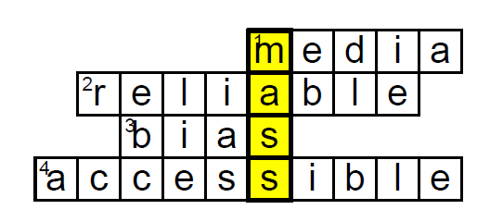
Grammar: Circle the mistake in each sentence. Then correct it. (4 mins)
- Ask Ss to read the whole sentence, focus on the underlined words / phrases  - Encourage them to check whether these underlined words / phrases are grammatically correct or not by studying both the underlined parts and the phrases and the sentences that contain these parts. E.g. 1. A. ‘The’ Internet is correct because we often use ‘the Internet’ to refer to the network we use to share information. B. ‘so a convenient tool’ is incorrect because we use ‘so’ with an adjective, not with a noun phrase like this.  - In weaker classes, remind them that the focus today is on the use of adverbial clauses of manner and result. Help them review these grammar rules before they complete the task.  - Check answers as a class by asking individual Ss to identify the incorrect part, give corrections and reasons for their corrections, e.g. 1. B. ‘so’ is the answer because we say ‘such a convenient tool’, not ‘so a convenient tool’. | - Ss read the sentences, circle the mistake in each sentence and correct it. | Answer key:  1. B (so 🡪 such)  2. D (like 🡪 if)  3. D (so 🡪 that)  4. C (as if 🡪 as)
e. Assessment:
- Teacher observes Ss’s work and gives feedback.

3. ACTIVITY 2: PROJECT (28 mins)
a. Objectives:
- To provide an opportunity for Ss to develop their research and collaboration skills, and to practise giving a presentation.
b. Content:
- The pros and cons of mass media
c. Expected outcomes:
- Students practice giving a presentation.
d. Organisation:

TEACHER’S ACTIVITIES | STUDENTS’ ACTIVITIES | CONTENTS
- As Ss have prepared for the project throughout the unit, the focus of this lesson should be on the final product, which is a presentation.  - Have Ss work in their groups. Give them a few minutes to get ready for the presentation.  - Give Ss a checklist for peer and self-assessment. Explain that they will have to tick appropriate items while studying the leaflet or listening to the presentation, and write comments if they have any. The presenters should complete their self-assessment checklist after completing their presentation.  - If necessary, go through the assessment criteria to make sure Ss are familiar with them.  - Invite one or two groups to present their ideas in front of the class. Ask others to listen and write down their feedback and comments. At the end of each presentation, invite peer feedback from the audience in oral and/or written forms.  - Give praise and feedback at the end. Teacher can also give Ss marks for their presentation as part of their continuous assessment. | - All groups exhibit their group preparation and make presentations.  - When one group makes a presentation, others listen and complete the evaluation sheet. | Students’ presentations
e. Assessment
- Teacher gives comments and feedback to all presentations.

4. CONSOLIDATION (3 mins)
a. Wrap-up
- T asks Ss to talk about what they have learnt in the lesson.
b. Homework
- Do exercises in the workbook.
- Prepare for Unit 8.

Board Plan

Date of teaching
Unit 7: The world of mass media
Lesson 8: Looking back and project
*Warm-up
Game: Lucky number
* Looking back
- Pronunciation
- Vocabulary
- Grammar

* Project: The pros and cons of mass media

*Homework

UNIT 8: WILDLIFE CONSERVATION

Lesson 1: Getting started – At a rescue center

I. OBJECTIVES

By the end of this lesson, Ss will be able to:

1. Knowledge

- Gain an overview about the topic wildlife conservation;

- Understand the words and phrases related to wildlife;

- Use adverbial clauses of condition and comparison correctly.

2. Competences

- Develop communication skills and creativity;

- Be collaborative and supportive in pair work and teamwork;

- Actively join in class activities.

3. Personal qualities

- Be aware of conservation issues and think of new ways to protect animals

II. MATERIALS

- Grade 12 textbook, Unit 8, Getting started

- Computer connected to the Internet

- Projector / TV

- hoclieu.vn

Language analysis
Form | Pronunciation | Meaning | Vietnamese equivalent
1. enclosure (n) | /ɪnˈkləʊʒə/ | an area surrounded by a wall or fence, and used for a particular purpose | mảnh đất đã được rào lại
2. primate (n) | /ˈpraɪmeɪt/ | a member of the group of animals that includes humans and monkeys | linh trưởng
3. house (v) | /haʊz/ | provide someone with a place to live | cung cấp nơi ở
4. endangered (adj) | /ɪnˈdeɪndʒəd/ | at risk of no longer existing | gặp nguy hiểm

Assumption
Anticipated difficulties | Solutions
Students are reluctant to work in groups. | - Encourage students to work in pairs and in groups so that they can help each other.  - Provide feedback and help if necessary.
Students may lack vocabulary to deliver a speech. | - Explain expectations for each task in detail.  - Continue to explain task expectations in small chunks (before every activity).  - Provide vocabulary and useful language before assigning tasks.  - Encourage students to work in groups so that they can help each other.

III. PROCEDURES

1. WARM-UP (5 mins)

a. Objectives:

- To create a friendly and lively atmosphere in the classroom;

- To set the context for the listening and reading part;

- To enhance students’ skills of cooperating with teammates.

b. Content:

- Video watching

c. Expected outcomes:

- Students can answer questions about wildlife conservation.

d. Organisation:

TEACHER’S ACTIVITIES | STUDENTS’ ACTIVITIES | CONTENTS
Video watching  - Teacher asks students to read through some questions before watching the video.  - Teacher asks students to watch a video about wildlife conservation.  - Call on some students to give their answers. | - Students work in groups.  - Students look at the picture that the teacher shows them and describe the picture.  - Other students try to guess the name. | Link video: https://www.youtube.com/watch?v=e-yAO267tvE  Questions:  - What is wildlife conservation?  - What can wildlife conservation be broken down into?  - Which country is mentioned in the video as an example of protecting wildlife?

e. Assessment:

- T observes and gives feedback.

2. ACTIVITY 1: PRESENTATION (5 mins)

a. Objectives:

- To provide students with new words related to the topic;

- To help students be well-prepared for the listening and reading tasks.

b. Content:

- Vocabulary pre-teaching

c. Expected outcomes:

- Students can identify some new words related to the topic.

d. Organisation

TEACHER’S ACTIVITIES | STUDENTS’ ACTIVITIES | CONTENTS
Vocabulary pre-teaching  - Teacher introduces the vocabulary.  - Teacher explains the meaning of the new vocabulary by pictures.  - Teacher checks students’ understanding with the “Rub out and remember” technique.  - Teacher reveals that these four words will appear in the reading text and asks students to open their textbook to discover further. | - Students listen to the teacher’s explanation and guess the words.  - Students write down the new words in their notebook. | New words:  1. enclosure (n)  2. primate (n)  3. house (v)  4. endangered (adj)

e. Assessment:

- Teacher checks students’ pronunciation and gives feedback.

- Teacher observes students’ writing of vocabulary in their notebooks.

3. ACTIVITY 2: PRACTICE (22 mins)

a. Objectives:

- To help students get to know the topic;

- To introduce words and phrases related to wildlife conservation;

- To help Ss identify adverbial clauses of condition and comparison.

b. Content:

- Task 1: Listen and read. (p.100, 101)
- Task 2: Read the conversation again and decide whether the statements are true or false. (p.101)
- Task 3: Match the words and phrases with their meanings. (p.101)
- Task 4: Complete the sentences using clauses from task 1. (p.101)

c. Expected outcomes:

- Students can thoroughly understand the content of the text and complete the tasks successfully.

d. Organisation:

TEACHER’S ACTIVITIES | STUDENTS’ ACTIVITIES | CONTENTS

Task 1: Listen and read. (6 mins)
- Put Ss into groups. Draw a mind map on the board and write Endangered Species in the middle. Have groups brainstorm as many aspects of the topic as possible, e.g. kinds of species, where they are found,…. Give Ss a time limit for the brainstorming.  - Ask some groups to call out their ideas and write them into the mind map on the board. Praise groups for good effort.  - Have Ss look at the picture and elicit the context of the conversation by asking some questions, e.g. What animals do you see in the pictures? Where is Mark?  - Play the recording twice for Ss to listen and read along. Have Ss underline words and phrases related to the world of work while they are listening and reading.  - Put Ss in pairs and ask them to compare the words and phrases they have underlined and discuss their meanings. Then check comprehension as a class.  - Call on three Ss to read the conversation aloud. | - Students brainstorm and write as many species as possible in the mind map.  - Students listen to the recording.  - Students underline words/phrases related to wildlife conservation.  - Students compare the words and phrases with their partners.  - Students read the conversation aloud. | 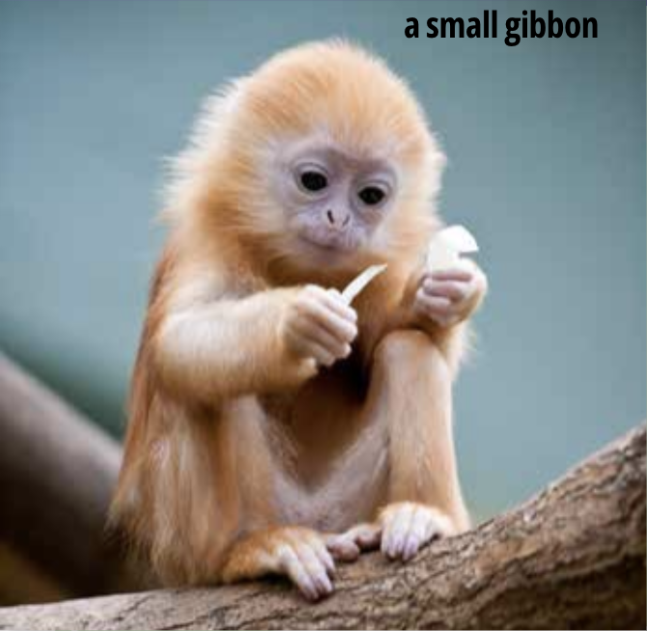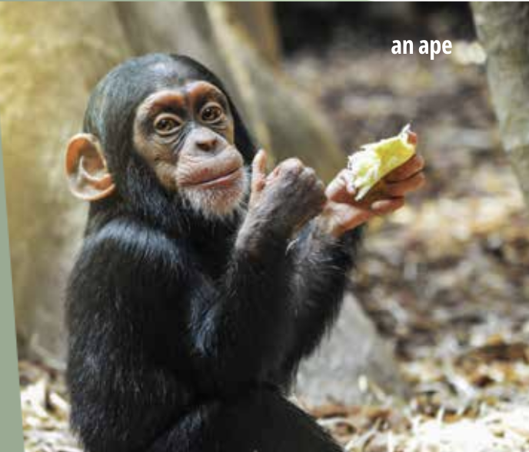

Task 2: Read the conversation again and decide whether the statements are true or false. (5 mins)
- Put Ss in pairs. Ask them to read the statements carefully and decide whether the statements are true or false. In stronger classes, encourage Ss to do the task without looking back at the conversation.  - Then have them read the conversation again and locate the part of the conversation that has the information for each of the questions.  - Have Ss share their answers with the class.  - Confirm the correct answers. | - Students work independently to do the activity.  - Students compare the answers in pairs. | Key:  1. T  2. F  3. F  4. T

Task 3: Match the words and phrases with their meanings. (6 mins)
- Have Ss read the conversation quickly again, find these words and phrases, and guess their meanings from the context.  - Ask Ss to do the matching.  - To check answers, write the individual words on the board and have Ss come to the board to match them.  - Alternatively, have one student read the word and another student say the meaning of the word.  - Give further explanation to the words and phrases. | - Students read the conversation again and work independently to do the activity.  - Students share and check the answers. | Answer key:  1. d  2. b  3. a  4. c

Task 4: Complete the sentences using clauses from task 1. (5 mins)
- Have Ss read each sentence and try to think of the missing information to complete the sentences.  - In weaker classes, encourage Ss to read the conversation again and find the sentences.  - Check answers by calling on individual Ss to read the complete sentences.  - Remind Ss of types of clauses learned in the unit (adverbial clauses of condition and comparison). Draw Ss’ attention to these types and tell Ss that they will revise all these types in later lessons. | - Students work individually to complete the sentences.  - Students share and check the answers. | Answer key:  1. If you have any questions during the tour, don’t hesitate to ask the guide.  2. Apes are as good at using tools as they’re at learning sign language.  3. We can help gibbons if we stop keeping them as pets.  4. Gibbons can become ill or weak unless they’re fed the right type of food.

e. Assessment:

- Teacher checks students’ exercises individually and gives feedback.

4. ACTIVITY 3: PRODUCTION (10 mins)

a. Objectives:

- To help Ss memorize the key information about wildlife conservation;

- To get Ss to speak about some ways to protect the wildlife.

b. Content:

- Make a mini presentation about ways to protect the wildlife.

c. Expected outcomes:

- Ss can make a presentation about ways to protect the wildlife before class.

d. Organisation:

TEACHER’S ACTIVITIES | STUDENTS’ ACTIVITIES | CONTENTS

Make a presentation about ways to protect the wildlife. (10 mins)
- Teacher lets Ss work in groups of 4. Give each group a big sheet of paper and colours.  - Give instructions to students.  - Ask students to make a mini presentation about ways to protect the wildlife. For example: stop keeping endangered species as pets.  - Teacher asks all groups to stick their works on the blackboard.  - Teacher calls on some groups to present their map.  - Teacher asks other groups to listen and give comments.  - Teacher gives feedback and gives marks to the best group. | - Students work in groups to follow teacher’s instructions.  - Students perform in front of the class. | Students’ own creativity

e. Assessment:

- Teacher’s observation on Ss’ performance.

- Teacher’s feedback and peers’ feedback.

5. CONSOLIDATION

a. Wrap-up:

- Teacher asks students to talk about what they have learnt in the lesson.

b. Homework:

- Do exercises in the workbook.

- Prepare for the project in Lesson 8.

Board plan

Date of teaching

Unit 8: WILDLIFE CONSERVATION

Lesson 1: Getting started

* Warm-up

* Vocabulary

1. enclosure (n)

2. primate (n)

3. house (v)

4. endangered (adj)

Task 1: Listen and read.

Task 2: True or false.

Task 3: Matching.

Task 4: Complete the sentences.

Mini presentation

*Homework

UNIT 8: WILDLIFE CONSERVATION

Lesson 2: Language

I. OBJECTIVES

By the end of this lesson, Ss will be able to:

1. Knowledge

- Use the lexical items related to the topic wildlife conservation;

- Identify and use assimilation in connected speech to sound natural;

- Use adverbial clauses of condition and comparison correctly.

2. Competences

- Develop communication skills;

- Be collaborative and supportive in pair work and team work;

- Actively join in class activities.

3. Personal qualities

- Be eager to learn more about ways to protectthe wildlife;

- Develop self-study skills.

II. MATERIALS

- Grade 12 textbook, Unit 8, Language

- Computer connected to the Internet

- Projector / TV

- hoclieu.vn

Assumption
Anticipated difficulties | Solutions
Students may lack knowledge about some lexical items. | Provide students with the meaning and pronunciation of some lexical items.
Students may have underdeveloped listening, speaking and co-operating skills. | - Play the recording many times if any necessary.  - Encourage students to work in pairs, in groups so that they can help each other.  - Provide feedback and help if necessary.
Some students will excessively talk in the class. | - Define expectation in explicit detail.  - Continue to define expectations in small chunks (before every activity).

III. PROCEDURES

1. WARM-UP (5 mins)

a. Objectives:

- To stir up the atmosphere and activate students’ knowledge on the topic;

- To enhance students’ skills of cooperating with teammates.

b. Content:

- Game: Say it out loud.

c. Expected outcomes:

- Students can list names of endangered species.

d. Organisation:

TEACHER’S ACTIVITIES | STUDENTS’ ACTIVITIES | CONTENTS
Game: SAY IT OUT LOUD  - Divide the class into two teams.  - Ask students to give names of endangered species.  - Each team takes turns to shout out the names.  - The team with more accepted species become the winner. | - Students work in groups to join the game.  - Students give names of endangered species. | Students’ own creativity.

e. Assessment

- Teacher observes and gives feedback.

2. ACTIVITY 1: PRONUNCIATION (12 mins)

a. Objectives:

- To help Ss recognise and practise assimilation of consonant sounds in connected speech.

b. Content:
- Task 1: Listen and repeat the examples above. Pay attention to the highlighted sounds. (p.102)
- Task 2: Listen and underline the parts where assimilation occurs. Then practice reading the sentences in pairs. (p.102)

c. Expected outcomes:

- Students can correctly pronounce the words in assimilation.

d. Organisation:

TEACHER’S ACTIVITIES | STUDENTS’ ACTIVITIES | CONTENTS

Task 1: Listen and repeat the examples above. Pay attention to the highlighted sounds. (6 mins)
- Explain the process of assimilation to Ss, that is, when the ending sound of one word blends into the beginning sound /m/, /b/, /p/, and /s/ of the following word. Tell them that this is a natural process that appears in rapid speech. (Ss should not intentionally change the ending sounds as described.)  - Play the recording for Ss to listen and follow.  - Read out the examples in the Remember Box (or play the recording again) for Ss to repeat as a class.  - Ask Ss to work in pairs and take turns pronouncing the phrases. Encourage Ss to say them as naturally as possible. | - Students listen to the recording, and then repeat the words.  - Students read the examples.  - Students practise in pairs. | Students’ practise.

Task 2: Listen and underline the parts where assimilation occurs. Then practice reading the sentences in pairs. (6 mins)
- Ask Ss to read the sentences and underline the parts where assimilation occurs.  - In weaker classes, demonstrate by reading the sentences or play the recording first then let Ss repeat the sentences.  - Extend this task by having Ss take turns reading each of the sentences twice: 1) slowly, trying to enunciate the sounds clearly and avoid any assimilation and 2) quickly, trying to blend the final and initial sounds. Ask their partners to listen carefully and identify any assimilated sounds.  - Play the recording (several times if necessary) to check the answers. Further explain this phenomenon in English so that Ss can understand more clearly. | - Students read the sentences and underline.  - Students check the answers with their partners.  - Students practise reading the sentences. | Answer key:  1. Apes are larger than monkeys. /ˈðəm ˈmʌŋkiz/  2. If fed properly, the bear will recover soon. /ˈʃeb ˈprɑːpərli/  3. Both species benefit from living together. /ˈbəʊs ˈspiːʃiːz/  4. Ten per cent of the world’s population was infected by the virus. /ˈtem pəˈsent/

e. Assessment

- Teacher checks students’ pronunciation and gives feedback.

- Students in class listen and give feedback on their friends’ performance.

3. ACTIVITY 2: VOCABULARY (12 mins)

a. Objectives:

- To introduce words related to wildlife conservation.

- To help Ss practise using the words in meaningful contexts.

b. Content:
- Task 1: Match the words with their meanings. (p.102)

- Task 2: Complete the sentences using the words in task 1. (p.103)

c. Expected outcomes:

- Students understand the meaning of words, memorise them and are able to use them in meaningful contexts.

d. Organisation:

TEACHER’S ACTIVITIES | STUDENTS’ ACTIVITIES | CONTENTS
Task 1: Match the words with their meanings. (6 mins)
- Ask Ss to work in pairs. Ask them to read the wordsand match them to their meanings.  - Check answers as a class. Call on one student to read an item aloud and another student to read its meaning.  - Have Ss practise vocabulary building skills by thinking of wordsassociated with the five items in this activity.  - Put Ss in pairs or groups. Provide some synonyms or antonyms for the words for Ss’ reference, e.g. extinct - common, conserve - destroy… | - Students match each word on the left with the one on the right.  - Students study the meanings and underline key words. | Answer key:  1. d  2. a  3. b  4. c  5. e

Task 2: Complete the sentences using the words in task 1. (6 mins)
- Have Ss work in pairs. Tell them to read the sentences carefully and decide which word in task 1 can be used to complete each of the sentences. Explain that they should use the context clues to decide on the word, e.g. in the first sentence, the gapped word is a verb that explains the reason why wild animals need to live in natural habitats.  - Check answers as a class. Have Ss call out the word they have used in each sentence first.  - Confirm the correct answers. Ask Ss to give reasons why they have chosen the words by referring to the context clues.  - Ask individual Ss to read the complete sentences. | - Read and complete the sentences.  - Check the answers and give reasons. | Answer key:  1. survive  2. rare  3. extinct  4. captivity  5. conserve

e. Assessment:

- Teacher’s observation on Ss’ performance.

- Teacher’s feedback and peers’ feedback.

4. ACTIVITY 3: GRAMMAR (13 mins)

a. Objectives:

- To give Ss an opportunity to practice adverbial clauses of condition and comparison.

- To help Ss practise adverbial clauses of condition and comparison in a speaking activity.

b. Content:

- Task 1: Combine the sentences using adverbial clauses of condition or comparison. Use the conjunctions in brackets and make any necessary changes. (p.103)
- Task 2: Work in pairs. Make sentences about endangered animals using adverbial clauses of condition or comparison. (p.103)

c. Expected outcomes:

- Students know how to use adverbial clauses of condition and comparison and can apply them to give a short talk on the given topic.

d. Organisation:
TEACHER’S ACTIVITIES | STUDENTS’ ACTIVITIES | CONTENTS

Task 1: Combine the sentences using adverbial clauses of condition or comparison. Use the conjunctions in brackets and make any necessary changes. (6 mins)
- Tell Ss to read the explanation and examples in the Remember! box. Check understanding of the grammar point by asking questions such as What does the clause describe? What conjunctions does it use?  - In weaker classes, give more examples to demonstrate the use of all conjunctions.  - In stronger classes, have Ss come up with their own example sentences.  - Ask Ss to work in pairs or individually to combine the pairs of sentences by using the conjunctions in brackets. If necessary, help Ss identify the type of adverbial clause before they start writing. In weaker classes, underline the words that they don’t need to include in their new sentences and tell  them where to place the conjunctions, e.g. at the beginning of the first or second sentence.  - Check answers as a class and ask Ss to explain the structure of each sentence. | - Students read the notes in the Remember box.  - Students combine the sentences using adverbial clauses of condition or comparison.  - Students explain their answers. | Answer key:  1. If you don’t release the sea turtle into the sea, it will die soon.  2. Raising people’s awareness is as important to preserve wildlife as imposing strict laws is.  3. Unless we stop poaching, many endangered species will become extinct.  4. A monkey is more intelligent than you may think.
Task 2: Work in pairs. Make sentences about endangered animals using adverbial clauses of condition or comparison. (7 mins)
- Have Ss read the instructions and example, and make sure they all understand the context and what they have to do. In weaker classes, brainstorm some ideas and write them as prompts on the board.  - Put Ss in pairs and have them make their own sentences.  - Invite some pairs of Ss to share their sentences with the class. | - Students work in pairs and make some sentences.  - Some pairs share the answers with the whole class. | Suggested answers:  You might be surprised to know that dolphins are more intelligent than many other sea creatures are.  If we do not take immediate measures to stop global warming, polar bears may become extinct.  If we continue to breed and keep tigers in captivity, they will not develop the skills to survive in  the wild.

e. Assessment:

- Teacher’s observation on Ss’ performance.

- Teacher’s feedback and peers’ feedback.

5. CONSOLIDATION (3 mins)

a. Wrap-up:

- T asks Ss to talk about what they have learnt in the lesson.

b. Homework:

- Do exercises in the workbook.

- Prepare for Lesson 3 - Reading.

Board plan

Date of teaching

Unit 8: WILDLIFE CONSERVATION

Lesson 2: Language

* Warm-up

Game: Say it out loud

* Pronunciation

- Task 1. Listen and repeat.

- Task 2. Listen and underline the parts.

* Vocabulary

- Task 1. Match the words with their meanings.

- Task 2. Complete the sentences.

* Grammar

- Task 1. Combine the sentences.

- Task 2. Make sentences.

* Homework

